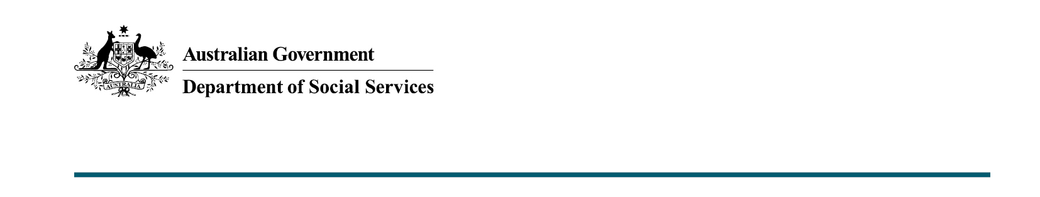

Supporting jobseekers with disability
  - Budget 2022-23

What was announced in Budget 2022-23?
The Australian Government is investing $6 million over two years to increase employment outcomes for jobseekers with disability, by connecting them to potential employers through a new digital job platform.

Promoting ‘The Field’
This measure will fund a national employment initiative to promote The Field to some of Australia’s biggest businesses, encouraging them to hire more than 100,000 people with disability across their organisations.
The Field is an online job platform being co-designed with people with disability. It will be launched later this year, and include accessible features to make the focus of the recruitment process about the person’s skills, experience and qualifications, rather than their disability.
2022 Australian of the Year Dylan Alcott AO’s organisation Get Skilled Access (GSA) organisation received a $3.5 million grant to develop The Field through the Department of Social Services Information, Linkages and Capacity Building (ILC) program in July 2021.
This additional funding will be used to build on the initial investment in The Field, by promoting the project to employers across corporate, government and small and medium-sized businesses.
This measure is one of the many ways the Australian Government is demonstrating its commitment to increasing employment and financial security for people with disability under Australia’s Disability Strategy 2021-2031 and Employ My Ability – the Disability Employment Strategy.

More information
For more information about this measure and other Department of Social Services’ Budget measures, go to www.dss.gov.au/budget.
For information about Budget 2022-23, go to www.budget.gov.au.

