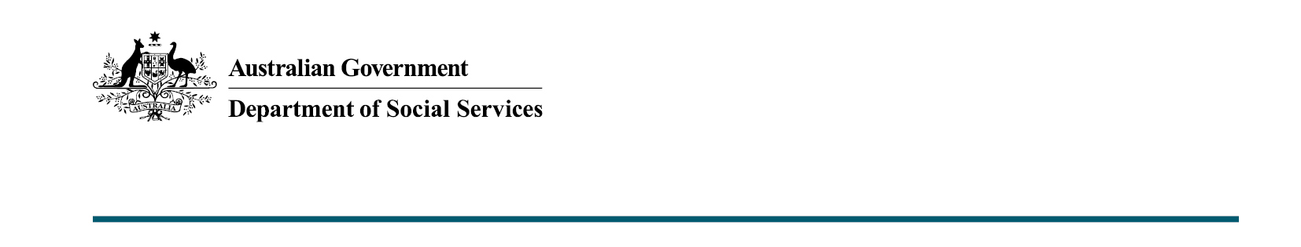

Cost of Living Payment
  - Budget 2022-23

What was announced in Budget 2022-23?
The Australian Government will invest $1.5 billion to assist around 6 million Australians with higher cost of living pressures. A one-off $250 Cost of Living Payment will be paid to eligible recipients from the end of April 2022.
Cost of Living Payment
The Cost of Living Payment is a one-off payment of $250 for eligible payment recipients and concession card holders.
The Cost of Living Payment will only be paid once for each person, even if they qualify in multiple ways. Each member of a couple will receive the payment if both are eligible.
The payment will not be taxable and will not count as income for social security purposes.
Services Australia and the Department of Veterans’ Affairs will automatically pay the Cost of Living Payment to eligible payment recipients and concession card holders.

Key facts
- The Cost of Living Payment will be made to eligible recipients of the:
  - Age Pension
  - Disability Support Pension
  - Carer Payment
  - Carer Allowance (not in receipt of a primary payment)
  - JobSeeker Payment
  - Youth Allowance (student, apprentice and jobseekers)
  - Farm Household Allowance
  - Parenting Payment
  - Special Benefit
  - Austudy
  - ABSTUDY Living Allowance
  - Commonwealth Seniors Health Card
  - Pensioner Concession Card (not in receipt of a primary payment)
  - Double Orphan Pension
  - certain Department of Veterans’ Affairs payment recipients and concession card holders.
- Relevant payment recipients and concession card holders must have been residing in Australia on the 29 March 2022 test date to be eligible.

More information
For more information about this measure and other Department of Social Services’ Budget measures, go to www.dss.gov.au/budget.
For information about Budget 2022-23, go to www.budget.gov.au

