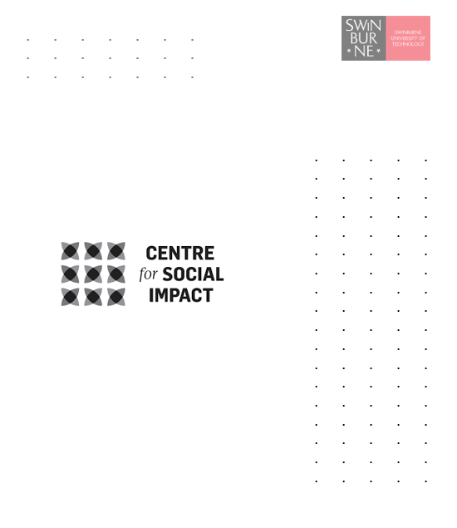

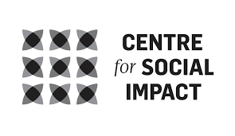

Overview of results
Informing Investment Design:
ILC Research Activity
November 26, 2021

Citation
Wilson, E., Qian-Khoo, J., Campain, R., Brown, C., Kelly, J. & Kamstra, P. (2021). Overview of results: Informing investment design, ILC Research Activity, Hawthorn: Centre for Social Impact, Swinburne University of Technology.

Project Team
Professor Erin Wilson
Dr Joanne Qian-Khoo
Dr Robert Campain
Dr Chris Brown
Dr Peter Kamstra
Mr James Kelly
Ms Jenny Crosbie
Dr Andrew Joyce
Ms Jasmine Knox

Funding
Funding was awarded to the Centre for Social Impact through the Information, Linkages and Capacity Building program of the Department of Social Services (DSS).

Acknowledgements
The research team received substantial support and guidance from the project managers at DSS. We are also indebted to the disability sector for sharing their views and experiences via surveys and interviews.

Contents
Acronyms and abbreviations iv
Executive Summary 5
Introduction 13
Background 13
Methods and reports 16
1. Methods 16
2. Limitations 18
3. Reports 18
Summary of funded ILC project activities 2019-2021 20
1. Investment 20
2. Jurisdictional distribution 20
3. Spatial mapping 22
4. Cohort focus of ILC projects 23
5. What organisations deliver ILC projects? 27
6. What do ILC projects focus on? 28
Summary of key themes from interviews and surveys 37
1. Original design of the ILC 37
2. Context affecting ILC 37
3. ILC as change-maker: Major logics of change 39
4. Purpose and scope of ILC 39
5. Needs, priorities, gaps 40
6. Funding design 43
7. Timescale of funding 46
8. Investment governance 47
9. Funds management, and project support 48
10. Sustainability 50
Implications and conclusions 51
References 53
Appendix 1: ILC Outcomes framework 55
Appendix 2: Chronology of ILC grant rounds 56
Appendix 3: National maps of SCP, ICB and EP delivery 57
Appendix 4: Examples of metropolitan maps of delivery 60
Appendix 5: Comparison labour market programs and EP projects 62
Appendix 6: List of information sources produced by NIP grantees 64

Acronyms and abbreviations
ABI Acquired Brain Injury
ADS Australian Disability Strategy (formerly the National Disability Strategy)
AWP Activity Work Plan
CRPD Convention on the Rights of Persons with Disabilities
DES Disability Employment Services
DPO Disabled Peoples Organisation
DPFOs Disabled Peoples and Family Organisations
DROs Disability Representative Organisations
DSO Disability Support Organisation
DSP Disability Support Pension
DSS Department of Social Services
ECEI Early Childhood Early Intervention
EP Economic Participation
ICB Individual Capacity Building
ILC Information, Linkages and Capacity Building
LACs Local Area Coordinators
LGA Local Government Authority
MCB Mainstream Capacity Building
NDA National Disability Agreement
NDS National Disability Strategy
NFP Not for Profit
NDIA National Disability Insurance Agency
NDIS National Disability Insurance Scheme
NDS National Disability Strategy
NGO Non-Government Organisation
NIP National Information Program
OCB Organisational Capacity Building
SCP Social and Community Participation
SEIFA Socio-Economic Indexes for Areas

Executive Summary

Introduction
Between June and November 2021, the Centre for Social Impact (CSI), Swinburne University of Technology, undertook this research project to assist the Department of Social Services (DSS) to build an evidence base for the Information, Linkages and Capacity Building (ILC) Program and inform the future investment strategy. The study includes a review of grants information, surveys and interviews of grantees and sector informants, and a desktop review of literature on current identified needs and priorities to achieve inclusion/equity for people with disability. This report is a final overview report comprising high level analysis across these data sources.

Background
The ILC was initially conceptualised as ‘Tier 2’ of the three-tiered National Disability Insurance Scheme (NDIS). While Tier 3 provides individualised funding to eligible people with disability to purchase the supports they require to maximise life activities and social and economic participation, Tier 2 was initially conceived as supporting all people with disability to have increased linkages to community supports and to foster social change (Productivity Commission, 2011).
The ILC Policy Framework, developed by the NDIA in 2015, identified five streams of activity, four of which are delivered through a grants program organised into four ‘discrete but complementary programs’ (NDIA, 2018, p. 6) described in Table 1.
Table 1: ILC components and alignment to grants program
ILC streams | ILC grants program | Grants program descriptors (NDIA, 2018)
Information, Linkages and Referrals | National Information Program (NIP) | ‘ensuring people with disability, their families and carers have access to up-to-date, relevant information linking them to supports and services in the community’ (p. 7).
Capacity building for mainstream services | Mainstream Capacity Building (MCB) | ‘building the capacity, knowledge, skills, practices and cultures of mainstream services so they have the skills to meet the needs of people with disability through short term catalyst investments’ (p. 7).
Community awareness and capacity building | Economic and Community Participation (ECP); Economic Participation (EP); Social and Community Participation (SCP) | ‘connecting people with disability to activities, employment and community supports and opportunities, helping communities and employers to be inclusive and responsive to people’s needs locally, and nationally’ (p. 7).
Individual capacity building | Individual Capacity Building (ICB) | ‘enabling systematic, nationwide access to peer support, mentoring and other skills building for people with disability, carers and families’. A network of DPFOs to be supported (p. 6).

In 2020, the ILC grants program was transferred from the governance of the NDIA to that of the Department of Social Services, which has continued to administer the program as designed in this investment period. The current investment period is coming to a close, and a new investment strategy will commence in 2024/5. This research is designed to be one element of the work to inform the development of the next investment strategy for the ILC.

Methods
Methods were selected to maximise informant viewpoints from both grantees and key informants from disability sector organisations, peaks and other bodies. This data was triangulated with DSS administrative data related to grant activity and allocation. Care was taken to ensure the sample of informants had national representation, across different cohort groups and geographies.
A desktop review was undertaken of priorities and needs in contemporary Australia relating to disability and inclusion, specifically on the topics within scope for the ILC grants program.
DSS provided a set of grantee data across each of the streams, providing details of 509 projects funded between 2019 and 2021. Data for each stream were quantitatively and qualitatively analysed against a range of categories.
Two online surveys were conducted targeting grantees and sector informants. Informants were representatives of either grantee or sector organisations and did not include people who were beneficiaries of grant activities. Surveys included both quantitative and qualitative questions and sought viewpoints in relation to the scope and purpose of the ILC program, key needs and priorities for investment, grants application and administration processes, and improvements in investment design.
Interviews were conducted by CSI researchers by phone, Zoom or Teams with samples of sector informants and grantees. Interviews covered similar content to the online surveys.
The research involved the participation of 477 individuals from across Australia. Various accommodations and supports were provided to improve accessibility and increase participation of informants.

Summary of funded ILC project activities 2019-2021

Investment
The ICB stream received the highest proportion of total funding allocation at 50%, followed by the NIP stream at 18% (Table 2).
Table 2: Total investment in the funding period 2019-2021 by stream
 | Total $ 2019-2021 | % of ILC investment | Grant range | Funding period
ICB | $160,559,432 | 50% | $12,000 - $1,950,000 | 1 to 3 years
NIP | $59,542,104 | 18% | $365,160 - $8,418,298 | 2 or 3 years
MCB | $37,889,707 | 12% | $270,000 - $6,000,000 | 2 or 3 years
EP | $36,014,589 | 11% | $250,000 - $3,731,456 | 1 or 2 years
SCP | $30,088,716 | 9% | $20,000 - $3,731,456 | 2 or 3 years

Geographic distribution
On a per stream basis, not all jurisdictions have been allocated grants in every stream, while the more populous States (QLD, Victoria and NSW) appeared to have received proportionately less funding across the streams than the less populous jurisdictions, though by relatively small margins of between 3%-6%.
The national maps of each of the ICB, EP and SCP streams identify significant clustering of project delivery in metropolitan and inner regional areas, with a sparseness of delivery across rural and remote areas. In particular, remote and very remote areas of QLD, WA and NT have almost no identified delivery in these areas, and South Australia has no delivery in remote or very remote areas from any of ICB, EP or SCP projects. Potential benefits from national or jurisdictional projects may apply in these cases.
Comparison of ILC project delivery locations, in the ICB, SCP and EP streams, to the Index of Relative Socio-economic Disadvantage (IRSD), SEIFA (ABS, 2018), by local government areas in Melbourne, Sydney and Brisbane highlighted that the most disadvantaged LGAs were not, in the main, locations of delivery for projects.

Cohort focus of ILC projects

Disability cohorts
The most common cohorts supported by projects, according to DSS data, are ‘all disability’, Intellectual Disability, Autism and Psychosocial disability. These are also the cohorts most commonly identified as the most in need by interviewees and survey respondents.

What do ILC projects focus on?
Analysis of the DSS data (supplied through grant applications) indicates a variety of activity descriptions though the dominant overarching theme is capacity building, including a focus on knowledge, social/networks, personal, material/resources, attitudinal, cultural, practice, and policy ‘capacities’. The largest area of investment, the ICB stream, encompassed a broad range of activity, but predominantly focused on social inclusion and choice/empowerment activities. Other data shows that the Economic Participation-focused projects are delivering employment supports that focus on areas that are not the main focus of Commonwealth labour market programs.

Summary of key themes from interviews and surveys

Original design of the ILC
As confirmed consistently by informants, the ILC grants investment is understood to be originally designed as one of several key planks of Tier 2 of the NDIS, acting as a key lever of systemic change (of mainstream services and communities), providing linkages to supports for those not eligible for the NDIS, and supporting individual capacity building and peer support.

Context affecting ILC
The context into which the ILC grants program has been implemented is described as markedly different from what was anticipated: LACs have not delivered community capacity building and linkages as intended; there is increased client ‘capture’ by service providers; and community inclusion is now reliant on individualised funding. For non-NDIS participants, who lack funds to purchase services, the expansion of the market model has been accompanied by a contraction of services available to them as jurisdictions have withdrawn funding and mainstream services have retreated, expecting NDIS-funded specialised services to fill the void.
In this context, the ‘demand sector’ (typically, DROs, DPOs, grassroots community organisations, non service providers) is identified (by informants in this study and by commentators such as Walsh, 2021) as the necessary counterbalance to the market and a key ‘infrastructure’ of Tier 2. This sector offers a source of information support and peer-leadership; is able to advocate for the needs of people with disability; and is a source of reform pressure for service providers. However, the sector describes a context of extremely precarious funding with significant gaps in coverage.

ILC as change-maker: Major logics of change
Sector informants offered a logic for the social change potential of the ILC., whereby it draws on the ‘whole of government’, cross jurisdictional framework of the Australian Disability Strategy to drive change in society and systems. The ILC is seen as critical given that the NDIS, as an individualised funding system, cannot achieve social change and overturn exclusion. Lives of inclusion require life beyond services which will not be achieved via a reliance on service providers but via increasing agency of people with disability paired with increased opportunities for inclusion in the community and economy. The ‘demand sector’ is seen as the major vehicle of this change given it is led by people with disability and lacks a commercial vested interest in the status quo. If adequately resourced, the ‘demand sector’ can direct the reform of services, support and resource individuals and their families, provide independent information, and inform and lead strategies for change at systems levels. By utilising non-NDIS funding, the sector can connect, collectivise and ‘aggregate individuals’ (EP7) into shared activity, in ways individualised funding, as delivered via service providers, drives against. For this change logic to work, the ILC needs a clearer strategy and targets, with funded activity that is coordinated and curated over the long term, with a mechanism to maximise knowledge sharing so as to scale and connect effective change activities.

Purpose and scope of the ILC
The majority of informants confirm that the ILC grants investment is highly valued and seen as filling a gap, in the absence of other funding, especially across Tier 2. Informants largely endorse the current scope of the ILC but call for a clearer strategy to tie together the necessary elements of the ILC encompassing both localised responses and programs of activity addressing key issues, including at the level of systems and societal change. The funded projects/activities need to be tied together via recognition of the purpose and place of each strategic piece in order to have maximum effect. Investment would necessarily include change strategies at the national, state/territory and regional/ local (place-based) levels as parts of an interconnected strategy. The current grants approach currently works to silo activity and disrupt the necessary connections to address intersecting and interdependent issues.
[ILC funding] It’s very unique. It’s an opportunity that if it didn’t exist, … people that don’t get the direct NDIS funding, would have really, really, limited opportunities … There’s no other program that’s out there, so it’s absolutely filling a gap … that’s really, really needed (NIP20).

Needs, priorities, gaps
Informants largely concur on the needs and gaps to be addressed by ILC investment, though there is tension in prioritising these within a limited budget, noting the interdependence of issues.
Broadly, informants concur with the IAC (2021) that mainstream and community change is essential to inclusion and needs significantly more attention and investment. Without change at these levels, much of ILC activity remains ‘band-aid measures’ that do little to address the ableism embedded across society (ICB13). While attention to accessibility of society and services remains important, a focus on systems change, and systemic barriers, is needed to address embedded exclusions and the underlying disconnect between systems (e.g. education, employment, transport, health services). Societal level change also requires activity to address negative attitudes, stigma and low expectations in relation to disability.
Move the focus towards building inclusion in the mainstream (non-disability) sectors. The social model of disability means that as we build capacity in mainstream, the functional impacts of impairment decrease (#74 sector survey participant).
Individual capacity building remains a high priority identified by both survey and interview respondents. Where sufficient investment is made, individual capacity building was thought to be a high value and high return investment in that its benefits and impacts continue to accrue and ripple out into many life areas.
Provision of and access to independent information must be a feature of investment. Particular areas of focus include: a need for diagnostic specific information (for newly diagnosed people with disability); information suitable to those with communication, language and cognitive barriers (including CALD, First Nations, Deaf, deafblind); and information support to people without digital access.
Employment is an area of societal level change identified by many respondents and remains ‘the known area of the greatest difficulty’ (NIP6) with attention needed at systemic levels as well as coordinated place-based activity.
Attention also needs to be directed to levels of (sometimes hidden) disability populations within systems such as criminal justice, out of home care, and family violence. Respondents felt that the ‘gap’ in focus on people with disability in these systems was only being addressed through piecemeal and insecure ILC funding, despite this activity having fiscal benefits for other portfolios and jurisdictions.
There was repeated discussion of the need to target those ineligible for the NDIS as well as those experiencing higher levels of marginalisation often resulting from multiple disabilities and intersectional identities / experiences, such as those who are homeless, people with disability from diverse cultural and language contexts (including Aboriginal and Torres Strait Islanders, CALD communities, Deaf and deafblind), women, and those in rural and remote communities.
There is very little footprint in regional rural and remote areas...it needs to have a regional localized footprint … Let's look at funding not through population size, but… through service provision. What services are in this area? (SCP8).
A major need is to support the infrastructure of peer-led work and to build the capacity of the ‘demand sector’. A particular lens needs to be applied to small and grassroots organisations, including cohort specific organisations such as First Nations, where often these organisations may be the only peer-led organisation for a cohort, in a region, or even in a State. Interviewees recounted that the work, heavily based on expert knowledge and trust, needs consistent investment to maintain the human, knowledge and social capital accrued. Without investment, activities will cease and some organisations will fold.
There are lots of really small organisations doing fantastic work who need some support with the infrastructure, because they don't have any other grant sources other than ILC (ICB28).

Funding design
Sector and grantee informants highlight the disjuncture between the current funding mechanism of the ILC and its change agenda. The ILC grants approach is currently viewed as a ‘piecemeal’, ‘scattergun’ and patchy ‘jigsaw’ of funding that undermines the achievement of the ILC outcomes.
A grants program, particularly one that predominantly offers short term funding, does not match the nature of the activities required to make change which require the building of trust and ongoing delivery of support and activities to meet entrenched needs. The competitive nature of a grants scheme is counter-productive to and disincentives collaboration and shared learning, stifles opportunities to expand the scale of change, and undermines organisational capacity and workforce retention.
If you get a grant, you do your two-year work, you stop, you get another one a year later. All of that experience and good will is … gone and you have to start again. That’s really disjointed - it’s just money down the toilet because you’ve got to start all over again (NIP4).
Informants consistently described a desired funding design that reflected a ‘targeted commissioned approach’ (ICB8) that takes a ‘strategic view’ of needs, resources (across jurisdictions and stakeholders) and of the current supply market (including service providers and other players) to develop an approach about ‘how to make the best use of available resources to meet needs’ (UK Department of Health quoted in Sturgess, 2018, p. 157). Interviewees strongly engaged with a funding design that was driven by strategy, and predominantly identified commissioning as a mechanism to focus investment on the necessary pieces of work, delivered by the ‘right’ combination of organisation/s for the task. Programs of work should be actively curated and managed by the Department to maximise opportunities for collaboration, scale/replication, and continuity of activities ‘that work’.
Informants supported funding mechanisms such as invited tenders or ‘pitches’, two-stage applications, such as via an Expression of Interest (EOI). Such approaches minimise the upfront organisational investment in application development (and the attendant waste of resources when not successful), and maximise opportunities to actively craft a strong project design through feedback and suggestions for collaboration. Regional commissioning was also considered a viable strategy to ensure greater local relevance and co-design of funding strategy and allocation. Additionally, the central role of people with disability in informing funding design was endorsed as critical.

Timescale of funding
To achieve change, funding predominantly needs to be longer term (three-five years). Longer term funding also recognises the extra time required to undertake co-design and to engage in work with some cohorts, for example people with intellectual disability, people whose first language is not English, people from culturally diverse backgrounds, and people in remote areas.
Recurrent funding for ‘core’ activities is needed where the targeted need is inherently ongoing including: information and peer support for people who are newly diagnosed; maintaining information delivery and currency; and activities needing longer timescales such as systems change. Recurrent funding was also frequently discussed as the necessary mechanism to ensure sufficient ‘demand sector’ infrastructure.
These are very long-term strategies and the nature of these grants are very short term and it makes it very, very difficult to have a real genuine impact … I'm working with vulnerable groups and when you're struggling with language barriers, cultural barriers, people not even necessarily understanding the concepts of speaking up for yourself … The government needs to understand that to be having an effective impact in months is very, very challenging. Because often it takes that amount of time just to build trust and build relationships ICB23).
Informants also wanted to maintain options for shorter term funding, in particular, for activities with a seeding or innovation focus. However, 12 month funding periods, other than for these reasons, were deemed to be ‘absolutely ridiculous’ (SKI5), not allowing sufficient time for co-design, staff and participant recruitment, and delivery.

Investment governance
Informants want to participate in more clearly naming the major change focuses and overarching strategy of the ILC, in order to plan the best deployment of investment. A stronger advisory structure is needed to both develop the ILC strategy, particularly identifying specific areas of change focus and the types of activities needed to achieve these, and to inform funds allocation.

Funds management, and project support
The current grants approach was criticised as: being poorly communicated (i.e. a lack of information about the grants schedule and focus that inhibits planning); lacking in transparency (both in terms of decision making process and feedback to applicants); and poorly executed (with critique over the allocation decisions made). Interviewees proposed increased roles for people with disability at every level of decision making along with engagement with sector intelligence about ‘good’ organisations, useful ideas, and areas of duplication to inform allocation decisions.
The current grant application process is deemed to be inaccessible to many due to a combination of modality, language requirements and workload/resource impost. In its current form it disadvantages small grassroots organisations and those for whom English is not a first language including Deaf people. The current process is perceived as favouring large organisations, with ability to recruit grant writing expertise. Alternate application methods were suggested including pitching applications through video/ teleconferencing or through interviews.
Grantees consider a partnership approach with DSS as vital, with many lamenting that active engagement with DSS was lacking. Not being able to purposefully work with grant managers undermines the endeavours of grantees. While some informants affirmed the approach, many felt the Departmental monitoring activity to be largely a bureaucratic ‘tick the box contract management approach’ (EP10) having limited utility for grantees.
There is a strong desire to learn about and from activities across the sector. At present, there is a noted lack of information about projects funded, and no potential for shared learning as a mechanism for wider collaboration, replication/scaling, and activity improvement. Further investment is needed to realise these opportunities and resource a shared learning approach.

Sustainability
Overall, most grantees confirm that sustaining activity at the currently funded levels would require ongoing funding. There is substantial negative impact of withdrawal of and ‘stop-start’ funding, where skilled personnel, knowledges and resources were lost between funding periods. Not only was this seen to be wasteful of resources, but undermined the trust of the target cohort (people with disability or community).
I just don’t see the value in running a project, proving that it works, proving that there is a gap, and then taking that money away because it would just go back to having a gap (ICB9).
In the main, it was not considered realistic or appropriate that organisations would find other sources of income, particularly within the short time frames of the grant. The push to seek mechanisms to sustain ILC-funded activity, including via commercialising it, was seen as a further disincentive to collaboration, undermining opportunities for shared learning, replication and scaling of activity. Commercialisation was considered to be counter to the organisational purpose of the ‘demand sector’ in the provision of support to people with disability regardless of the capacity to pay for it.

Introduction
Between June and November 2021, the Centre for Social Impact (CSI), Swinburne University of Technology, undertook this research project to assist the Department of Social Services (DSS) to build an evidence base for the Information, Linkages and Capacity Building (ILC) Program and inform the future investment strategy. The study includes a review of grants information, surveys and interviews of grantees and sector informants, and a desktop review of literature on current identified needs and priorities to achieve inclusion/equity for people with disability. A number of reports have been produced for this research project (available separately). This report is a final overview report comprising high level analysis across these data sources.

Background
The ILC was initially conceptualised as ‘Tier 2’ of the three-tiered National Disability Insurance Scheme (NDIS). While Tier 3 provides individualised funding to eligible people with disability to purchase the supports they require to maximise life activities and social and economic participation, Tier 2 was initially conceived as supporting all people with disability to have increased linkages to community supports and to foster social change (Productivity Commission, 2011).
In 2015, Tier 2 was renamed as Information, Linkages and Capacity Building (ILC) and the ILC Policy was agreed to by the Council of Australian Governments (COAG) Minister’s Disability Reform Council (DRC). According to the ILC Policy Framework, the ILC has a broad agenda:
ILC is the component of the NDIS that provides information, linkages and referrals to efficiently and effectively connect people with disability, their families and carers, with appropriate disability, community and mainstream supports. ILC will also ensure the NDIS establishes and facilitates capacity building supports for people with disability, their families, and carers that are not directly tied to a person through an individually funded package (IFP). ILC will also promote collaboration and partnership with local communities and mainstream and universal services to create greater inclusivity and accessibility of people with disability (NDIA, 2015, p. 1).
The ILC Policy Framework articulates a social model of disability and affirms that societal change is needed, alongside individualised provision of funding and supports, to achieve ‘inclusion, access and equity of people with disability’ (NDIA, 2015, p. 3):
Investment in community education, broad-based interventions and capacity building and supports for carers and families is needed. This investment sustains and strengthens informal support and promotes the social and economic inclusion and meaningful participation of people with disability (NDIA, 2015, p. 3).
The ILC Policy Framework identifies a range of functions of the ILC:
- Strengthening mainstream services and supports and community capacity to be inclusive of people with disability;
- Fostering continual improvement and innovation in disability support delivery;
- Minimising the need for escalation of support (largely via the Local Area Coordination (LAC) and Early Childhood Early Intervention (ECEI) programs);
- Supporting carers, and;
- Building and promoting individual capacity and peer support (NDIA, 2015).
Within this context, the ILC Policy Framework explicitly links the sustainability of the NDIS (and individualised funding) to the ILC’s role in achieving social change that reduces the need for mediating supports.
Following national public consultation in 2016 (after the release of The ILC Commissioning Framework Consultation Draft in December 2015), the initial nine outcomes proposed for the ILC were revised to five, and described in the ILC Commissioning Framework (NDIA, 2016a):
- People with disabilities are connected and have the information they need to make decisions and choices.
- People with disabilities have the skills and confidence to participate and contribute to the community and protect their rights.
- People with disability actively contribute to leading, shaping and influencing their community.
- People with disability participate in and benefit from the same community activities as everyone else.
- People with disability use and benefit from the same mainstream services as everyone else.
An outcomes framework for these provides descriptors that help articulate the intentions of the ILC (see Appendix 1).
These outcome areas are broadly linked to 5 streams of focus for the ILC, described in the ILC Policy Framework (NDIA, 2015). Four of these were translated into the ILC grants program (listed below in Table 1), with the fifth stream being Partners in Community (LAC/ECEI). The grants program was organised into four ‘discrete but complementary programs’ (NDIA, 2018, p. 6). matching these streams, described in Table 1.
Table 1: ILC components and alignment to grants program
ILC streams | ILC grants program | Grants program descriptors (NDIA, 2018)
Information, Linkages and Referrals | National Information Program (NIP) | ‘ensuring people with disability, their families and carers have access to up-to-date, relevant information linking them to supports and services in the community’ (p. 7).
Capacity building for mainstream services | Mainstream Capacity Building (MCB) | ‘building the capacity, knowledge, skills, practices and cultures of mainstream services so they have the skills to meet the needs of people with disability through short term catalyst investments’ (p. 7).
Community awareness and capacity building | Economic and Community Participation (ECP); Economic Participation (EP); Social and Community Participation (SCP) | ‘connecting people with disability to activities, employment and community supports and opportunities, helping communities and employers to be inclusive and responsive to people’s needs locally, and nationally’ (p. 7).
Individual capacity building | Individual Capacity Building (ICB) | ‘enabling systematic, nationwide access to peer support, mentoring and other skills building for people with disability, carers and families’. A network of DPFOs to be supported (p. 6).

In 2016, the National Disability Insurance Agency (NDIA) began the implementation of the ILC grants program with a focus on supporting the disability sector (broadly defined) to transition to the NDIS, and provided a series of national and jurisdictional grant opportunities. In 2018, the ILC grants strategy was revised and the ILC grants program redesigned based on feedback that:
- Annual grants are administratively burdensome;
- One year grants provide too short a time to make a difference;
- A more strategic approach should be taken;
- Programs should be nationally scalable;
- Outcomes from programs should be measurable, and;
- The capability of the organisations involved in the ILC program should be enhanced (NDIA, 2018, p. 4).
This resulted in the subsequent roll out of a grants program largely as described in Table 1, with multiple rounds of some of these grants, with durations between 1 and 3 years. A summary of the grant rounds and timing is provided at Appendix 2.
In 2020, the ILC grants program was transferred from the governance of the NDIA to that of the Department of Social Services, which has continued to administer the program as designed in this investment period.
The current investment period is coming to a close, and a new investment strategy will commence in 2024/5. This research is designed to be one element of the work to inform the development of the next investment strategy for the ILC.

Methods and reports
Methods were selected to maximise informant viewpoints from both grantees and key informants from disability sector organisations, peaks and other bodies. This data was triangulated with DSS administrative data related to grant activity and allocation. While the research did not target people with disability as beneficiaries of ILC grant activities, it was expected that organisational personnel may be people with disability, so the research team provided alternatives modes of participation, in addition to supports and adjustments where appropriate. Care was taken to ensure the sample of informants had national representation, across different cohort groups and geographies.
Research ethics approval was obtained from Swinburne University Human Research Ethics Committee to undertake the study.

Methods
A desktop review was undertaken of priorities and needs in contemporary Australia relating to disability and inclusion, specifically on the topics within scope for the ILC grants program. This review focused on ILC policy documents, recent public consultations (including for the National Disability Strategy, National Disability Employment Strategy and the Royal Commission into Violence, Abuse, Neglect and Exploitation of People with Disability) and academic literature related to the broad aims of the Information, Linkages and Capacity Building (ILC) grants program.
DSS provided a set of grantee data across each of the streams, providing details of 509 projects funded between 2019 and 2021. This data was first cleaned and re-organised. In particular, the Economic and Community Participation 2019-2020 grant round was separated into two streams. This grant round included a focus on either economic participation or community and social participation. Grants from this round were separated by focus, then either combined with the data from the Economic Participation 2020-2021 round or the Social and Community Participation 2020-2021 round. Throughout this report the combined rounds focusing on economic participation are referred to as EP and the combined rounds focusing on social and community participation are referred to as SCP. This provides a clearer analysis of the activities and reach of each focus/stream. Noting this redistribution, data for each stream were quantitively analysed against a range of categories including cohort, coverage, and allocation size, among others. Activity descriptions were qualitatively analysed using schema relevant to each grant stream, as detailed in each separate data report. Aspects of data analysis suitable to spatial mapping were mapped to highlight key geographic elements in three grant streams, ICB (2019-20 round only), EP and SCP.
Two online surveys were conducted targeting grantees and sector informants. Informants were representatives of either grantee or sector organisations and did not include people who were beneficiaries of grant activities. Surveys included both quantitative and qualitative questions and sought viewpoints in relation to the scope and purpose of the ILC program, key needs and priorities for investment, grants application and administration processes, and improvements in investment design. Data were quantitatively and qualitatively analysed.
Interviews were conducted by CSI researchers by phone, Zoom or Teams with samples of sector informants and grantees. Interviews covered similar content to the online surveys but allowed more in-depth discussion. Data were thematically analysed using a common coding frame across all streams and sector informants.
The research was organised into multiple rounds of data collection and analysis. A key consideration for the development of knowledge products was to provide DSS with data findings across the life of the project, at each point of analysis completion.
Table 2 below summarises the data collection parameters.
Table 2: Summary of data
DSS Grantee data (administrative data) 2019-2021
EP | Analysed June – September | Data from 54 projects | 2019-2021 rounds
ICB |  | Data from 244 projects
MCB |  | Data from 28 projects
NIP |  | Data from 37 projects
SCP |  | Date from 146 projects
Online survey
Grantee survey | Conducted 2-30 August 2021 | Grantees of 5 ILC streams: ICB, EP, MCB, NIP, SCP | 512 invited  (across 405 organisations)  294 final sample
Sector survey | Conducted 27 July – 20 August 2021 | DPOs, DROs, Family and carer organisations, and a small number of disability service providers, and mainstream organisations | 233 invited  76 final sample
Interviews
Grantee interviews | Conducted mid August – mid September 2021 | Grantees of 5 ILC streams: ICB, EP, MCB, NIP, SCP | 213 invited (including those who self-nominated via survey)  74 final sample
Sector interviews | August – September 2021 | DPOs, DROs, Family and carer organisations, disability service providers, mainstream organisations | 30 invited  32 final sample (additions made on request)

The research involved the participation of 477 individuals from across Australia, as summarised in Table 3 below.

Table 3: Sample: participants and data
 | Online survey  # responses | Interviews  # participants
EP | 29 | 13
ICB | 160 | 27
MCB | 18 | 7*
NIP | 19 | 18
SCP | 68 | 10
Sub Total Grantees | 294 | 75
Sector | 76 | 32**
Total | 370 | 107
*6 interviews **28 interviews

Limitations
Grantee data supplied by DSS and data collection by CSI includes only those who have been successful in obtaining ILC funding. While these individuals and organisations may also have experience of unsuccessful applications, the research methods did not seek to include the views of unsuccessful applicants. Sector informants (both in survey and interview data), to some extent, offer viewpoints encompassing this perspective.
DSS administrative data supplied to CSI has inbuilt limitations and inaccuracies being largely based on application and progress report data supplied by grantees. Initial application data is general in nature and reflected intention not actual implementation. Data fields used in progress reporting are not consistent across grant streams thereby limiting comparison and the level of completion was varied. No evaluative data was available.
Given the timeframes and resources required, this research was not designed to include the views of people with disability who are beneficiaries and active peer-partners in the ILC projects. However, some respondents to surveys and interviews were people with a disability (though no data was collected regarding prevalence of this characteristic).

Reports
Given the range and depth of data, individual reports were produced to capture data related to different stages of the research as well as each discrete stream. This enabled regular provision of reporting to DSS throughout the project as well as the ability to differently assemble collections of data reports for different audiences. Figure 1 summarises the reports provided.

Figure 1: Reports produced from data

Summary of funded ILC project activities 2019-2021
The following section provides a snapshot of investment across the streams 2019-2021, including cohort and location distribution. As noted above, given data from the ECP 2019-2020 round has been separated and then combined with data from other rounds, the EP and SCP data below will not correspond directly to the grant round allocations published by DSS.

Investment
The ICB stream received the highest proportion of total funding allocation at 50%, followed by the NIP stream at 18% (Table 4).
Table 4: Total investment in the funding period 2019-2021 by stream
 | Total $ 2019-2021 | % of ILC investment | Grant range | Funding period
ICB | $160,559,432 | 50% | $12,000 - $1,950,000 | 1 to 3 years
NIP | $59,542,104 | 18% | $365,160 - $8,418,298 | 2 or 3 years
MCB | $37,889,707 | 12% | $270,000 - $6,000,000 | 2 or 3 years
EP | $36,014,589 | 11% | $250,000 - $3,731,456 | 1 or 2 years
SCP | $30,088,716 | 9% | $20,000 - $3,731,456 | 2 or 3 years

Jurisdictional distribution
A range of analyses can be used to determine the equity of distribution of investment across jurisdictions. Table 5 provides a population-based analysis, comparing allocations per jurisdiction in each of the grant streams. In the individual stream data, this analysis lists the multi-jurisdictional and nation-wide projects separately, rather than divide these into jurisdictional portions and add to each jurisdictional total. It should be noted that the population-based funding allocation model has significant limitations, as it is does not match to population of people with disability, nor provide any recognition of other measures of disadvantage including remoteness and levels of service provision.
On a per stream basis, not all jurisdictions have been allocated grants in every stream. Notably, Tasmania has not received any EP funding (the only jurisdiction not to receive any), though it is possible that the relatively large number of multi-jurisdictional projects funded in this stream may provide some coverage.
Similarly, the more populous States (NSW, VIC and QLD) appeared to have received proportionately less funding across the streams than the less populous jurisdictions, though by relatively small margins of between 3%-6%. For example, New South Wales accounts for 32% of Australia’s population but received 26% of ILC funding in the 2019-2021 rounds. By contrast, the less populous jurisdictions (WA, SA, TAS, NT) received funding at 2-4% above their respective population levels (Table 5). The proportion of each jurisdiction’s population that has a disability is provided in the last column of Table 5. Of note here is the much higher level of disability in the population of Tasmania (27%) than other jurisdictions. This is somewhat matched by a 3% higher allocation to Tasmania of ILC grants than might be expected if only using a population-based funding model, though Western Australia received a slightly higher pro rata level of ILC funds (4% above population levels) with a lower proportion of disability (16%).
Table 5: Distribution of project by stream by State and Territory jurisdictions
Grant focus | EP | ICB | MCB | SCP | NIP |  | Across | streams | ABS (2021) | ABS (2019)
 | grants (n=54)  % | grants (n=244)  % | grants (n=28)  % | grants (n=146)  % | grants (n=37)  % | location of HQ  % | total grants  % | total ILC funding  % | Australian population  % | Disability prevalence  in State  %
VIC | 20 | 17 | 17 | 18 |  | 36 | 17 | 21 | 26 | 17
NSW | 15 | 21 | 21 | 16 |  | 25 | 17 | 26 | 32 | 17
SA | 13 | 6 | 7 | 14 |  | 11 | 9 | 10 | 7 | 19
WA | 13 | 11 | 14 | 12 | 5 | 11 | 11 | 14 | 10 | 16
QLD | 9 | 10 | 14 | 14 |  | 14 | 11 | 17 | 20 | 19
NT | 4 | 3 | 3 | 3 |  | 3 | 3 | 3 | 1 | 12
ACT | 2 | 6 | 0 | 1 |  | 3 | 3 | 4 | 2 | 19
TAS | 0 | 5 | 7 | 2 |  |  | 3 | 5 | 2 | 27
National | 0 | 13 | 14 | 10 | 92 |  | 17 | *
Multijuris-dictional | 24 | 9 | 3 | 9 | 3 | 3 | 10 | *

*For the purposes of comparing to ABS national population data, the ILC funding for national and multi-jurisdictional projects has been re-distributed to jurisdictions and included in the jurisdictional calculations in the ‘total ILC funding %’ column.

Due to critique from interviewees who expressed the perception that NIP projects were based in capital cities and more populous States, researchers considered the location of the grant recipient headquarters (HQ) for the NIP grants (being largely national projects). This analysis (Table 5) shows that these are spread across jurisdictions though the location of base does not necessarily correlate with locations of beneficiaries.
Within the DSS data, national projects are prevalent in NIP, but also present in all other grant streams except EP. However, the data from the Grantee survey is not fully consistent with the data from the DSS data set, with all streams reporting between 3-11% more national projects except for NIP which reported 13% fewer (Table 6). This inconsistency may be a feature of the survey sample or may reflect changes in implementation focus over time.

Table 6: Distribution of national programs by stream – Grantee survey data compared to DSS data
 | # national projects | % of all national projects | % of projects in the stream (survey sample) | % of projects in the stream (DSS data above)
ICB | 38 | 53 | 24 | 13
NIP | 15 | 21 | 79 | 92
SCP | 13 | 18 | 19 | 10
MCB | 3 | 4 | 17 | 14
EP | 3 | 4 | 10 | 0
Total | 72 | 100

Spatial mapping
Spatial mapping was undertaken using DSS data identifying postcodes of project delivery for three ILC streams: EP, SCP and ICB (ICB2019-20 only). As spatial mapping, as a visualisation tool, is not suited to the mapping of projects with a broad geographic reach, the NIP was not included given that most projects aimed to have national reach. The MCB stream also was not included as 17% of projects were multi-jurisdictional or national, along with a large number of projects that were regional in nature. Spatial mapping provides an opportunity to analyse the micro-geography of grants. The mapping identifies broad geographic spread, linking ILC delivery locations with disadvantaged areas. This analysis uses the Socio-Economic Indexes for Areas (SEIFA) Index of Relative Socio-economic Disadvantage (IRSD) which is a measure of relative disadvantage considering both economic and social conditions (ABS, 2018), to provide assessments of disadvantage for local government areas in the three capital cities, where most grants are clustered.

ILC reach to rural and remote locations
For some grant streams (but not all), the ILC program has listed a ‘priority cohort’ as people with disability from rural and remote locations. Alongside this (partial) priority focus, the coverage of rural and remote areas by ILC projects is a question of interest given disability rates are higher in in these areas with fewer services existing in comparison to metropolitan areas (Wakely, Wolfgang & Wakely, 2019).
The national maps of each of the three streams (EP, SCP and ICB) (Appendix 3) identify significant clustering of project delivery in metropolitan and inner regional areas, as would be expected given both population density and location of host organisations. As a result, there is a sparseness of delivery across rural and remote areas. In particular, remote and very remote areas of QLD, WA and NT have almost no identified delivery and South Australia has no delivery in remote or very remote areas from any ICB, EP or SCP projects. While, given the total size of ILC investment, it would not be expected that its reach should fully encompass rural and remote areas, the mapping highlights considerable gaps.
It should be noted that rural and remote locations may be beneficiaries of regional, multi-jurisdictional and national projects which have been excluded from the mapping. This conclusion would go some way to explaining the disparity between the spatial mapping of areas of project delivery and DSS data which identifies that an average of 11% of projects target rural and remote locations (Table 8), while some streams record a much higher level of rural and remote focus (for example 46% of NIP and 64% of MCB projects). By contrast, interviewees and survey respondents queried whether projects with a larger geographic scope actually reach rural and remote areas. While there is a need for caution in conclusions given the limitations of the data, this analysis suggests that more attention needs to be paid to ensuring the needs of people with disability are met in these remote and rural locations.

ILC reach to disadvantaged locations in metropolitan areas
Spatial mapping was undertaken to show the location of delivery for three streams, ICB (2019-20 only), SCP and EP, in three capital cities: Melbourne, Sydney and Brisbane. This data was selected given that each stream offered a sizeable sample in these localities. In each case, a comparison of ILC project delivery locations to the SEIFA/IRSD by local government area highlighted that the most disadvantaged LGAs were not, in the large majority of instances, locations of delivery for projects. This result was consistent in each of the three streams, with clusters of projects across three streams targeting more advantaged areas in metropolitan localities (see Appendix 4 and individual stream DSS Data Analysis Reports). The lack of delivery to relatively more disadvantaged areas represents a lack of alignment with locations of priority cohorts such as people from culturally and linguistically diverse backgrounds and Aboriginal and Torres Strait Islander people whose populations tend to be higher in these areas.

Cohort focus of ILC projects

Disability cohorts
Cohort data is available, in DSS data, in relation to projects’ intention to focus on particular cohorts of disability (Table 7). The most common cohorts are ‘all disability’, Intellectual Disability, Autism and Psychosocial disability. These are also the cohorts most commonly identified as the most in need by interviewees and survey respondents.
According to DSS data, the MCB stream prioritised a focus on people with ABI, in addition to the above groups. The NIP stream added a focus on ‘Other Neurological’ disabilities. By contrast, some disability cohorts have not been targeted in multiple streams, including those related to Multiple Sclerosis, and Stroke, suggesting they are yet to benefit from streams such as NIP, EP and ICB, unless as part of more generic activities.

Table 7: Project intention regarding targeted cohorts by disability group based on DSS data
 | EP | ICB | MCB | NIP | SCP | Across streams
Disability group | % of projects (n=54) | % of grants (n=244) | % of grants (n=28) | % of grants (n=37) | % of grants (n=146) | % of total grants (n=507)
All | 56 | 42 | 29 | 16 | 60 | 46
Intellectual Disability | 19 | 19 | 54 | 19 | 23 | 22
Psychosocial | 19 | 12 | 21 | 11 | 14 | 14
Other | 13 | 4 | 0 | 0 | 2 | 4
Autism | 9 | 15 | 43 | 8 | 25 | 18
Developmental Delay | 7 | 8 | 25 | 3 | 16 | 11
Visual Impairment | 6 | 4 | 1 | 3 | 13 | 7
Other Physical | 6 | 5 | 0 | 3 | 16 | 8
Other Neurological | 4 | 5 | 0 | 14 | 14 | 8
Other Sensory / Speech | 4 | 6 | 11 | 5 | 17 | 9
ABI | 2 | 6 | 61 | 5 | 10 | 10
Spinal Cord Injury | 2 | 1 | 7 | 5 | 5 | 3
Cerebral Palsy | 0 | 1 | 14 | 3 | 10 | 4
Hearing Impairment | 0 | 3 | 14 | 5 | 16 | 7
Multiple Sclerosis | 0 | 0 | 4 | 0 | 8 | 3
Stroke | 0 | 1 | 7 | 0 | 8 | 3

Priority cohorts
Priority cohorts have also been a focus of the ILC program, though with varying definition. The NDIA (2018), in the ILC national strategy document, defined priority cohorts as ‘people from: Aboriginal and Torres Strait Islander communities; culturally and linguistically diverse communities; rural and remote areas; and LGBTIQ+ communities’ (p. 5), however not all grant rounds or streams since have had this definition applied. Some rounds have added or replaced a focus by including people experiencing or at risk of experiencing homelessness, and children and young people, and one ICB round did not include those living in rural or remote areas. Grant applicants are required to nominate priority cohort focus, if any, and this data formed part of the DSS administrative data analysed for this research, presented in Table 8.

Table 8: ILC priority cohort across grant stream by DSS data and as claimed by online survey respondents
ILC priority cohort | EP  grants | ICB grants | MCB grants | NIP grants | SCP  grants | Across streams | Grantee survey sample
 | %  (n=54) | %  (n=244) | %  (n=28) | %  (n=37) | %  (n=146) | %  (n=507) | %  (n=294)
Aboriginal and Torres Strait Islander | 33 | 11 | 29 | 11 | 23 | 18 | 25
CALD | 35 | 7 | 18 | 8 | 25 | 16 | 30
People living in rural or remote areas | 28 | N.A. | 64 | 46 | 17 | 11 | 27
Children and young people | 56¹ | 6¹ | N.A. | N.A. | 58¹ | 9 | 35
LGBTIQ+ | 15¹ | 2 | 0 | 3 | 10 | 3 | 16
Homeless or at risk of homelessness | N.A. | 2¹ | N.A. | N.A. | N.A. | 1 | 6

Notes:
N.A. denotes that this group was not included as a priority cohort in the grant guidelines for these streams/ grant rounds.
1. This cohort was included as a priority cohort in only one round of the two rounds included in the data of this report.

As shown in Table 8, the sample of respondents in the grantee survey presents a markedly different focus on priority cohorts than is reported in DSS data. Grantee data indicate sizeable increases in the number of projects targeting ILC priority cohorts, with the highest increased focus in regard to children and young people. This may reflect inadequate, and therefore under-representative, data capture in DSS administrative data, as some cohorts were not identified as priorities in all streams and data therefore not provided by grantees. Additionally, survey data may reflect expansions in cohort focus during project implementation.
Despite more than 1 in 3 grantee survey respondents claiming they were targeting these groups, there is no outcomes data to establish whether this level of targeting actually occurred or is achieving results. Interviewees representing priority cohorts were concerned that projects were targeting these groups without making connection to cohort peaks or other community organisations working with these groups. These informants also expressed concern that some grantees who did seek advice from cohort peaks, did so only after grant success and without seeking to renumerate the peak body for engagement and assistance.

Cohort by age
While age data was not collected as part of the DSS dataset, data from the online grantee survey (Figure 2) does offer insights into the age break down of project participants, showing that the vast majority of projects focus on adults of working age (18-64). Within this group, the most frequent level of project focus is on young people aged 18-24 (85% of projects). Around one third of projects focus on children of primary school age, and almost one quarter (23%) focus on children of before school age. 42% of projects focus on people with disability over 65 years of age.

Figure 2: Age group of project participants targeted

Other cohorts
Survey data from grantees also provides a different lens on project participant targets. Figure 3 suggests that the majority of projects do not differentiate between people with disability who are or are not NDIS participants. This is consistent with other data, including interview data, that records a preference to focus on all people with disability, with strong interest in supporting those without NDIS funding. This suggests the vital role the ILC has played for people without NDIS funding.

Figure 3: Target group of project activities

A large proportion of projects (67%) also target families and carers of people with disability. However, despite a focus of the ILC on community capacity building, less than half (47%) report targeting community members, though this may be a feature of the sample heavily weighted toward ICB projects. Even so, ICB interviewees noted the importance of also focusing on community capacity as an interconnected element of individuals with disability achieving their goals.
Finally, there is virtually no data to provide a gender analysis of grant allocation or of project activity focus. Additional analysis was undertaken of ICB and EP DSS data to assess focus on women, revealing only 6 projects across both streams (approximately 2%) that identified an explicit and intentional focus on women. This is not to suggest that all projects do not include a focus on women, but that there is little explicit attention on this cohort, despite the noted needs of women particularly in relation to employment and violence and abuse (Women with Disabilities Australia, 2020, 2021; Centre of Research Excellence in Disability and Health, 2021).

What organisations deliver ILC projects?
The sector interviewees, in particular, highlight the important alignment between the type of organisation funded and the focus of ILC activity. They argue for the critical role of the ‘demand sector’ (i.e. peer-led and DPO sector), in a marketized environment, particularly in relation to independent information provision and individual capacity building. Commentators, such as John Walsh (2021) - a Scheme designer and former NDIS Board member- have called for more funding to be allocated to support this necessary community infrastructure of Tier 2.
Grantee survey data offers some insight into the distribution of organisation type across grant streams, to test the level of investment in this Tier 2 infrastructure. Table 9 shows the distribution of organisation type across grant streams. The most prominent organisation type (measured by the number of funded projects) in all streams, except ICB, is community/non-government organisations, closely followed by DPOs which was the most common organisation type of ICB projects. DPOs, community or non-government organisations, and (disability or priority cohort related) peak bodies were the major organisations delivering ICB activities, which is consistent with the funding guidelines. The priority cohort led organisations were mainly involved in ICB, EP and SCP activities and Family Organisations (FOs) in ICB activities. The streams with the highest level of involvement of Disability Services providers were those of SCP, delivering 17 projects (25% of grantees) and EP (6 grantees -21% of grantee organisations).
The data offers a broad litmus test of the extent to which the ILC has funded the ‘demand sector’ (i.e. peer led, non service provider organisations). Overall, approximately 50% of projects appear to be hosted by this sector (including aggregation of DPOs, peak bodies, priority cohort led organisations, family organisations, and consortia). However, the data should be treated with caution as survey respondents represent only 58% of total grantees.

Table 9: Grantee organisation types cross tabulated by ILC grant streams (grantee survey data)
Organisation type | ILC grant stream project funded under |  |  |  |  | Total
 | Individual Capacity Building (ICB)  # grants | National Information Program (NIP)  # grants | Mainstream Capacity Building (MCB)  # grants | Economic Participation (EP)  # grants | Social and Community Participation (SCP)  # grants
Community / Ngo | 32 | 8 | 7 | 10 | 21 | 78
Disabled People’s Organisation | 60 | 2 | 1 | 1 | 10 | 74
Disability Services Provider | 10 | 3 | 3 | 6 | 17 | 39
Peak Body | 21 | 3 | 1 | 3 | 5 | 33
Priority Cohort Led Organisation | 10 | 1 | 1 | 6 | 6 | 24
Family Organisation | 12 | 0 | 0 | 1 | 0 | 13
Other | 12 | 1 | 4 | 2 | 9 | 28
Consortium of Organisations | 2 | 1 | 1 | 0 | 0 | 4
Industry or Employer Organisation | 1 | 0 | 0 | 0 | 0 | 1
Total | 160 | 19 | 18 | 29 | 68 | 294

What do ILC projects focus on?
Activity descriptions are descriptions of the project supplied at the time of grant application. These were analysed for all funded projects in the DSS data set in order to better understand the types and clusters of activity delivered by projects. Different classification schema were used for each stream, selected on the basis of relevance to the focus of the stream. These are described below.

EP projects
EP projects are funded to increase the economic participation of people with disability. Researchers used a Typology of Employment Support Interventions (Wilson et al., 2021a) to analyse the focus of the employment support activities used across EP projects. This draws on previous work which used the Typology to undertake an analysis of 33 Commonwealth labour market programs (such as jobactive, DES, Transition to Work etc.) and compare this with the type of supports offered by EP projects (Wilson et al., 2021b), represented below. This analysis helps explain the types of support EP projects provide, and also enables an assessment of the level of complementarity or duplication of EP supports with Commonwealth labour market programs.
EP projects offer interventions that fall broadly into three types (or a mixture of these):
- Supply side interventions (focusing on support to job seeker/ worker);
- Demand side interventions (focusing on support to employer/ workplace);
- Societal change interventions (to increase capacity to contribute to employment outcomes).
Overall, most EP projects focus on Supply side interventions. There were two strong clusters of activities, one cluster on each on of the Supply and Demand side:
- increasing the capacity of employers and workplaces through ‘Inclusive workplaces capacity building’ (44%), a Demand side intervention;
- increasing the capacity of jobseekers through ‘Building foundation skills and work expectations’ (41%), a Supply side intervention.
Major concentrations of activity are presented in Table 10, with a full list provided at Appendix 5. For EP projects these were focused on the following Supply side interventions:
- supporting jobseekers in ‘Building and mobilising professional/ employment networks’ (39% of projects);
- ‘Developing soft skills’ of job seekers (35%);
- providing ‘Career guidance and planning’ to jobseekers (33%);
- supporting jobseekers with ‘Work experience/ internships/ volunteering’ (28%).

Table 10: Concentrations of activity, excerpt from Typology analysis (Appendix 5)
Group | Domain | Component focus | EP % of projects  (n=54) | Commonwealth % of programs (n=33)
Supply side | Addressing personal factors | Building foundation skills and work expectations | 41 | 15
 | Service access and information | Service co-ordination and navigation | 0 | 45
 | Building and mobilising social capital (to link to employment) | Building and mobilising peer support | 19 | 3
 |  | Building and mobilising professional/ employment networks | 39 | 9
 | Planning and preparation for work | Developing soft skills | 35 | 24
 |  | Career guidance and planning | 33 | 18
 | Vocational skills development | Work experience/ internships/ volunteering | 28 | 36
 | Self-employment / entrepreneurship | Business skills and development | 20 | 6
Demand side | Recruitment services and support | Recruitment services/support | 4 | 21
 | Workplace / employer capacity building | Inclusive workplaces capacity building | 44 | 18

EP funding has worked in a complementary way to that of Commonwealth labour market funding. In the main, EP funding is concentrated in areas where there are gaps or limited focus of Commonwealth labour market programs. For example, while Commonwealth labour market programs offer interventions targeting the employer and workplace, these largely cluster in the domain of ‘Recruitment services/support’, with 21% of Commonwealth programs focused in this area. In contrast, this is not a domain that receives substantial focus from EP projects. Instead, EP employer-focused work is concentrated on ‘Inclusive workplaces capacity building’, with 44% of ILC projects focused on this, while only 18% of the Commonwealth programs provide interventions in this area.
In the supply-side interventions, the Commonwealth’s highest area of focus is that of ‘Service co-ordination and navigation’ (45% of programs have a focus here), while no EP projects have identified this focus in their activity descriptions. The most prevalent area of Supply side intervention for EP projects is that of ‘Building foundation skills and work expectations’ (41% of projects), whereas only 15% of Commonwealth programs focus here.
Perhaps of most interest are the areas that the EP projects focus on where the Commonwealth labour market programs provide no or little focus. For example, the area of self employment and entrepreneurship is one that is supported by EP projects with 20% supporting ‘Business skills and development’, where only 6% of Commonwealth programs do so. It should also be noted that Commonwealth programs in this area have strict eligibility criteria that can exclude people with disability, particularly those who can only work part time, hence creating a noted gap. Another example of ‘gap’ response is that of ‘Building and mobilising professional/ employment networks’ of jobseekers where 39% of EP projects are focused, along with the related ‘Building and mobilising peer support’ where 19% of EP projects are focused. By contrast, very few Commonwealth programs focus on these areas of building social capital of jobseekers as a mechanism to mobilise employment opportunities.
EP projects appear to be filling a needed gap, if only for a short time frame of funding and with a strong focus on localised, rather than national, projects. Given the substantial clustering of project activity there would appear to be scope to align similar activities, share learning and seek opportunities to collaborate, replicate and scale activity. Project descriptions suggest that there is potential to further pool and curate resources developed in relation to:
- Inclusive workplace capacity building (with 24 projects undertaking activity in this area);
- Building foundation skills and work expectations (with 22 projects focused here);
- Building and mobilising employment networks (21 projects).

ICB projects

Individual capacity building
ICB projects focus on building the capacity of individuals with disability, families and carers, however there has been little guidance as to what this encompasses. Given this, researchers analysed the focus of this capacity building using two schema.
First, the four ‘capitals’ of citizenhood were analysed. This is a model developed by Purple Orange, a disability organisation based in South Australia. In this model, ‘capital’ is understood to be ‘any assets or resources which might be made available to a person to assist them to move into a life of active Citizenhood’ (Williams, 2013, p. 13). Capitals include:
- ‘personal capital’, related to belief in self, personal agency and aspirations;
- ‘knowledge capital’ related to information and skills;
- ‘material capital’ related to tangible physical/material resources; and
- ‘social capital’ being connectivity with other people (Williams, 2013).
All of the four capitals were addressed by projects, with most (90%) addressing more than one type of capital, highlighting their interconnectedness (Table 11). The capital most frequently addressed was that of social capital with 81% of ICB grants focused on this, with 79% investing in personal capital. Around one third of projects focused on two or three types of capital, with only a small number (10%) focusing only on building one type of capital.

Table 11: ICB project activities mapped against the four capitals
 | % of grants (n=242) |  | % of grants (n=242)
Social capital | 81 | Grants with 1 capital | 10
Personal capital | 79 | Grants with 2 capitals | 32
Knowledge capital | 60 | Grants with 3 capitals | 36
Material capital | 50 | Grants with 4 capitals | 22

Examples of projects delivering each type of capital are provided below as illustrative, though not representative, given the diversity of project focus. Data is from activity descriptions provided in DSS grant applications.
Personal capital:
‘The self-advocacy support drop-in service would provide free resources and practical support for consumers to use and build skills to advocate for themselves. This would give them more choice and control, and build self-efficacy and self-esteem’.
Knowledge capital:
‘This project will help in the further development of skills such as: governance, administration, liaising with stakeholders, the mainstream community and other day to day tasks of running a DPO’.
Social capital:
‘A Peer Support Group for young carers and online platform will also be developed; enabling young people to develop supportive peer relationships with other carers, share information and provide mutual support and understanding’.

Material capital:
‘The Network proposes to support people to advocate for themselves …This includes providing access to resources such as technology and stationery, and a safe place and time to use them, with support in terms of assistance to use technology, navigate the internet, fill in and check forms, and write letters, job applications and other documents’.
The second schema is an outcomes schema, the Community Services Outcomes Tree (Wilson, Campain & Brown, 2021), that is comprised of twelve domains, and a set of nested outcomes within each, reflecting life outcomes often supported by community services. Project activities were classified by the type of outcome area they appeared to focus on. Activities related to the domain of ‘Social inclusion’ were the most common among projects, along with those in the domains of ‘Choice and Empowerment’, and access to ‘Services and benefits’.

Table 12: ICB project activity focus by major areas
Major area | # | % of projects (n=242)
Social inclusion | 185 | 76
Choice and empowerment | 140 | 58
Services and benefits | 138 | 57
Learning, skills and development | 74 | 31
Employment | 64 | 26

This set of domains can be further disaggregated to reveal the common sub themes within them. The majority of activities (62%) within the Social Inclusion domain focus on those related to social support, 45% focus on fostering social connections and relationships, and 29% on participation in social and community activities. In relation to Services and Benefits, half of activities focus on supporting access to information about services, including the NDIS, and 38% focus on supporting access to and use of services. Another major area of focus is on Choice and Empowerment, with 26% of these activities focusing on increasing individuals’ ability to self-advocate, and similarly 26% focused on fostering leadership, contribution and advocacy. A smaller set of activities focus on choice and control in daily life (11%) and choice in decision making (10%).
Consistent with its intent, the strong focus of capacity building in the ICB stream is on social, personal and knowledge capacities of varying kinds.

Organisational capacity building
Many ICB projects were also funded to deliver Organisational Capacity Building through an ICB grant. Data about organisational capacity building is drawn from the grantee survey where respondents were asked to select, from a list, the organisational capacities they were addressing.
The key organisational capacity building aspects addressed by these projects are shown in Table 13, with a focus on ‘capacity and activity to involve people with disability and/or families and carers in organisational decisions’ being the most common (54% of projects). Overall, more than one third of grantee organisations were focusing capacity building across multiple areas listed, with the exception of a focus on financial security (only a focus for 19%). This may suggest a broad range of organisational capacity building needs and/or the interrelationship between them.

Table 13: Organisational capacity building aspects addressed by ICB grants, from Grantee survey data
Organisational capacity building focus | Projects with this focus %
Capacity and activity to involve people with disability and/or families and carers in organisational decisions | 54
Leadership capacity in organisation | 52
Capacity to strengthening the quality of organisational activities or services | 51
Capacity of organisational systems or processes to deliver organisational efficiencies | 46
Capacity and activity for committee/board members with and without disability to share knowledge and skills | 37
Capacity to establish and maintain partnership and collaborations with other organisations | 36
Capacity to develop organisational strategy and future outlook | 35
Capacity to plan for financial security of the organisation | 19
Other | 9

Many sector and grantee informants reflected on the lack of organisational capacity (both financial and knowledge/skills) of many ‘demand sector’ organisations, particularly small organisations. Capacities needing further development were identified as those relating to program evaluation and grant writing, with a strong interest in learning from similar organisations and project activities.

MCB projects
MCB projects, almost entirely, were focused on building capacity in the health sector. Analysis of project activity identified capacity building themes from within the activity descriptions.
Almost all projects sought to build the capacity of health professionals (93%), with less than half (43%) focused on the capacities of people with disability to better understand, select and access health services. One fifth (21%) of projects specifically focused on hospital contexts.
Overall, there was a strong orientation to capacity building of the practice of health practitioners (79% of projects), with other strong focuses being on building knowledge and communication practice (Table 14). Interestingly, attitude and culture capacities were less frequently a focus despite these being identified in the literature as a particular issue in mainstream services (Royal Commission, 2019; Wilson, Campain & Hayward, 2019).

Table 14: Capacity building focus of MCB projects
Capacity building focus | Number of projects | % of projects (n=28)
Practice | 22 | 79
Knowledge | 16 | 57
Communication | 13 | 46
Skills | 10 | 36
Networks | 7 | 25
Service coordination | 6 | 21
Attitudes | 5 | 18
Infrastructure | 3 | 11
Navigation | 3 | 11
Identifying needs/barriers | 3 | 11
Policy | 1 | 4
Culture | 1 | 4

Overall, the MCB stream focused capacity building heavily in the areas of practice and knowledge.
Sixty-eight percent (68%) of projects expressed a stated intention to develop knowledge products or resources of varying kinds, including curricula, online training resources, best practice guides, service directories and videos, the majority of which were educational/training resources. Project descriptions suggest that there is potential to further pool and curate resources developed in relation to:
- People with cognitive and intellectual disability, with four projects focusing on resources and training for health care staff to effectively communicate and work with this cohort, and a further two specifically targeting those with Down Syndrome;
- General accessibility of health care settings, particularly hospitals and emergency departments, with seven projects developing resources in this area.

NIP projects
Overall, the vast majority of NIP funded projects focused on a specific disability cohort (diagnostic specific), unlike ILC grants generally that favoured an ‘all disability groups’ approach. As noted earlier, not all disability groups were identified targets of NIP.
As with the other streams, DSS activity data was used to assess the focus of NIP projects, and was also used to develop a NIP resource list (comprised of publicly available information resources). In the main, projects appear to focus information in the areas of understanding the impairment and the available supports and services. Information is commonly targeted to people with disability, families/carers as well as service providers. Only a small number of projects focus on more targeted areas such as puberty, safe transport, sexuality, or home. No NIP projects appear to focus on education or employment. While difficult to judge, few appear to offer resources targeting the general public and attitude change. See Appendix 6 for list of NIP resources.
It should be noted that interviewees (both sector and grantees) discussed the role of information provision in more depth. Information was delivered via a range of modalities including online, phone advice services, resource packs and face to face. In some instances (for example help phone lines), information providers also collected data about needs of people with disability that they suggested could be of use to government and service providers.

SCP projects
SCP projects were analysed against the same outcomes schema (Wilson, Campain & Brown, 2021) used for the ICB projects. While varied, the vast majority of projects (79%) focused on increasing participation of people with disability in community and social activities. Only a small proportion had this as their single focus (11%), while most also encompassed other areas. Other strong focus areas included fostering social connections and relationships (29% of projects), building social-emotional health (11%), and personal development and living skills (10%). The range of focus reflects project rationales that use participation in community as a vehicle to other ends, for example a project that focuses on sports participation for young people as a vehicle to school completion and transition to further study.

Table 15: Top 7 focus areas of SCP grants
Project focus | Number of projects | % of projects (n=146)
Participation in community & social activities | 116 | 79
Social connections & relationships | 43 | 29
Social-emotional health | 16 | 11
Personal development & living skills | 14 | 10
Connection to culture | 9 | 6
Leadership, contribution and advocacy | 7 | 5
Social support | 6 | 4

Given the prevalence of activity in the area of ‘Participation in community and social activities’, this theme was further coded to identify areas of activity. Within this code comprising 116 projects, the vast majority of projects (61%) focused on sport, recreation or fitness participation, or used this as a vehicle for a range of other focuses. Almost one third of projects in this code (31%) focused on arts (music, dance, performance, visual arts), crafts, comedy and media (film, television and radio). A small number of projects (3%) focused on inclusive play activities for children with disability.
Activities were also analysed in relation to their capacity building focus, using a similar schema to that used for MCB projects. Unlike MCB capacity building focus, most SCP projects built infrastructure/resources capacity (via provision of accessible equipment, for example).

Table 16: Capacity building focus of SCP projects
Project focus | Number of projects | % of projects (n=146)
Infrastructure/resources | 53 | 36
Knowledge | 48 | 33
Skills | 40 | 27
Practice, behaviour, actions | 15 | 10
Attitudes | 9 | 6
Networks | 8 | 5
Policy (including legislation) | 2 | 1
Culture | 1 | 1

Summary – capacity building in the ILC
This analysis of capacity building focus across the ILC grant streams highlights a need to enable a range of capacities to be built: knowledge, social/networks, personal, material/resources, attitudinal, cultural, practice, and policy. This range of focus, along with a range of target cohorts for capacity building – people with disability, family members, mainstream and community services, community members, employers – suggests an understanding of ‘capacity’ that can be shaped to suit context. The breadth of focus poses challenges for evaluation of project activities and the capturing of outcomes, particularly given analysis of project activities frequently identifies projects with multiple and interlocking purposes and activities, as well as cohort targets.

Summary of key themes from interviews and surveys
This section summarises the key themes identified from qualitative data supplied in interviews and qualitative comments in surveys, from both sector informants and grantees. Interviews and surveys sought viewpoints about the scope and focus of the ILC grants program, identified needs and priorities for people with disability in Australia, funding design (including length of funding), the experience of grant application and monitoring of projects once funded, project sustainability and opportunities for involvement of key stakeholders in the future design of the ILC. Informants were encouraged to both identify strengths and areas for change in relation to the ILC, and to problem solve identified issues.
This extensive data set has been thematically analysed and the themes narrated below, drawing also on data from other parts of the project (such as the desktop literature scan). Overall, this data identifies implications for the shape of the ILC going forward, based on identified needs and gaps.

Original design of the ILC
Respondents contextualised their understanding of the ILC through explaining its original purpose as they understood it. As confirmed consistently by informants, the ILC grants investment is understood to be originally designed as one of several key planks of Tier 2 of the NDIS, where the focus centred on supporting all people with disability. In this position, the ILC broadly aligned with the National Disability Strategy, and was considered to be a key lever of systemic change (of mainstream services and communities), providing linkages to supports for those not eligible for the NDIS, and supporting individual capacity building and peer support. In this role, some informants noted the intention that the ILC contribute to NDIS sustainability (as is apparent in ILC Policy and Commissioning documents, and noted by Walsh, 2021). Sector informants highlighted that exclusions were applied to ILC investment including the funding of individual (formal) and systemic advocacy (funded by other programs in DSS and, in some instances, by the States and Territories), along with activities for which other jurisdictions or portfolios were responsible. Importantly, the ILC grants program was understood as initially designed to complement not duplicate the role of Local Area Coordinators (LACs) whose original ambit was to include community capacity building and linkages of individuals with disability to activities and services.

Context affecting ILC
- LAC not delivering ILC.
- Increased client ‘capture’ by service providers.
- Contraction of services available to non NDIS participants.
- ‘Demand sector’ as necessary counterbalance in a market system.
- ‘Demand sector’ under-funded and precarious.
- Poor understanding of need in new post-NDIS environment.

The context into which the ILC grants program has been implemented is described as markedly different from what was anticipated. First, LACs have not delivered community capacity building and linkages as intended. As noted by interviewees and the IAC (2021), this means that the ILC grants investment is the only investment for this activity and is therefore insufficient to span the entire intention of the ILC program. Simultaneously, the market-based system of the NDIS has strengthened the position of many service providers, resulting in increased client ‘capture’, according to Walsh (2021), interviewees and survey respondents. Sector interviewees assert that the NDIS has also re-cast community inclusion within this market model, whereby individuals need to use individualised funding to purchase it as a commodity, making it dependent on this funding. For non-NDIS participants, who lack funds to purchase services, the expansion of the market model has been accompanied by a contraction of services available to them as jurisdictions have withdrawn funding and mainstream services have retreated, expecting NDIS-funded specialised services to fill the void. Walsh (2021, p. 2) describes this as a near total ‘absence of other innovative and appropriate community and mainstream infrastructure and opportunities’ within Tier 2. However, informants and the literature highlight the lack of a detailed understanding of what is now available in Tier 2 and calls have been made for analysis of this. There is agreement that much better intelligence is needed about the nature of need, across sectors (health, education, housing etc), in this new environment.
If the people who haven't met those [NDIS] criteria aren't getting the support to get out and about in the community and engage, then we're going to have a whole generation of people who, whilst considered mildly disabled, are going to be much more impacted than those who had a heavy disability and meet the NDIS criteria (MCB4).
In this context, the ‘demand sector’ (typically, DROs, DPOs, grassroots community organisations, non service providers) is identified (by informants in this study and by commentators such as Walsh, 2021) as the necessary counterbalance to the market and a key ‘infrastructure’ of Tier 2.
[The ‘demand sector’ is] the space where we've got agencies who aren't service providers, who are involved in getting people great information, supporting people to believe in themselves, think about informed choice making, coalesce with other people for purposes of shared journeys, mutual support collectives, advocacy, offering content where people feel like they're growing their capacity, understanding how to navigate certain things (SKI2).
This sector offers a source of information support and peer-leadership; is able to advocate for the needs of people with disability; and is a source of reform pressure for service providers. However, despite this key set of roles, the sector describes a context of extremely precarious funding with significant gaps in coverage. One major element of this precarity is the insufficient amount and coverage of advocacy funding from the Commonwealth and jurisdictions as reported by a majority of interviewees and in other research (NDS, 2020). Respondents identify the ILC as often the sole source of funding to support this necessary Tier 2 infrastructure, yet the ILC funding is grants based (and therefore short term and ad hoc) and insufficient in scale.

ILC as change-maker: Major logics of change
Sector informants offered a logic for the social change potential of the ILC. In this logic, the Australian Disability Strategy sets the frame and offers a ‘whole of government’, cross jurisdictional framework that is necessary for the change required. The ILC investment sits within this and can be used to drive change in society and systems. This mechanism to drive change is critical given that the NDIS, as an individualised funding system, cannot achieve social change and overturn exclusion. Lives of inclusion require life beyond services which will not be achieved via a reliance on service providers but via increasing agency of people with disability paired with increased opportunities for inclusion in the community and economy. The ‘demand sector’ is the major vehicle of this change given it is led by people with disability and lacks a commercial vested interest in the status quo. If adequately resourced, the ‘demand sector’ can direct the reform of services, support and resource individuals and their families, provide independent information, and inform and lead strategies for change at systems levels. By utilising non-NDIS funding, the sector can connect, collectivise and ‘aggregate individuals’ (EP7) into shared activity, in ways individualised funding, as delivered via service providers, drives against. For this change logic to work, the ILC needs a clearer strategy and targets, with funded activity that recognises interdependencies (such as between individual and mainstream capacity building). Funded activities need to be coordinated and curated over the long term, with a mechanism to maximise knowledge sharing so as to scale and connect effective change. ILC projects also offer a major opportunity to incentivise and lead increases in the employment of people with disability, in itself a model of the change desired.

Purpose and scope of ILC
- ILC fills a gap at Tier 2.
- Requires a clearer strategy for change, with targeted activities that deliver against this.
- ILC needs to enable integrated, holistic activity and not silo these in disconnected grant streams.
- Funded activities work across a spectrum of change, including local and place-based activity alongside national programs.

Across the majority of informants, the ILC grants investment is highly valued and seen as filling a gap, in the absence of other funding, especially across Tier 2.
[ILC funding] It’s very unique. It’s an opportunity that if it didn’t exist, … people that don’t get the direct NDIS funding, would have really, really, limited opportunities … There’s no other program that’s out there, so it’s absolutely filling a gap … that’s really, really needed (NIP20).
Informants call for a clearer strategy to tie together the necessary elements of the ILC as a change strategy. At the level of delivery, ILC should be highly contextualised and customised. But this is widely seen as insufficient to drive change unless it is a mechanism of a coordinated strategy that also delivers activity at the level of systems and societal change. As a whole, these activities have to hold clearly identified places in a change model that articulates the strategy to address specific issues. The funded projects/activities need to be tied together via recognition of the purpose and place of each strategic piece in order to have maximum effect.
Employment support is a good example of this. Some informants focused on individual-level delivery in recognition of the need for more customised, place-based activity, whilst others identified the need for a higher level national strategy and a larger scale program of delivery to drive broad-scale change in relation to dismal employment outcomes for people with disability overall. In this way, projects work across the spectrum of this logic of change, according to their capacity and their assessment of need. In the employment context, some projects offer highly individualised employment supports (such as microbusiness support), whilst others seek to embed inclusive practice around employment readiness within school systems. Investment would necessarily include change strategies at the national, state/territory and regional/ local (place-based) levels as parts of an interconnected strategy. While informants agree that the current ILC program is broad enough in scope to allow grantees to mould funding to the needs they identify, it does not offer this clear logic of change and lacks coordination of effort to maximise effect. The streamed focus of grants currently works to silo activity and disrupt the necessary connections to address intersecting and interdependent issues.
[ILC investment stewards need to ask] ‘Does this make sense as a strategic collective purchase? … How about joining some of the dots’ (SKI2).

Needs, priorities, gaps
- Mainstream and community change as a major gap area, with a focus on systemic issues.
- Individual capacity building is core, expand focus on those with high needs.
- Independent information provision and maintenance of information resources is ongoing.
- People experiencing marginalisation through multiple disability and intersectional experiences require holistic, developmental, long term activities.
- Support the infrastructure of peer-led work and build the capacity of the ‘demand sector’.

The current purpose and scope of the ILC investment received endorsement across interviewees and survey respondents, though with a noted need to refine and clarify the strategy and change logic. Informants largely concur on the needs and gaps to be addressed by ILC investment, though there is tension in prioritising these within a limited budget, noting the interdependence of issues.
Broadly, informants concur with the IAC (2021) that mainstream and community change is essential to inclusion and needs significantly more attention and investment. Without change at these levels, much of ILC activity remains ‘band-aid measures’ that do little to address the ableism embedded across society (ICB13).
There is an over investment of ILC that focuses on a very individual level response, and really lacks impetus to create any sort of systemic change (NIP9).

While attention to the accessibility of society and services remains important, a focus on systems change, and systemic barriers, is needed to address embedded exclusions and the underlying disconnect between systems (e.g. education, employment, transport, health services). Societal level change also requires activity to address negative attitudes, stigma and low expectations in relation to disability identified as barriers by all respondent groups. This echoes findings of consultations for the National Disability Strategy (The Social Deck, 2021) and research literature that confirms negative attitudes have not improved for people with intellectual/cognitive disability and psychosocial disability. Low expectations of the capacity of people with disability function as barriers to all forms of participation (for example, capacity to work), and to achieving agency in all areas of life. Negative attitudes and lack of knowledge are also reported by survey and interview informants to be a feature of the disability and mainstream service workforce, with the need for funded activity to address these given they influence both service access and service design.
Move the focus towards building inclusion in the mainstream (non-disability) sectors. The social model of disability means that as we build capacity in mainstream, the functional impacts of impairment decrease (#74 sector survey participant).
Individual capacity building remains a priority identified by both survey and interview respondents. Grantee survey data shows that individual capacity building is either rated the highest or 2nd highest area of need for grantees in all streams, with sector survey respondents also prioritising this as the highest area of need. Where sufficient investment is made, capacity building was thought to be a high value and high return investment in that its benefits and impacts continue to accrue and ripple out into many life areas. While the ICB stream tends to have a focus on individuals with disability, interviewees also highlighted the needed focus on the capacity of family (parents and siblings) to hold high expectations and appropriately support the individual capacity of their family member. Informants highlight the gap in focus on those with more complex, hidden or intersectional needs, where individual capacity building activity is often lacking or inadequately short term.
There's lots of stuff out there, but it's only going to be as good as the capacity and the capability of people with disabilities and their families to engage with it, to absorb it, to use it and then deal with the system or process (ICB6).
Provision of and access to independent information must be a feature of investment. Particular areas of focus include: a need for diagnostic specific information (for newly diagnosed people with disability); information suitable to those with communication, language and cognitive barriers (including CALD, First Nations, Deaf, deafblind); and information support to people without digital access. Interviewees note the level of prior investment to develop information resources that will need ongoing maintenance to remain active and current. Information access is achieved by offering multiple modalities, with an emphasis on customised and individualised delivery to high needs groups (often through peer-led activity, one-on-one activity, live/synchronous phone advice etc.). Finally, information provision is also a mechanism of mainstream and service change, particularly workforce capacity building.
There’s a need for information, and it’s a need for tailored information. So, the National Disability Gateway doesn’t do it. People need disability specific information delivered on the ground in their community. … that information piece is probably one of the highest priorities because I think you can actually see it as preventative. If people are getting the information they need at the right time, it can often reduce the demand on the NDIS or reduce the demand on the health system (NIP8).
Employment is an area of societal level change identified by many respondents and remains ‘the known area of the greatest difficulty’ (NIP6) with attention needed at systemic levels as well as coordinated place-based activity. Respondents report the failure of existing Commonwealth employment supports for people with disability, and the need for more investment in supporting employment, particularly acknowledging ongoing supports for people with cognitive or complex disabilities.
We don’t talk about wanting to take people’s wheelchairs away because if they try hard enough, they’ll walk. But there is that sort of expectation that they’ll get a job and they won’t need supports. If they’ve got brain impairment, they actually will. They’ll never hold a job without the support (NIP6).
Attention also needs to be directed to levels of (sometimes hidden) disability populations within systems such as criminal justice, out of home care, and family violence. Respondents felt that the ‘gap’ in focus on people with disability in these systems was only being addressed, through piecemeal and insecure ILC funding, despite this activity having fiscal benefits for other portfolios and jurisdictions, and having wider social benefits.
The NDIS has created a really significant gap around some of those services …. We are the safety net for those people [with brain injury] ... If they don't get that service and support from us or get directed to the right service, they end up in prison. We know people with brain injury are overrepresented in prison. They end up in the hospital system, they end up homeless. They're all services that are being funded by state governments and the cost is far greater through the prison, or the hospital, or your health system, or your homelessness system…. than what they were paying us to deliver that service (EP4).
While sector informants and grantees in the online survey rated ‘all people with disability’ as the cohort with highest need in the area they serve, this is largely seen as a strategy to ensure the widest access to resources, particularly where there is otherwise limited availability. A consistent focus is identified as those ineligible for the NDIS. Alongside an endorsement of this holistic focus, interviewees prioritised the needs of specific cohorts of people with disability. People with intellectual disability, psychosocial disability and Autism were consistently prioritised by informants (noting these have received significant attention from ILC projects to date). Those largely invisible to the system (such as low incidence disability) were also noted as having unmet needs.
In particular, there was repeated discussion of the need to target those experiencing higher levels of marginalisation often resulting from multiple disabilities and intersectional identities / experiences. For example, those in the criminal justice system, in out of home care, who are homeless, experiencing family violence, people with disability from diverse cultural and language contexts (including Aboriginal and Torres Strait Islanders, CALD communities, Deaf and deafblind), women, and those in rural and remote communities. Both the data and informants identify the lack of coverage of ILC activities in rural, regional and remote areas. Needs in these areas must be interpreted through a range of lenses, not just consideration of population size but presence of and access to services, as well as other elements of intersectional marginalisation.
There is very little footprint in regional rural and remote areas...it needs to have a regional localized footprint … Let's look at funding not through population size, but… through service provision. What services are in this area? If I can prove in evidence that we have no youth services in our area, potentially we go up the scale to attract more funding … And then you might go back to population size and go, “We can fund this much because there's this much need”. It's a balance between service provision and population and not just that one focus (SCP8).
Interviewees highlighted that achieving change for these groups, where complex contextual and intersectional factors heighten need, requires more holistic approaches (both systemic and place-based), involving long term developmental work.
Given both the key role for the ‘demand sector’ in ILC strategy, and its lack of funded capacity, a major need is to support the infrastructure of peer-led work and to build the capacity of the ‘demand sector’. A particular lens needs to be applied to small and grassroots organisations, including cohort specific organisations such as First Nations, where often these organisations may be the only peer-led organisation for a cohort, in a region, or even in a State.
There are lots of really small organisations doing fantastic work who need some support with the infrastructure, because they don't have any other grant sources other than ILC (ICB28).
Interviewees recounted that the work, heavily based on expert knowledge and trust, needs consistent investment to maintain the human, knowledge and social capital accrued. Investment in this sector is also noted as a need by the IAC (2021). Like the IAC, informants report that the work of the sector is a necessary piece of overall disability support, underpinning activities of the NDIS. Without investment, activities will cease and some organisations will fold.
[The NDIA Support for Decision Making and the Home and Living policy changes] both lean on peer support and say that there should be capacity building activities, but there's nothing in there around how they will be funded. … and there is nowhere else [other than ILC] that they're being funded. They're currently just being propped up by organisations that don't really have the resources to prop them up. I think that should be a really key focus for ILC (ICB21).

Funding design
- Fund targeted pieces of work linked to overarching ILC strategy.
- Funding mechanism should match strategy.
- Competitive grants program is counter-productive to goals of ILC.
- Commissioning approach (including regional commissioning).
- Active commissioning to match partners, build collaboration, sustain activities ‘that work’.
- EOI process, invited tender, etc.
- Blend of funding sizes.
- Prioritise ‘demand sector’ organisations.
- Involve people with disability in funding design.

Sector and grantee informants highlight the disjuncture between the current funding mechanism of the ILC and its change agenda. The ILC grants approach is currently viewed as a ‘piecemeal’, ‘scattergun’ and patchy ‘jigsaw’ of funding that undermines the achievement of the ILC outcomes.
How would you, in a grant scheme, create systemic change? (SKI7).
A grants program, particularly one that predominantly offers short term funding, does not match the nature of the activities required to make change which require the building of trust, and ongoing delivery of support and activities to meet entrenched needs. The competitive nature of a grants scheme is counter-productive to and disincentives collaboration and shared learning, stifling the opportunities to expand the scale of change. Short term funding also undermines organisational capacity and results in loss of skilled personnel which runs counter to the effort to train and retain a skilled workforce in the disability sector.
How much knowledge and skill resources are we losing every time these projects end? (SCP3).
If you get a grant, you do your two-year work, you stop, you get another one a year later. All of that experience and good will is … gone and you have to start again. That’s really disjointed - it’s just money down the toilet because you’ve got to start all over again (NIP4).
The net result is a loss of knowledge and resources. In short, the funding design needs to match the purpose of the investment.
Informants consistently described a desired funding design that reflected a ‘targeted commissioned approach’ (ICB8). The characteristics of this approach are consistent with descriptions of commissioning in the literature, focusing on a ‘strategic view’ of needs, resources (across jurisdictions and stakeholders) and the current supply market (including service providers and other players) to develop an approach about ‘how to make the best use of available resources to meet needs’ (UK Department of Health quoted in Sturgess, 2018, p. 157). A commissioning approach places emphasis on both the usual procurement aspects of funding delivery as well as on the ‘design and stewardship of systems’ that support it (Sturgess, 2018, p. 160). This necessitates a range of activity by the commissioning department including enacting strategies to address fragmentation of funding and delivery activities, as well as identifying other mechanisms that foster increased outcomes for the funded delivery partners (Sturgess, 2018).
It's really important that DSS actually have really strong intelligence around what is happening on the ground. … It's really understanding the landscape and then where can the Department, through its funding, make the biggest impact (NIP19).
I think it’s important for ILC going forward to get the balance right of what’s needed in each jurisdiction. And some strategic prioritisation – because every State is different … and there is a level of infrastructure and networks and collateral that exists in each State that needs to be nurtured and recognised. As well as what needs to happen at that national level (ICB28).
Interviewees strongly engaged with a funding design that was driven by strategy, and predominantly identified commissioning as a mechanism to focus investment on the necessary pieces of work, delivered by the ‘right’ combination of organisation/s for the task. A commissioning approach allows the work to be designed as inter-dependent and include activities purchased to be delivered at different levels of the ecosystem (national, State/Territory, local). Informants argue that commissioning needs to be actively curated and managed by the Department to maximise opportunities for collaboration, scale/replication, and continuity of activities ‘that work’. Informants were unanimous in seeking a funding design that was able to identify and support both needed activities in an ongoing way, as well as able to extend funding to activities demonstrating efficacy and impact without having to return to the haphazard and resource-consuming nature of a grants process in order to be refunded.
There needs to be translation of where you see a good program and you see a long-term need for it, for that to then move into a pool of long-term sustainable funding (EP12).
If you’ve gone for a grant, it’s been successful, let’s not go and compete again to come up with a thousand different ways of doing the same thing. If they’re achieving their outcomes then turn it into a model so that you’re funded based on the outcomes you get (NIP20).
Informants supported funding mechanisms such as invited tenders or ‘pitches’, two-stage applications, via an Expression of Interest (EOI). Such approaches minimise the upfront organisational investment in application development (and the attendant waste of resources when not successful), and maximise opportunities to actively craft a strong project design through feedback and suggestions for collaboration.
The way the grant rounds work, there’s not enough time and there’s not enough incentive to try and collaborate across organisations (NIP8).
Regional commissioning, by using a trusted representative or regional body as the funds-holder, was also considered a viable strategy to ensure greater local relevance and co-design of regional strategy and funds allocation.
Funding amount and duration need to match the activities funded and their place in the overall strategy. While larger funding amounts over longer timeframes were preferred, interviewees noted the place for shorter term and smaller funding envelopes to suit specific purposes (such as seeding, testing and innovation), or the role and organisational capacity of some smaller ‘demand sector’ organisations.
Given the inherent role of the ‘demand sector’ in the ILC strategy, as described by informants, a stronger focus on funding to the ‘demand sector’ and a preference for peer-led activity at all levels of strategy delivery (i.e. at national through to local scale) was desired. Quotas or funding incentives for the employment of people with disability in funded projects could be set to in order to embed a change mechanism through offering individuals opportunities to increase skills and experience, whilst also normalising and showcasing the employment of people with disability more widely. Additionally, the central role of people with disability in informing funding design was endorsed as critical.
If the grant conditions prioritise organisations that are led by people and employ people and support people with disability, then you’re creating an incentive for organisations to lift their game (NIP4).

Timescale of funding
- Longer term funding 3-5 years.
- Recurrent funding for ongoing needs.
- Short term funding for seed and innovation focus.

To achieve change, funding predominantly needs to be longer term (at least three years, with many informants arguing for five year periods or longer). Longer term funding also recognises the extra time required to undertake co-design and to engage in work with some cohorts, for example people with intellectual disability, people whose first language is not English, people from culturally diverse backgrounds, and people in remote areas. Some contexts, such as where staff recruitment takes more time (e.g. finding staff with appropriate Auslan or deafblind communication skills), also require extended time-frames to be able to develop activities of maximum relevance and utility to their target cohorts.
These are very long-term strategies and the nature of these grants are very short term and it makes it very, very difficult to have a real genuine impact … I'm working with vulnerable groups and when you're struggling with language barriers, cultural barriers, people not even necessarily understanding the concepts of speaking up for yourself … The government needs to understand that to be having an effective impact in months is very, very challenging. Because often it takes that amount of time just to build trust and build relationships (ICB23).
Recurrent funding for ‘core’ activities is needed where the targeted need is inherently ongoing including: information and peer support for people who are newly diagnosed; maintaining information delivery and currency; and activities needing longer timescales such as systems change. Informants engaged with the tension around ‘block’ funding, noting that the NDIS represented an intentional move away from the block funding of services as a means to decrease client capture, incentivise service reform, and provide greater individual control. In recognition of these risks, some informants only proposed block funding for some activities delivered by the ‘demand sector’ not service providers, reflecting a set of more general preferences to favour the use of ILC funding for the ‘demand sector’ rather than services providers. Informants also highlighted the need for sufficient accountability for any recurrent funding provided to the ‘demand sector’.
Potentially there should be a consideration of some block-funding for some core information services - but only to disability peak organisations. I don’t think it should go to service providers (NIP8).
Recurrent funding was also frequently discussed as the necessary mechanism to ensure sufficient ‘demand sector’ infrastructure. Without this, ‘demand sector’ organisations could not secure premises and staff, and invest in organisational capacity building, let alone maintain the delivery of necessary supports seen as part of this core ‘infrastructure’. These include individual and family capacity building, leadership development, provision of information, self advocacy development and support, and peer support, among other things.
But there does seem to be a bigger proportion of funding coming by way of these kinds of project grants these days, as opposed to recurrent funding. It creates difficulties in terms of being able to move to bigger premises and having confidence that you're going to have recurring funding to be able to sustain a workforce, and to justify investment in staff and training and all those kinds of things (EP8).
Informants also noted the false assumption that the sector could maintain operations through volunteer activity, noting that volunteering requires ongoing funding.
While longer periods of funding align to the nature of the change strategy articulated for ILC, informants also wanted to maintain options for shorter term funding, in particular for activities with a seeding or innovation focus. However, 12 month funding periods, other than for these reasons, were deemed to be ‘absolutely ridiculous’ (SKI5), not allowing sufficient time for co-design, staff and participant recruitment, and delivery.
The trouble with any project, whether it's 12 months or three years, is that a lot of good work gets done, momentum picks up, people with disabilities become engaged and invested in it, and then it's all over and everything shuts down and it's just history (SKI21).

Investment governance
Respondents want to participate in more clearly naming the major change focuses and overarching strategy of the ILC, in order to plan the best deployment of investment. A stronger advisory structure is needed to both develop the ILC strategy, particularly identifying specific areas of change focus and the types of activities needed to achieve these, as well as to inform funds allocation. Sector interviewees suggest an advisory structure involving people with disability (DPOs, DROs, priority cohort organisations) and State/Territory jurisdictions as organisations that both offer knowledge of needs, organisational activities and capacities. An advisory structure should be supported by consultative processes to a wider cohort, which the ‘demand sector’ could be resourced to conduct.

Funds management, and project support
- Increase information about investment schedule (to inform planning).
- Increase transparency of allocation decisions, including feedback to applicants.
- Increase accessibility of funds application process and level the playing field through different mechanisms.
- Funds/grants managers to take a partnership approach and resource projects with information, potential collaborators and support.
- Make monitoring processes meaningful, focused on realistic outcomes and capturing practices that work.
- Resource a mechanism for sharing learning across projects to maximise change opportunities.
- Involve people with disability at all levels of decision making.

The current grants approach was strongly criticised as: being poorly communicated (i.e. there is a lack of information about the grants schedule and focus that inhibits planning); lacking in transparency (both in terms of decision making process and feedback to applicants); and poorly executed (with widespread critique over the allocation decisions made). To counter these perceived failings, the next ILC investment schedule needs early and widespread communication, and an allocation process based on a clear ILC strategy and informed by intelligence from the sector (about ‘good’ organisations, useful ideas, and areas of duplication etc.). Interviewees proposed increased roles for people with disability at every level of decision making.
The current grant application process is deemed to be inaccessible to many due to a combination of modality, language requirements and workload/resource impost. While the majority of grantee survey respondents reported that the application process was ‘reasonable’ in comparison to size of grant, qualitative commentary in surveys and interviewees reported a different view. Many informants found the application process particularly resource intensive, estimating that the grant application took in excess of 99 hours or many weeks (of unfunded) work. In its current form it disadvantages small grassroots organisations and those for whom English is not a first language including Deaf people. The current process is perceived as favouring large organisations, with ability to recruit grant writing expertise, which appears to be confirmed by interview responses where representatives from larger organisations tended to find the application process workable. A lack of grant writing skill excludes many desirable applicant organisations, particularly small organisations. Alternate application methods were suggested including pitching applications through video/ teleconferencing or through interviews.
When you're a small organisation that's running on the smell of an oily rag, the capacity to do that [dedicate time to grant writing] is really limited (EP4).
These suggestions align with a clear preference for an active commissioning role of the Department, where project selection occurs through several steps of curating and ‘match making’ of collaborations, and collaborative effort to evolve project designs. In this role, funds/grants managers are actively invested in the project and resource it with information and support.
The NDIA had their heart in it and they could give you ideas – including who to talk to and what they’re doing. It was like a partnership (EP7).
Informants requested a partnership approach from grant managers, but generally felt that it was not currently being realised due to insufficient continuity of and access to fund managers, whose role appeared not to be aligned with sector expectations.
DSS is just seen as an administrative body rather than having a deep commitment to impacting change (EP9).
An active partnership role of the Department should continue into monitoring, which encompasses a more meaningful approach designed to help access future funding sources and inform decisions about further resource allocation to continue activities that ‘work’.
It would be good if, as we approach the end of the grant, it'd not just be, "Okay, cool, see you later", it's, “Okay well what did you make here? What were the outcomes? Is that something that we, as the funder, want to continue some sort of arrangement with because we think it's worthwhile?” (NIP2).
A more active engagement of the Department with projects was thought to also support conversations about needed flexibility, such as allowing changes to project activities and timelines where these make sense in context and contribute to better outcomes.
Informants commonly sought a greater focus on outcomes and evaluation, as a mechanism to both provide a rationale for extended funding, but also to enable shared learning. At present, Departmental monitoring activity is thought to be largely a bureaucratic ‘tick the box contract management approach’ (EP10), which monopolises resources needed elsewhere. Some agencies have developed their own outcomes measurement approaches that are seen as more useful. Informants endorsed an outcomes measurement approach that is grounded in what can be achieved, relevant to context, inclusive of qualitative elements, and focused on capturing the practices that work (not just the outcomes).
I think you’ve got to … understand these types of projects. They’re not projects where you just want to get people in the door and record it. We’re aiming to change people’s lives, and you’ve got to have the capacity to write that up - because that’s the heart of what the project’s about (EP7).
Overall, there is a strong desire to learn about and from activities across the sector, but no way to do so currently. At present, there is a noted lack of information about projects funded, with only a brief announcement of successful projects made public. A focus on evidence building and knowledge sharing was commonly expressed across interviews, with various strategies proposed as to how this might occur such as via communities of practice, regional networks, knowledge repositories and seminars.
It needs a connector role … that could bring us all together (ICB3).
Shared learning is seen as a mechanism for upscaling the change potential of a project, through wider collaboration, replication/ adaptation, partnering to scale, and sharing information to improve. This was one of the most noted gaps of the current ILC and seen as critical to best use of funds and attainment of ILC strategic goals. However, further investment is required to operate collaborative learning opportunities and build and share an evidence base of the ‘field we’re creating’ (NIP11).

Sustainability
Sustainability of ILC project activity is a vexed issue with informants, with little clarity about what sustainability means. While 44% of grantee survey respondents anticipated some level of continuity of activity beyond ILC funding, overall most informants confirmed that sustaining activity at the currently funded levels would require ongoing funding. There was significant discussion about the negative impact of withdrawal of funding and ‘stop-start’ funding, where skilled personnel, knowledges and resources were lost between funding periods. Not only was this seen to be wasteful of resources, but undermined the trust of the target cohort (people with disability or community).
I just don’t see the value in running a project, proving that it works, proving that there is a gap, and then taking that money away because it would just go back to having a gap (ICB9).
In the main, it was not considered realistic or appropriate that organisations would find other sources of income, particularly within the short time frames of the grant when products and resources may still be requiring further development and evaluation.
I challenge any organisation, DPO or otherwise, to go from incubation to self-sustainability in three years (ICB13).
Some informants commented that other funding sources were not available, while others engaged with the possibility of commercialising the product or activity developed under the ILC grant. Some explained the stance of their organisation against commercialising their ILC activity into a fee for service model (suitable for NDIS funding) in that this ran counter to their role in the ‘demand sector’ and created a conflict of interest. In addition, changing the nature of the ILC-funded activity from freely available to all, to fee for service for those who could pay (predominantly NDIS-funded people with disability) fundamentally reduced the reach and utility of the activity. The push to seek mechanisms to sustain ILC-funded activity, including via commercialising it, was seen as a further disincentive to collaboration, undermining opportunities for shared learning, replication and scaling of activity.
If we’re not investing long term in capacity building services, then there is a level of competition that we’re going to have to sell what we develop and innovate… there’s a level of reluctance to share all of our IP nationally. It is a conflict of interest. … But the reality is, if any funding … remains grant funded – it is not going to encourage people with the expertise and resources to share because they want to keep a competitive edge (MCB5).
Sector informants felt that there was currently a disinterest from government in the various opportunities for continuity, scaling and replication. Such disinterest is inconsistent with the change agenda of the ILC desired by informants.

Implications and conclusions
The Tier 2 landscape of the NDIS has changed since the commencement of the ILC grants investment. After the initial focus on the roll out of individualised funding via the NDIS, the focus is increasingly shifting to the supports available in Tier 2 via mainstream services and community activities that must, therefore, adequately understand and cater to the needs of people with disability. Informants report that the ILC grants have been valuable in enabling them to undertake worthwhile programs that have delivered positive outcomes for people with disability. However, while the ILC program has also done some good work to build mainstream and community capacity, it has been limited and much more needs to be done, attending not only to building knowledge of disability and inclusion practice but also to the systemic drivers of exclusion. Of particular concern are those people with disability whose experiences of exclusion and disempowerment are constructed by multiple factors including complex, invisible or rare disability, socio-economic, cultural, language and other elements that together increase experiences of marginalisation. In this context, there are calls for considered analysis of particular areas of entrenched marginalisation and the development of planned and inter-connected suites of activity across the levels of systems that hold such marginalisation in place.
The advent of the NDIS has heightened the delineation between activities and supports that are offered on a commercial basis (fee for service) and those offered on a non commercial basis (generally available to all people with disability regardless of whether the person has an individualised funding package). Informants to this study highlight the necessary role in this marketized environment for organisations, here called ‘demand sector’, that are independent of commercial service provision and are peer-led, to provide information and develop the skills and knowledge of people with disability and their family members. These activities are considered ‘core’ and must continue to be funded as they are fundamental elements that support and inform people with disability and families. Informants argue that, in addition, ‘demand sector’ activities underpin other areas of the system (such as supporting inclusive education), and the NDIS (for example, via building capacity to engage in home and living funding). In these roles, the ‘demand sector’ is considered a necessary infrastructure of Tier 2. However, since the advent of the NDIS, this sector has experienced funding reductions and is increasingly insecure with diminished capacity to provide adequate geographic and content coverage. The ILC grants have provided a level of funding to this sector though in a largely ad hoc and short term fashion given the nature of a grants scheme. This results in program and organisation closure, loss of staff and expertise to the sector and, most importantly, a precarity in the provision of supports to people with disability and their families. In the absence of other investment for ‘core’ ‘demand sector’ activities, the ILC needs to determine the best mechanism and level of investment to secure this infrastructure, and to enable it to expand its reach and impact, including through new initiatives. Overwhelmingly, informants agree that an ad hoc grants approach is not suited to this purpose.
The breadth of focus of the current ILC investment spans the priority areas identified by informants, though the quantum of investment is insufficient to its purpose. While informants argue that ILC grants have funded needed and useful activities, not otherwise able to be funded elsewhere, they also argue that short term (1-2 year) investment is inefficient and wasteful of both funding resources and organisational capital in creating a constant churn of short term, stop-start activity, which also undermines trust in organisations from people with disability. Additionally, given that many activities address ongoing or perpetual needs (such as supporting those with new diagnoses of disability or those experiencing key life transitions), ongoing investment is needed.
In this context, informants see the need to clarify the change agenda of the ILC, with articulated programs of activity where investment is targeted and connected. This is a shift from an individual granting approach which produces atomised and dispersed activity. In its place is a more curated approach that explicitly seeks to invest in identified activities across the ecosystem (local/place-based, regional, jurisdictional and national), and connect these together in order to maximise change. Funding allocation mechanisms should also shift to match the purpose of investment and the anticipated time scale of change, and might include elements of recurrent funding, invited tenders and EOIs, and grants to seed, pilot or test activities and innovations. This approach aligns with understandings of ‘commissioning’ which require expansion into curating and stewardship roles for the funder, and focus the work of grants/contract managers on supporting alignments, collaborations, knowledge development and transfer via a partnership approach. Partnership with DSS was regarded as vital, with many grantees lamenting that active engagement with DSS was lacking. Not being able to purposefully work with grant managers undermined the endeavours of grantees.
One critical aspect of a revised approach is strategic investment in activities ‘that work’, seeking both to embed valued activities for the longer term and also to expand and scale them or their impact through facilitating collaboration and alignment with other investment and programs. This ‘lifts’ the impact potential of existing investment through ‘joining the dots’ of discrete activities to maximise outcomes around clearly identified pieces of work in the change agenda.
As articulated by informants, to enact these enhancements in investment design requires strong engagement with the disability sector and with other stakeholders such as State, Territory and local governments. There is substantial enthusiasm for and commitment to increasing the involvement of people with disability and their representative organisations in informing decisions about ILC strategy and funding allocation. The role of people with disability at all levels of funding design and project implementation can be further inbuilt into the ILC which offers a mechanism by which to drive change in all participating organisations and, more broadly, in society.
Despite existing project activities of the ILC being fragmented and disconnected, a level of change infrastructure and practice has been established. Without further ILC funding, and in the absence of other funding sources, this will ‘eventually…fall away’ (SKI9). The ILC is a highly valued and unique investment pool, and there is now potential to maximise its apparent and latent capital, and to drive change through coordinated activity and strategic investment.

References
Australian Bureau of Statistics (ABS) (n.d. a). Region summary: Brimbank (C). https://dbr.abs.gov.au/region.html?lyr=lga&rgn=21180
Australian Bureau of Statistics (ABS) (n.d. b). Region summary: Greater Dandenong (C). https://dbr.abs.gov.au/region.html?lyr=lga&rgn=22670
Australian Bureau of Statistics (ABS) (n.d. c). Region summary: Hume (C). https://dbr.abs.gov.au/region.html?lyr=lga&rgn=23270
Australian Bureau of Statistics (ABS) (n.d. d). Region summary: Fairfield (C). https://dbr.abs.gov.au/region.html?lyr=lga&rgn=12850
Australian Bureau of Statistics (ABS) (2018). Census of Population and Housing: Socio-Economic Indexes for Areas (SEIFA), Australia, 2016, https://www.abs.gov.au/ausstats/abs@.nsf/Lookup/by%20Subject/2033.0.55.001~2016~Main%20Features~IRSD~19
Australian Bureau of Statistics (ABS) (2019). Disability, Ageing and Carers, Australia: Summary of Findings, https://www.abs.gov.au/statistics/health/disability/disability-ageing-and-carers-australia-summary-findings/latest-release
Australian Bureau of Statistics (ABS) (2021). National, state and territory population. Statistics about the population and components of change (births, deaths, migration) for Australia and its states and territories, March 2021, https://www.abs.gov.au/statistics/people/population/national-state-and-territory-population/latest-release
Centre of Research Excellence in Disability and Health (CRE-DH) (2021). Nature and extent of violence, abuse, neglect and exploitation against people with disability in Australia, Royal Commission into Violence, Abuse, Neglect and Exploitation of People with Disability, https://disability.royalcommission.gov.au/system/files/2021-03/Research%20Report%20-%20Nature%20and%20extent%20of%20violence%2C%20abuse%2C%20neglect%20and%20exploitation%20against%20people%20with%20disability%20in%20Australia.pdf
Department of Social Services (2021). Information, Linkages and Capacity Building Program Review Report, March 2021.
Independent Advisory Council (IAC) to the NDIS (2021). Strengthening Scheme Reforms to Access and Planning, https://www.ndis-iac.com.au/advice
NDIA (2015). The ILC Policy Framework, https://www.dss.gov.au/disability-and-carers-programs-services-for-people-with-disability-information-linkages-and-capacity-building-ilc/information-linkages-and-capacity-building-policy-framework
NDIA (2016a). ILC Commissioning Framework, NDIA, https://www.ndis.gov.au/media/244/download
NDIA (2016b). Information, Linkages and Capacity Building (ILC) Outcomes Framework Discussion Starter, https://www.ndis.gov.au/medias/zip/.../ILC-Outcomes-Framework-Web-Version.docx
NDIA (2018). Strengthening ILC. A National Strategy towards 2022, https://www.dss.gov.au/sites/default/files/documents/10_2020/ndia-website-ilc-investment-strategy.pdf
NDS (2020). State of the Disability Sector Report 2020, National Disability Services, https://www.nds.org.au/images/State_of_the_Disability_Sector_Reports/SoTDS_2020.pdf
Productivity Commission (2011). Disability Care and Support, Report No. 54, Canberra.
Royal Commission into Violence, Abuse, Neglect and Exploitation of People with Disability (2019). Issues Paper: Health care for people with cognitive disability, https://disability.royalcommission.gov.au/system/files/2020-07/Issues-paper-Health-care-for-people-with-cognitive-disability.pdf
Sturgess, G.L. (2018). Public service commissioning: origins, influences, and characteristics, Policy Design and Practice, 1, (3), 155-168, https://doi.org/10.1080/25741292.2018.1473100
The Social Deck (2021). Report on Targeted Workshops, Department of Social Services, https://www.dss.gov.au/sites/default/files/documents/05_2021/ndsstage2fullreport200521.pdf
Wakely, L., Wolfgang, R. and Wakely, K. M., (2019). Powerless facing the wave of change: the lived experience of providing services in rural areas under the National Disability Insurance Scheme, Rural and Remote Health, 19, 3: 5337 https://www.rrh.org.au/journal/article/5337
Walsh, J. (2021). Submission to Joint Standing Committee on the National Disability Insurance Scheme (NDIS). Independent Assessments and Related Issues, https://www.aph.gov.au/DocumentStore.ashx?id=a48038c0-758c-4a6e-8357-af46b06d75b4&subId=706545
Wilson, E., Campain, R. & Brown, C. (2021). The Community Services Outcomes Tree. An Introduction, Centre for Social Impact, Swinburne University of Technology, Hawthorne, https://apo.org.au/node/314643
Wilson, E., Campain, R. & Hayward, S.M. (2019). Building capacities for inclusion: Identifying the priorities of inclusion and mainstream capacity building for people with a spinal cord injury (SCI) and post-polio syndrome. Swinburne University of Technology, Hawthorn.
Wilson, E., Qian-Khoo, J., Campain, R., Joyce, A., & Kelly, J, (2021a). Typology of employment support interventions, Hawthorn: Centre for Social Impact, Swinburne University of Technology.
Wilson, E., Qian-Khoo, J., Campain, R., Joyce, A. & Kelly, J. (2021b). Summary Report. Mapping the employment support interventions for people with work restrictions in Australia, Hawthorn: Centre for Social Impact, Swinburne University of Technology.
Women with Disabilities Australia (2020). The National Disability Strategy Beyond 2020: WWDA's Response to the NDS Position Paper. November 2020. WWDA: Hobart, Tasmania. https://wwda.org.au/wp-content/uploads/2020/11/WWDAs-Responce-to-the-NDS-Position-Paper.pdf
Women with Disabilities Australia (2021). National Disability Employment Strategy Consultation paper. Women with Disabilities Australia Submission, https://engage.dss.gov.au/wp-content/uploads/2021/06/WWDA_NDES_May2021_FINAL.pdf

Appendix 1: ILC Outcomes framework
ILC Policy framework (NDIA, 2016) | NDIS Outcomes framework (NDIA, 2016b, Appendix)
People with disabilities are connected and have the information they need to make decisions and choices | - Increased access to high quality, accessible, relevant and easy to understand information,  - Improved knowledge about disability and/or where to find support from mainstream and community services,  - Increased effectiveness of referrals resulting in a connection with mainstream and community services,  - Increased use of information to make decisions to shape and plan an ordinary life.
People with disabilities have the skills and confidence to participate and contribute to the community and protect their rights | - Increased skills and capacity,  - Increased motivation, confidence & empowerment to act,  - Increased self-advocacy, independence and relationship building,  - Increased participation in community life,  - Increased contribution to community life.
People with disability actively contribute to leading, shaping and influencing their community | - Increased connections between all key stakeholders (including Mainstream, community and NDIA registered providers of support),  - Increased connections, relationships and support networks in community,  - Increased opportunities for active participation and feelings of belonging in community,  - Increased shared understanding, experiences, collaboration and leadership.
People with disability participate in and benefit from the same community activities as everyone else | - Increased community understanding of rights and barriers for people with disability,  - Positive change in individual attitudes and community culture,  - Increased knowledge and capability within business and community based organisations,  - More inclusive behaviour within communities,  - Active involvement and collaboration in the community to drive inclusion for people with disability.
People with disability use and benefit from the same mainstream services as everyone else | - Increased understanding of rights, obligations and barriers surrounding disability within mainstream services,  - Positive change in attitudes and culture within mainstream services,  - Increased knowledge and capability within mainstream services,  - More inclusive behaviour within mainstream services,  - Active involvement and collaboration in mainstream services to drive inclusion for people with disability.

Appendix 2: Chronology of ILC grant rounds
2011 | Productivity Commission, Disability Care and Support report, recommend a three tiered NDIS, including Tier 2 as information, linkages and referrals
2013 | NDIS trial sites commence
2015 (August) | ILC Policy Framework approved by Ministerial Council  ‘Tier 2’ term replaced with ‘Information, Linkages and Capacity Building’ (ILC)
2015 (Dec) | Consultation Draft of ILC Commissioning Framework (following national consultations on ILC outcomes, and followed by further consultation)
2016 (July) | Transition to full Scheme commences
2016 (Nov) | ILC Commissioning Framework released
2017 (from July) | 1st ILC grants roll out  State and Territory governments commence withdrawing from funding ILC-like activities  - Round 1 Jurisdictional ACT ($3M, 64 grants)¹  - Round 1 National Readiness (14M, 39 grants)²
2018 (from Jan) | - Round 2 National Readiness 2 ($28M, 43 grants)²
2018 (from July) | Grants 2018-19  - 2017-18 Round 2 Jurisdictional NSW, SA, ACT ($28.5M, 104 grants)²  - Rural and Remote ($9.3M, 13 grants)²
2018 (Dec) | ILC Investment Strategy (Strengthening Information, Linkages and Capacity Building (ILC) – A national strategy towards 2022) approved by NDIA Board, with 4 grant streams (NIP, MCB, ECP, ICB)
2019 (from July) | - 2018 Disabled People and Families Organisations round ($15.5M, 114 grants)²  - Economic Participation round ($19.6M, 64 grants)²
2019 (Oct-Dec)  (Dec) | New ILC strategy rounds:  - National Information Program ($65M, 37 grants)²  - Individual Capacity Building Round 1 ($105.9M, 105 grants)²  Disability Reform Council agree NDIA would develop new evidence-based ILC Investment strategy commencing with review of current strategy (2018-2022)
2020 (from Jan) | - Mainstream Capacity Building ($35.1M, 28 grants)²  - 2020-23 Economic and Community Participation ($32.7M, 28 grants)²
2020 (from July) | - Individual Capacity Building Round 2 ($64.9M, 138 grants)²
2020 | ILC grants program transfer from NDIA to DSS to realise alignment with National Disability Strategy and Commonwealth programs/services
2021 | - 2021-22 Economic and Community Participation ($36M, 160 grants)³
2024 | New ILC Investment strategy to commence
Grants information from:
¹ https://www.ndis.gov.au/community/information-linkages-and-capacity-building-ilc/funded-projects
² https://www.dss.gov.au/disability-and-carers-programs-services-for-people-with-disability/individual-capacity-building
³ https://www.dss.gov.au/disability-and-carers-programs-services-for-people-with-disability/economic-and-community-participation

Appendix 3: National maps of SCP, ICB and EP delivery
SCP National Map showing location of regional and local projects
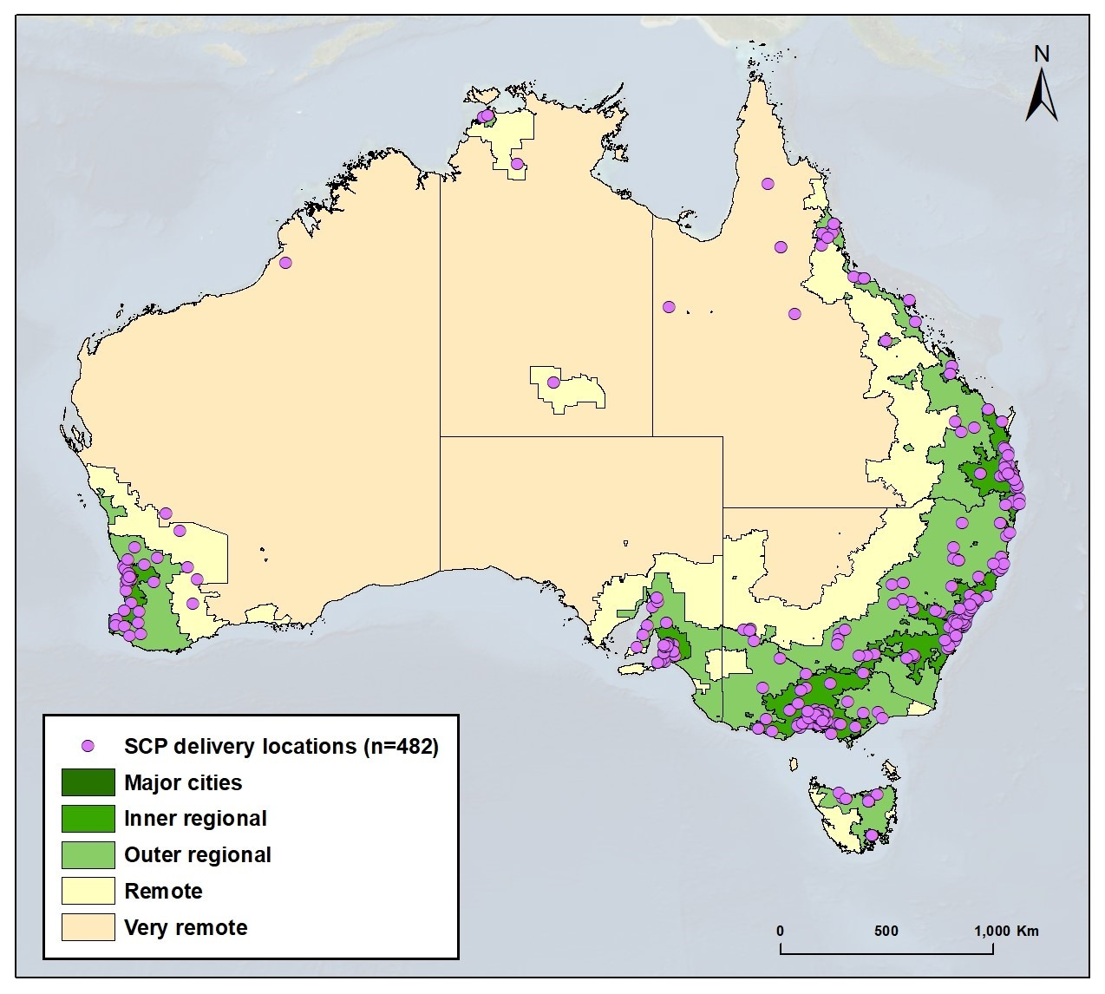
Key: Mapping data SCP
# Grants mapped | 101
# Delivery locations (post codes) mapped | 482
# Unique delivery locations | 248*
*Purple circles (i.e. location markers) overlay each other therefore density cannot be identified at this scale.
The national distribution of SCP project delivery locations is presented on an Australian Statistical Geography Standard (ASGS) map showing areas of varying geographical remoteness. The total number of projects analysed in this spatial mapping is 101. SCP activities were delivered to 248 unique locations. The spatial mapping shows the majority of delivery locations (post codes) in major cities and inner regional areas. There is a scattering of delivery in remote and very remote areas in WA, QLD and NT.

ICB2019-20 National Map showing location of regional and local projects
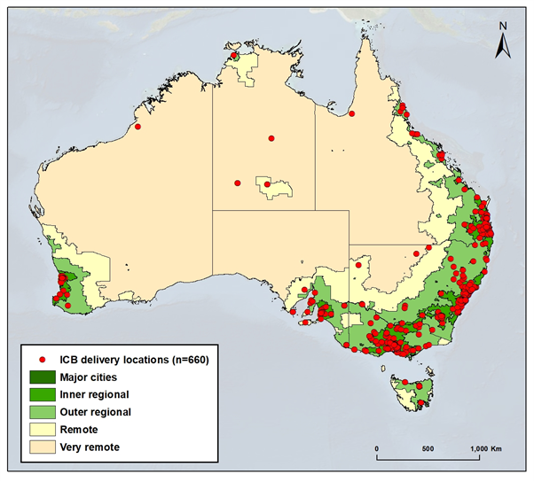
Key: Mapping data ICB2019-20
# Grants mapped | 71
# Delivery locations (post codes) mapped | 660
# Unique delivery locations | 486*
*Red circles (i.e. location markers) overlay each other so density cannot be identified at this scale.
The total number of projects analysed in this spatial mapping is 71 (Figure 1). ICB activities have been delivered to 660 locations across States and Territories, among which 486 are unique locations. The spatial mapping shows that the majority of delivery locations (post codes) are in major cities and inner regional areas. A small number of projects were delivered to locations in remote and very remote NSW, QLD, NT and WA. This geographic spread might reflect the fact that this grant round did not have a priority cohort focus on people with disability living in rural and remote areas.

EP National Map showing location of regional and local projects
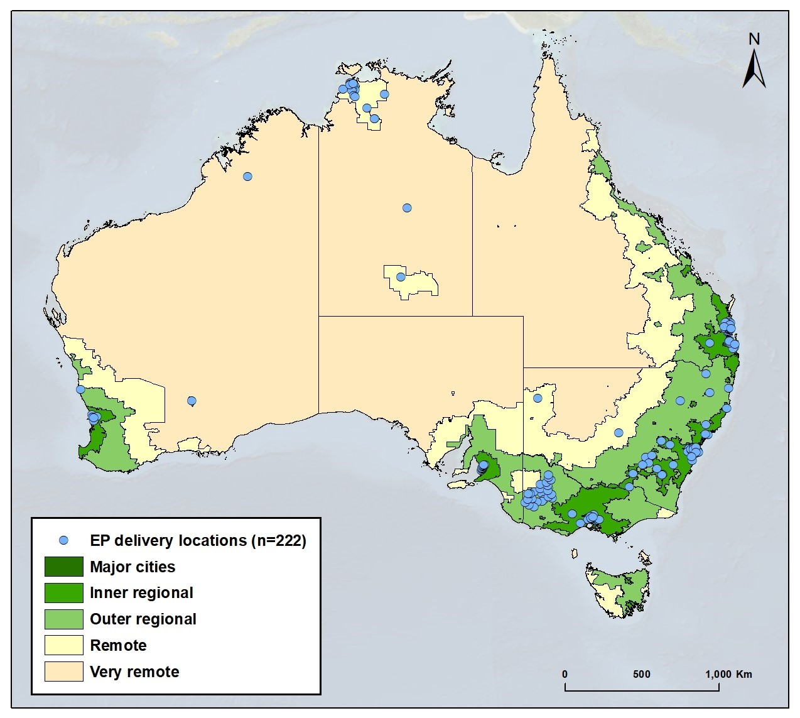
Key: Mapping data EP
# Grants mapped | 41
# Delivery locations (post codes) mapped | 222
# Unique delivery locations | 194*
*Blue circles (i.e. location markers) overlay each other therefore density cannot be identified at this scale.
The total number of projects analysed in this spatial mapping is 41. EP activities were delivered to 222 locations across States and Territories, among which 194 are unique locations. The spatial mapping shows the majority of delivery locations (post codes) in major cities and inner regional areas. Delivery locations in QLD were confined to the south east region. There is a scattering of delivery in remote and very remote areas in NSW, NT and WA, though none in other jurisdictions. This likely reflects the small number of projects funded in the combined EP rounds.

Appendix 4: Examples of metropolitan maps of delivery
Example of metropolitan mapping: SCP Projects in Metropolitan Melbourne
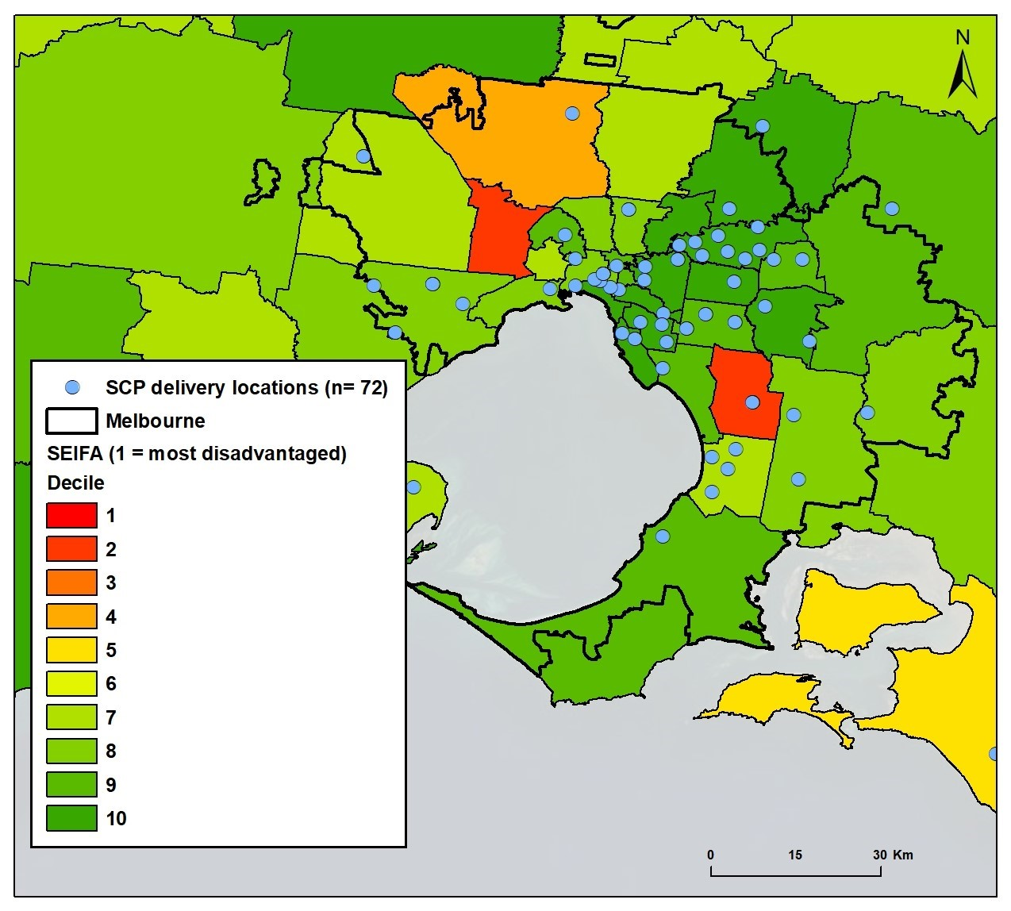
Key: Mapping data SCP
# Grants mapped | 20
# Delivery locations (post codes) mapped | 72
# Unique delivery locations | 54*
*Blue circles (i.e. location markers) overlay each other therefore density cannot be identified at this scale.
Mapping of SCP activities delivered in Melbourne metropolitan area presents project delivery locations with LGA identifiers and SEIFA Index of Relative Socio-economic Disadvantage scores (ABS, n.d.). Project delivery is almost entirely clustered in areas lacking disadvantage relative to other areas (with upper IRSD deciles - represented by green zones on the map). No localised delivery is being undertaken to Brimbank (indicated in red on the map). Brimbank, Greater Dandenong and Hume are the top three most disadvantaged LGAs in metropolitan Melbourne (ABS, 2018). These LGAs also have high proportions of population speaking a language other than English at home (ABS, n.d. a, b, c). In addition, Greater Dandenong has a higher density of Aboriginal and Torres Strait Islander people (1.2%) than most other metro LGAs.
Example of metropolitan mapping: EP projects in Metropolitan Sydney
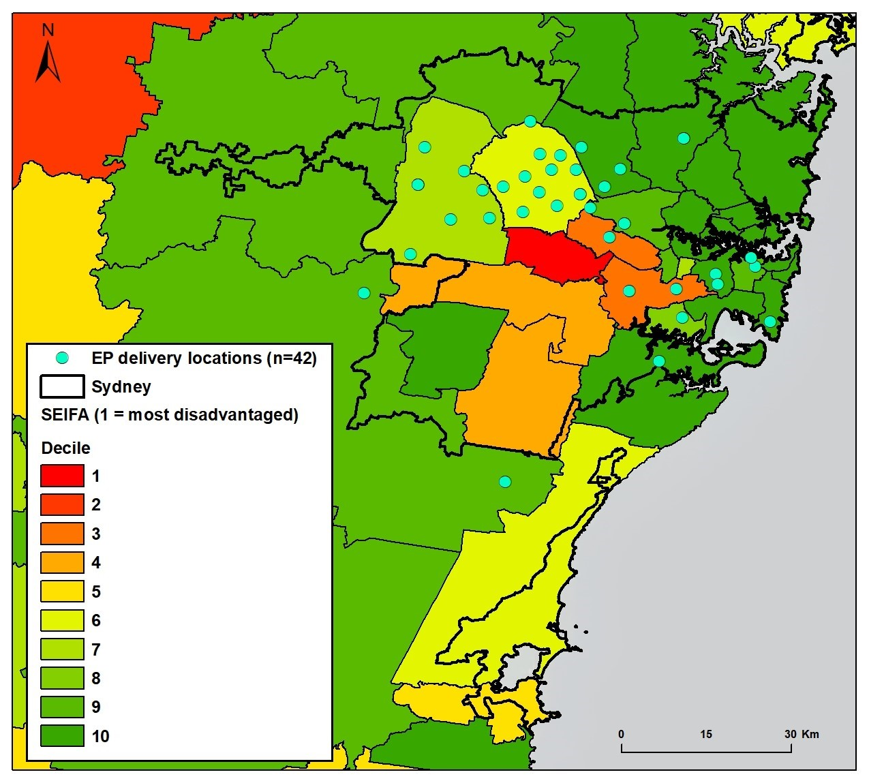
Key: Mapping data EP
# Grants mapped | 9
# Delivery locations (post codes) mapped | 42
# Unique delivery locations | 36*
*Aqua circles (i.e. location markers) overlay each other so density cannot be identified at this scale.
Nine EP projects delivering in metropolitan Sydney deliver to 36 unique locations. The spatial mapping shows the majority of EP activities have taken place in areas indicated as neither particularly disadvantaged nor lacking disadvantage relative to other areas (with mid-range IRSD deciles). Fairfield, the most disadvantaged LGA in metropolitan Sydney (ABS, 2018), has seen no EP project activities. This area is also highly populated by people from CALD backgrounds (ABS, n.d. d).

Appendix 5: Comparison labour market programs and EP projects
Group | Domain | Component focus | EP projects  (n=54)  % | Commonwealth  Labour market programs (n=33)  %
Supply side interventions (focusing on support to job seeker/ worker) | Addressing personal factors | Addressing personal context |  | 0
 |  | Addressing health context |  | 9
 |  | Integration of health, disability and employment supports |  | 3
 |  | Building capacity of informal (family) supports to support employment | 4 | 0
 |  | Building foundation skills and work expectations | 41 | 15
 | Service access and information | Information provision (job seeker/worker) |  | 9
 |  | Referrals/ connecting to services |  | 27
 |  | Service co-ordination and navigation |  | 45
 | Financial assistance and incentives | Financial support for personal factors |  | 6
 |  | Financial support for vocational training |  | 6
 |  | Financial support related to employment |  | 24
 | Building and mobilising social capital (to link to employment) | Building and mobilising peer support | 19 | 3
 |  | Building and mobilising professional/ employment networks | 39 | 9
 |  | Building and mobilising community networks | 6 | 9
 | Planning and preparation for work | Developing soft skills | 35 | 24
 |  | Career guidance and planning | 33 | 18
 |  | Assessments of work ‘capacity’ and need for supports |  | 24
 |  | Transition to work activities (School/Education to work i.e. young people; ADE/day service to open employment; prison to reintegration) | 2 | 12
 | Vocational skills development | Vocational training | 11 | 24
 |  | Work experience/ internships/ volunteering | 28 | 36
 | Self-employment/ entrepreneurship | Business skills and development | 20 | 6
 |  | Access to capital and business resources | 4 | 0
 | Job search | Job search information resources | 2 | 18
 |  | Job search skills building | 6 | 18
 |  | Job search matching and assistance | 4 | 21
 | (Pre) Placement support | Job commencement/ RTW and customisation | 4 | 12
 |  | Workplace modifications, equipment and disclosure |  | 9
 | Post-placement/ on the job support | On the job / workplace-based training | 7 | 9
 |  | Post placement support (limited or fixed period) | 2 | 15
 |  | Ongoing assistance in the workplace (day to day) |  | 9
 | Mass job creation | Employment-focused social enterprises |  | 0
 |  | Supported employment service (ADEs) |  | 3
Demand side interventions (focusing on support to employer/ workplace) | Information | Information provision/co-ordination (employer) |  | 9
 | Financial assistance incentive | Financial assistance for wages |  | 27
 |  | Financial assistance for modifications |  | 6
 |  | Other financial support/incentives |  | 9
 | Recruitment services and support | Recruitment services/support | 4 | 21
 |  | Connecting to target cohort | 9 | 9
 |  | Hosting work experience/ interns/ volunteers | 4 | 15
 | Workplace/ employer capacity building | Skill building, training, resources | 11 | 9
 |  | Inclusive workplaces capacity building | 44 | 18
 |  | Employer and stakeholder networks | 2 | 12
 | Supports in the workplace | General support to employers | 17 | 9
 |  | New supports in the workplace |  | 0
Societal change interventions (to increase capacity to contribute to employment outcomes) | Service capacity building | DES/employment services capacity building |  | 6
 |  | Employment support services complaints handling |  | 6
 |  | Schools / education and training organisations capacity building |  | 3
 |  | Interagency collaboration |  | 0
 | Community/ regional capacity building | Development of local employment strategies |  | 6
 |  | Financial support to local employment outcomes |  | 6
 | Structural/ macro change activities | Cross sectoral collaboration |  | 3
 |  | Policy interventions |  | 0
 |  | Government agencies to drive wholesale reform |  | 0
 |  | Job creation (in public sector) |  | 0

Key: % of projects offering the intervention focus
0-10%
11-33%
34-66%
67-100%

Appendix 6: List of information sources produced by NIP grantees
Category of disability | Total no. | National Information Program product | Topic
All disabilities | 11 | - Clickability, https://clickability.com.au/ | Disability service directory
 |  | - Mobility and Accessibility for Children in Australia Limited, not available | Guide to safe and accessible transport for children
 |  | - Children with disability, https://raisingchildren.net.au/disability | Parenting support and information
 |  | - Sexuality, Relationships and Your Rights (SRAYR) resource at https://www.secca.org.au/resources/sexuality-relationships-and-your-rights-resource/ | Sexuality, rights, relationships
 |  | - WAiS Online Resources (individualised living), https://waindividualisedservices.org.au/online-courses/ | Planning, Self Management and Shared Management
 |  | - My Home My Design (not available, https://imaginemore.org.au/projects-and-grants/my-home-my-design/) | Resources related to Home
 |  | - AT Chat Australia, https://www.atchat.com.au/ | Assistive technology
 |  | - Disability Information for Aboriginal people living in the remote NPY Lands of Central Australia (not available, Ngaanyatjarra Pitjantjatjara Yankunytjatjara Women's Council Aboriginal Corporation) | Aboriginal people and disability
 |  | - National Disability Information Sharing Platform - Doin' Business Our Way (not yet available, National Aboriginal and Torres Strait Islander Corporation - Transport and Community) | Aboriginal people and disability, ways to access supports
 |  | - Speak My Language (Disability), https://speakmylanguage.com.au/ | CALD: personal skills, talents, and community resources
 |  | - National CALD Disability Information Program (not yet available, Cultural Perspectives) | Translated and easy English information for CALD people
Intellectual disability | 3 | - Planet Puberty, https://www.planetpuberty.org.au/ | Parent guide - puberty
 |  | - Information Resources for the inclusion of LGBTQI People with Intellectual Disability (not available, Inclusion Melbourne) | LGBTIQA+ people with intellectual disability
 |  | - My Life, My Choices (not available, NSW Council for Intellectual Disability) | Supported decision making resources
Down Syndrome | 1 | - Down Syndrome national information portal, https://www.downsyndrome.org.au/ | Down Syndrome
Psychosocial disability | 3 | - National information program, https://www.mifa.org.au/en/minetwork/mi-networks-info-sheets | Information on psychosocial disability across life stages
 |  | - The Mind-Life Project (not yet available, https://www.bridgeshcc.org.au/mind-life) | Information, resources and service options (QLD)
 |  | - Direct Connect - ILC to the Home (not available, Community Mental Health Australia) | Local mental health services and support
Cerebral Palsy | 1 | - The CP Info Project, under development at https://cpinfoproject.org.au/ | Information on cerebral palsy
Autism | 3 | - Planet Puberty, https://www.planetpuberty.org.au/ | Parent guide - puberty
 |  | - Autism Connect, https://www.amaze.org.au/autismconnect/ | Autism information
 |  | - Autism modules for adults (not yet available, Autism Association of SA) | Autism resources for individuals and services
Other neurological  - Motor Neurone Disease | 2 | - MND Connect, https://www.mndaustralia.org.au/mnd-connect/for-health-professionals-service-providers | MND for health /care professionals
- Parkinson’s |  | - Young Onset Parkinson's Exchange, https://youngonsetparkinsons.org.au/ | Stories and info re Parkinson’s and daily needs
Developmental delay | 0
Other physical  - Cystic fibrosis | 1 | - CFStrong, https://cfstrong.org.au/ | Cystic Fibrosis information
Hearing impairment | 2 | - Auslan Information Hub (Serving the information needs of the Deaf community across Australia), building on Virtual Auslan Service Hub in regional, rural and remote areas - IWF (https://www.nds.org.au/) | Immediate info provision to Deaf community
 |  | - Deaf Central website (for families and carers of children and young people), website under development | First point of info for families of Deaf children
Acquired Brain Injury (ABI) | 1 | - Brain injury information hub, https://synapse.org.au/understanding-brain-injury/ | ABI- post injury stages and information
Visual impairment | 1 | - Vision Information Service (VIS), under development by Vision Australia | Information to support people with vision impairment
Multiple Sclerosis | 0
Global Developmental Delay | 1 | - Living Well with Global Developmental Delay (not yet available, Western Sydney University) | Information for people with global developmental delay
Stroke | 1 | - Young Stroke Project, https://youngstrokeproject.org.au/ | Tailored supports following stroke
Spinal Cord Injury | 1 | - SCIA Resource Library, https://library.scia.org.au/cgi-bin/koha/opac-main.pl | Spinal Cord Injury
Other Sensory/ Speech  - Communication | 2 | - Communication hub, website under construction (https://www.speechpathologyaustralia.org.au/SPAweb/whats_on/ILC_Grant_Project/SPAweb/What_s_On/ILC_Project/ILC_Project.aspx?hkey=9c54fdd5-c9fa-47bd-9adc2cfa3226868f) | Understanding communication
 |  | - Key Word Sign Australia, https://www.scopeaust.org.au/services-for-individuals/specialised-communication-services/key-word-sign-australia/ | Expand use of key word sign
- Deafblind | 2 | - Deafblind Information Hub, expanding https://www.deafblindinformation.org.au/ | Deafblind information, services, communication and supports
 |  | - Deafblindness resources and workshops, AFDO and Deafblind Australia | Resources for individuals to support inclusion & control
Other  - Fetal Alcohol Spectrum Disorders | 2 | - Range of resources types, see NOFASD Australia - National Organisation for Fetal Alcohol Spectrum Disorder, https://www.nofasd.org.au/ | FASD information
- Spina Bifida and/or Hydrocephalus |  | - Portal and resources, https://www.spinabifida.org/resource-portal | Spina bifida and/or hydrocephalus

