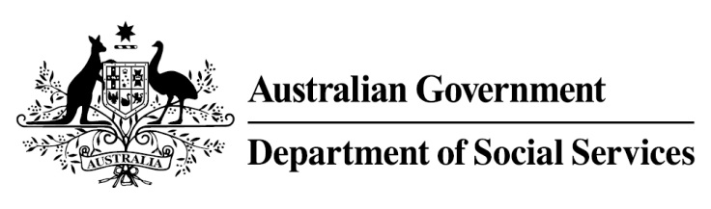

Try, Test and Learn Fund

Initiative: Warra Warra Kanyi (‘Caring for people’ in Warlpiri language)
Location: Northern Territory
Using insights from the Priority Investment Approach, the Try, Test and Learn Fund is gathering evidence on new or innovative approaches to addressing barriers to work.
The Try, Test and Learn Fund will help achieve the objectives of welfare reform — that is, to develop a modern welfare system that increases the capacity of individuals, reduces the risk of welfare dependency and maintains a strong welfare safety net.

What are we trying to achieve?

Fast facts
Priority group: Other
Target participant number: 75
Locations: Yuendumu and Lajamanu
Trial period: 24 months
Total funding: $1.5 million
Service provider: Warlpiri Youth Development Aboriginal Corporation
Potential future saving: This project supports a group of people identified through the provider’s experience in working with vulnerable people, and other research. To date, potential future savings for this group have not been calculated. Such a calculation may be possible once data on participants in this project is available if an appropriate comparison group can be identified.
Note: Due to changes in circumstances, adjustments have been made to the trial period and total funding.

To improve the health and wellbeing of Indigenous people, aged between 12 and 35 years, living in two remote Warlpiri communities to assist them to become more resilient, engaged and productive. The project tests whether higher levels of social and emotional wellbeing lead to improved education and employment outcomes.

What is Warra Warra Kanyi?
Through Warra Warra Kanyi, participants receive intensive case management to address the reasons that have led them to become disengaged from education and employment. The case managers are community members, who are supported by experienced practitioners. Through this bi-cultural model, the project works with participants to provide them with the skills and supports needed to improve their psychological, emotional and physical wellbeing.
Warra Warra Kanyi has been successfully operating for a decade in Yuendumu. This project enables the approach to be continued, clearly documented, and rolled out to Lajamanu community, where no case management services currently exist.

What does the evidence tell us?
Young unemployed Indigenous people face a variety of barriers to further education and employment, particularly those living in very remote areas.
Indigenous people living in very remote areas are 1.4 times more likely to be unemployed and 1.5 times more likely to receive government allowances as their main income source than Indigenous people living in major cities (AIHW, Australia’s Welfare, 2017).

How is this initiative new and innovative?
This project tests the scaling up of a bi-cultural approach to delivering services, in a remote Indigenous community where no such services currently exist. The approach embeds systems and skills that reduce the risk of welfare dependence. It also helps to develop skills in the educational, emotional and psychological domains of Warlpiri life that increase employability and the likelihood of maintaining employment.

