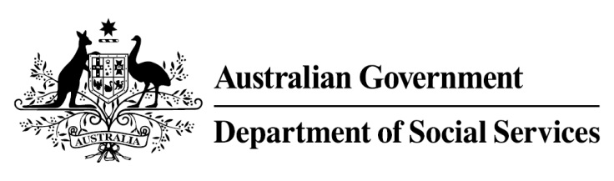

Try, Test and Learn Fund

Initiative: Sisters Support Business Together

Location: Queensland
Using insights from the Priority Investment Approach, the Try, Test and Learn Fund is gathering evidence on new or innovative approaches to addressing barriers to work.
The Try, Test and Learn Fund will help achieve the objectives of welfare reform—that is, to develop a modern welfare system that increases the capacity of individuals, reduces the risk of welfare dependency and maintains a strong welfare safety net.

Fast facts
Priority group: Older unemployed
Target participant number: 38
Location: Brisbane and Gold Coast
Trial period: 25 months
Total funding: $772,200
Service provider: Griffith University
Potential future saving: The purpose of these initiatives is to test whether an intervention works to reduce long-term reliance on welfare. If around 23 per cent of participants (9) move off income support because of this project, the savings to the welfare system are likely to outweigh the costs of the project.
Note: Due to changes in circumstances, adjustments have been made to target participant numbers, trial period and total funding.

What are we trying to achieve?
Provide participants with the practical skills to start small businesses to build the necessary knowledge and confidence for increased likelihood of moving to financial independence.

What is Sisters Support Business Together?
Women aged 50 and over, who are either living in social housing or are at-risk of entering social housing, are trained and supported to start a small business in partnerships or in small groups.
Participants complete a self-efficacy test and participate in interviews to establish what skills and knowledge they need to succeed and to identify business ideas. They are provided an opportunity to meet and form groups with other women who have similar ideas.
Training will cover business, management, finance, marketing, promotion and self-development. Each participant is mentored and provided assistance with starting a business, and access to seed funding.

What does the evidence tell us?
- Many older Australians want to work but find it difficult to get work.
- Australians are on average living into their 80s, and older jobseekers may draw on income support payments for many years.
- If nothing changes, 85 per cent of this group will be receiving income support payments in 10 years, and 76 per cent will be receiving income support payments in 20 years.

How is this initiative new and innovative?
This tests the effectiveness of starting micro-enterprises in a group setting, for this particularly vulnerable group.

