**Aboriginal art provides a storyline and is used as a background pattern. The story depicts people coming together to yarn about disability.
A New National Disability Strategy**

**Stage 2 Consultations:**

**Report on Aboriginal and Torres Strait Islander**

**Community Engagements**

**Autism Queensland logo with a stylised butterflyDecember 2020 – January 2021**

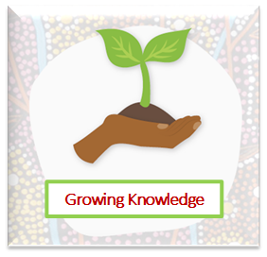

# **The Purpose**

The National Disability Strategy (NDS) is the Australian Governments’ plan to make the lives of people with disability better. In 2021 a revised NDS will be implemented, so Governments across Australia have been working together during 2020 to create the new Strategy. To assist in writing the new Strategy the Australian Government reached out to disability organisations to talk with people with disability to ensure what they think and know to be important in their lives can be included in the Strategy. As part of this the Australian Government Department of Social Services funded Autism Queensland to talk to Aboriginal and Torres Strait Islander people with disability about what is important to them in their lives.

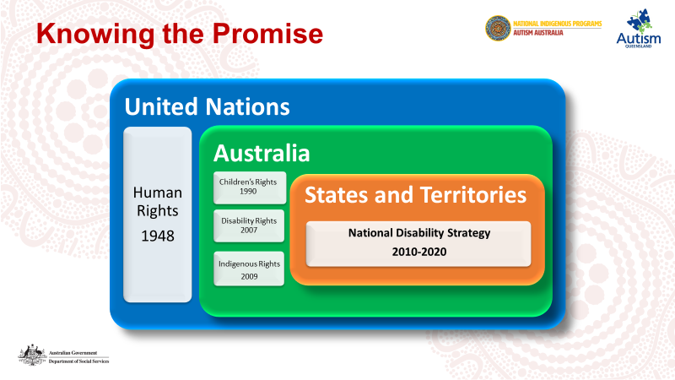

The opportunity for sharing perspectives and stories supports the rights of Australians First peoples with disability and creates a pathway for their message sticks to be passed on to those in the Government who have capacity to consider their experiences and perspectives when developing disability policy for positive change.

Five speech bubbles with the following quotes:
“I didn’t know I was a part of that disability…”
“It is hard to get food… the barge comes once a week – fresh fruit and veg runs out on the day.”
“He’s a very private boy – doesn’t talk about his disability.”
“Family groups - houses are close together – so they can help each other if something is going on – call the police or doctor.”
“Make it easier way – best way is to be going around doing a survey for the start – asking there what they want – porching with parents…to explore what is the truth…don’t feel blame or shame…”


Autism Queensland assisted the Australian Government through consultation with First Nations peoples living in remote locations in Queensland and the Northern Territory. This report intends to provide a synopsis of the conversations, or yarns, that arose during the consultations. The important knowledge that was shared by Aboriginal peoples will contribute to the Australian Government’s understanding of living in remote communities with a disability.

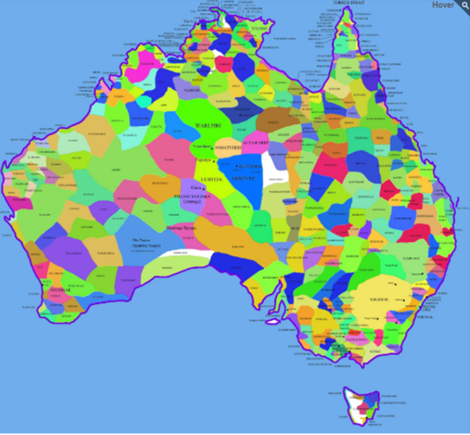*We acknowledge the traditional custodians of all the lands on which we meet and pay respects to elders past whose spirits have carried us safely through our consultation yarns across this great nation of nations. We also acknowledge elders present who support raising awareness and understanding of disability and those emerging leaders who carry forward the important knowledge about supporting choice and control for persons with disability. We thank those First Nations peoples who have willingly shared their disability story with us and acknowledge their hopes, challenges, and dreams for the future.*

# **The Approach**

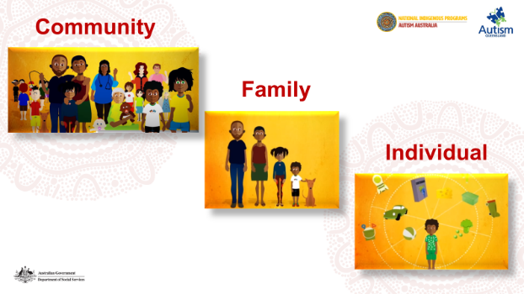Consultation materials were provided by The Social Deck to progress the conversations and align with the six key outcomes areas of the Strategy. In consultation with partner community-controlled organisations the materials were then modified with a cultural lens to ensure increased accessibility for participants who had no knowledge of the National Disability Strategy. In line with community ways, the community, family, and the individual were considered as key stakeholders in the yarns.

To assist participants to frame the kinds of conversations required of the consultation, they were provided with a visual image to detail the six core outcomes areas of the NDS. Additional adjustments were made to the word choice, images, and structure of the consultation materials to support participant understanding, particularly for those who used English as a second language. The modifications also accounted for low literacy skills amongst many participants. Community interpreters were available throughout all consultations to increase participant capacity for understanding the questions.

Partner organisations provided a printed copy of the modified materials to participants ahead of the consultation to obtain verbal consent to proceed with participants sharing their story about disability. The social story format is provided for your perusal. Partner organisations included Miwatj Health, Save the Children Foundation, Gidgee Healing, Yalu Marnggithinyaraw Indigenous Corporation, and East Arnhem Regional Council.

Images of the printed copy of the modified materials to particpants. They show:
- Footprints snaking forwards from the words "Sharing your story about Disability" toward the words "Who I Am".
- Australia with Aboriginal art depicting how the nations come together.
- Stylised sheet of paper containing the words "We want to hear about your journey living with disability".
- Image of two heads - one head contains questions, and the other head is sharing the knowledge depicted as a light bulb, arrows and cogs. What you tell us is private. No one will know this is your story. Everyone's knowledge will be shared with the Australian Government.




Images of the printed copy of the modified materials to particpants. They say:
'You can tell us if it is okay to record you and your voice while you are telling your story. There is an image of an ipad.'

'The recording will be used to help the Australian Government hear the information you are sharing. There is an image of a small bird singing out information in a speech bubble.'

'You can tell us if you need a break or if you want to stop participating. There are images of a tree, a person sitting in a bean bag, a stop sign, a sandwich, a restroom sign, a cup of steaming tea, and a person sitting crossed legged doing meditation.'

'You can tell us about the things that are important to you. The words "Proud of who I am" are written around a stylised heart with the colours of the rainbow.'

Your knowledge will help build a new National Disability Strategy. The image is a smart art that has National Disability Strategy 2010-2020 at the centre which is surrounded by the six core areas - Taking Part in the Community, Rights, Fair Treatment and Safety, Work, Money and Housing, Getting Support, Learning and Skills, Health and Wellbeing. The Strategy helps to make sure people with disability are respected and included.

# **Participants**

Three communities engaged in the NDS consultations which enabled seventeen (17) persons with disability to share their disability story. Participants were supported by eleven (11) formal and informal community and family supports who, to varying degrees, also shared their knowledge about the lives of people with disability living in their communities. Two communities in the Northern Territory and one community from Queensland participated in the yarns. Due to the timing of the consultation across December and January, and the impact of COVID, the number of communities Autism Queensland intended to engage was limited and discussions occurred either on virtual digital platforms or via telephone.

Participants were asked three (3) questions and the key themes from all consultations were related to family, transport, and formal supports. More detail has been provided within each of the key outcome areas throughout this report.

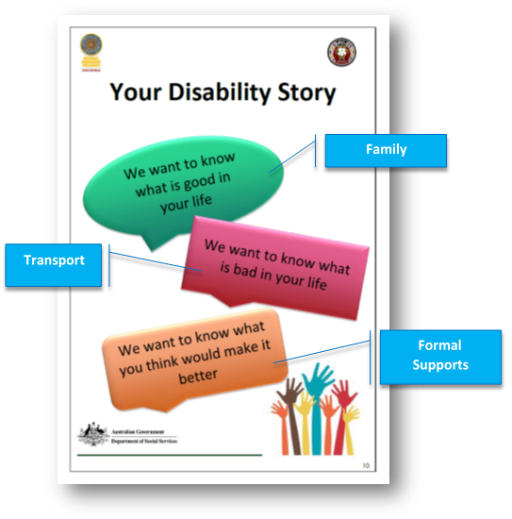

# **The Consultation**

For the purposes of reporting outcomes from the consultation, the remainder of the report will provide details of key components of conversations in each community and are aligned to each of the six outcomes areas of the Strategy.

## **Aboriginal art depicting individual, story, and family.Taking Part in the Community**

### **What is good in your life?**

Overall participants expressed that being with family was an important component of taking part in community life and cultural ways.

*“Join cultural activities – sometimes drawing, sorry business – going to funeral and participate in listening – hearing the yidaki (digeridoo) and clap sticks. That is good for my spirit.”*

Opportunity to “*visit family every couple of days, or once a week”*, sit, listen with family groups was a high priority. *“Travelling a lot more often to other communities to visit family, makes everyone happy.”*

Having support workers to assist access to community and activities was important and this took the load off family obligations and helped people feel independent.

*“Support workers take us fishing, swimming group, sometimes we go out to get bark. We tell them what we want to do. Church every Sunday, Thursday we do music.”*

### **What is bad in your life?**

Accessible, reliable transport was discussed at length with all participants. Participants indicated that due to the geographical isolation of the remote communities in which they lived they relied heavily on air transport to visit family, however *“flights are expensive so travelling to see family is hard.”*

Most participants do not own cars and rely on aged care, school, or health services accessible buses to transport them around the community. Transport is not available on weekends, so participants felt isolated at a time when they wanted to be included in community and family activities.

*“We want to go out on the weekends, have a bus come to pick us up. At the moment there is no-one taking them out to the homelands. Need someone who’s reliable to come and pick us up – take us to the shops. When you’re at the shops you need a lift home.”*

In one community it is not safe to walk around, the wild and feral animals pose a high risk when navigating the community on foot.

### **What would make it better?**

Having the chance to be supported by skilled workers to go with family to outstations or family camps to do hunting, fishing, cultural activities was perceived as one way to make life better. Additional incentives for skilled workers to live and work in remote communities is necessary to ensure quality services are delivered consistently to people with disability.

*“More skilled workers to support people with disability – different supports and specialist supports for safe and regular community access. Support workers to live in community – building trust to have them help.”*

Participants thought that utilising the accessible buses on the weekends would enhance their quality of life because they would have more opportunity to get out and about in the community. *“Transport on weekends would help people to go to family camps on outstations and be a part of that.”* Having reliable drivers and skilled support workers would help community members with disability to feel safe, included and provide a sense of independence. A participant explained that disability accessible transport was critical to future successful outcomes for people in community as it *is “hard to get to school, transport to get to school would be good.”*

## **Rights, Fair Treatment and Safety**

### **set of scales weighing fair and unfairWhat is good in your life?**

It is acknowledged that cultural and social histories of Aboriginal peoples have been impacted by colonisation and their experience may have included violence and unjust treatment. Building trustful relationships with First Nations peoples supports individual agency, lessens the power differential, and opens a main stream for truth to flow without fear of retribution or punishment. Community members *“want to work together…so every voice is heard.”*

Providing culturally relevant advocacy services in community is a critical mechanism to ensure that individuals rights are being upheld and that concepts of rights, fair treatment and safety are understood.

*“It was hard when disability workers were first introduced to me. I didn’t know about the disability program when they introduced me.”*

Participants thought that family carers who felt obligated to provide care should be paid for their support, especially when paid carer support was not available in their community.

*“I feel safe in my community – feel cared for sometimes – the niece comes to look after me sometimes. It is family obligation to look after the old ones. Son looks after me but not paid carer.”*

Sometimes choosing care, from available paid carers, was impacted by cultural safety and participants explained that it can be *“hard with moiety and poison blood – ways around that…”.*

### **What is bad in your life?**

In community there can be hierarchies where the rights of the individual are superseded by the needs of the family group. For instance, if a person goes on the Disability Support Pension (DSP) or has an NDIS plan, then all the family mob come to live with them because it is perceived they have an income. There is also a wider misconception that the NDIS is a welfare payment. Participants highlighted how difficult it can be to access welfare payments and there were indications that there are many family members who are eligible but not receiving payments.

Carers struggled to understand why they receive only one carer allowance or payment even if they are caring for multiple family members. *“More support for family carers is needed to have care plans.”* The Carer Gateway offers a range of services however these are not always accessible to Aboriginal peoples in remote locations. Overcrowding in homes often contribute to complexities for family groups and it can be challenging to access suitable supports.

*“Who has the skills in an emergency? I call the police, the health mob – they come and talk with the boys I care for. Do they know about disability care and support? Where is their training? Prevent rather than react.”*

### **What would make it better?**

*“Family counsellor with helpful ideas – knowing community ways”* would make life better especially if those supports were *“separated from family history, …skills to change behaviours, skill families on getting along”* so we feel safe. A community safety strategy would help to define expectations around basic infrastructure, accessible and reliable transport, and housing.

*”There are no footpaths at all. People with wheelchairs or walkers are on the road and it’s very dangerous.”*

## **Health and Wellbeing**

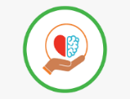

### **What is good in your life?**

Participants spoke about having strong accessible health services and there was a bus that takes them to appointments. There was an understanding that sometimes they had to go to the nearest city to receive necessary treatment but preferred when the Doctor came to them in community. Participants shared knowledge that health and wellbeing was directly linked with accessing family, country, spirit, and these experiences contributed to capacity for healing the heart, the body and mind. Knowing they were *“being supported on the journey by the government helped to plan for family health and spirit wellbeing”.*

### **What is bad in your life?**

Access to reasonably priced and abundant food in remote communities was challenging for some participants who had limited means of getting to the shop when the barge came in once per week.

*“Most organisations don’t have emergency food packages. Elders have asked us not to do food, because they feel it disempowers people. Barge comes in once a week…if you don’t get there on that day, the fresh food runs out.”*

Being stressed about food, access to clean water, and purchasing power cards for electricity for cooking or food storage were concerns that impacted upon daily living standards, “quality of life, and independence” for people with disability living in remote communities.

The troubled behaviour of youth in communities were of great concern to participants during the consultation. *“Some kids disability, mental, autism, but not diagnosed.”* Having programs addressing diagnosis, youth behaviours that were destructive, dangerous, and self-harming were perceived as ways to help people with disability feel safe and not so stressed with worries about their personal safety.

### **What would make it better?**

Having access to traditional and cultural activities as a part of everyday life in the community setting was perceived as the key way to enhance health and wellbeing.

*“Going out on the weekend, visiting family and homeland is important. If you lose a loved one, even just to be able to visit the graveyard…that would be good for their wellbeing. Being able to go to sorry business.”*

Building a sense of regular and consistent inclusion helped participants feel there were opportunities to contribute to the family and the community. Wellbeing was defined as *“going good in my heart, head and spirit…thinking good way”.* Feeling valued, respected, and useful was perceived as supporting mental wellbeing and *“family carer support groups would help feel less alone”.*

In some communities the shop provided a delivery service for people with disability which was a great way to reduce the worry about missing out on fresh food the day it was delivered. Shops in remote communities have varying management arrangements, and it may be of value to raise awareness of the types of accommodations that need to be made for people with disability to access fresh food.

Including youth in intensive supported programs, particularly those with disability, through health promotion was necessary to reduce *“a lot of stress-out worries”.* Programs and activities that supported health and mental wellbeing were available, but some were time-limited with funding and some did not make change for the young ones because *“there were some still left-out*”. There were some identified service gaps for parents who needed *“help to see disability”.*

## **Learning and Skills**



### **What is good in your life?**

In many remote communities there can be high unemployment and low school attendance for a variety of reasons. The consultation findings supported the necessity to re-frame the value and perception of participation in work and education in cultural ways for people with disability.

*“Still going to school – it is good to learn. Best learning at school is meeting up with other kids. Sharing anything that is important or funny. I play the yidaki (digeridoo) – have three - one at school, home, family group. Someone holds the yidaki for me – I can’t lift anything, but I can hold my phone!”*

Motivation toward learning and skills were enhanced when the individual dreams were considered as central to successful outcomes.

*“…good learners when they are interested in one subject. One man interested in music – wants $25,000 to buy equipment – brings youth to the music – feel meaning and importance. Give music to community in church grounds – bring disability together. Need help to make dreams.”*

### **What is bad in your life?**

Some participants believed that having more knowledge about what is happening in other parts of Australia for people with disability would help them to feel less isolated and to focus more on the future goals and opportunity.

*“Elders only know about local organisations, not the NDS. More chance to learn about what is happening in other parts of Australia.”*

### **What would make it better?**

Engaging in learning and acquiring new skills might require that the focus can be pivoted to include cultural learning combined with everyday living skills and implemented at a pace that suits the community.

“Have more opportunity for learning of all types. Instead of sending to the city – learning here. Learning things that are relevant in community – hunting, learning, activities. Recognise skills that we already have and transferring those skills to jobs and other help.”

There was extensive conversation about how the art centres could be the place for learning and have programs for people with disability to learn new things and get along with others while doing their art.

*“I would like to go to the art centre for cultural activities, see family, feel a part of everything.”*

Opportunities to engage in learning to develop support worker skills was considered of high importance so that people with disability had options and choices about their care. Many family members provided informal care already so it was suggested that it may be possible to encourage them to more formal learning, to become qualified.

*“Building skills to start and then run social enterprises where people with disability can make their ideas for independent jobs come alive…”*

It was important that gaps in support services were identified and that learning be cultural way and not all focus on reading and writing because this was a real challenge for many people in community.

## **Work, Money, and Housing**

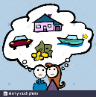

### **What is good in your life?**

There were indications that there are some communities where there are many opportunities for people with disability to have work. *“I work with regional council, used to be a builder, build offices and houses. Now do cleaning in offices.”*

Having capacity to work was closely linked with having formal supports, community acceptance, and a cultural narrative that affirms working is a natural part of the life journey. Working made people feel good when they worked in a job that had a special interest for them. *“Heaps of job opportunities – wanting to be doing in this community. People with disability have jobs and like it.”*

Housing was a key topic of discussion and many stories were shared about how making life better across NDS outcomes areas were linked back to work, money, housing and getting support. *“Before NDIS hard with housing and care for my Grandson – things have changed – now a house, electric and manual wheelchair.”*

### **What is bad in your life?**

The greatest challenges were associated with the limited options for staying in the community, having independent supported living, and feeling cultural respect. *”Aged care is very full up. Sometimes there are families that don’t get along with each other. Respect cultural hierarchies across the lifetime.”*

Current stocks of housing and families coming to visit, and stay for extended periods, were contributors to overcrowding in houses. *“Overcrowding – once on disability, all the family come to stay – humbug.”* In some communities there were limited, or no disability housing and participants were not quite sure how to get those modifications to increase their independence.

### **What would make it better?**

There was overwhelming discussion about the need for creation of supported independent living options and determining how current empty facilities in communities could be utilised. *“Having a house on the land and in my community close to family is important.”* There were suggestions that so much red tape meant that buildings sat empty. Participants were not quite sure who was responsible or what level of government had control over certain assets in the community. *“It would be good to have single units for people with disability.”*

Working together in a whole of community approach was identified as a strategic need to stimulate economic growth. Supporting training and enhancing the job market by leveraging the opportunities associated with supply and demand arising from the NDIS seemed to make sense to build skills of First Nations peoples. An initiative to build local skills would make earning money more available through recognising and transferring their care skills to real jobs. For those with disability, this means more choice and control, more consistent access to supports and community activities. *“Empty dongas could be used for disability housing – make a village in town for disability people – safe and activities.”*

Developing financial literacy skills through training was perceived as important to assist with budgeting personal finances and understanding NDIS funding processes. *“People need help and support with budgeting their money and making it last for the two weeks for Centrelink pay. More chances to learn financial literacy.”* Developing an understanding of finances was regarded as an ongoing process.

Matching supply with demand in a more co-ordinated approach, with defined goals, and measurable outcomes should be influenced by people with disability. Determining a pathway toward choice and control requires guidance and formalised supports to explore the demand for disability services in remote communities. Working together in a whole of community approach was identified as a strategic need.

## **Getting Support**



### **What is good in your life?**

Family is the primary source of support for people with disability in remote areas. *“Being close to family for support is important.”* The preference was to spend time with family, live in family groups, go to family camps and outstations. Due to moiety and blood lines – there can be some restrictions around who you can speak to, look at, or associate – it is for this reason that for some Aboriginal mobs, the known family also forms the friendship group. *“I have been travelling a lot to see family – you have to go out to visit family. It’s important being with family, to go and yarn with family and stay with family.”* There now needs to be a strong focus on job creation for traditional owners in culturally appropriate design to provide a pathway for those NDIS recipients to utilise their plans.

There is an indication that there are lots of NDIS plans in communities and this is perceived as a good thing that disability is recognised. *“I get support from NDIS – community access. I have a family member with brain damage. Other family help but no-one with paid support.”* Sometimes having non-indigenous support is the best way because they are not involved with the traditional hierarchy that governs many peoples in remote communities.

### **What is bad in your life?**

There are limitations on formal respite in remote communities and because of the scarcity of disability focussed programs during the day there is still a focus on the concept of respite being away from home in the nearest big city for a few weeks. *“Respite away from community – take people away from homelands.”* There was a preference to have options for day and night activities in their communities so they can have a break from family care and do other things they like.

*“There are a lot of cars on the island. But it is really hard for them to ask family members for a lift. Transport is an issue and so people are relying on family. I find it hard to get to work. No one is inclined to give you a lift. If you want to get out of the house for the day. But you have to rely on people with good legs. If we want to go visit our family then we have to rely on the organisation buses. Transport can be irregular so there is a need for reliable drivers. It is hard for family members to be solely responsible. Her son has brain damage and stays at home. There is little or no support to assist him with the bus. We want to visit family, sit around all day then come back home.”*

The NDIA indicate that family are unable to be employed by those with NDIS plans. Due to the nature of complex family lines, it is likely that most people in each remote community are regarded as family – and those other traditional owners who are not recognised as family are likely to be from a poison moiety so are unable to associate or be employed by a person with disability. The rule needs to be overcome for those people living with disability in remote communities and provide them with the skills to be strong in understanding they have the right to choose who cares for them.

### **What would make it better?**

Training programs for family carers in ways that suit learning on country would strengthen the pool of skilled personal support workers who are eligible for employment. *“The only respite people get is family support. That would be an easy fix, to get trained support.”* Once trained and certified, then people may be more able to design programs that are suited to the types of activities people with disabilities are seeking. *“Having more respite in the community and more buildings for organisations to make a footprint*.” Great knowledge was shared about the type, frequency, and intensity of supports they might be seeking. People with disability have been looking forward to ways in which their needs can be shared with those who can help to make the change and assist with filling in the service gaps. *“More training for support workers that is in language and understanding for us - those who live in the community already and looking for work.”*

# **Final Thoughts**

This consultation process has created the opportunity for Aboriginal and Torres Strait Islander peoples with disability and their caregivers living in remote communities to share their journeys and stories. The yarning opportunity supports the rights of Australians First peoples with disability to discuss what is important to them. It also created a direct link to those in the government who design positive impact policies by assisting the Commonwealth to understand unique perspectives of First Nation’s peoples.

The engagement process has sought to include the whole community in understanding experiences and perceptions of disability, as well as providing the opportunity for people with disability to share their hopes and dreams for the future.

You can tell your story with others or tell it on your own. Image of chairs around a table with a couple of chairs on their own.

Speech bubbles say:
"Have the chance to be supported in community."
“Respite area in homelands with power, tracks, shelter, food, activities – to be safe and home – not lost in the big city.”

If you need extra support after telling your story, you can ask for help. We can talk to other organisations with, so you feel supported. Images of logos from Yalu, the NDIS, and the National Indigenous Programs at Autism Australia.

Speech bubble says “I need more help and support to make life good. Having those groups (talk about dreams for the future) think about your whole family as well as myself.”

You can tell us at any time if you change your mind about sharing your story about disability. Image of handprints in the shape of a tree. Thank you for sharing your time and knowledge with us.

Speech bubble says "Going good in my heart, head and spirit. Thinking good way."



The intention of this NDS consultation report is to circulate a message stick directly from Aboriginal and Torres Strait Islander peoples living in remote communities to the Commonwealth.

Key themes identified by participants to this consultation process include:

* Having consistent and frequent access to family and cultural activities as a part of everyday life in community.
* Improving basic amenities like adequate housing arrangements, access to safe water and fresh food, consistently safe and reliable transport, and increased personal security.
* Embedding cultural considerations across community training and skills programs to increase opportunities for job creation and recognition of the pathways to formal supports.
* Understanding the mechanisms associated with supply and demand of skills in remote communities.

In conclusion, Autism Queensland and the Department of Social Services would like to thank our partner organisations for their efforts in ensuring that those community members who so generously shared their stories continue to be well supported in the remote places in which they follow their life journey.