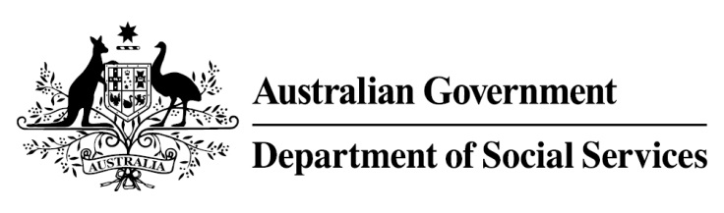

Try, Test and Learn Fund

Initiative: Multicultural Enterprise Development Project

Location: Western Australia
Using insights from the Priority Investment Approach, the Try, Test and Learn Fund is gathering evidence on new or innovative approaches to addressing barriers to work.
The Try, Test and Learn Fund will help achieve the objectives of welfare reform — that is, to develop a modern welfare system that increases the capacity of individuals, reduces the risk of welfare dependency and maintains a strong welfare safety net.

What are we trying to achieve?

Fast facts
Priority group: Migrants and refugees
Target participant number: 142
Locations: Northern and southern suburbs of Perth
Trial period: 24 months
Total funding: $1.69 million
Service provider: Metropolitan Migrant Resource Centre
Potential future saving: The purpose of these initiatives is to test whether an intervention works to reduce long-term reliance on welfare. If 15 per cent (21) of participants move off income support because of this project, the savings to the welfare system are likely to outweigh the costs of the project.
Note: Due to changes in circumstances, adjustments have been made to target participant numbers, trial period and total funding.
This project aims to improve the employment outcomes of migrants and refugees by: supporting them to build skills and confidence; providing work experience; and access to a culturally customised self-employment program.

What is the Multicultural Enterprise Development Project?
The Multicultural Enterprise Development Project helps migrants and refugees through two streams of culturally-customised training and individualised support:
- Stream one participants receive business training, coaching, and direct support, if needed, for example, counselling or crèche services. Practical English-language skills are embedded in all project activities. Participants gain business skills and work experience in a social enterprise.
- Stream two participants undertake a culturally-customised version of the Australian Government’s New Business Assistance with NEIS to help participants start their own businesses. Participants have access to training materials in community languages, culturally-appropriate business mentoring and individualised support.

What does the evidence tell us?
Many migrants and refugees successfully gain employment within the first few years of arrival, a small group continue to struggle and this group is at elevated risk of long-term welfare dependence.
On average, migrants and refugees who currently receive income support are likely to be on income support in 30 years over their lifetime. If nothing changes, 53 per cent of this group will be receiving income support payments in 10 years, and 50 per cent will be receiving income support payments in 20 years.

How is this initiative new and innovative?
This project is innovative because it builds on the existing skills and interests of participants, identifying the most appropriate approach to help them become job-ready. It trials whether providing migrants and refugees with culturally-customised business training, individualised support and practical English-language skills helps reduce barriers to employment.

