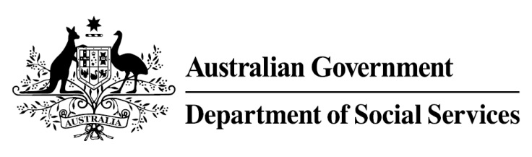

Try, Test and Learn Fund

Initiative: Lead with Culture

Location: New South Wales
Using insights from the Priority Investment Approach, the Try, Test and Learn Fund is gathering evidence on new or innovative approaches to addressing barriers to work.
The Try, Test and Learn Fund will help achieve the objectives of welfare reform—that is, to develop a modern welfare system that increases the capacity of individuals, reduces the risk of welfare dependency and maintains a strong welfare safety net.

What are we trying to achieve?

Fast facts
Priority group: At-risk young Indigenous people
Target participant number: 306
Locations: Western Sydney and South Coast NSW
Trial period: 28 months
Total funding: $2.12 million
Service provider: KARI Foundation
Potential future saving: The purpose of these initiatives is to test whether an intervention works to reduce long-term reliance on welfare. If around 7 per cent (20) of participants move off income support because of this project, the savings to the welfare system are likely to outweigh the costs of the project.
Note: Due to changes in circumstances, adjustments have been made to target participant numbers, trial period and total funding.
To reconnect young Indigenous people with their culture by building a sense of identity, purpose and meaning. The project tests whether improvements in cultural connectedness, health and lifestyle will lead to increased employability and better long-term employment outcomes for participants.

What is Lead with Culture?
  - Lead with Culture helps young Indigenous people overcome their barriers to employment through multi-tiered supports centred on reconnecting with Indigenous culture.

  - Participants undergo a four step process structured around a series of workshops to improve their cultural connectedness and help them into employment and training. Lead with Culture seeks to:
- build trust and rapport with participants
- connect participants with counsellors, mentors and other supports, including assessment of health, education, lifestyle and cultural connection
- build the foundations for belonging and empowerment through goal-setting with mentors and supports
- engage participants in training, education, employment, building pathways to empowerment.

What does the evidence tell us?
- Young unemployed people face a variety of barriers to further education and employment. While some will face minimal barriers to engaging in further education or taking up employment opportunities, others will face a number of challenges to making a successful transition.
- If nothing changes, 64 per cent of 16-21 year olds currently receiving Youth Allowance (other) or Disability Support Pension with mental health as the primary condition will be receiving income support payments in 10 years, and 54 per cent will be receiving income support payments in 20 years.

How is this initiative new and innovative?
This project aims to test the connection between Indigenous cultural continuity and employment outcomes. A similar program in Canada has shown positive outcomes and could be replicated here.

