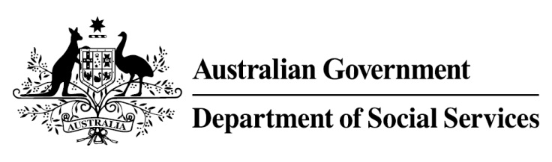

Try, Test and Learn Fund

Initiative: IMPACT Club
Location: Western Australia
Using insights from the Priority Investment Approach, the Try, Test and Learn Fund is gathering evidence on new or innovative approaches to addressing barriers to work.
The Try, Test and Learn Fund will help achieve the objectives of welfare reform — that is, to develop a modern welfare system that increases the capacity of individuals, reduces the risk of welfare dependency and maintains a strong welfare safety net.

What are we trying to achieve?

Fast facts
Priority group: Other — young people aged 12–18 in a remote area with a large Indigenous population
Target participant number: 50
Locations: West Kimberley
Trial period: 23 months
Total funding: $392,300
Service provider: World Vision Australia
Potential future saving: This project supports a group of people identified through the provider’s experience in working with vulnerable people, and other research. To date, potential future savings for this group have not been calculated. Such a calculation may be possible once data on participants in this project is available if an appropriate comparison group can be identified.
The IMPACT Club helps disadvantaged young people develop the skills, behaviours and attitudes necessary to enter education, employment or enterprise pathways and make a positive contribution to their community. The program uses a youth-led, service-learning approach. Participants identify and undertake practical projects with outcomes that benefit their community.

What is IMPACT Club?
The IMPACT Club model takes an innovative and highly-regarded international model for youth and community development and adapts it to the unique needs of young people in the West Kimberley region of Western Australia. This ensures a user-centred and culturally appropriate program that addresses key barriers to employment.
New IMPACT Clubs undergo a ten-week 'active citizenship’ curriculum involving fun activities and experiential learning. IMPACT Club members then identify community projects that they plan and implement. Projects run for three months with each project being increasing in complexity and delving deeper into community issues.
Through IMPACT Clubs, participants develop new skills and improved behaviours and attitudes that improve their employment prospects while also benefiting their community.

What does the evidence tell us?
- Young unemployed people face a variety of barriers to further education and employment. While some will face minimal barriers to engaging in further education or taking up employment opportunities, others will face a number of challenges to making a successful transition.
- Indigenous people living in very remote areas are 1.4 times more likely to be unemployed and 1.5 times more likely to receive government allowances as their main income source than Indigenous people living in major cities (AIHW, Australia’s Welfare, 2017).

How is this initiative new and innovative?
The IMPACT Club project takes a model that has been successful in a range of countries and adapts it for young people in the West Kimberley region. IMPACT Clubs designs, develops and delivers projects based on local community issues. This allow participants to develop practical marketable skills and consolidate new behaviours and life skills in an employment-like environment while also giving back to their local community.

