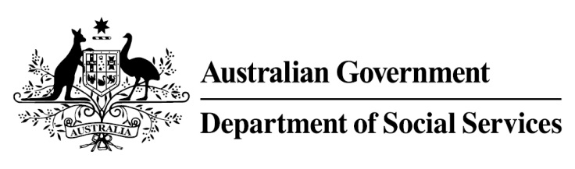

Try, Test and Learn Fund

Initiative: Getting Ready for Take Off

Location: South Australia
Using insights from the Priority Investment Approach, the Try, Test and Learn Fund is gathering evidence on new or innovative approaches to addressing barriers to work.
The Try, Test and Learn Fund will help achieve the objectives of welfare reform — that is, to develop a modern welfare system that increases the capacity of individuals, reduces the risk of welfare dependency and maintains a strong welfare safety net.

What are we trying to achieve?

Fast facts
Priority group: Other
Target participant number: 160
Location: Adelaide
Trial period: 27 months
Total funding: $2.53 million
Service provider: Second Chances SA
Potential future saving: This project supports a group of people identified through the provider’s experience in working with vulnerable people, and other research. To date, potential future savings for this group have not been calculated. Such a calculation may be possible once data on participants in this project is available if an appropriate comparison group can be identified.
This project aims to break the inter-generational cycle of welfare dependency for young people, aged up to 25 years, who have or have had a parent or guardian in prison. It aims to do this by supporting participants to develop a vision of their future including a pathway to employment.

What is Getting Ready for Take Off?
This project seeks to improve participants’ employability by addressing their particular barriers to education and employment. The project establishes two hubs, one each in the north and the south of Adelaide, where life coaches, who have had similar life experiences, will work one-on-one with each participant to develop an individualised employment or training plan based on their personal barriers and strengths.
Working with their life coach, each young person is encouraged to reach their goal. For example, they could be supported to enrol in vocational training with financial assistance from the project, first aid training, and/or receive literacy and numeracy support at the hub. Each young person also participates in group workshops to help develop their self-esteem, problem-solving and decision-making skills. They also have access to transport to get to the hub, if necessary, and can also be linked to job services providers.

What does the evidence tell us?
- There are an estimated 40,000 Australian children with a parent in prison.
- In 2018, the Australian Institute of Health and Welfare reported that 38 per cent of prisoners have children who depend on them for their basic needs, and 18 per cent of prisoners reported that when they were children, one or more parent or carer had been imprisoned.
- Young people whose parent or guardian is in prison or is an ex-prisoner face social stigma and can experience emotional, social and behavioural problems that lead to anti-social and criminal behaviour. They also often have un-treated health issues and perform poorly at school. Over their lifetime, these children are likely to incur high social welfare, justice and health costs.

How is this initiative new and innovative?
This project provides valuable evidence about the effectiveness of interventions that are designed to support a particularly vulnerable group of young people.

