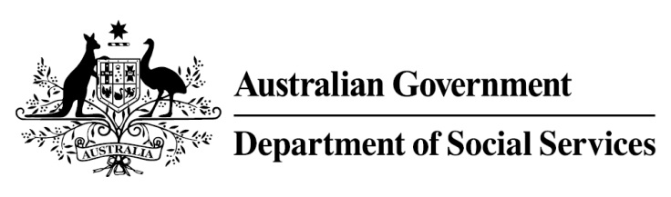

Try, Test and Learn Fund

Initiative: A Bridge to Regional Employment and Opportunities
Location: Victoria
Using insights from the Priority Investment Approach, the Try, Test and Learn Fund is gathering evidence on new or innovative approaches to addressing barriers to work.
The Try, Test and Learn Fund will help achieve the objectives of welfare reform — that is, to develop a modern welfare system that increases the capacity of individuals, reduces the risk of welfare dependency and maintains a strong welfare safety net.

What are we trying to achieve?

Fast facts
Priority group: Migrants and refugees
Target participant number: 30 job seekers (and their families)
Locations: Melbourne, Loddon Mallee and the Grampians
Trial period: 24 months
Total funding: $1.93 million
Service provider: AMES Australia
Potential future saving: The purpose of these initiatives is to test whether an intervention works to reduce long-term reliance on welfare. If around 73 per cent (22) of participants (job seekers) move off income support because of this project, the savings to the welfare system are likely to outweigh the costs of the project. Note that this does not account for any secondary benefits for participants’ family members.
This project links migrants and refugees currently living in Melbourne who are having difficulty finding work, and are willing to relocate to regional areas, with employers with vacancies in the Grampians and Loddon Mallee regions. This project delivers economic and social benefits to the participants, their families and the receiving towns and regions.

What is A Bridge to Regional Employment and Opportunities?
Migrants and refugees receive information about employment and housing opportunities in the two trial re-settlement areas, as well as information about education, health, transport and community services for their families. They are able to visit the area and meet with potential employers, schools and members of the community. Participants and their families who decide to relocate are able to access up to $8,000 to help cover the costs associated with moving from Melbourne to their new community.
The Central Grampians Services Pty Ltd in the Grampians region, and Sunraysia Mallee Ethnic Communities Council in the Loddon Mallee region work with the receiving communities to ensure that there are appropriate services for participants and their families. They provide information to local employers and real estate agents, work with schools, community services and recently arrived migrants who have successfully settled in the area to set up supports for the new arrivals.

What does the evidence tell us?
- While many migrants and refugees successfully gain employment within the first few years of arrival, a small group continues to struggle and this group is at elevated risk of long-term welfare dependence.
- On average, migrants and refugees who currently receive working-age payments are likely to be on income support for some or all of 30 years over the rest of their lives.
- If nothing changes, 55 per cent of this group will be receiving income support payments in 10 years, and 51 per cent will be receiving income support payments in 20 years.

How is this initiative new and innovative?
The services and supports delivered under this project complement and leverage existing services and supports designed to attract job seekers and migrants to areas with labour force shortages. It tests a sustainable, family focused and secure model for tackling both unemployment within recently arrived migrant and refugee groups and the mismatch between supply and demand for labour in regional areas.

