For further assistance, please contact [nrasithelpdesk@dss.gov.au](mailto:nrasithelpdesk@dss.gov.au)

## National Rental Affordability Scheme (NRAS) Portal

## Quick Reference Guide

How to Log into the NRAS Portal

This Quick Reference Guide (QRG) will take you through the steps to obtain a myGovID and log into the NRAS Portal.

Access Required:

* Participant Read Write User; or Participant Claims User.

Warning Do not use the navigation buttons on your web browser while working in the portal. Using the back, forward or refresh buttons on your browser will cause you to lose the information you have entered.

Use the **Back** and **Continue** buttons to move through the different sections.

In order to be granted access to the NRAS Portal, you will need to:

* Obtain a myGovID;
* Have the Principal Authority for the ABN link the organisation to your myGovID in Relationship Authorisation Manager (RAM); and
* Complete a portal access request form.

Obtaining a myGovID

1. You will need a smart phone and an email address to register.
2. Navigate to the app or play store on your smart phone and download the myGovID app;
3. Enter your details and follow prompts to prove your identity; and
4. The principal authority will need to follow the directions [here](https://info.authorisationmanager.gov.au/get-started) to link the myGovID to the ABN in RAM.

Additional Information Note If you have trouble registering for myGovID or linking the ABN in RAM, please seek assistance from the ATO helpdesk on 1300 287 539. The NRAS Helpdesk is not able to assist with myGovID registrations.

Completing a portal access request form

Depending on the type of access you require, you will need to complete one of these:

* Portal Access Request Form – Approved Participants; or
* [Portal](https://www.dss.gov.au/housing-support/programs-services/housing/national-rental-affordability-scheme/nras-tenants) Access Request Form – Tenancy and Property Managers.

The above forms are available on the NRAS Website via the following link: [NRAS Forms](https://www.dss.gov.au/housing-support/programs-services/housing/national-rental-affordability-scheme/nras-portal-and-it-project#access) or by emailing [nrasithelpdesk@dss.gov.au](mailto:nrasithelpdesk@dss.gov.au).

Once the Portal access has been actioned, you will receive a person number and an activation code, along with a link to the NRAS Participant Portal: [NRAS Portal](https://nras.dss.gov.au/nrasportal/).

The first time you log in, you will need to type in the:

* myGovID code;
* Email address; and
* Activation code.

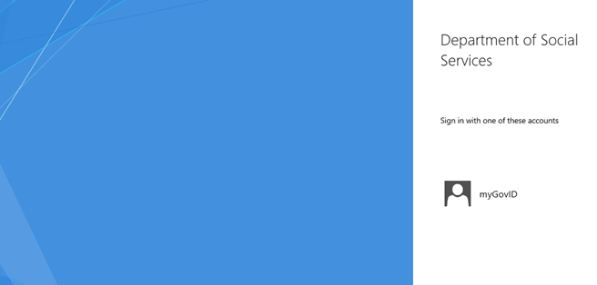

Note icon. For technical support enquiries, please contact the NRAS IT Helpdesk by phone on: 1300 911 235 or via email at: [nrasithelpdesk@dss.gov.au](mailto:nrasithelpdesk@dss.gov.au)