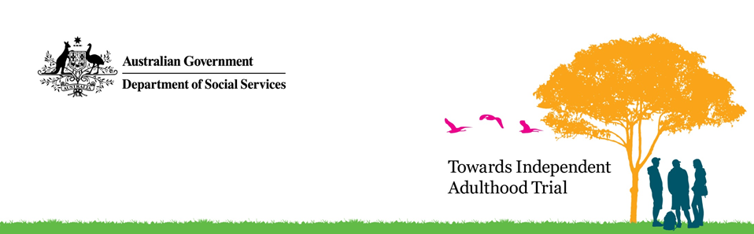

Towards Independent Adulthood trial
  - Information Sheet
The Towards Independent Adulthood trial will deliver one-on-one mentoring and targeted supports to around 80 young people aged 16 years who have agreed to participate. Support for participants will focus on employment, education and training.

About the trial
The trial aims to increase the wellbeing, and future economic and social outcomes of young people as they transition from out-of-home care.
It will test a new service delivery model to better support young people as they move from out-of-home-care to independent adulthood.
The trial will be delivered in metropolitan Perth and the Peel, Wheatbelt and South West regions of Western Australia (WA).
Wanslea Family Services (Wanslea), a non-government organisation, will deliver the services.

Support for the participants
Young people will be invited by their WA Department of Communities case managers to participate. Participation is voluntary and young people must provide informed consent to participate. They can leave at any time by revoking consent in writing.
Each young person will be supported by a Personal Adviser from mid-2017 to mid-2020. Personal Advisers will support the young people to:
- gain skills to live independently
- find a place to live
- manage their health and finances
- sort out legal matters,
- maintain their social connections, culture and identity.
Depending on their aspirations, Personal Advisers will also support the young people to:
- enrol in a TAFE course or university
- start a training course or apprenticeship, and/or
- find a job.
During the trial, WA Department of Communities case managers will continue to provide case management and support until participants turn 18 years old. Post leaving care Wanslea continues to support delivery during the trial period.
Personal Advisers will work closely with WA Department of Communities case managers to implement the young people’s leaving care plans and cultural plans. This may involve working with the young people’s families and carers, or other people, for example, a teacher or training worker.

Access to government payments and other services
Taking part in the trial will not affect any government payments or allowances. However, young people currently receiving leaving care services who want to take part in the trial will need to transfer over to the trial’s services.

Use of personal information
Some personal information will be collected about participants during the trial in relation to their health, education, finances, living arrangements and other relevant information. This information will help Youth Workers to provide appropriate support to participants.
Youth Workers may then share this information with relevant agencies to:
- obtain accommodation, employment or legal advice for participants
- secure education or training opportunities, and/or
- access health, financial, counselling, and/or other services.
All personal information collected as part of the trial will be managed under the Australian Privacy Principles contained in Schedule 1 of the Privacy Act 1988.

Evaluation of the trial
The trial will be independently evaluated.
The evaluation will run for the life of the trial and will consider the service delivery model used, how well the trial was implemented and whether the aim of the trial was achieved.
The evaluation team may gather information from Youth Workers, WA Department of Communities case managers, Wanslea Family Services (Wanslea) staff, participants, and their families and carers.
This information may be gathered through face-to-face interviews, questionnaires, observations and focus groups. Information may also be collected from WA Government agencies, such as WA Department of Communities, and Health, Education and Corrective Services.
Information collected as part of the evaluation will only be used for evaluation purposes. It may be shared with Wanslea, WA Department of Communities and DSS in a confidential and secure manner.
The evaluation team will provide a final report to DSS after the trial ends.

Contact details
General enquiries about the trial can be emailed to childandyouthinitiatives@dss.gov.au

More information
More information about the trial is available on the DSS website (www.dss.gov.au/families-and-children/programs-services/children/towards-independent-adulthood-trial).

