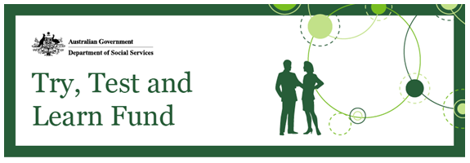
Message from the Minister
The Turnbull Government is focussed on helping Australians find a job and keep it.
The health and social benefits of having a job are considerable. Work helps build financial independence and improves self-esteem.
The Try, Test and Learn Fund was established to find and trial innovative, new ways to help vulnerable people at risk of long-term welfare dependence to find employment.
There are 14 initiatives in the first phase of the trial about to get underway.
The University of Queensland, in association with the University of Melbourne, have been contracted to conduct an evaluation of these initiatives.
Quantitative and qualitative reviews will be ongoing until 2020, including stakeholder interviews, participant surveys, case studies, program data analysis and secondary data analysis.
The idea generating process continues with applications for the second tranche of the fund being assessed.
The Department successfully hosted an ‘ideas exchange’ event in the Tasmanian town of Burnie on 28 March, bringing together around 40 locals who workshopped practical solutions to link older unemployed people with work.
You are invited to submit a Try, Test and Learn Fund grant application at Community Grants Hub or GrantConnect.

The Hon Dan Tehan MP, Minister for Social Services

Assessment of Tranche 2 applications
The Try, Test and Learn Fund is taking an innovative and flexible approach to seeking proposals for funding. Tranche 2 provides an extended application period to be flexible to applicants’ needs and emerging policy priorities. We have developed a robust assessment process that will allow us to select applications in a way that is fair and maximises value for money. Among the considerations in the assessment of applications will be the need to ensure a reasonable funding spread geographically, across priority groups and across the batches.
We will distribute funding across five assessment batches and across different groups at risk of long-term welfare dependence, including the four priority groups: Newstart Allowance recipients aged 50 and over, working age migrants receiving income support, working age carers receiving Carer Payment and at-risk young people aged 16-21 receiving income support. We will manage demand by funding suitable applications at different times; this means we may revisit suitable applications later in the tranche.
If you submitted an application in the January batch, we will notify you of your application’s outcome. If your application was not suitable, it will not be considered further. If your application was assessed as suitable but you did not receive funding immediately, we will notify you that we may consider it later. You can apply as many times as you like and can withdraw applications at any stage.
More Tranche 2 information sessions: Register now
Registration is now open for a number of tranche 2 information sessions. If you would like to attend one of the events, please register via Eventbrite at the links below. Please note that these dates are subject to change. If dates, times, or venues change, we will contact anyone registered to attend through Eventbrite.
  - Perth on 11 April 2018 – register to attend
  - Canberra on 19 April 2018 – register to attend
  - Western Sydney on 16 May 2018 – register to attend
  - Dubbo on 6 June 2018 – register to attend
  - Coffs Harbour on 7 June 2018 – register to attend
  - Wagga Wagga on 20 June 2018 – register to attend
These sessions outline the process and priority groups for tranche 2, with time for questions and answers at the end. Presentation notes and transcripts of the questions and answers will be posted on the Community Grants Hub and GrantConnect.
Keep in touch
Until the next update, please feel free to distribute this newsletter to your networks, and encourage them to sign up for updates here. You can also contact us at TTLFund@dss.gov.au.

