Cashless Debit Card
Goldfields region, Western Australia

The Cashless Debit Card looks and operates like any regular bankcard, however, it restricts the purchase of alcohol, gambling products and gift cards and cannot be used to withdraw cash.

What area will the Cashless Debit Card cover?
The Goldfields region covers the local government areas of Kalgoorlie-Boulder, Laverton, Leonora, Coolgardie and the suburbs of Menzies, Kookynie and Ularring in the Shire of Menzies in Western Australia (WA).

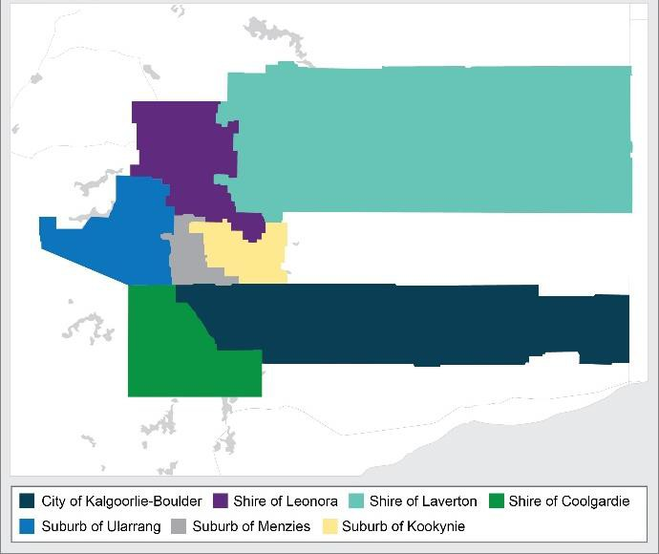

When will the program begin?

The card will be progressively rolled out from 26 March 2018.

Who will receive the Cashless Debit Card?
Around 3,600 people who are recipients of working age payments (such as Newstart and Youth Allowance) will receive the card.
Age Pension and Veterans’ pension recipients will not be included, however, they can volunteer to be part of the program.

Why the Goldfields region?
The Goldfields region was selected based on the support of community leaders for its introduction and a demonstrable need identified. For example, WA Police data indicated the domestic and non-domestic assault rate in the Goldfields region is more than twice the state average.

Alcohol is a factor in two thirds of all domestic assaults (2009-13) and half of all non-domestic assaults.
Alcohol-related hospitalisations and deaths were 25 per cent higher than the WA state average in 2007-11.

Will Income Management continue to operate in the Goldfields region?
People who are on Income Management and live in the Goldfields region will transfer on to the cashless debit card.

What if a Cashless Debit Card participant moves out of the region?
The cashless debit card will stay with the participant even if they move out of the Goldfields region.

What support services will be available for people on the Cashless Debit Card?
The Australian Government will make an additional investment of more than $1 million over three years to ensure children and families in the Goldfields region have well-targeted, coordinated and effective system of services.

The Commonwealth Government will work with the Western Australian Government and the local community to work out how best to do this. There will also be an intense effort in the Goldfields to help people move onto the card.

GET THE FACTS

The Cashless Debit Card is just like a
regular bankcard – use the card to:

- pay rent or mortgage
- pay bills
- pay for medical appointments
- pay electricity bills
- pay car registration
- buy groceries
- check balance and transaction history for free

Did you know?
- Medicare rebates can still go into your
regular bank account

The Cashless Debit Card cannot be used to buy alcohol, gambling products, gift cards or to withdraw cash.

People on the Cashless Debit Card receive:

- 20 per cent of their welfare payment into their regular bank account
- 80 per cent of their welfare payment onto their cashless debit card
- 100 per cent of lump sum payments from Centrelink (e.g. Family Tax Benefit) are placed onto the cashless debit card

Did you know?
- Centrepay and Rent Deduction Scheme stay the same

