Cashless Debit Card
How it works and where it can be used

The Cashless Debit Card looks and operates like any regular bankcard, however, it restricts the purchase of alcohol, gambling products and gift cards and cannot be used to withdraw cash.

What does the Cashless Debit Card look like?

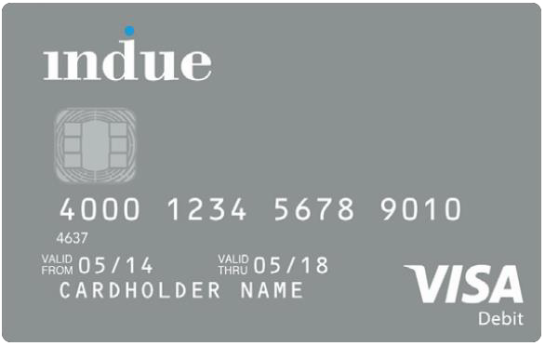

Where can the Cashless Debit Card be used?
It can be used:
- in any store that accepts EFTPOS nationwide to shop at approved online stores
- to pay bills and make recurring payments (such as rent or mortgages)
- for online banking via the Indue website or with an app for both Android and Apple devices

It cannot be used to: x buy alcohol
x buy gambling products and/or gift cards
x withdraw cash

How does the Cashless Debit Card work?
- The cashless debit card does not change the amount of money people receive from Centrelink
- It only changes the way in which people receive and spend their fortnightly payments

People on the Cashless Debit Card receive:

- 20 per cent of their welfare payment into their
regular bank account
- 80 per cent of their welfare payment onto their
cashless debit card
- 100 per cent of lump sum payments from Centrelink (e.g. Family Tax Benefit) onto their cashless debit card

Example of how someone might receive their payments if they are on the Cashless Debit Card:

If a single person with three children aged under eight and renting receives $1,468 in Newstart Allowance, Family Tax Benefit and other payments every fortnight:

  - $1,174 will go onto their cashless debit card
  - $294 will go into their regular bank account, which they can access as cash

GET THE FACTS

The Cashless Debit Card is just like a regular bankcard. To use EFTPOS simply:

- Insert the card and select "CR" (Credit), "SAV" (Savings) or "CHQ" (Cheque)

- Enter PIN

- The transaction will be processed just like any other transaction.

× The transaction will be declined if there is no money in the account or if the purchase is for a restricted item.

Note: The Visa payWave option is not available on the cashless debit card.

There are five ways to check your balance:

- Online - login to your online account indue.com.au/dct/login
- Mobile App - download the Indue DCT app via the App Store or Google Play.
- SMS – text “BAL XXXX” from your registered mobile to 0488 112 114 and receive a reply with your balance (XXXX is the last 4 digits of your cashless debit card number).
- ATM - free of charge from participating Westpac and DC Payments ATMs.
- Call the Indue Customer Service Centre on 1800 710 265.
