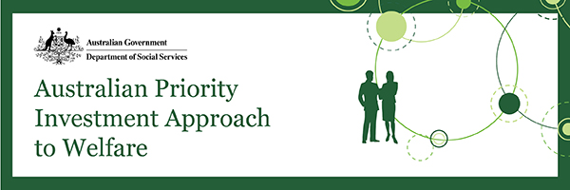
Ideas shortlisting
Since 24 February 2017—when ideas submissions closed for the Try, Test and Learn Fund’s first tranche—we have been assessing, shortlisting and planning for co-development. The quality and quantity of ideas received was impressive. It emphasised how stakeholders are embracing this opportunity to trial new or innovative approaches to assist people who have the capacity to work, and who are at risk of long-term reliance on welfare, into stable and sustainable employment. If you submitted an idea, then thank you for the work you put in to submitting your idea or ideas.
About three-quarters of the 389 ideas submitted were found eligible for further consideration. We assessed all eligible ideas, according to the criteria outlined in the Handbook. A number of common themes arose across the ideas submitted. This assessment has resulted in an initial shortlist of ideas. In a number of cases, the projects proposals that are developed as a result of the co-development process will include elements from more than one idea within one of the common themes.
Over the coming weeks we will be inviting people and organisations who submitted shortlisted ideas, and their collaborators where relevant, to participate in co-development; we will also invite submitters of similar or complementary ideas to collaborate in the co-development work.
We will also soon email all other idea submitters about the outcome of their idea as we finalise our shortlist. Even if your idea is not selected for co-development at this stage, it is possible that you will be contacted in the future. This is because we may continue to identify further linkages, or possible collaborations, during or following co-development. In addition, there will be more opportunities to submit proposals for subsequent tranches; the Fund is expected to open for ideas several times over multiple years, including in the second half of 2017. We will let you know when it happens.
Co-development
The co-development process is outlined in a framework document that will be released on DSS Engage soon. Specialist facilitators will lead co-development. These facilitators will devise collaborative activities across April with the end goal of developing robust project proposals for each of the shortlisted ideas, or groups of ideas. The proposals will include, for example refined project descriptions, a monitoring and evaluation framework for the proposed project and the development of a budget.
Co-development activities will be tailored to each idea or group of ideas depending on factors such as the nature and scope of the idea/s, the collaborators involved, and the extent to which the idea/s has/have already been developed or tested.
After co-development, we will seek ministerial approval for funding the project proposals. In many, but not all, cases it is anticipated that proponents of the original idea would have the opportunity to participate in the selection process for delivery partners.
We expect that the Minister for Social Services will announce the projects selected for delivery in the middle of 2017.
More information on co-development and funding is available in the Handbook.
Until next time
Please feel free to distribute this newsletter to your networks, and encourage them to sign up for updates. If you have enquiries, you can also contact us at InvestmentApproach@dss.gov.au.

