Gender Equality Action Plan 2017 - 2020

Table of Contents
Background 3
Purpose and priority areas 5
Current State 5
Measurement and evaluation 11
Glossary – Attachment A 12

Background
Balancing the Future: Australian Public Service Gender Equality Strategy 2016-19 (the Strategy) sets out actions on changing culture through leadership, flexibility and innovation. It focuses on driving high performance and boosting productivity in the Australian Public Service (APS). The Strategy is one of several actions to support the Government’s G20 commitment to reduce the gender gap in workforce participation by 25 per cent by 2025.
The Secretaries Equality and Diversity Council has committed each agency to developing a Gender Equality Action Plan (Action Plan). This Action Plan aligns with the APS Strategy and is informed by the Workplace Gender Equality Agency’s (WGEA) diagnostic tool. The Action Plan builds on the Department’s existing framework and commitment to diversity and inclusion, enhancing our existing gender equality and culture where all employees are able to receive and enjoy the same rewards, resources and opportunities regardless of their gender identity. Women are strongly represented across the social services sector and DSS’s workforce reflects this for both APS and SES employees, confirming our ability to foster equitable and high performing workplaces.

Assessment against the WGEA Gender Equality Diagnostic Tool
In October 2016, the Department assessed itself against the WGEA Gender Equality Diagnostic Tool, achieving a total score of 43 out of a possible 60, with an aggregate score of four – Integrated on the Gender Equality Roadmap. Organisations in the Integrated phase can demonstrate that gender equality is internalised within their systems:
- Gender equality best practice is integrated in business and people polices and processes
- The business case for gender equality is understood and embraced at all organisational levels
- Commitment to and investment in gender equality progress is unaffected by business challenges
- Structural and cultural barriers to female career progression are actively challenged and addressed

DSS general equality maturity was assessed across 12 key focus areas on the Gender Equality Roadmap:
Gender Equality Roadmap
Focus area | Roadmap phase | Roadmap signposts
Policy and Processes | Sustainable | Gender equality objectives are fully embedded within business and people polices and processes rather than standing alone.
Gender pay equity |  | Pay policy design and practice is transparent and bias-free and gender-equitable reward is a business and cultural norms.
Talent Pipeline |  | Access to development is gender-equitable for employees at all levels, talent is fully leveraged irrespective of gender.
Gender inclusive culture |  | A gender equitable and inclusive culture is intuitive to all employees and defines how all business and work is conducted.
Measurement and Reporting | Integrated | Gender equality/diversity metrics form part of routine management information which informs leadership action planning
Stakeholder Engagement | Strategic | A full range of gender equality stakeholders (male and female, internal and external) is identified during strategy development.
Leadership Accountability |  | Senior leadership team recognises the need for gender equality action and actively communicates its role in driving progress against clear metrics.
Strategy and Business Case |  | The value of the gender strategy based on a credible business case has been recognised and developed.
Gender composition |  | Team and overall workforce gender composition is monitored as are business and people process outcomes by gender.
Flexibility |  | Flexible work and family-friendly polices/practices are designed and accessible to benefit all employees; the flexibility business case is established.
Leader and Manager Capability | Programmatic | Individual development addresses specific gender quality needs as they arise and focuses on knowledge rather than skills.
Supply Chain |  | Promotion of gender equality through procurement/supply chain practices is limited to specific vendor types (eg. recruiters) and ad hoc tender responses.

Purpose and priority areas
The purpose of the Action Plan is to contribute to the Government’s G20 commitment to reduce the gender gap in workforce participation. In doing so, the Action Plan outlines our program of activities to achieve the Department’s Gender Equality goals.
DSS will focus on maintaining and improving its maturity in areas where gender equality is already integrated in its people, policy and culture. Effort in the Action Plan will concentrate on the WGEA roadmap phases of Strategic and Programmatic. Conscious and deliberate effort in these areas is likely to yield significant results.
The DSS Action Plan sets out a range of goals and actions to reinforce our Department’s commitment to diversity and gender equality. As a result, the priority areas for DSS within the Action Plan are:
- Developing the capability of leaders and managers to embed gender equality across teams and business units
- Demonstrating the Department’s commitment to gender equality when procuring its goods and services
- Sustaining a gender inclusive culture, including through senior level promotion of the business case for equality
- Promoting flexible work arrangements regardless of classification and gender
- Meeting stretch gender-based diversity targets
- Maintaining our gender profile across all business areas and gender balance in leadership roles
- Developing more diverse employment practices.

Current State
The Department is already a leader in the APS and performs well in gender equality.
As at 31 January 2017, within DSS:
- 67 per cent of DSS staff are women
- 53 per cent of DSS senior executive service leaders are women
- There is reasonable pay equity across APS workforce as a consequence of the APS remuneration structures and DSS Enterprise Agreement
- SES pay rates are marginally higher overall for males than females ($197,530 compared to $195,832). However the average pay rate is slightly higher for females in the SES Band 2 cohort ($235,116 compared to $233,327) and the SES Band 3 cohort
- Women slightly outnumber men (55 per cent to 45 per cent) in financial services roles
- Women make up one third (35 per cent) of the DSS Information Management Technology workforce
- 20 per cent of the DSS APS workforce and 2 per cent of SES access part-time arrangements, with 86 per cent of staff who access these arrangements being women
- 72 per cent of women identify as having carer responsibilities, which is significantly above the rate of men at 28 per cent
- The Department’s separation rate of 15.38 per cent is similar for both women and men
- Census data indicates that women are slightly more engaged (61 per cent) than men (59 per cent) with their work, team, supervisor and agency
- Gender representation by organisational structure is detailed in the graph below, with only one Group showing a lower female to male ratio
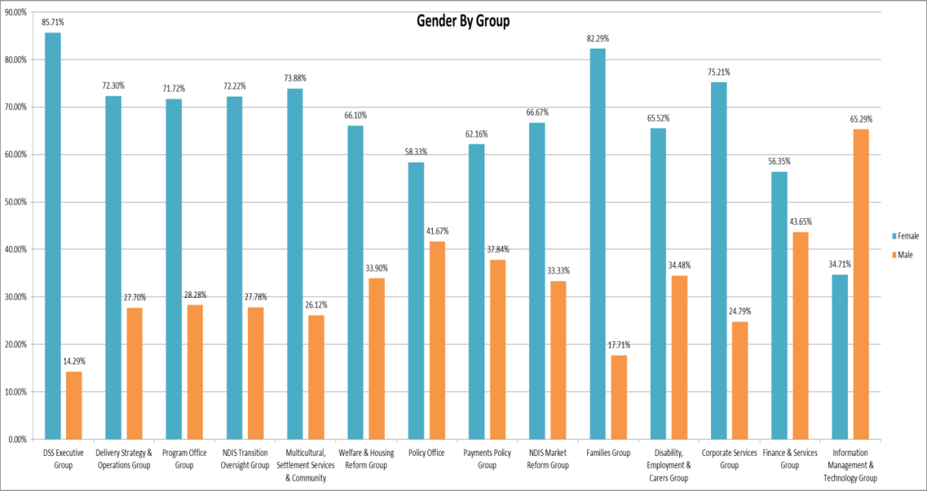

DSS Gender Equality Action Plan
Goal | Action Item | Sub actions | Timeframe to complete | Area Responsible
Leadership and Workplace culture | Promote and raise awareness of the importance and benefits of gender equality as a business priority | Executive endorsed communication campaigns to support the principles of the APS Gender Equality Strategy and DSS Action Plan. | Q1 2017 | EMG
 |  | Provide toolkit for Senior Managers and supervisors to promote the benefits of an inclusive workplace and Departmental initiatives by June 2017. | Q2 2017 | CSG/all senior managers
 |  | Support our portfolio agencies to establish and monitor gender equality initiatives by December 2017. | Q2 2017 | EMG
 |  | Review corporate policies and procedures to ensure compliance with the Department’s gender equality commitment by December 2017. | Q4 2017 | CSG/WCF
 | Ensure consistent, supportive, and respectful approaches for the safety of employees and their workplaces | Provide training to managers to recognise and respond appropriately to employees, including utilising leave provisions by June 2017. | Q2 2017 | CSG/all managers
 |  | Improve policies relating to domestic and family violence and communication of those policies to employees by June 2017. | Q2 2017 | CSG
 |  | Establish web based resources relating to domestic violence information and supports by June 2017. | Q2 2017 | CSG
 | Establish a Gender Equality Network | Allocation of support for the Gender Equality Network in the Departmental budget. | Q2 2017 | EMG
 |  | Nominate SES Gender Equality Champions – female and male representation | Q2 2017 | EMG
 |  | Promote Gender Equality Network | Q2 2017 | EMG/SMG
Gender Equality in Leadership | Maintain our gender profile across all leadership levels and business areas over the life of the Strategy. | Utilise established mechanisms to monitor gender ratios for all business areas to ensure current profiles are maintained. | Q4 2017 | All managers
 |  | Develop targeted programs to address gender imbalance in those areas where it has yet to be achieved. | Q2 2017 | Group Managers
 | Ensure gender balance when nominating Departmental representation. | DSS Executive commit to the Panel Pledge which requires them to only participate as panellists/speakers in those events where women are participating in a meaningful way; and establish a communication campaign | Q1 2017 | EMG
 |  | Use and maintain a Board Representation Register. | Q3 2017 | CSG
 |  |  | Q3 2017 | CSG
 | Ensure opportunities for leadership and career progression regardless of gender over the life of the Strategy. | Provide specialised leadership and career development programs that support the progression of women and men into senior leadership roles. | Q3 2017 | EMG/ all managers
 |  | Use mechanisms in recruitment campaigns and selection processes that address unconscious bias | Q2 2017 | All selection panel members and recruitment delegates
 |  | Develop SES exchange programs for functional areas affected by gender balance | Q3 2017 | EMG
Innovate for Gender Equality and Diversity in  employment practices | Develop and promote a ‘think differently, work differently’ approach to our personnel practices. | Review retention, development and performance management practices to identify areas for innovation in personnel practices | Q4 2017 | CSG
 |  | Ensure gender and diversity balance on recruitment selection panels | Q1 2017 | All selection panel members and recruitment delegates
 |  | Develop a digital strategy that supports flexible working arrangements | Q3 2017 | CSG
 |  | Research and develop strategies to assist staff with caring responsibilities in terms of career progression and retirement income. | Q3 2017 | CSG, informed by policy areas
 | Collaborate with the APSC and the Workplace Gender Equality Agency | 30 per cent of staff to participate in relevant APSC training | Q4 2017 | All managers
 |  | Meet the criteria of the Workplace Gender Equality Agency’s ‘Employer of Choice for Gender Equality’ citation | Q4 2019 | EMG/CSG
 |  | Work with NGO partners and suppliers to embed gender equality practices | Q4 2019 | Program Office/Finance and Services Group
 | Expand and promote flexible work arrangements. | Promote examples and benefits of flexible work arrangements which challenge assumptions about how work should be done and how jobs are designed | Q4 2017 | All managers
 |  | Adopt a ‘flexible by default’ approach and appropriate supports for managers | Q4 2017 | All managers
 |  | Profile male and female SES or Senior Managers who currently work flexibly to encourage uptake across the Department | Q4 2017 | CSG
 |  | Review framework for working parents to encourage men to use parental leave provisions | Q4 2017 | CSG/ all managers
Gender Equality and Diversity Stretch Targets | Establish and meet gender equality and diversity stretch targets across all levels and business areas over the life of the Strategy. | Increase female Aboriginal and Torres Strait Islander representation at the SES level. | Q4 2019 | EMG
 |  | Increase percentage of women at SES Band 2 level from 43 per cent to 50 per cent. | Q4 2019 | EMG
 |  | Maintain an equal representation of gender for culturally and linguistically diverse SES. | Q4 2019 | EMG
 |  | Increase male staff with disability representation at the SES level. | Q4 2019 | EMG
 |  | Increase awareness of supply chain practices and procurement requirements under the Workplace Gender Equality Act by annual advertising and ensure 100% compliance of tender documentation. | Q4 2019 | Finance and Services Group
 |  | Monitor and maintain non-SES gender ratios for all business areas to ensure current profiles are maintained. | Q4 2019 | All managers
 |  | Increase the representation of women in Information Management and Technology | Q4 2019 | IMTG

Measurement and evaluation
The effectiveness of the Department’s gender equality initiatives will be measured regularly to allow for the actions to be reviewed and updated as they are completed.
Action Item | Sub actions | Responsibility
Monitor and evaluate gender equality initiatives and ratios across all classifications, business areas and board representation. | Quarterly analysis of workforce metrics. | EMG/CSG
 | Analysis of APSC State of Service Survey results | EMG/CSG
 | Analysis of uptake of flexible work arrangements, including parental leave, by men and women | EMG
Report on progress of this Action Plan and other gender equality initiatives | Biannual Report to DSS’ Executive Management Group | EMG/CSG
 | Provide relevant data to APSC as required. | CSG
 | Provide data relating to agency and individual board representation to the Office for Women for the annual Gender Balance on Australian Boards Report and as requested. | CSG
Evaluate organisational culture towards gender equity and address issues and review policies and procedures as required | Quarterly analysis of workforce metrics. | EMG/CSG
 | Analysis of APSC State of Service Survey results | EMG/CSG
 | Analysis of diversity audit by June 2017. | EMG/CSG

Glossary – Attachment A

Diversity | In the workplace, diversity means having employees from a range of backgrounds. This can include having employees of different ages, gender, ethnicity, physical ability, sexual orientation, religious belief, work experience, educational background, and so on.
Equality | Equality is achieved when people are able to access and enjoy the same rewards, resources and opportunities regardless of their background.
*Sex and Gender | Sex refers to the chromosomal, gonadal and anatomical characteristics associated with biological sex.  Gender is part of a person’s personal and social identity. It refers to the way a person feels, presents and is recognised within the community. A person’s gender may be reflected in outward social markers, including their name, outward appearance, mannerisms and dress.  A person’s sex and gender may not necessarily be the same. Some people may identify as a different gender to their birth sex and some people may identify as neither exclusively male nor female.
Inclusive workplace | An inclusive workplace is one where diversity is embraced and everyone can succeed in achieving their personal and professional goals.
Diversity audit | A diversity audit is a review of an organisation’ workplace culture and employment practices.

* Australian Government Guidelines on the Recognition of Sex and Gender

