eNewsletter, Issue 7, March 2016

Welcome to the seventh issue of the National Plan e-Newsletter.

This has been another busy quarter, with planning underway for the Third Action Plan, the inaugural Australia’s National Research Organisation for Women’s Safety (ANROWS) national research conference, International Women’s Day on 8 March, and the final report and recommendations from the Royal Commission into Family Violence being delivered to the Victorian Government.

In this issue, you’ll see updates from Our Watch and ANROWS and you’ll also get updates from governments around the country about work they’re doing to reduce violence against women.

We would like to thank everyone for their continued support of the National Plan and your ongoing efforts to make Australia safer for women and their children in 2016.

Ministers Message

Overcoming Indigenous Family Violence – Northern Territory
The Northern Territory Minister for Men’s Policy and Minister for Women’s Policy,
the Hon Bess Nungarrayi Price MLA, said in her keynote address on breaking the Indigenous family violence cycle that the Northern Territory Government’s true partnership and consultation with communities is yielding positive changes for men and women of Alice Springs and putting an end to the culture of silence on family violence. The women living in Alice Springs town camps are leading the way on this cultural journey of change and have formed the Tangentyere Women’s Committee. Contributing to this positive change is the Four Corners Men’s Family Safety Group that provides training on respectful relationship and prevention of family violence.

The Northern Territory Government is committed to overcoming Indigenous family violence in the Territory says Ms Price (Minister Price), a Walpiri woman from Yuendumu.

Further information about the Northern Territory Government’s work supporting women and girls in the Policy Framework for Northern Territory Women 2015-2020.

Minister for Women’s Policy Bess Price and NOMORE anti-family violence campaigner and ABC Broadcaster Charlie King launched the NOMORE signage at CricketNT which complements the Darwin Bus Service “BusWrap” to promote the NOMORE to family violence campaign. NOMORE signs sponsored by the Minister are being erected at Sporting Grounds across the Territory.

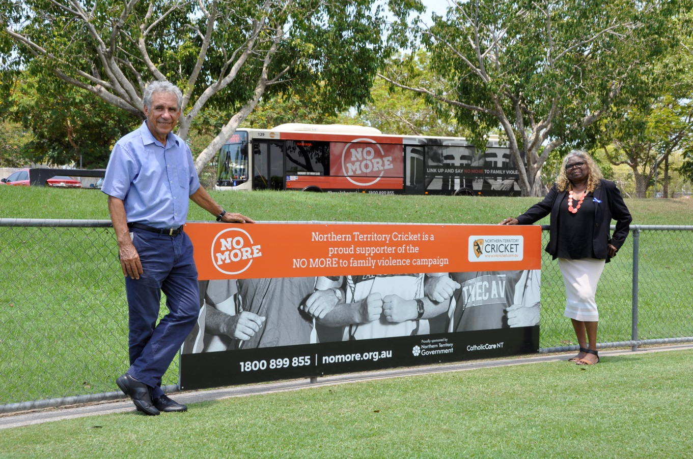

Table of Contents
What has been happening? 4
Feature stories 5
Third Action Plan of the National Plan to Reduce Violence against Women and their Children 5
Safe phones for domestic violence victims 5
National sporting organisations initiative 5
National Media Engagement – curriculum for journalists 6
First release of data on offenders of family and domestic violence 6
Australia’s National Research Organisation for Women’s Safety 7
Senate Inquiry into revenge porn 7
ANROWS Perpetrator Interventions Research Stream 8
Updates from around the country 9
Highlights from New South Wales 9
Highlights from Victoria 10
Highlights from South Australia 12
Highlights from Tasmania 13
Highlights from Queensland 14
Dates for your diary 15
Have your say! 15
Do you need help? 15

What has been happening?

6 February International Day of Zero Tolerance to Female Genital Mutilation

23 February Inaugural ANROWS National Research Conference

25 February 2nd Annual National Family & Domestic Violence Summit

1 March Zero Discrimination Day

7 – 13 March Queensland Women’s Week

8 March International Women’s Day

14 – 24 March 60th session of the Commission on the Status of Women

17 – 19 March The National Family Violence Summit

29 March Royal Commission into Family Violence final report and recommendations delivered to Victorian Government

Feature stories

Third Action Plan of the National Plan to Reduce Violence against Women and their Children
The Third Action Plan of the National Plan to Reduce Violence against Women and their Children (the National Plan) is currently under development and due for release in
mid-2016.

It will be informed by experts and will set out Australia’s policy priorities, actions and direction to help reduce violence against women and their children for the next three years.

The Third Action Plan marks the half way point for the National Plan. This milestone, combined with the momentum around violence against women in the Australian community, makes this action plan a particularly exciting and important one.

For more information on the development of the Third Action Plan and how you can participate visit the plan4womenssafety webpage.

Safe phones for domestic violence victims
On 17 March, the Commonwealth Government announced it is providing $2.5 million to the Women’s Services Network (WESNET) to distribute 20,000 smartphones donated by Telstra. The funding will also help WESNET train frontline service providers.

Technology has changed the way we live and touches nearly every aspect of our lives –making it easier and helping us stay connected to family and friends. However we also know that technology can be used as a tool by perpetrators to inflict domestic violence. It can be used to harass, track or stalk victims.

The funding provided by the Commonwealth Government under the Safe Technology for Women measure of the Women’s Safety Package will allow domestic violence victims access to safe and secure communications when they need it most.

For more information see the Prime Minister’s announcement.

National sporting organisations initiative
The Australian Football League (AFL), National Rugby League (NRL), Netball Australia, and Australian Rugby Union (ARU) have utilised a $250 000 Commonwealth Government grant to help prevent violence against women in their sporting code.

The grants are part of the $1 million Sports Grants Bank and are the first component of the Our Watch Sports Engagement Program.

Through the programme each sporting code is actively working on tailored activities to prevent violence against women and their children, including:
- committing to a joint leadership statement
- appointing ambassadors to challenge the current culture and ensure gender equality
- contributing to the development of standardised policies, tools and resources for partner and other national sporting organisations
- reviewing current training and education to strengthen messages around respectful relationships, challenging gender stereotypes, roles and equality.

Under the programme the sporting codes will also use their social media audience to promote positive, equal and respectful relationships.

To find out more about the programme visit Our Watch Sports Engagement Program. You can also watch Kate Palmer (Netball Australia) and Bill Pulver (ARU) pledge their commitment.

National Media Engagement – curriculum for journalists
As part of Our Watch’s National Media Engagement project a new unit of curriculum for current and future journalists is currently under development.

The unit aims to:
- improve the practical knowledge and professional expertise of journalists
- facilitate their understanding of issues related to violence against women
- provide practical approaches to reporting on the issue in an accurate and ethical way.

Our Watch has commissioned a consortium of three partners to develop the curriculum – Centre for Advancing Journalism (Melbourne University), Dart Centre for Journalism and Trauma – Asia Pacific, and the Domestic Violence Resource Centre Victoria.

Curriculum pilot sessions will be held with journalism students and journalists in March 2016. The curriculum material is expected to be finalised in June 2016, with the unit available to newsrooms and tertiary institutions from next financial year.

To learn more about the National Media Engagement project visit Our Watch.

First release of data on offenders of family and domestic violence
On 24 February 2016 the ABS released the first experimental statistics on offenders of family and domestic violence derived from police recording systems.

This project was funded by the Department of Social Services to build a stronger evidence base for family, domestic and sexual violence in support of the national plan.

In addition to providing a separate data cube for offenders of family and domestic violence, the ABS has released a feature article which contains background information, methodology and a summary of key findings.
The experimental data follows the supplementary release of information about victims of family and domestic violence in the ABS’s publication: Recorded Crime - Victims (cat. no. 4510.0) published in September 2015.

To view and download the new data see the Recorded Crime – Offenders, Australia 2014-15 (cat. no. 4519.0) from the ABS website.

Australia’s National Research Organisation for Women’s Safety
In February 2016 Australia’s National Research Organisation for Women’s Safety (ANROWS) held its inaugural national research conference on violence against women and their children.

Held in Melbourne, the conference gathered Australia’s leading researchers together to present new evidence on domestic violence to government policy-makers and practitioners.

The conference theme was Translating research intro policy and practice, and it was facilitated by ABC journalist Sarah Ferguson.

Research presented at the conference focused on one of four strategic research themes:
- women’s experiences of violence and its impact on their lives
- gender inequality and primary prevention
- service responses and interventions
- how systems can work better together to reduce violence against women and their children.

Effects of violence on children and Indigenous family violence research also featured at the conference.

Presentation slides from the conference are now available, and video/audio recordings will soon be uploaded. See the ANROWS webpage for more information.

Senate Inquiry into revenge porn
On 25 February 2016 the Legal and Constitutional Affairs References Committee (the Committee) submitted a report on their inquiry into the phenomenon known as revenge porn.

The inquiry considered the following issues:
- the phenomenon colloquially referred to as ‘revenge porn’, which involves sharing private sexual images and recordings of a person without their consent, with intention to cause that person harm
- the impact this has on the targets of revenge porn, and in the Australian community more broadly
- potential policy responses to this emerging problem, including civil and criminal remedies
- the response to revenge porn taken by Parliaments in other Australian jurisdictions and comparable to overseas.

The report outlines eight recommendations around the reference, definition and legislation around revenge porn. The Commonwealth Government will prepare a formal response to the recommendations.

For more information or, to view the report and recommendations visit the Parliament of Australia website.

ANROWS Perpetrator Interventions Research Stream
ANROWS is currently inviting applications as part of the Perpetrator Interventions Research Stream (the stream).

The stream is funded by the Commonwealth Government and is a priority under the Second Action Plan of the national plan. It will support states and territories to implement the National Outcome Standards for Perpetrator Interventions (NOSPI).

The grants round follows the release of ANROWS’s research paper on Perpetrator Interventions in Australia, which mapped the pathways, interventions and responses to perpetrators of domestic and family violence, and sexual assault.

Research projects under the stream will build the evidence base on perpetrator interventions and will be based on the following four themes:
1) systems effectiveness;
2) effectiveness of interventions;
3) models to address diversity of perpetrators; and
4) interventions developed by, with and for Indigenous communities.

Research applications close 5pm April 28th.

For more information on the grants and how to apply visit ANROWS's current grants webpage.

Updates from around the country

Highlights from New South Wales

Domestic Violence Disclosure Scheme

In early 2016 NSW is piloting a domestic violence disclosure scheme (DVDS) in four police local area commands (Oxley, Sutherland, Shoalhaven and St George).

The DVDS will enable a person who has concerns about their current/former partner to find out if that person has a history of domestic violence offending. It will also allow concerned third parties such as family, friends and professionals working with the family, to make an application for the person to receive information about their current/former partner.

To support the DVDS funding of $2.3 million over two years (commencing April 2016) has been allocated to Police-NGO Partnerships that will provide NGO-led early intervention support and crisis responses to applicants of the DVDS and victims of domestic and family violence incidents within the pilot areas. These partnerships will also enhance referral pathways within the service system.

Sexual assault strategy
The NSW Government is currently developing a whole of government strategy to support better delivery of prevention and support services for sexual assault.

During the project establishment phase, Women NSW will do an inventory of existing NSW government policies and programs relating to sexual violence.

A literature review will inform the strategy. This will be conducted by the Sexual Violence Research Unit at the Australian Institute of Family Studies.

Sexual assault experts are being invited to join the NSW Domestic and Family Violence and Sexual Assault Council (a Ministerial advisory council of government and NGO) who will advise on the development of the strategy and an expert group. A public consultation process will also commence soon.

For more information on the strategy please contact Kara Beavis, Principle Policy Analyst on (02) 9461 7163 or kara.beavis@moh.health.nsw.gov.au.

Highlights from Victoria

Royal Commission into Family Violence
The final report and recommendations from the Royal Commission into Family Violence was delivered to the Victorian Government on 29 March 2016.

The Royal Commission received nearly 1000 written submissions, hosted 44 group sessions which approximately 850 people attended, and held 25 days of hearings with 220 witnesses appearing before it. Information gathered during the consultation will be used to inform the report.

Find out more from the Royal Commission's website.

Gender equality strategy
Submissions to the consultation paper for the Victorian Government’s first ever gender equality strategy closed on 18 March 2016.

The consultation involved identifying the key challenges and opportunities that gender equality presents. Over 180 submissions were received.

Information on the consultation and the development of the strategy can be found on the Department of Premier and Cabinet website.

Personal safety initiative pilot
A $900,000 pilot is underway to trial innovative technology to help keep women and their children safe in their homes and communities.

The Personal Safety Initiative, led by the Safe Futures Foundation, will provide personal duress alarms and CCTV technology to more than 70 women and test how technological interventions can be used to improve the safety of those experiencing family violence. The twelve-month pilot is being trialled in Eastern Melbourne, Darebin, Whittlesea, Moreland, Hume, Wellington Shire and the Latrobe Valley.

The pilot is scheduled to be completed in February 2017.

Tackling Aboriginal family Violence
On 18 February 2016, the Victorian Government announced $350,000 to tackle Aboriginal family violence through community led action. Under this funding package:
- the Indigenous Family Violence Regional Action Groups will receive $220,000 to support the work it undertakes in developing education tools and initiative for family violence prevention.
- Victoria Police will receive $50,000 to expand the Koori Police Protocols to help build trust and mutual understating between police and the Aboriginal community; and
- $80,000 will be allocated to a communications campaign that will be developed in consultation with the Aboriginal community.

Additional funding for men’s behaviour change programs
In late February 2016, additional funding of $1.25 million was announced for Men’s Behaviour Change Programs. This investment is part of the Victorian Government’s Family Violence Fund established to respond to increased demand for services while the Royal Commission into Family Violence is underway.

The funding includes $145,000 for the Men’s Referral Services which provides anonymous and confidential telephone counselling and referrals for men seeking help for violent and controlling behaviour.

The Victorian Aids Council Gay Men’s Health Centre which delivers services to the LGBTIQ community will also receive $145,000. This is the first time that an LGBTIQ community organisation will receive funding for men’s family violence services in Victoria.
Funding of $100,000 has also been provided to support professional training for men’s behaviour change program facilitators to help reduce waitlists.

New protections for sexual assault victims
A new Bill was put to the Victorian Parliament in February that will amend the Criminal Procedure Act 2009. The amendment will allow the recorded evidence of a sexual assault victim from the Children’s Court to be used in appeals in higher courts and other related criminal or civil proceedings.

Complainants in serious sexual offence cases heard in the Children’s Court are currently required to repeat their evidence in the County Court if the accused appeals their conviction. Repeating this difficult evidence causes unnecessary trauma to victims, delays proceedings, and sometimes results in the prosecution of serious charges being discontinued because the victim is unable, or unwilling, to repeat their evidence on appeal.

The Bill will protect complainants in serious sexual offence matters including rape, sexual penetration, incest, persistent sexual abuse of a child and indecent acts with children.

Highlights from South Australia

Women’s economic empowerment
On International Women’s Day, 8 March 2016, the South Australian Government released a new blueprint for women’s economic empowerment, Investing in Women’s Futures.

The blueprint contains a number of initiatives, including an audit to identify where pay gaps exist within State Government departments and the levels, roles or agencies where the gap is more prevalent. Analysis of the data will inform the development of a strategy to address any gender pay gaps within the public service.

Other initiatives within the blueprint include:
- strengthening legislation to ensure public servants on paid parental leave receive superannuation contributions
- a job-swap network and “shadowing” program where women in the public sector can work within another government agency to gain skills and experience - particularly in non-traditional areas such as IT and other Science, Technology and Engineering and Maths (STEM) fields
- financial literacy information sessions.

The Investing in Women’s Futures blueprint was a commitment under the South Australia’s women’s policy Achieving Women’s Equality, which was released last year.
For more information visit the Office for Women webpage.

Domestic violence protections for renters
Renting laws in South Australia changed on 10 December 2015 to provide more options to people escaping domestic violence. The laws will allow victims:
- to stay at the rented home and have the perpetrator leave, or
- to leave rented premises and be removed from the rental agreement.

If the victim chooses to stay an application will need to be made to the South Australian Civil and Administrative Tribunal (SACAT). Leaving will mean applying to SACAT to either end your part in the agreement or terminate the agreement altogether.
Other changes to the laws will:
- empower SACAT to determine that one or more, but not all co-tenants, are liable for compensation to the landlord.
- prohibit a tenant’s personal information being listed on a Residential Tenancy Database (tenant’s blacklist) in certain situations of domestic violence. For example, where the damage was caused from an act of abuse.

For more information about the changes to renting laws please visit the South Australian Government website.

Highlights from Tasmania

Safe Homes, Safe Families, Tasmania’s Family Violence Action Plan 2015 - 2020
A major achievement of Safe Homes, Safe Families has been the establishment of the Safe Families Coordination Unit. The unit brings together staff from across Tasmanian Government agencies to establish the best available evidence and information to ensure at-risk families are identified and supported as early as possible.

The Coordination Unit moved into their new office in January 2016. Most operational staff will be in place by April 2016, when the trial phase of the Unit begins, which involves members of the unit working together to develop policies and protocols to underpin their ground-breaking work. The Coordination Unit will commence full operations in June 2016.

The Premier, the Hon Will Hodgman MP, and the Minister for Women, the Hon Jacquie Petrusma MP, led a media tour of the Coordination Unit’s offices on 15 March 2016.

To complement the Coordination Unit, a new wraparound service called Safe Choices, which will provide practical planning and support for people in, or exiting, violent relationships, is being developed. The request for proposal process to select a service provider closed on 10 March 2016. Safe Choices will initially be trialled in southern Tasmania in 2016-17 and then rolled out to other regions.

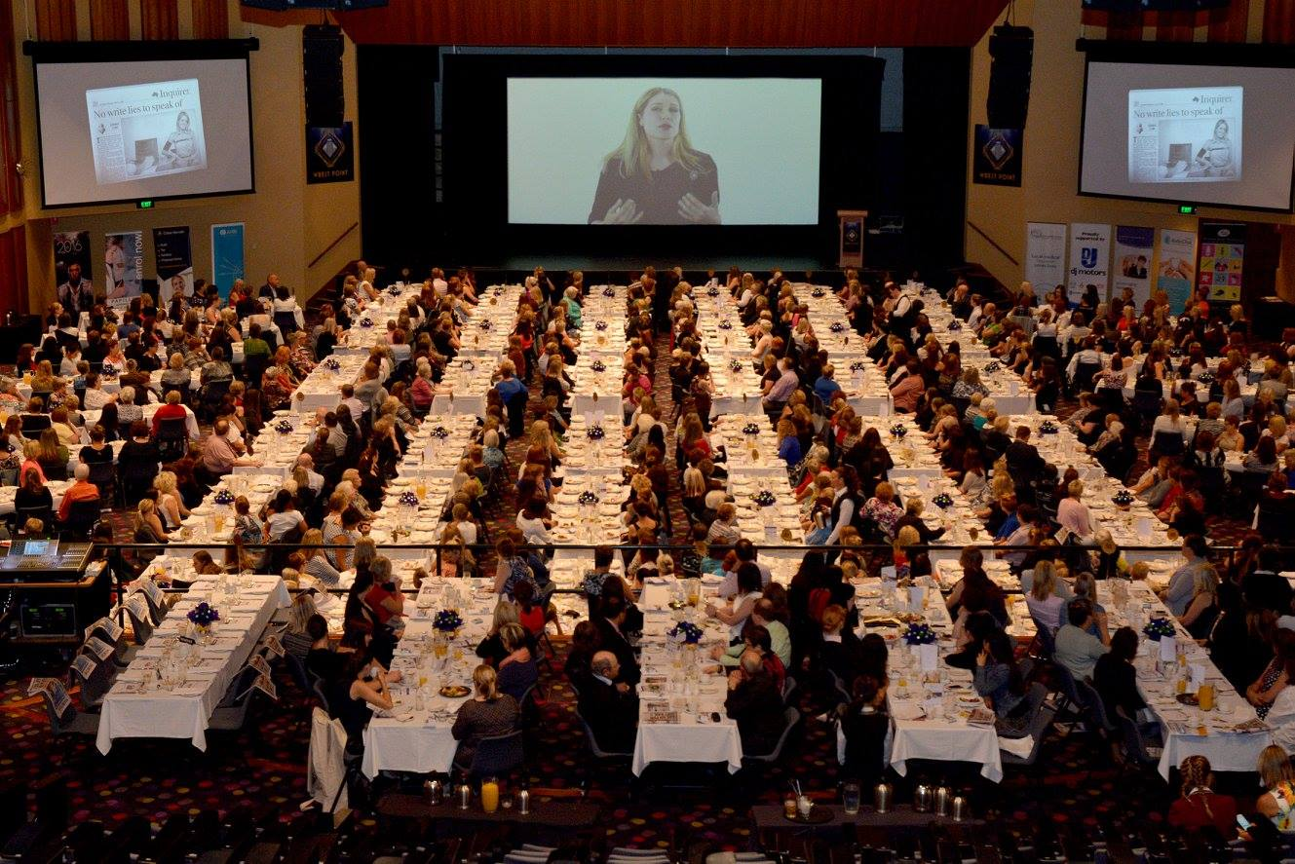

International Women’s Day
The Department of Premier and Cabinet supported the Royal Hobart Hospital Research Foundation to host the 2016 International Women’s Day Big Breakfast. The event featured family violence activist Tara Moss as guest speaker.

Highlights from Queensland

Queensland Women’s Week
From 7 to 13 March 2016 Queensland celebrated the inaugural Queensland Women’s Week, a state-wide series of events and activities, including International Women’s Day celebrations. These events and activities offered opportunities for Queenslanders of all ages and linguistic and cultural backgrounds to join together in celebration.

The theme for Queensland Women’s Week 2016 was ‘Good for her. Great for us. When women achieve, Queensland succeeds.’ This theme celebrated women's achievements as well as acknowledging that supporting and enabling women to take advantage of opportunities to succeed is good for everyone in Queensland.

Queensland Women’s Strategy
The Queensland Women’s Strategy (QWS) was released during the inaugural Queensland Women’s Week on 9 March 2016. The QWS outlines the government’s vision for women and girls in the state. It aims to achieve gender equality by supporting women and girls in areas which restrict their full participation in the social, economic and cultural opportunities that Queensland offers.

The QWS focuses on four priority areas to achieve gender equality - participation and leadership, economic security, safety, health and wellbeing. The strong intention of the QWS is that it is a whole-of-community strategy that must be driven and implemented not only by government but by the private sector and the wider community. It identifies a range of actions that will be further development by July 2016.as part of a whole of community implementation plan.

Queensland Domestic and Family Violence Prevention Strategy
The recently published Domestic and Family Violence Prevention Strategy 2016-2026 was developed through consultation with service sector providers, community leaders and the general public. It sets out a 10 year plan to end domestic and family violence in Queensland and is underpinned by three foundational elements – shifting community attitudes and behaviours, integrating service responses, and strengthening justice system responses. The key outcome of the strategy is for all Queenslanders to live safely in their own homes and children can grow up and develop in safe and secure environments.

Sexual Assault Services
Tenders were released in January 2016 for five new sexual assault services. These procurement processes have been finalised and funding totalling $1.04 million per annum have been approved. The contracts are being negotiated and expected to commence from 1 April 2016.

Dates for your diary

8 – 10 April SA Conference 2016: Standing up for Gender Equality

15 May International Day of Families

15 – 21 May National Families Week

18 - 19 May Child Aware Approaches Conference

29 May White Wreath Day (action against suicide)

9 August International day of the world’s Indigenous People

19 – 22 September Australian Women Against Violence organisation International Conference

Have your say!
We would love to hear from you! If you’d like your event included in future editions of this
e-Newsletter, or have other questions, comments or ideas, please email us at NPSecretariat@dss.gov.au.

Do you need help?
If you or someone you know is experiencing domestic and family violence or sexual assault, get help by calling:
- 000 if you, a child, or another person is in immediate danger
- 1800RESPECT – 1800 737 732
- Relationships Australia – 1300 364 277
- Mensline – 1300 789 978
- You can ask for a free interpreter if needed.

National Relay Service
- TTY users - phone 133 677 then ask for the phone number you wish to contact
- Speak and Listen (speech-to-speech relay) users - phone 1300 555 727 then ask for the phone number you wish to contact
- Internet relay users - visit the National Relay Service website and ask for the phone number you wish to contact.

