National Plan to Reduce Violence against Women and their Children

eNewsletter, Issue 3, April 2015

Welcome to the third issue of the National Plan e-newsletter.

On Australia Day we saw Rosie Batty announced as the 2015 Australian of the Year, for her commitment to championing efforts to fight domestic violence after the loss of her 11-year old son, Luke. Throughout 2014, we witnessed Rosie Batty’s courage in speaking out and giving a voice to women experiencing violence, inspiring the Australian community to recognise that family violence can happen to anyone, regardless of circumstance or history.

This has been a busy quarter, with the elevation of the issue of violence against women to the Council of Australian Governments in 2015; International Women’s Day on 8 March, with the theme Make it happen; the 59th session of the Commission on the Status of Women (CSW), and an announcement that the Commonwealth Government would provide $230 million to extend the National Partnership Agreement on Homelessness to 2017.

In this issue, you’ll hear from NT Minister for Women’s Policy, the Hon Bess Nungarrayi Price MLA, find an article about the launch of the new Daisy app, updates from Our Watch and ANROWS and details about White Ribbon Australia’s new Diversity Program. You’ll also get updates from governments around the country about work they’re doing in 2015 to reduce violence against women.

We would like to thank everyone for their support of the National Plan and your ongoing efforts to make Australia safer for women and their children in 2015.

MESSAGE FROM THE HON BESS NUNGARRAYI PRICE MLA
As we celebrated International Women’s Day around the country and the world, it is timely to look at how far the National Plan has come and the opportunities we have before us to ensure that the national lens remains focused on confronting the scourge of family and domestic violence, and in particular, the prevalent violence against women and their children.

The National Plan is a great achievement. This is the first comprehensive long-term plan, which brings together Commonwealth, state and territory governments, organisations, communities, women and men, to reduce violence against women and their children. At its core, the National Plan acknowledges that where gender inequality exists, the equal right of women and their children to be safe and free from violence can be disrespected and too often with horrendous effects. Herein lies the place where our hearts and minds must meet to ensure our society and communities never accept violence against women and their children. The National Plan provides a strong framework for us to work together towards this important goal. But it is just the first step. The First Action Plan stirred energy and commitment. The Second Action Plan is the practical action.

The rights of women and women’s safety are priority matters for me. My personal experiences of family and domestic violence have shaped my views and drive me towards action. In the Northern Territory, especially in my home region of Alice Springs, the Integrated Response to Family and Domestic Violence as part of our broader framework, ‘Safety is Everyone’s Right’, is already showing remarkable results in keeping women safe. The first round of the Men’s Change Behaviour Program is progressing well. We’ve seen the first group of graduates complete the Tangentyere Women’s Committee Family Safety Training program. These are women living in town camps that have had enough of the violence against women and their children in their community and are doing something about it. These strong women have produced a great poster outlining their rights to be safe in their homes and communities. They have undertaken the long-term and ongoing healing process for their communities. For all communities around Australia, the same challenge applies. It is not an easy task to change attitudes and acceptance built up over several generations. But we can do this.

Family and domestic violence is a matter for all Australians. Until each and every one of us makes this a personal matter, we will not affect any change. We have to look at our own arenas and spaces, our sporting clubs, workplaces, schools, political boardrooms, in the shopping centres, through our everyday interactions and actions. We have to affect thinking around personal responsibility to want to change, to help, to make it different because unless we change behaviours, we will fail. What then will be the future for our children?

International Women’s Day reminds us of what we can each achieve as individuals and together what we can overcome. But men must walk alongside women, side by side. Governments too must support organisations, groups and individuals doing the hard work, strengthen and support women’s development and leadership potential, ensure that service providers are adequately resourced to support their communities, especially women affected by violence and its impacts.

As parents, we must recognise the importance of how we raise our children in imprinting gender equality and respect from the very start. As a community we cannot continue to turn a blind eye to what’s happening around us. We must learn how to respond positively, appropriately and effectively. Together we can nurture a broader generosity of spirit and raise the standards in our communities and reduce violence against women and their children. Let’s make it happen. 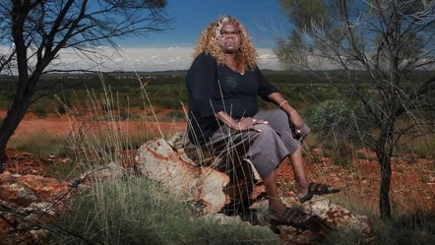

What has happened over the past three months?
25 January Rosie Batty named as 2015 Australian of the Year
28 January The Commonwealth Government announced that violence against women would be a Council of Australian Governments priority in 2015 and a new Advisory Panel on Violence against Women would be established

6 February International Day of Zero Tolerance to Female Genital Mutilation
10-12 February Inaugural Asia-Pacific Conference on Gendered Violence & Violations
17 February Release of “The Cost of Youth Homelessness in Australia” Snapshot Report
17-20 February 8th meeting of the ASEAN Commission on the Protection of the Rights of Women and Children
23 February Victoria’s Royal Commission into Family Violence began
28 February Queensland’s Special Taskforce on Domestic and Family Violence handed down its report

2 March Rosie Batty addressed the Parliamentarians against Family Violence forum
4 March The Commonwealth Government announced it will work with state and territory governments to develop a new national campaign focused on reducing violence against women and their children
5 March Launch of the Daisy App for women experiencing gendered violence
8 March International Women’s Day
18 March Parliamentary launch of the Refocus app
9-20 March 59th session of the Commission on the Status of Women
23 March The Commonwealth Minister for Social Services announced an extension of funding for the National Partnership Agreement on Homelessness
26 March The Commonwealth Attorney-General announced funding for the legal assistance sector
28 March New South Wales State Election

Feature stories

Violence against women as a COAG priority
On 28 January 2015, the Prime Minister, the Hon Tony Abbott MP, announced that addressing violence against women would be a COAG priority in 2015. The Prime Minister also announced the establishment of a new Advisory Panel on Violence against Women, with Ms Rosie Batty and former Victorian Chief Commissioner, Mr Ken Lay, as founding members.

As part of this announcement, the Prime Minister announced three priorities for the COAG agenda:
- a national Domestic Violence Order (DVO) scheme;
- national standards for perpetrator interventions; and
- a national approach to dealing with online safety and the misuse of technology.
On 4 March 2015, the Prime Minister announced that the Commonwealth Government will work with state and territory governments to deliver a national campaign focused on reducing violence against women and their children.

In other critical national announcements:
- On 23 March 2015, Commonwealth Minister for Social Services, the Hon Scott Morrison MP, announced $230 million to extend the National Partnership Agreement on Homelessness (NPAH) for two years to 2017, with funding priority given to frontline services focusing on women and children experiencing domestic and family violence and homeless youth or youth at risk of homelessness.
- On 26 March 2015, the Commonwealth Attorney-General, Senator the Hon George Brandis QC, announced that the Commonwealth Government will contribute over $1.372 billion to the legal assistance sector over the next two years to 30 June 2017. This restoration of
$25.5 million of funding for Legal Aid Commissions, Community Legal Centres and Indigenous legal service providers build on the Commonwealth Government’s significant commitment to address domestic violence, both in terms of front line services and policies that will lead to long term cultural change.

A message from Ken Lay AMP
As the Victoria Police Commissioner, I saw the damage that family violence and sexual assault can wreak on communities and individuals. I regularly described these challenges as the most significant law and order issue facing our community.

Despite the enormous resources that police, the courts, governments, and support agencies have committed, we continue to see examples of men committing horrible and reprehensible acts of violence against women and children.

Upon stepping down from my previous role, I was pleased to accept an invitation from the Prime Minister, along with the 2015 Australian of the Year Rosie Batty, as a founding member of the COAG Advisory Panel on Reducing Violence against Women. Whilst the Terms of Reference are still to be finalised, this position will give both Rosie and me an opportunity to inform the debate at the very highest levels, an opportunity to challenge the status quo, and an opportunity to contribute to a building momentum for change.

The National Plan has created a vision, now it is up to all of us to translate this plan into outcomes that will make our community safer. I feel proud and privileged to be involved.

As a community we have an opportunity, an opportunity that few before us have been given - we must not waste it!
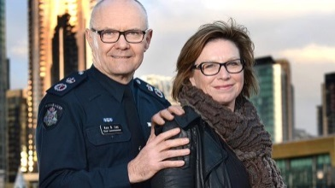

I am Daisy – A national app for women experiencing gendered violence
Meet Daisy, an app that connects women experiencing gendered violence to state and local services. The Minister Assisting the Prime Minister for Women Senator the Hon Michaelia Cash and Ms Rosie Batty launched the app on 5 March 2015. Minister Cash said, “Women experiencing violence have well-founded fears around the concept of ‘just leaving’. We cannot forget the frightening statistic that every week, one woman is killed by a current or former partner”.

Daisy supports women’s decision making and increases safety in a number of ways by including information about:
- national 24/7 services
- state and territory services
- specialist services
- housing and legal services
- specialist services for CALD, Aboriginal and Torres Strait Islander women, and
- children’s services.
Daisy offers:
- a quick exit button
- a get help button
- private web browsing, and
- a Technology Tips page to increase safety online.
Daisy is not just for women experiencing violence.
- Friends and family can use the app to support a loved one’s decision making, and
- workers to find the right services.
Rosie Batty praised the app, saying, “The phone is often the thing that you keep the closest so to have all this information on an app is fantastic. It’s helpful and convenient and it will make connecting to the right organisations a lot easier. Ultimately, Daisy helps raise awareness.”

Daisy is an initiative under the Second Action Plan, developed by 1800RESPECT, with input from all state and territory governments. Share Daisy by tweeting at #iamdaisy and by sharing 1800RESPECT.org.au/daisy on your Facebook and twitter accounts.
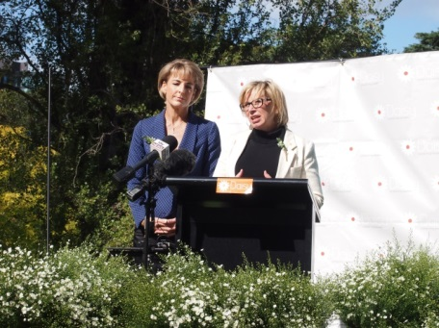
Senator the Hon Michaelia Cash and Ms Rosie Batty, Australian of the Year, at the launch of the Daisy app.

Australia’s National Research Organisation for Women’s Safety Research Program 2014-16
The ANROWS Research Program 2014-16 (Part 1) is well under way. This includes several projects that are investigating integrated services and systems to determine what works when supporting women and children who have experienced domestic and family violence and sexual assault.

The findings of these projects will aid in the development of good policies and practices to reduce violence against women and their children. The projects include:
- the PATRICIA Project: Pathways And Research In Collaborative Inter-Agency working
- Women’s Input to a Trauma-informed systems model of care in Health settings: The WITH study
- meta-evaluation of existing interagency partnerships, collaboration, coordination and/or integrated interventions and service responses to violence against women
- Safe at Home meta-evaluation
- evaluation of innovative models of interagency partnerships, collaboration and/or integrated responses to family and/or sexual violence against women in Indigenous communities, and
- establishing the connection between alcohol and other drug use and sexual victimisation.
ANROWS’s Research Program comprises 20 projects. Projects vary in length and results will be delivered at different points over the next two years. More information on all research projects is available on the ANROWS website. You can also subscribe to receive updates on research and upcoming events, as well as the fortnightly ANROWS Notepad and quarterly ANROWS Footprints.

Consultation begins for national violence prevention framework
Our Watch, in partnership with ANROWS and VicHealth held the first of a series of nationwide consultations on the development of the National Framework to Prevent Violence Against Women and their Children.

Held in Adelaide on 26 February 2015, the consultation included stakeholders from state and local government, community sector service providers, the health, sports, and media sectors, as well as selected local academics.

Participants had the opportunity to hear about the development of the Framework and provide feedback on a draft explanatory model for violence against women and their children, and provide input into the emerging framework for prevention.

The Framework is bringing together international research, and nationwide experience, on what works to prevent violence. As a critical part of this process, the current round of stakeholder consultations will help ensure it is informed by the significant expertise and understanding that currently exists across diverse fields and settings.

These consultations provide Our Watch the opportunity to ‘road test’ with stakeholders some of the conceptual models, explanations, language and communication tools as part of the Framework.

Due for launch in mid to late 2015, the Framework aims to establish a shared understanding of the evidence and principles of effective prevention, and present a way forward.

Rather than prescribing specific actions, the Framework will be a guide to assist governments and other stakeholders to develop their own appropriate policies, strategies and programs to prevent violence against women and their children. Consultations on the Framework are taking place across Australia throughout March, April and May.

Opportunities for early intervention: bringing perpetrators of family violence back into view
Australian of the Year, Ms Rosie Batty, launched the RMIT University report, Opportunities for early intervention: bringing perpetrators of family violence back into view, on Thursday 19 March 2015 at RMIT in Melbourne.

The report, produced by the RMIT Centre for Innovative Justice with funding from the Commonwealth Attorney-General’s Department, recognises that family violence is a national epidemic in need of a systemic response. It highlights the potential of the justice system to step in early and be proactive in interventions with perpetrators of family and domestic violence.

The recommendations of the report explore opportunities for improving interventions with perpetrators of family and domestic violence; including perpetrators’ contact with police agencies, justice, courts and corrections systems and programme interventions. The report also calls for responses to dealing with the intergenerational cycle of family violence through interventions which respond effectively to adolescents who use violence, or children at risk of using violence.
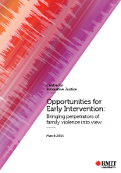

New Diversity Program for White Ribbon Australia
White Ribbon is Australia’s only national, male led Campaign to end men’s violence against women.

The vision of White Ribbon is that all women live in safety, free from all forms of men’s violence. White Ribbon recognise and support the positive role men play in preventing violence against women.

White Ribbon, with the support of the Australian and NSW Governments, is enhancing engagement with Australia’s many culturally and linguistically diverse and Aboriginal and Torres Strait Islander communities through the White Ribbon Diversity Program. The Diversity Program is focusing on making the White Ribbon Campaign more inclusive; build on existing strengths of the Campaign and in collaboration with communities across Australia.

The Diversity Program will focus on:
- engaging culturally diverse and Aboriginal and Torres Strait Islander men as White Ribbon Ambassadors
- building greater engagement with men and women from diverse communities through the Advocates Program
- community engagement activities
- developing culturally accessible and appropriate resources to support community engagement
- eLearning and face-to-face training.

Craig Rigney, CEO of Kornar Winmil Yunti Aboriginal Corporation in South Australia, talks to SBS about White Ribbon’s program to recruit Ambassadors from culturally diverse backgrounds, including Aboriginal and Torres Strait Islander men. Listen now! For more information please contact diversity@whiteribbon.org.au
or visit the White Ribbon website.
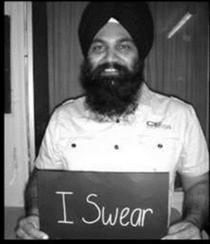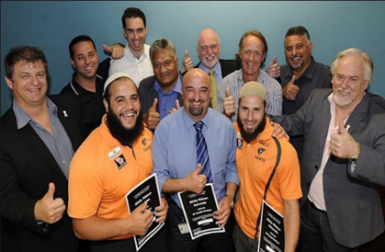
Images provided by White Ribbon Australia.

DV-alert supporting integrated service delivery
RECOGNISE, RESPOND AND REFER is the tagline used for DV-alert (Domestic Violence Response Training). Training is free of charge, nationally accredited and delivered by qualified Lifeline and partner providers for health, allied health and frontline workers to recognise, respond and refer cases of domestic and family violence.

The critical REFER component of the program focuses on effective referrals and how communities and organisations can collaborate to support the integration of services. The objective of this component is to reduce the number of times a woman and her children have to tell their story.

DV-alert brings workers from different professional, personal, cultural and religious backgrounds together and facilitates a discussion over a 2 day workshop with the intention of building relationships and helping reduce the issues faced due to poor referrals.

Acknowledging that engagement and referrals must be made in a culturally safe manner, Lifeline first developed an Indigenous stream in 2012 and a multicultural stream in 2014, partnering with Aboriginal and multicultural partner organisations across the country to deliver the workshops.

The partnerships have enhanced the program as we demonstrate integration of knowledge from both our Lifeline trainer and our specialist partner provider trainer. Lifeline will be continuing to work with our partner providers to deliver specialised DV-alert training across Australia over the coming year.

Visit the DV-alert website for more information on DV-alert and their partner providers.

The 59th session of the United Nations Commission on the Status of Women (CSW59)
The prevention of violence against women and girls was central to Australia’s priorities at the 59th session of the United Nations Commission on the Status of Women in New York (CSW59).
CSW59 was held in New York between 9 and 20 March. The Australian Government delegation was led by the Minister Assisting the Prime Minister for Women, Senator the Hon Michaelia Cash. The focus for CSW59 was on reviewing progress made towards the empowerment of women and girls and achieving gender equality since the adoption of the Beijing Declaration and Platform for Action two decades ago. CSW59 also served to highlight challenges to achieving the agreement’s full realisation.

Australia hosted and co-sponsored a range of side events over the two week period of CSW59. A highly successful event was hosted together with the Women’s Services Network (WESNET) and centred on preventing violence against women and girls in the digital and technological age. The event was opened by Minister Cash and featured a panel discussion between the Australian Ambassador for Women and Girls, Natasha Stott Despoja AM, the Vice President of Development and Innovation at the National Network to End Domestic Violence, Cindy Southworth, the National Chair of WESNET, Julie Oberin, and the Executive Chair of Saathi, Bandana Rana. The panel generated robust discussion on the exploitation of technology by perpetrators of abuse, as well as the role of technology in preventing violence against women and girls.

A recording of the event, “Preventing Violence against Women and Girls in the Digital and Technological Age”, can be found at http://webtv.un.org/search/preventing-violence-against-women-and-girls-in-the-digital-and-technological-age
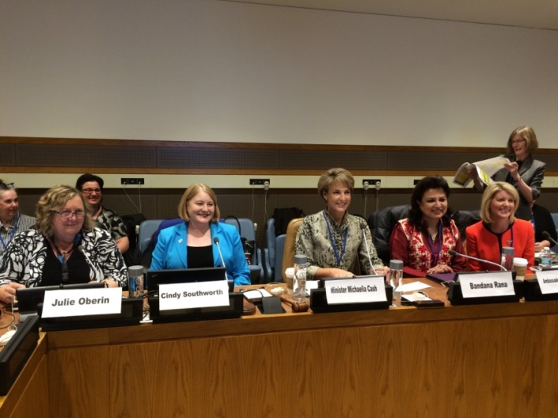
Left to right: Julie Oberin, Cindy Southworth, Minister Michaelia Cash, Bandana Rana, Natasha Stott Despoja.

Together with Our Watch, the Australian Government also co-hosted a side event focused on driving social change to achieve gender equality and eliminate violence against women and girls. The event featured a panel discussion between representatives from Our Watch, the Australian Women Against Violence Alliance (AWAVA), South African based non-government organisation (NGO) Sonke Gender Justice and the Brazilian based Promundo NGO. The event identified both the progress made and challenges remaining in driving social change at the individual, community and government levels.

A recording of the “Where Does Change Come From? Driving Social Transformation to Prevent Violence Against Women” event can be found at http://webtv.un.org/ 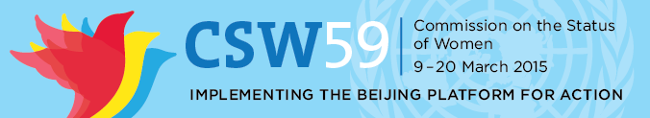

HE FOR SHE
HeForShe is a solidarity movement for gender equality developed by UN Women to engage men and boys as advocates and agents of change for the achievement of gender equality and women’s rights. The campaign encourages them to speak out and take action against inequalities faced by women and girls.

On 3 March 2015, the Prime Minister, the Hon Tony Abbott MP, and the Opposition Leader, the Hon Bill Shorten MP, signed a pledge at an International Women’s Day Parliamentary breakfast in Canberra to “take action against all forms of violence and discrimination faced by women and girls”, and to acknowledge that “gender equality is not only a women’s issue it is a human rights issue that requires my participation”.
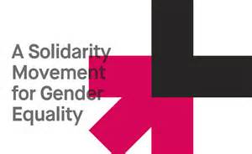

Updates from around the country

Victorian Royal Commission into Family Violence
Australia’s first Royal Commission into Family Violence formally commenced in Victoria on
22 February 2015, and has been tasked with providing practical recommendations to prevent family violence, based on an examination of the current service system and best practice approaches. The Terms of Reference ask the Royal Commission to make recommendations on:
- prevention of family violence
- early intervention to identify and protect those at risk of family violence and prevent the escalation of violence
- support for victims of family violence and measures to address the impacts on victims, particularly women and children
- perpetrator accountability.
Justice Marcia Neave AO has been appointed as Chair of the Royal Commission. Justice Neave will be supported by two Deputy Commissioners, Patricia Faulkner AO and Tony Nicholson. The Royal Commission will deliver its report in February 2016.

2015 Victorian Honour Roll of Women
The Minister for Women, Minister for the Prevention of Family Violence, the Hon Fiona Richardson MP, hosted a celebratory lunch on Wednesday 11 March 2015 to induct 22 outstanding women onto the Victorian Honour Roll of Women. This year’s inductees have contributed to lasting change across science and research, business and industry, prevention of family violence, community services, Aboriginal affairs, health, training and education, and the arts.

Several inductees have been recognised for their dedication to raising awareness and advocating for change to prevent and respond to family violence, including Mrs Wendy Austin, Ms Rosie Batty,
Mrs Delma Clapp, and Ms Maryclare Machen. Since its establishment in 2001, the Victorian Honour Roll of Women has inducted 562 women, who have made a significant difference for women and communities in Victoria, Australia or internationally.

A full list of inductees can be viewed on the Department of Premier and Cabinet website and for further information on the Honour Roll, please contact vhrw@dpc.vic.gov.au.
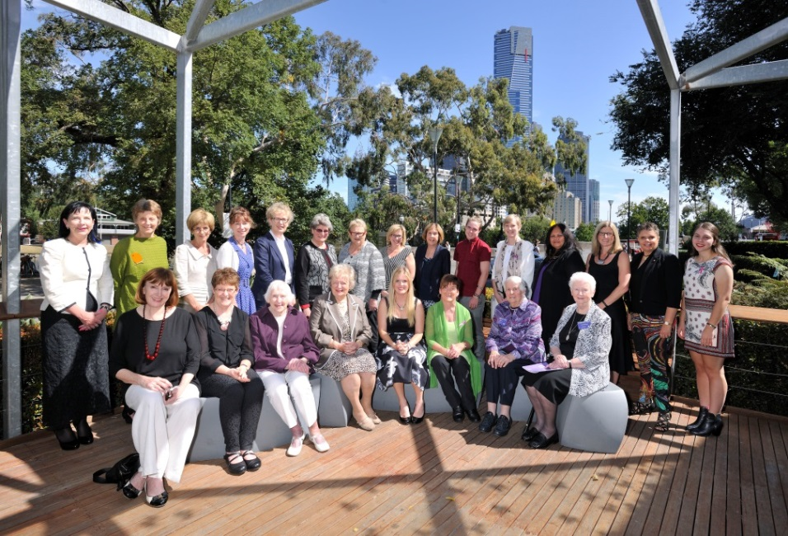
Back row (L-R): Ms Janet Whiting, Ms Maryclare Machen, Ms Barbara Yeoh, Dr Jacqueline Boyle, Professor Christina Mitchell, Dr Olga Kanitsaki AM, Professor Anne Mitchel AO, Ms Rosie Batty, Ms Rosemary Malone, Mr Jackson Williamson (for the Hon Lynne Kosky), the Hon Fiona Richardson, Ms Ngardarb Francine Riches, Ms Caroline Elliott (for Mrs Lorraine Elliott AM), Ms Deborah Cheetham AO, Miss Olivia Kurczycki (for Mrs Louise Kurczycki).

Front row (L-R): Ms Mary Lou Jelbart, Mrs Wendy Austin, Ms Olive Hamilton (for Dr Eva Eden AM), Ms Malvina Malinek OAM, Miss Hana Jackson (for the Hon Lynne Kosky), Ms Karleen Plunkett, Mrs Delma Clapp, Sister Mary Glowrey LCM (for Dr Sr Mary Glowrey).
FYI - those who are standing in for an inductee are their next of kin, as the inductee was nominated posthumously.

International Women’s Day in Tasmania
The Department of Premier and Cabinet (DPAC)'s Communities Sport and Recreation Tasmania (CSRT) supported the Royal Hobart Research Foundation to host the International Women's Day Big Breakfast in Hobart on 11 March 2015.

Tasmania’s first female Governor, Her Excellency Professor the Honourable Kate Warner AM, was the guest speaker. Her Excellency spoke about the importance of education and discussed the gender pay gap.

The Tasmanian Minister for Women, the Hon Jacquie Petrusma MP, also spoke at the event, acknowledging ground breaking Tasmania female politicians; the first female Speaker of the House of Assembly Elise Archer MP, the first female Premier of Tasmania Lara Giddings MP and the first female leader of a party, Senator Christine Milne.

CSRT also partnered with the Clifford Craig Medical Research Trust to host the International Women's Day Luncheon in Launceston on 4 March 2015. The Governor also spoke at this event.

Other International Women’s Day events in Tasmania included:
- The Hobart Women’s Health Centre IWD Quiz Show “Femmes and Facts”, which saw two panels of women attempting to answer the impossible in a Spicks and Specks inspired quiz night
- The Australian Computer Society (Tasmania)’s networking event focusing on women in ICT;
- The University of Tasmania’s International Women’s Day address presented by pioneering journalist Helene Chung
- Devonport City Council’s “Diamonds of Devonport” Dinner to recognise women who quietly contribute to their community
- The launch of the West Coast Women Get Active program in Queenstown
The full calendar of International Women’s Day Events for March 2015 is available.

The Tasmanian Women’s Plan 2013 – 2018 is the Tasmanian Government’s gender equality agenda, with the objective of ‘equality for all women and girls and their full participation in the economic, social, political and community life of Tasmania’.

International Women’s Day 2015 in Queensland
Queenslanders celebrated International Women’s Day 2015 by taking the theme, ‘Make it happen,’ literally – celebrations, breakfasts, talks and activities were held right across the state.

While the theme encouraged women to actively pursue their goals and aspirations, it also provided a strong link for community-based events, with more than 70 events taking place.
In Brisbane, the Department of Communities, Child Safety and Disability Services were once again proud sponsors of the UN Women’s International Women’s Day Breakfast and the Black, Bold and
Beautiful Indigenous Women’s Luncheon. Both of these are popular and important ‘sell-out’ events on the IWD calendar and this year’s turnout was no exception.

The Department of Communities, Child Safety and Disability Services tailored a community awareness campaign in the lead-up to and throughout the IWD week. Central to the campaign was connecting women to the wide range of information and services on the International Women’s Day – Queensland Facebook page and the women’s web portal. 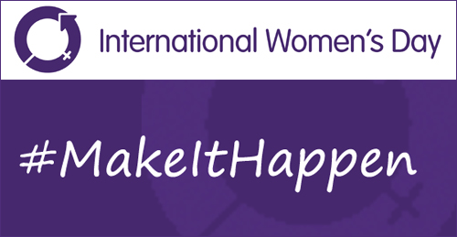

Multi Agency Protection Service (MAPS) in South Australia
An early intervention gateway for the sharing of information about domestic and family violence and child protection matters has been operating since July 2014. Based on a similar model from the United Kingdom, MAPS is led by the South Australia Police.

MAPS is a partnership between the Police and other State Government departments, including correctional services, schools, child protection, health and housing. The statewide program brings agencies together in a unique co-location arrangement.

MAPS streamlines the referral and notification processes of key agencies and enables them to assess, analyse and respond to child protection and domestic violence issues in a more timely and coordinated way. Currently MAPS referrals come from Police only, but when fully implemented the service will extend to include referrals about domestic violence and child protection concerns from all partner agencies. The work of MAPS is complementary to another South Australian initiative, the Family Safety Framework.

South Australian Family Safety Framework
The Family Safety Framework (the Framework) seeks to ensure that services to families most at risk of violence are provided in a structured and systematic way, through agencies sharing information about high risk families and taking responsibility for supporting these families to navigate the service system.

The Framework involves an agreement across government departments, non-government organisations and agencies for a consistent understanding and approach to domestic and family violence that has a focus on women’s and children’s safety and the accountability of perpetrators.

Stakeholders participate in Family Safety Meetings, held fortnightly at the local level focusing on individual high risk cases and common risk assessment, to ensure consistency in the assessment and actioning of high risk cases.

Initially trialled in three policing regions in 2007, the Framework now encompasses all of South Australia. Since November 2013 Family Safety Meetings are held in 19 regions throughout metropolitan and regional South Australia on an ongoing basis.
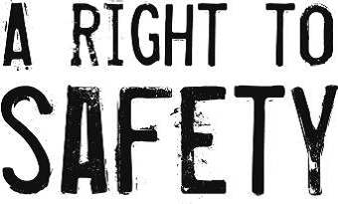

ACT reconfirms commitment to tackling domestic violence
On 17 March 2015, the ACT Legislative Assembly passed a motion by the Attorney-General Simon Corbell MLA that recognised the abhorrence of family and domestic violence, and called on all governments, political parties and the community to work together to put an end to the harm it causes in our society. “Everyone in the community plays a role in addressing this violence
by working towards a culture that is safe, respectful and just for all. We must view acts of domestic and family abuse as intolerable and have a strong and ongoing commitment to ending this violence” Mr Corbell said.

Earlier in the month, Mr Corbell announced an extra $300,000 in funding from the Confiscated Asset Trust Fund for domestic violence prevention, following the death of Tara Costigan. These funds will be used for a number of purposes aimed at addressing domestic and family violence and will go toward women’s safety grants, the Domestic Violence Prevention Council and strengthening data collection on domestic violence crime. Mr Corbell reaffirmed the commitment of the ACT to curb domestic violence “I am proud that our government is changing support services to be more responsive to those most in need in our community.”

Dates for your diary

10-19 April National Youth Week
April Council of Australian Governments (COAG) Meeting

18-19 May Child Aware Approaches Conference

Mid-late 2015 Launch of the National Framework for Prevention of Violence against Women and their Children

18-19 May – Child Aware Approaches Conference
Families Australia and the Commonwealth Government Department of Social Services invite you to the 3rd annual Child Aware Approaches Conference (CAA 2015) in Melbourne from 18-19 May 2015. The focus of the conference is Innovations in early intervention, community collaboration and partnership beyond the child & family welfare sector.

Advancing the goals of the National Framework for Protecting Australia's Children 2009-2020, CAA 2015 will bring together a broad range of practitioners, researchers, and policy-makers interested in developing new strategies and forging new links to develop a deeper understanding of the approaches needed to make the safety and wellbeing of Australia's children a shared community responsibility.

The conference will provide a unique forum in which to advance thinking and innovative practice in five key thematic areas:
- Building stronger partnerships across sectors
- Strengthening families across the life course, including restoration of relationships
- Detection and prevention strategies to prevent harm to children
- Working with community leaders to improve outcomes for Indigenous children
- Working within diverse communities to promote child aware approaches

Have your say!
We would love to hear from you! If you’d like your event included in this newsletter, or have other questions, comments or ideas, please email us.

If you’ve not done so already, please subscribe to receive this e-Newsletter.

Do you need help?
If you or someone you know is experiencing domestic and family violence or sexual assault, get help by calling:
- 000 if you, a child, or another person is in immediate danger
- 1800RESPECT – 1800 737 732
- Relationships Australia – 1300 364 277
- Mensline – 1300 789 978

You can ask for a free interpreter if needed.
National Relay Service
- TTY users - phone 133 677 then ask for the phone number you wish to contact
- Speak and Listen (speech-to-speech relay) users - phone 1300 555 727 then ask for the phone number you wish to contact
- Internet relay users - visit the National Relay Service website and ask for the phone number you wish to contact

