Child Safety Compliance
  - How to complete the online form

Purpose
This task card details the process for Funding Recipients to complete the online Child Safety Compliance form.
If you have any questions regarding the Child Safety Compliance form, please contact the Financial Assurance Centre of Expertise through the relevant inbox:
Agency Name | Inbox
Department of Social Services | childsafetycompliance@dss.gov.au

If you experience technical difficulties with the online form or the Grant Recipient Portal please contact our helpdesk at GRP.Helpdesk@communitygrants.gov.au or on 1800 020 283, ext. 5. If these issues persist, you can submit your form manually by requesting the template emailing. childsafetycompliance@dss.gov.au

Process
You will receive a reminder email 30-days before the child safety compliance milestone due date. The email will include instructions on how to access the online child safety compliance form.
If your Organisation is registered for the Grant Recipient Portal, you will be prompted to access your acquittal form directly from the portal links. If you require assistance to access the Grant Recipient Portal, please visit the Community Grants Hub website here. If you are a registered funding recipient, please start at Step 1.
If your Organisation is not registered for the Grant Recipient Portal, you will be provided with a link and code to access the Child Safety Compliance form. Please note that each grant has a unique link and access code, you cannot complete your form using an old or alternate link. If you are not a registered funding recipient, please start at Step 4.s

Accessing the Child Safety Compliance form - Portal
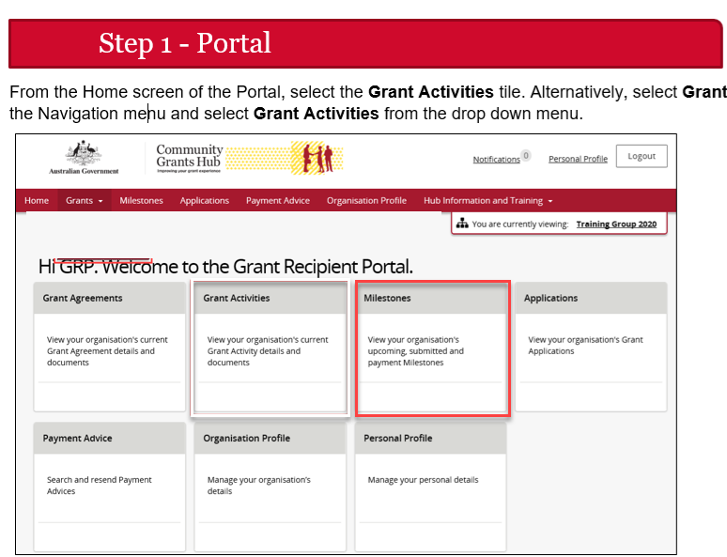

Step 2
The Milestones screen will display. Filter for Upcoming milestones to display open the relevant milestones details.
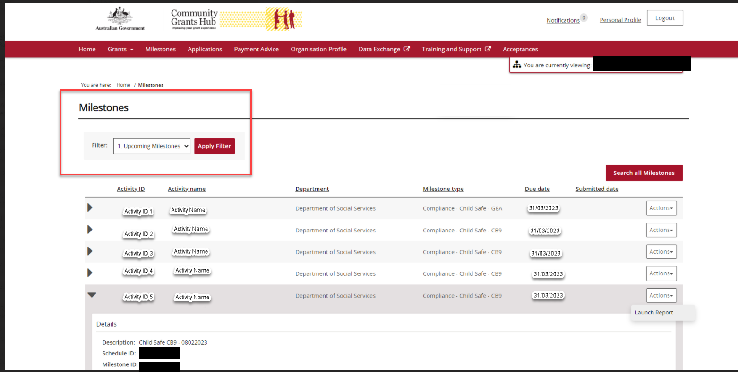
Step 3
When the correct milestone has been identified, select Actions and then Launch Report to open the online report form.
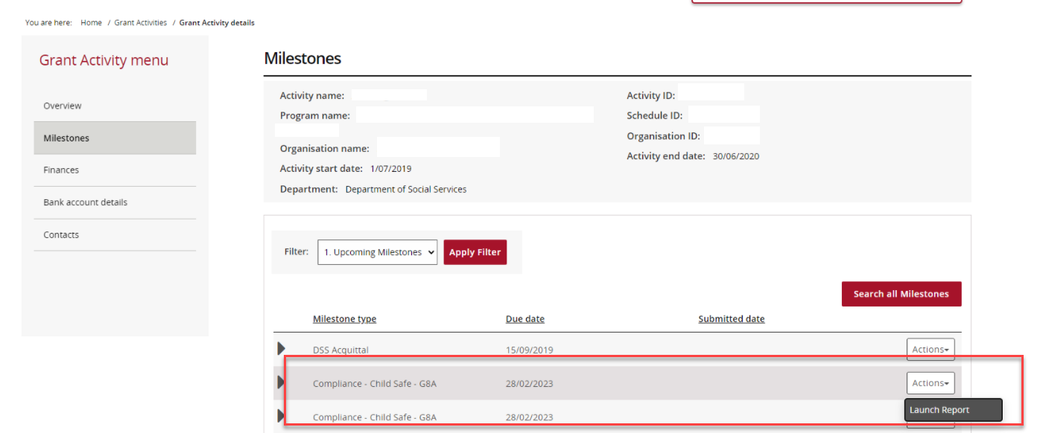

Proceed to Step 9 to complete your online Child Safety Compliance form

Accessing the Child Safety Compliance form – Non-Portal
Step 4 – Non-Portal
30 days before the acquittal due date, you will receive an email with a link and unique access code to complete your Child Safety Compliance form.
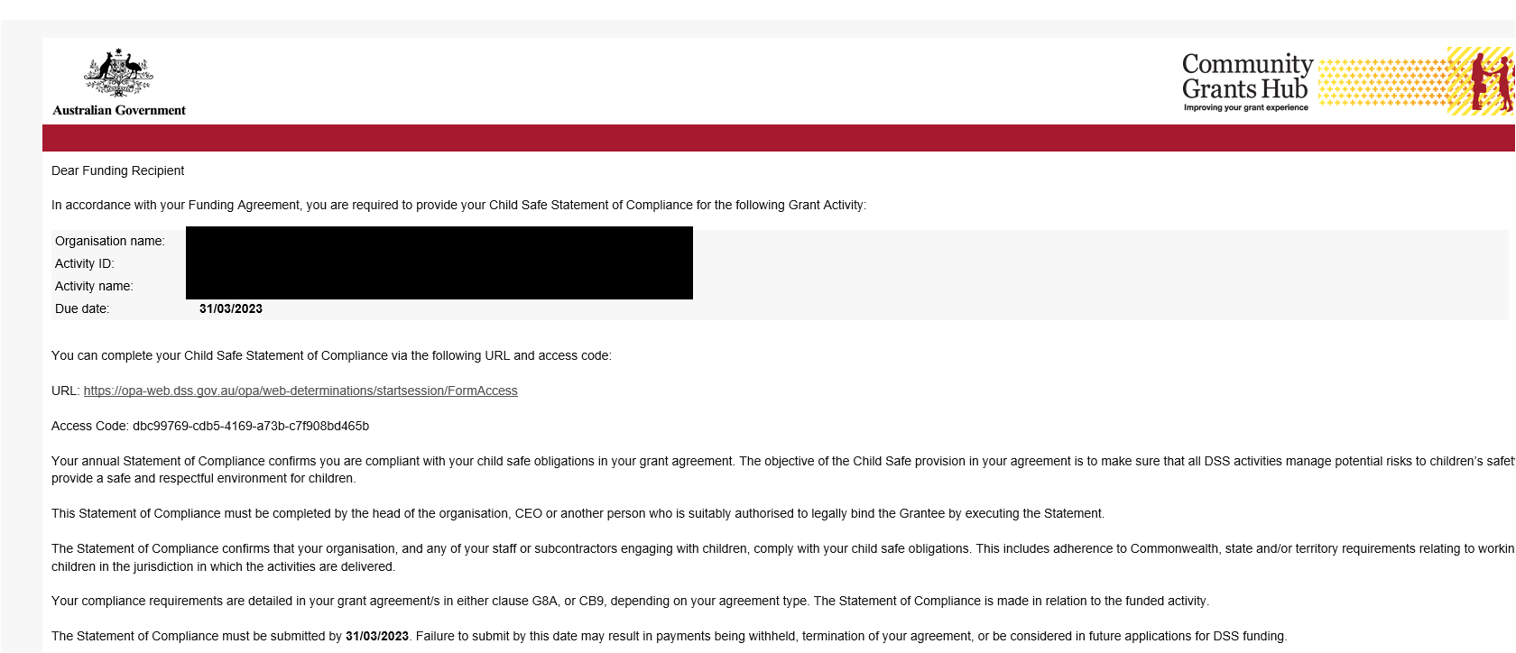

Step 5
Click the URL, or copy and paste into your browser search bar, to open your form. Copy the access code from the email and paste it into the into the Access Code box. Press Next.
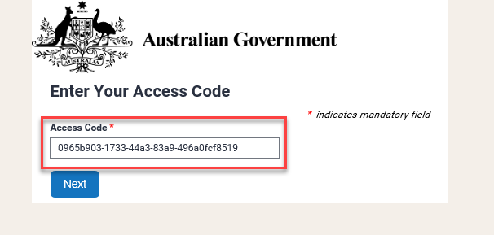

Step 6
Enter in your password and press Next. Please skip to Step 10 if you know your password.
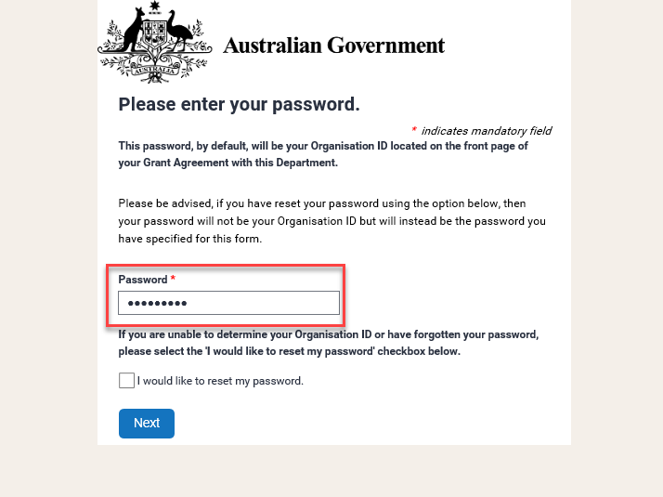
Your password is your Organisation ID and can be found on the front page of your Grant Agreement.
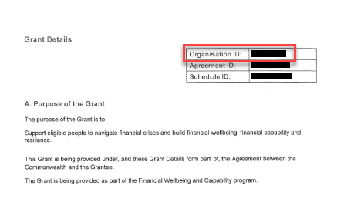
If you do not know your Organisation ID, please check the ‘I would like to reset my password’ checkbox and press Next. Please continue to Step 9.
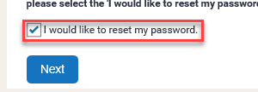

Step 7
This step is only applicable if you have checked the ‘I would like to reset my password’ box.
To reset the password, please:
- Enter in your email address and press Next.
Please note only the email that received the original acquittal email will be able to reset the password.
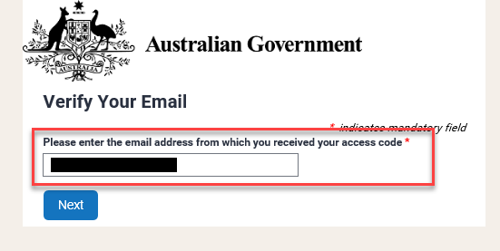
- You will receive an email with a reset token.
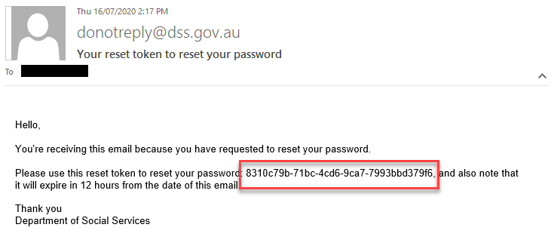
- Copy the reset token and paste it into the Reset Token field. Press Next.
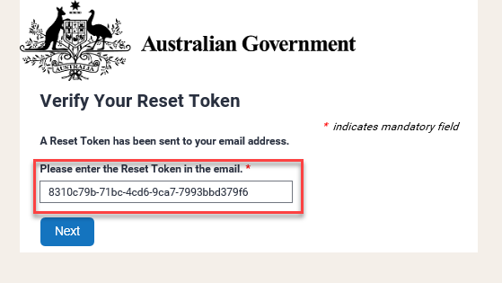
- Set and confirm a new password and press Next.
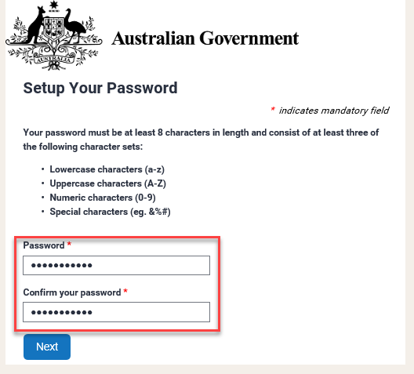
Step 8
When you have entered in your password (or reset your password), you will be directed to the ‘Child Safety Compliance form’ page.
Proceed to Step 9 to complete your online Child Safety Compliance form.

Step 9

The Child Safety Compliance form screen will display and include details about your grant.
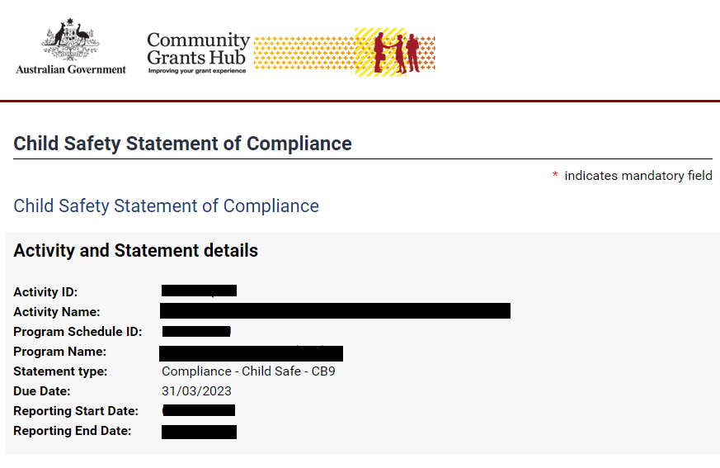
Step 10
Review the Disclaimer and select the checkbox to agree to the Disclaimer. Select Submit.

If your organisation has met all the conditions outlines in the statement, please click the below option.

For some funded activities in 2024 with CB9 Requirements, the following additional question will be applicant for your compliance, please provide a description on how you have implemented the Child Safe clause.
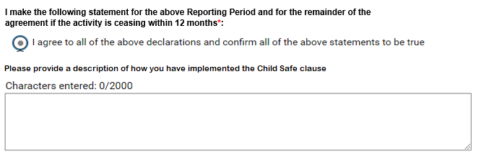

Or, if your organisation has not met all the conditions outlines in the statement, please click the below option, and state the reason.

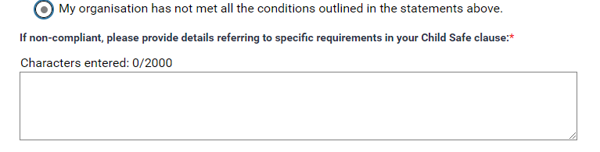
Please note that by completing the checkbox and entering your name and position you are electronically signing the acquittal document, declaring that the information you have provided is accurate and that you are authorised to make this declaration on behalf of the organisation.

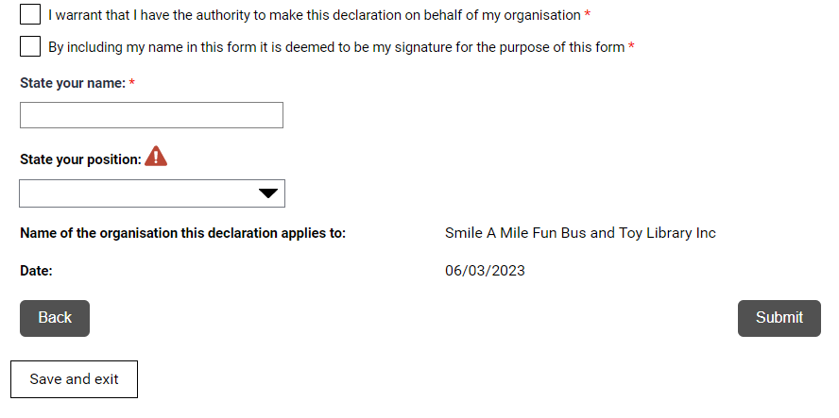

Step 11
A confirmation page will display. Select Save and exit to close the form.
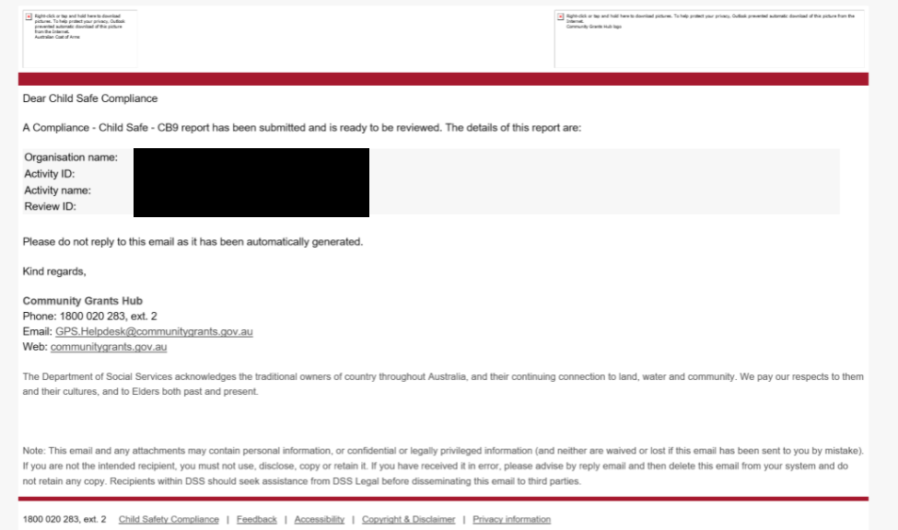

You will also receive an email to confirming the submission of the online Child Safe compliance form.
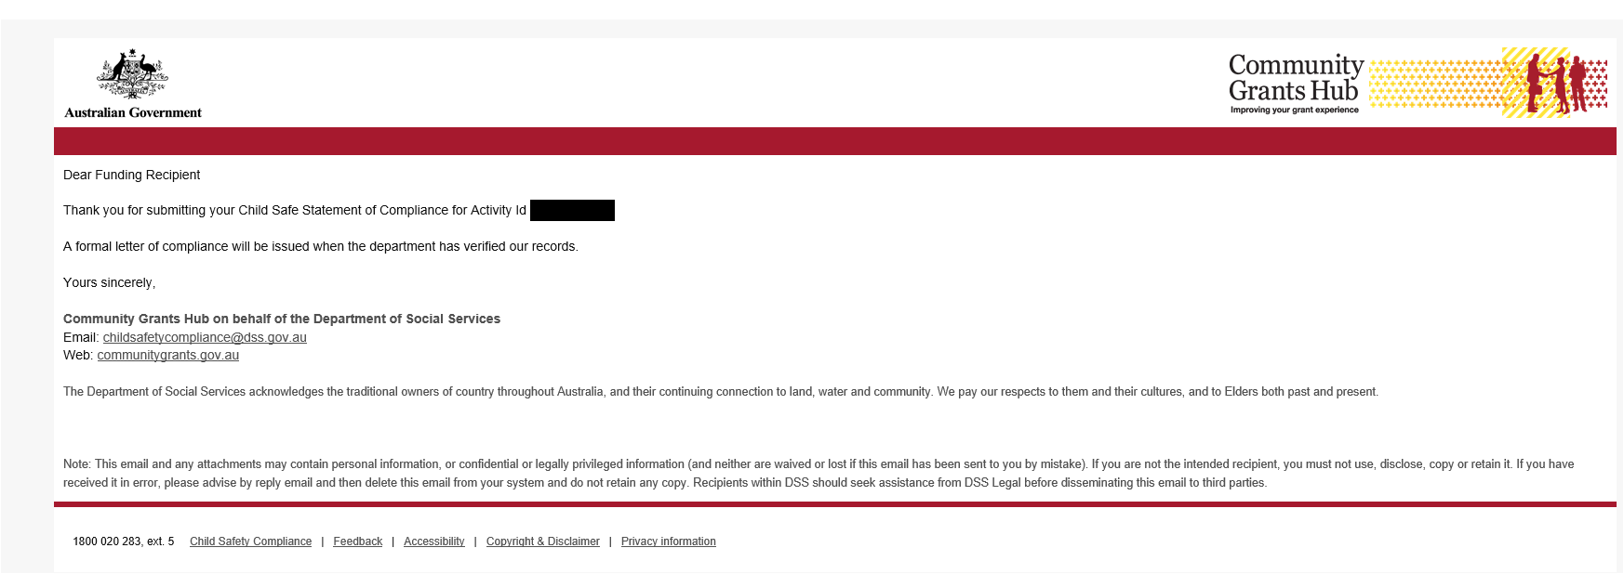

Need further assistance?
If you require any clarification regarding your financial reporting obligations, please contact the Financial Assurance Centre of Expertise via email below:
Agency Name | Financial Acquittal Inbox
Department of Social Services | childsafetycompliance@dss.gov.au
If you require an extension to the due date to meet your financial reporting obligations, please contact your Funding Arrangement Manager.

If you experience technical difficulties with the online form or the Grant Recipient Portal please contact our helpdesk at GRP.Helpdesk@communitygrants.gov.au or on 1800 020 283, ext. 5.

