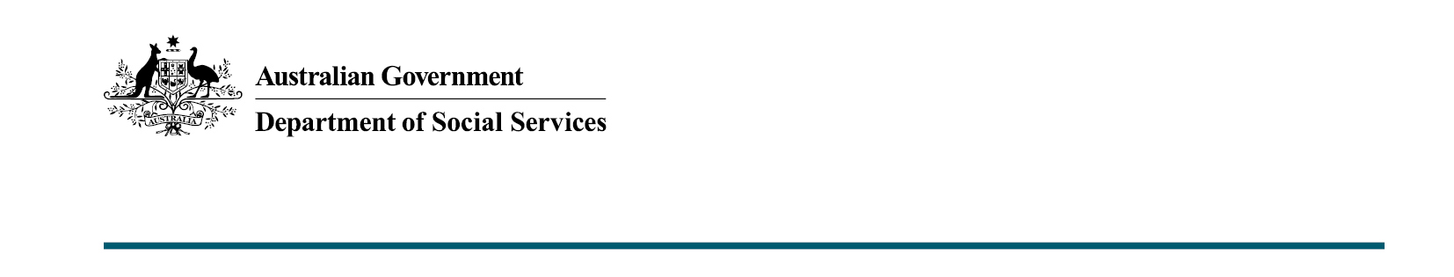

Total estimated cost of delivering enhanced Income Management for the period 4 September 2023 to 3 March 2024 is approximately $30.2 million.

As at 4 March 2024.

