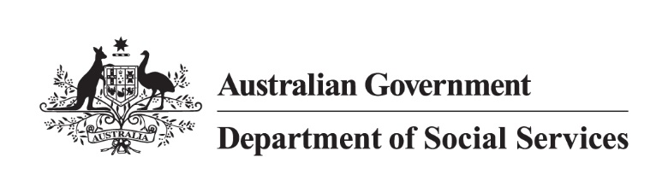

Getting the NDIS Back on Track
Changes to the NDIS Act
The final report of the Independent Review into the National Disability Insurance Scheme (NDIS Review) was released in December 2023. The NDIS Review looked at how the NDIS was designed, how it works, and how to make sure it can continue into the future.
The NDIS Review recommended changes to the NDIS Act 2013 (NDIS Act) to improve how the NDIS works for people with permanent and significant disability.

Legislative changes to the NDIS Act
The Australian Government, with state and territory governments, is taking the first step to reform the NDIS following the NDIS Review.
The Australian Government is introducing changes to the NDIS Act that will enable future improvements to the NDIS. Most of these future improvements will occur through new NDIS Rules
or legislative instruments.
What are the NDIS Rules?
The NDIS Act established the NDIS and how it operates. The NDIS Rules sit under the NDIS Act and provide the detail about how the NDIS operates. States and territories are involved in the approval process for all NDIS Rules. Legislative instruments may be made by the Minister for the NDIS after consulting with affected stakeholders.
The changes to the NDIS Act – also known as the ‘Getting the NDIS Back on Track’ Bill – will:
- enable better early intervention pathways for people living with psychosocial disability and children under 9 years old, meaning the NDIS would work differently for different groups of people, based on their needs
- improve how NDIS participant budgets are set and provide clearer information on how they can be spent
- strengthen the NDIS Quality and Safeguards Commission.
Many of the changes to the NDIS will be implemented through new NDIS Rules. The new NDIS Rules will outline how people can access the NDIS, what assessments are needed, and how budgets will work. These changes will be developed with people with disability, their families and carers and the disability sector.

Accessing the NDIS
When the bill passes, the National Disability Insurance Agency (NDIA), will need to advise new participants if they are entering the NDIS under:
- the disability requirements
- the new early intervention requirements
- both the disability and early intervention requirements.
This decision on how a new participant will enter the NDIS will inform how the participant’s future support needs are assessed. It will also help to ensure a reasonable and necessary budget is set, based on the participant’s needs.
This change is required before other changes to the NDIS Act can be designed. For example, designing a new pathway for participants who access the NDIS through the early intervention requirements.
The real impact of this change will be experienced once the new pathways are designed and implemented. This will take time.
These changes to the NDIS Act also expand the NDIS Rules about accessing the NDIS, including setting out how decisions should be made about the disability and early intervention criteria. This will enable the Australian Government to define key concepts such as ‘substantially reduced functional capacity’ as recommended by the NDIS Review.

How NDIS budgets are set and spent
One of the major changes recommended by the NDIS Review was to set participant budgets at a ‘whole-of-person’ level, rather than for individual support items. These changes to the NDIS Act create a new budget framework for making NDIS plans that include flexible budget and stated supports.
New NDIS Rules will set out what flexible budgets can and cannot be spent on, which will make it easier for participants to understand what NDIS supports their funds can buy. These new NDIS Rules will be developed in consultation with the disability community, including people with disability, their families and carers.
Participants will receive funding based on how they enter the NDIS—that is, whether they access it under disability requirements, the early intervention requirements, or both.
Future changes will set out how the NDIA sets budgets and when supports will be stated (as non-flexible items) in plans.

Strengthening the NDIS Quality and Safeguards Commission
These changes to the NDIS Act will enable the NDIS Quality and Safeguards Commission to administer parts of its compliance and enforcement powers more efficiently.
The NDIS Quality and Safeguards Commissioner will be able to make a rule that means an approved quality auditor does not employ the wrong people.
This change will occur immediately while the Australian Government considers other recommendations from the final reports of the NDIS Review and Disability Royal Commission.

When will these changes happen?
If the bill becomes law, some changes will happen straight away. This includes returning the NDIS to its original intent and strengthening the NDIS Quality and Safeguards Commission.
Other changes will happen later, when new NDIS Rules are made. This includes changes to the early intervention pathways, what assessments are needed, and how budgets will work.

Next steps
These changes to the NDIS Act are an important first step towards future improvements to the NDIS.
When legislation passes, the Australian Government will go through a consultation and co-design process with the disability community on updates to the NDIS Rules—continuing to put people with disability at the heart of NDIS reforms.

Further information
We will hold webinars in April 2024 to provide more information about these proposed changes to the NDIS Act and future changes to the NDIS Rules. These webinars will be promoted on the Department of Social Services website and social media channels.
For more information on the changes to the NDIS Act, visit dss.gov.au/NDISreforms
Subscribe for our updates about coming engagement opportunities at dss.gov.au/disability-and-carers
To contact the Department of Social Services, you can email us at enquiries@dss.gov.au or alternatively call 1300 653 227, Monday to Friday between 8.30am and 5.00pm (AEDT).
If you are Deaf, hard of hearing, or have a speech impairment, you can use the National Relay Service to contact us.
For more information about the NDIS Review, visit ndisreview.gov.au

