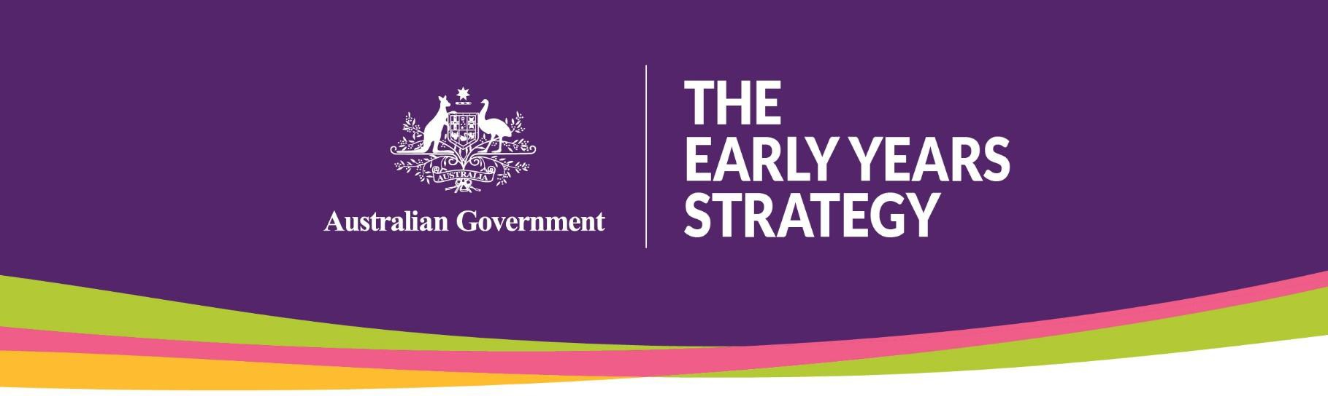

National Early Years Summit Agenda
Friday 17 February 2023

07:30 | Check-in and registration | 30 minutes
08:00 | Networking opportunity | 30 minutes
08:30 | Master of Ceremonies introduction | 5 minutes
08:35 | Welcome to Country  Introduction by the Hon Linda Burney MP, Minister for Indigenous Australians Welcome to Country performed by Paul House | 10 minutes
08:45 | Opening address  The Hon Amanda Rishworth MP, Minister for Social Services  The Hon Dr Anne Aly MP, Minister for Early Childhood Education and Minister for Youth | 20 minutes
09:05 | Video screening | 5 minutes
Session 1: A vision for the early years
9:10 | Q&A Panel: A vision for the early years. What does success look like?  Moderator: Master of Ceremonies – Jan Fran  Panel members:  Professor Fiona Stanley AC - Founding Director and Patron, Telethon Kids Institute  Professor Ngiare Brown - Chair, National Mental Health Commission Advisory Board  Myra Geddes - General Manager - Social Impact, Goodstart Early Learning  Sue Tape - Inclusive Education Project Coordinator, Children and Young People with Disability Australia  Andrew Baechle - General Manager, Community Service Delivery, Settlement Services International  Catherine Liddle - CEO, SNAICC - National Voice for Our Children | 45 minutes
09:55 | Workshop: What does success look like in the early years? | 60 minutes
10:55 | Break | 15 minutes

National Early Years Summit

Session 2: Principles – What is important for children and families?
11:10 | Q&A Panel: How do we ensure children and families are embedded at the centre of policy-making and service delivery?  Moderator: Anne Hollonds, National Children's Commissioner  Panel members:  Georgie Dent - CEO, The Parenthood  Associate Professor Cathrine Neilsen-Hewett - Apiary Fellow; Academic Director of the Early Years, University of Wollongong  Sylvana Mahmic - CEO, Plumtree Children's Services  Jackie Brady - Executive Director, Family & Relationship Services Australia | 60 minutes
12:10 | Workshop: Identifying principles that will guide the Early Years Strategy | 60 minutes
13:10 | Lunch | 30 minutes
Session 3: Priorities - Where to from here?
13:40 | Recap of Discussion: Session 1 and 2 | 45 minutes
14:25 | Q&A Panel: What should the Government prioritise to achieve improved outcomes for children and families in the early years?  Moderator: Professor Sharon Goldfeld, Director, Centre for Community Child Health; Theme Director, Population Health, Murdoch Children's Research Institute  Panel members:  Professor Catherine Chamberlain - Head of the Indigenous Health Equity Unit, University of Melbourne  Dinah Thomasset - Founder and CEO, Villagehood Australia  Leslie Loble AM - Fellow, Centre for Policy Development; Co-chair of the Early Childcare Development Council; Industry Professor, University of Technology Sydney  Jamie Crosby - CEO, Families Australia Samantha Page - CEO, Early Childhood Australia  Jenny Buckland - CEO, Australian Children’s Television Foundation | 60 minutes
15:25 | Break | 15 minutes
15:40 | Workshop: Identifying priorities for supporting children in the early years | 60 minutes
16:40 | Recap of Discussion: Session 3 | 30 minutes
17:10 | Reflections | 20 minutes
17:30 | Close

National Early Years Summit

