National Disability Abuse and Neglect Hotline data
Period: 01 January 2021 – 30 June 2021
The Hotline is a nationally accessible service designed to aid reporting of abuse and neglect of people with disability in Commonwealth, State and Territory funded disability services, and to refer the reports appropriately. The Hotline is not a complaints resolution service or an individual advocacy service. It works with callers to find appropriate ways of dealing with reports of abuse or neglect through a process of referral, including providing information and support, but also direct referrals to the complaints handling mechanisms relevant to the appropriate state and territory, as well as other complaints handling bodies such as the various Ombudsman, Anti-Discrimination Boards and the Complaints Resolution and Referral Service (CRRS).
Data from the Hotline from January 2021 – 30 June 2021 is provided below.
Table 1: Hotline Clients by Age
Count of Case Numbers
Age as reported | 2021– Cases by Month
 | Jan | Feb | Mar | Apr | May | Jun
16 to 19 | 4 | 4 | 5 | 4 | 2 | 2
20 to 24 | 3 | 3 | 5 | 3 | 1 | 0
25 to 40 | 10 | 8 | 5 | 2 | 4 | 3
41 to 54 | 3 | 2 | 3 | 2 | 2 | 3
Less than 16 | 1 | 0 | 4 | 0 | 0 | 1
Over 54 | 6 | 9 | 10 | 8 | 3 | 2
Not provided | 13 | 26 | 29 | 27 | 14 | 23
Grand Total | 40 | 52 | 61 | 46 | 26 | 34

Table 2: Hotline reports by Gender

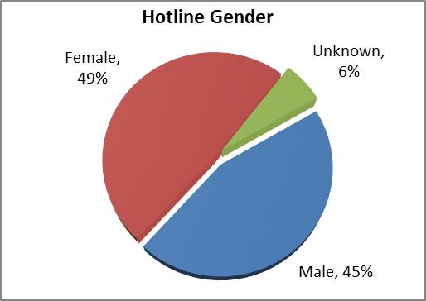
Table 3: Disability Type as reported*
Disability Type as reported | Jan 21 | Feb 21 | Mar 21 | Apr 21 | May 21 | Jun 21 | Total
ABI | 2 | 2 | 5 | 2 | 0 | 0 | 11
Autism | 5 | 6 | 5 | 7 | 6 | 3 | 32
Hearing Disability | 1 | 2 | 1 | 1 | 0 | 1 | 6
Intellectual Disability | 10 | 5 | 11 | 4 | 2 | 7 | 39
Learning Disability | 0 | 1 | 1 | 0 | 1 | 0 | 3
Neurological Disability | 1 | 7 | 5 | 2 | 5 | 0 | 20
Physical Disability | 9 | 13 | 7 | 5 | 3 | 5 | 42
Psychiatric Disability | 8 | 7 | 8 | 10 | 2 | 5 | 40
Speech | 5 | 3 | 0 | 0 | 0 | 0 | 8
Not provided | 18 | 19 | 15 | 17 | 19 | 25 | 113
Vision Impairment | 1 | 2 | 0 | 1 | 0 | 0 | 4
Total | 60 | 67 | 58 | 49 | 38 | 46 | 318
*N.B. people may report more than one disability
Table 4: Number of Hotline reports by month
Month | Reports
Jan 21 | 40
Feb 21 | 52
Mar 21 | 61
Apr 21 | 46
May 21 | 26
Jun 21 | 34
Total | 259
Table 5: Timeliness of closure
Time period | Total
Less than 30 days | 99.7%
90 days or less | 0.3%
Greater than 90 days | 0.0%
Total | 100%

Type of Abuse and Neglect | Jan 21 | Feb 21 | Mar 21 | Apr 21 | May 21 | June 21 | Total
Physical Neglect | 13 | 14 | 24 | 12 | 5 | 13 | 81
Passive Neglect | 2 | 9 | 13 | 7 | 2 | 6 | 39
Emotional Neglect | 8 | 14 | 21 | 15 | 13 | 18 | 89
Wilful Neglect | 7 | 8 | 12 | 11 | 2 | 4 | 44
Constrain Abuse | 2 | 5 | 5 | 5 | 2 | 2 | 21
Financial Abuse | 12 | 13 | 15 | 18 | 8 | 9 | 75
Physical Abuse | 13 | 16 | 15 | 17 | 7 | 16 | 84
Psychological Abuse | 18 | 20 | 24 | 20 | 12 | 16 | 110
Sexual Abuse | 0 | 5 | 1 | 2 | 3 | 2 | 13
Systematic Abuse | 5 | 5 | 5 | 5 | 4 | 1 | 25
Total | 80 | 109 | 135 | 112 | 58 | 87 | 581
Table 6: Reported types of alleged Abuse and Neglect*
*N.B. reports may include more than one type of abuse and/or neglect.

