National Disability Abuse and Neglect Hotline data
Period: January 2020 to June 2020
The Hotline is a nationally accessible service designed to aid reporting of abuse and neglect of people with disability in Commonwealth, State and Territory funded disability services, and to refer the reports appropriately. The Hotline is not a complaints resolution service or an individual advocacy service. It works with callers to find appropriate ways of dealing with reports of abuse or neglect through a process of referral, including providing information and support, but also direct referrals to the complaints handling mechanisms relevant to the appropriate state and territory, as well as other complaints handling bodies such as the various Ombudsman, Anti-Discrimination Boards and the Complaints Resolution and Referral Service (CRRS).
Data from the Hotline from January 2020 to June 2020 is provided below.
Table 1: Hotline Clients by Age
Count of Case Numbers
Age as reported | Jan - Jun 2020 – Cases by Month
 | Jan 20 | Feb 20 | Mar 20 | Apr 20 | May 20 | Jun 20
16 to 19 | 1 | 1 | 3 | 5 | 3 | 2
20 to 24 | 5 | 2 | 1 | 3 | 6 | 5
25 to 40 | 6 | 1 | 3 | 4 | 4 | 10
41 to 54 | 6 | 7 | 3 | 7 | 10 | 9
Less than 16 | 0 | 1 | 0 | 0 | 2 | 0
Over 54 | 9 | 4 | 4 | 22 | 7 | 10
Not provided | 14 | 22 | 18 | 10 | 23 | 18
Grand Total | 41 | 38 | 32 | 51 | 55 | 54
Table 2: Hotline reports by Gender

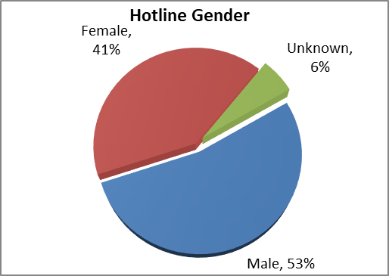
Table 3: Disability Type as reported*
Disability Type as reported | Jan 20 | Feb 20 | Mar 20 | Apr 20 | May 20 | Jun 20 | Total
ABI | 5 | 3 | 1 | 5 | 7 | 3 | 24
Autism | 1 | 2 | 3 | 3 | 1 | 1 | 11
Hearing Disability | 1 | 0 | 0 | 0 | 1 | 1 | 3
Intellectual Disability | 6 | 7 | 6 | 11 | 7 | 13 | 50
Learning Disability | 1 | 1 | 1 | 1 | 1 | 3 | 8
Neurological Disability | 4 | 2 | 2 | 1 | 5 | 2 | 16
Physical Disability | 11 | 7 | 8 | 11 | 19 | 19 | 75
Psychiatric Disability | 9 | 8 | 3 | 7 | 11 | 13 | 51
Speech | 1 | 0 | 3 | 3 | 1 | 0 | 8
Not provided | 14 | 13 | 15 | 13 | 32 | 25 | 112
Vision Impairment | 0 | 0 | 0 | 1 | 0 | 0 | 1
Total | 53 | 43 | 42 | 56 | 85 | 80 | 359
*N.B. people may report more than one disability
Table 4: Number of Hotline reports by month
Month | Reports
Jan 2020 | 41
Feb 2020 | 38
Mar 2020 | 32
Apr 2020 | 51
May 2020 | 55
Jun 2020 | 54
Total | 271
Table 5: Timeliness of closure
Time period | Total
Less than 30 days | 98.6%
90 days or less | 0.8%
Greater than 90 days | 0.6%
Total | 100%

Type of Abuse and Neglect | Jan 20 | Feb 20 | Mar 20 | Apr 20 | May 20 | Jun 20 | Total
Physical Neglect | 9 | 12 | 3 | 20 | 17 | 12 | 73
Passive Neglect | 2 | 1 | 0 | 1 | 2 | 1 | 7
Emotional Neglect | 10 | 5 | 4 | 9 | 21 | 11 | 60
Wilful Neglect | 9 | 3 | 1 | 5 | 1 | 5 | 24
Constrain Abuse | 1 | 0 | 0 | 6 | 1 | 1 | 9
Financial Abuse | 11 | 8 | 3 | 6 | 18 | 12 | 58
Physical Abuse | 16 | 9 | 8 | 11 | 15 | 20 | 79
Psychological Abuse | 14 | 11 | 11 | 19 | 25 | 24 | 104
Sexual Abuse | 1 | 1 | 1 | 2 | 2 | 3 | 10
Systematic Abuse | 6 | 3 | 4 | 8 | 8 | 10 | 39
Total | 79 | 53 | 35 | 87 | 110 | 99 | 463
Table 6: Reported types of alleged Abuse and Neglect*
*N.B. reports may include more than one type of abuse and/or neglect.

