Interim Report on long-term options for dispute resolution under the
National Disability Insurance Scheme

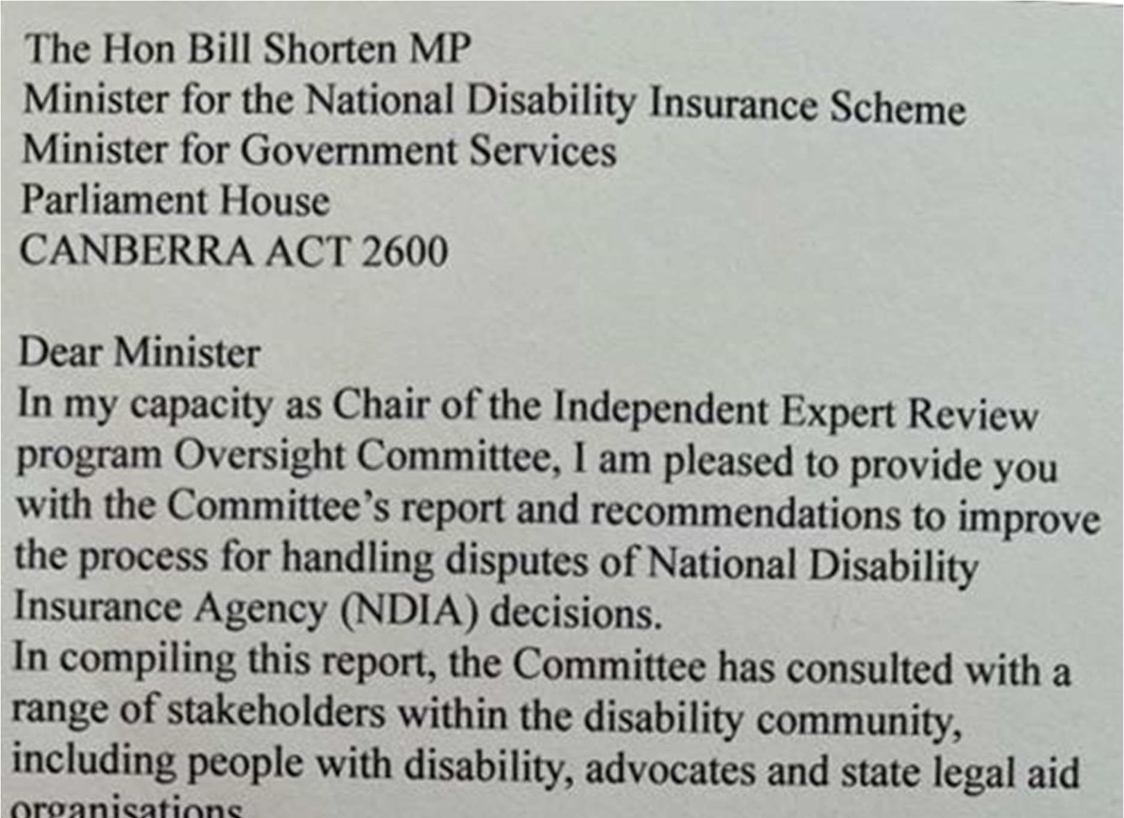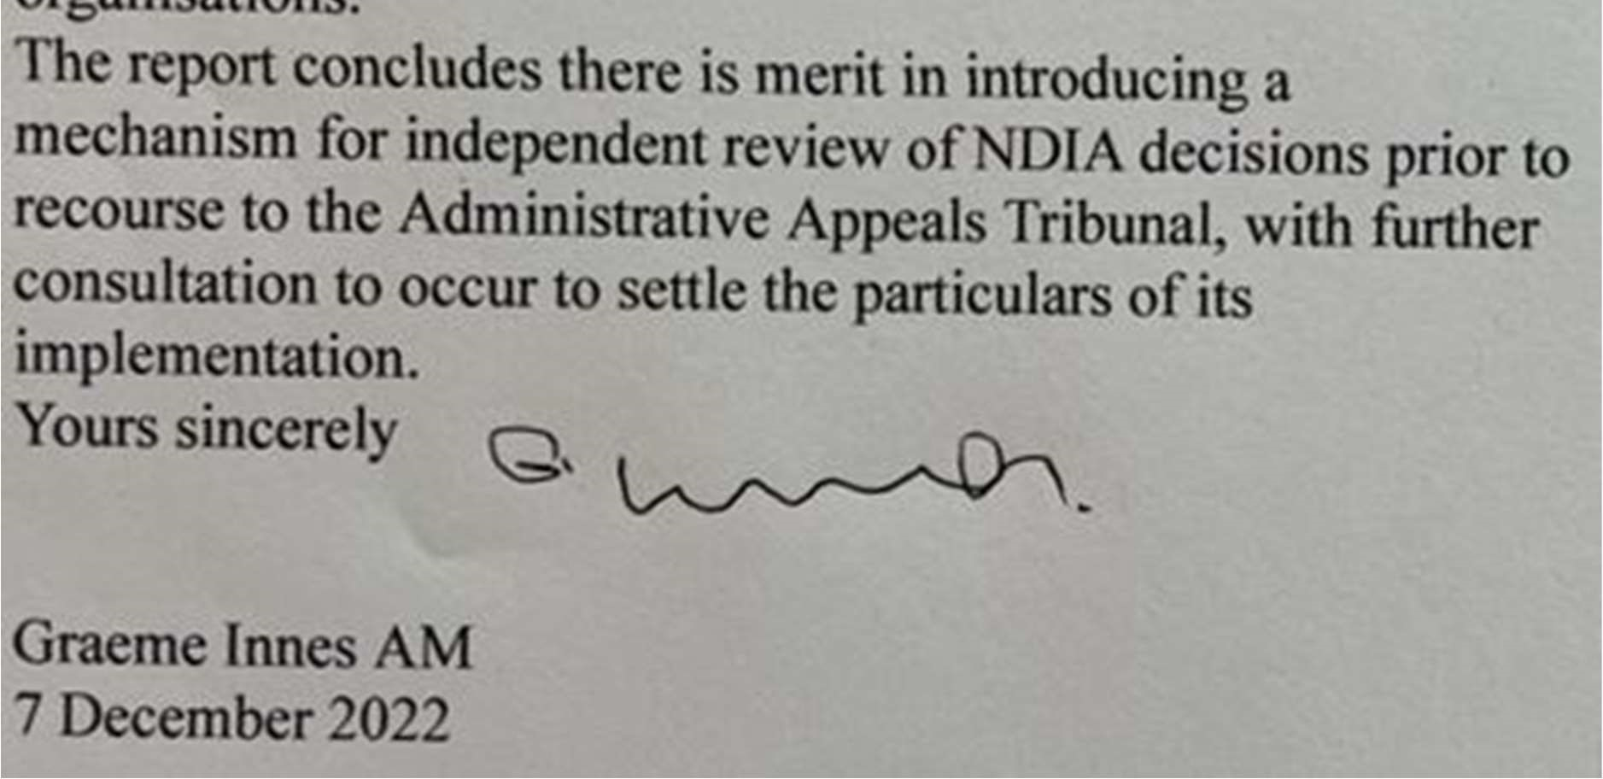

Executive Summary

“The adversarial process presents a battlefield that is unproductive”

The National Disability Insurance Scheme Act 2013 (the NDIS Act) was enacted to deliver the National Disability Insurance Scheme (NDIS; the scheme) – a world first approach to the provision of disability support that puts people with disability at the centre of decision-making through the principles of reasonable and necessary supports and individual choice and control.
On 1 July 2023 the NDIS will celebrate its tenth birthday, a landmark moment in the history of the scheme. However, the scheme, and the National Disability Insurance Agency (NDIA; the agency) as an entity, is not mature. Its establishment and rollout was highly ambitious, experiencing rapid growth as the agency moved from administering a number of small trials involving approximately 30,000 participants at 30 June 2016, to grow the scheme by an average of 100,000 per year between 2017-18 and 2019-20. The scheme continues to observe around 70,000 additional participants per annum, and is currently supporting more than 550,000 Australians with disability. Of these, over 330,000 or 60 per cent of participants are receiving supports for the very first time.
This speed of growth has created significant challenges for the NDIA in scaling its workforce and decision-making capability. These challenges have been particularly reflected in the administration of reviews, with a large spike in the number of internal reviews and Administrative Appeals Tribunal (AAT) reviews in recent years. At their highest, AAT case numbers were in the order of 4,500.
While some steps have been taken by the NDIA to improve decision-making and address delays in resolving disputes, more can and should be done to ensure that the review process is working efficiently and effectively. It will be a continuing challenge for the agency to ensure its own decision-making at the initial and internal review stages incorporate processes that meaningfully involves participants and that its workforce provides detailed reasons for decisions.
There is merit in introducing a tier of independent review of NDIA decisions following the NDIA conducting an internal review but prior to a review proceeding to the AAT. This would promote a positive participant experience and provide an efficient and effective pathway to reduce the number of matters that progress to the AAT. Such a process should be built upon five principles: independent, informal, timely, inquisitorial and accessible.
Any new model of independent review, or any change to existing review processes, should also be co-designed with, and led by, people with disability with lived experience of the NDIS. It should also be accompanied with an appropriate investment in case management within the NDIA, provision of independent advocacy and legal support and initiatives to promote supported decision-making.
The reasons for decisions should also be published as a way to level the playing field between people with disability and decision-makers (and reviewers). Appropriately deidentified, and with the consent of the person with disability, this would provide the community with greater clarity over the basis for decision-making, promote quality and consistency of decision-making and reduce unnecessary requests for reviews.
The NDIS Act would need to be amended to give effect to such a model. In keeping with the Government’s commitment to co-design, additional consultation should occur to refine the detailed operating parameters. Subject to timing, progressing the required legislative changes may best occur in conjunction with relevant recommendations arising in the parallel review of NDIS design, operations and sustainability, which is due to report to Government in October 2023.

Recommendations
- The Australian Government implement a new tier of independent review prior to a matter escalating to the Administrative Appeals Tribunal (AAT).
- In keeping with a commitment to co-design, that further consultation occur in early 2023 to refine the mechanics of the new tier of independent review.
- The new tier of independent review, or any other change to the review pathway under the NDIS, be guided by five principles: independent, informal, timely, inquisitorial and accessible.
- The NDIA continue to give priority to initiatives to:
  - improve the transparency, timeliness and consistency of decision-making
  - support the active involvement of participants in decision-making
  - improve participant understanding of decisions by including clear reasons for decisions and reference to the evidence on which those decisions were based.
- The Government publish deidentified summaries of decisions and reasons for decisions, for the Independent Expert Review Program and where AAT cases are resolved without advancing to a formal hearing.
- The Government ensures there is appropriate resourcing for Commonwealth funded advocacy and legal aid programs, to support people with disability to effectively navigate any newly introduced independent review process.
Table of Contents
Executive Summary 3
Recommendations 5
Chapter 1: Introduction 7
Consultation activities 8
Scope 9
Chapter 2: Background and Context 11
Improving the participant experience 11
Current demand for external review 12
Other considerations 14
Chapter 3: Existing review and appeal pathway 16
The NDIS review and appeals process 16
Role and function of the AAT’s NDIS Division 17
Existing initiatives to improve the participant experience 17
Chapter 4: A participant-focused approach to reform 19
Guiding Principles 20
Pain points 22
Key features of a new model 24
Publishing of outcomes 28
Chapter 5: Comparable models of dispute resolution 29
Model 1: An independent statutory tribunal 29
Model 2: An expanded role of the AAT 32
Chapter 6: The way forward 34

Chapter 1: Introduction

In October 2022, the NDIA established the Independent Expert Review (IER) program to contribute to quickly, fairly and easily resolve existing reviews before the AAT.

The IER operates as a form of dispute resolution for matters where proceedings have been brought in the AAT for review of an access or planning decision. It aims to provide better and earlier outcomes for NDIS participants by obtaining a non-binding recommendation on the matter from an Independent Expert, funded by the NDIA, which is implemented by the parties should they agree. These experts may be current or former judicial officers, experienced Alternative Dispute Resolution (ADR), NDIS or legal practitioners and people with a disability.

The IER seeks to deliver the following advantages over current arrangements:
- Maintain the relationships between the participant and agency.
- Resolve the dispute faster than current AAT arrangements.
- Provide an opportunity for participants to be heard outside AAT processes, reducing stress and anxiety.
- Provide a circuit-breaker in disputes that are not progressing to resolution through AAT conciliation processes.
- Reduce the legal costs the agency incurs in AAT matters.
- Demonstrate the agency’s commitment to meet its Model Litigant Obligations by seeking early resolution and avoiding contested AAT matters where possible.
- Encourage the resolution of disputes in a framework that is not overly legalistic nor adversarial in its approach.

The IER is being rolled out in three phases. The first phase began in October 2022 with a sample of around 30 cases and the appointment of 3 independent expert reviewers. As at 5 December 2022:
- 4 cases have been resolved in full, with the independent expert’s recommendations accepted by the participant and the NDIA.
- 13 recommendations have been made by the expert reviewers, under consideration by the parties.
- 17 cases have been referred to expert reviewers for consideration.
- 5 cases are in the pipeline for referral.

The second phase is due to commence in December 2022, with a further 220 referrals and the appointment of 12 additional expert reviewers. The third phase will involve a rapid scale up commencing in March 2023, growing to over 1,000 participants involved in the program by 30 June 2023.

The Oversight Committee (OC) was established to monitor the implementation and outcomes of the IER program in real time to ensure:
- expert reviews are conducted independently of the Agency
- perspectives of people with disability and the disability sector are embedded in the expert review process
- transparency on progress of the IER program.

The OC is also responsible for the appointment of the independent experts and is working closely with the NDIA to develop evaluation and prioritisation frameworks to support the scale up of the program into Phase 2 and 3.

The Minister for the NDIS, the Hon Bill Shorten MP, also requested the OC provide advice to Disability Reform Ministers (DRM) on potential broader changes to the resolution of disputes arising from agency decisions. This advice was requested by 7 December 2022, for discussion at their next meeting of 13 December 2022. This report outlines the OC’s considerations and findings in response to the Minister’s request.

Consultation activities

The OC facilitated consultation to assist in the development of this report. The objectives of consultation were to understand:
- what people with disability, advocacy bodies and state legal aid organisations see as the challenges and opportunities for reform
- what the disability community consider would provide a quicker and fairer experience for people disputing NDIA decisions
- what issues require further engagement with the disability community and how further engagement should occur.

The approaches outlined in this report were tested with a small advisory group of representatives from the advocacy and legal aid sector. In addition, an online consultation was held on 21 November 2022. In total, just over 130 people participated in the online consultation, with a strong presence of advocates (46 per cent). Written submissions were also invited to be made by 25 November 2022. The OC received three submissions.
Across all engagement platforms, responses were materially consistent, with many expressing frustration and dissatisfaction about the process for asking for an internal review or AAT review of an NDIA decision. Existing processes were framed as “broken”, with the administrative burden of pursing reviews arduous and traumatising for people with disability. This is consistent with the intent of the requested advice, which sought to understand what initiatives could lead to improvements in the handling of reviews.
The short timelines for the preparation of this report constrained the ability to undertake broader public consultation (including with current NDIS participants and people with disability). Consultations would have been enhanced by a greater attendance and diversity of participants including, but not limited to, people with disability, people from First Nations, Aboriginal and Torres Strait Islander and culturally diverse backgrounds, and representatives of children and young people.
The OC strongly recommends that future consultations engage in meaningful ways with the disability community, in order to determine the nature and priority of any reform to the review pathway. That said, there have been some strong themes that have emerged from the consultations to date and these are detailed in this report.
There has also been insufficient time to consider the early outcomes of the IER program, which will yield relevant considerations for any long-term model. To this extent, this report should be regarded as an interim report, with a further report to follow in the first half of 2023 once further appropriate and accessible consultation and evaluation of the IER program has been undertaken.
Scope
The OC notes the majority opinion of those consulted in the preparation of this report considered introducing a tier of independent review prior to the AAT would likely be advantageous. However, improving the participant experience also necessitates improving the NDIA’s current approaches to original decision-making, including in the giving of clear and accessible reasons for its decisions.
This report does not make comment on the adequacy, or effectiveness, of other initiatives being pursued by the NDIA or Government to achieve consistency and equity in access and planning decisions. Rather, the OC acknowledges these are being delivered through other co-design processes with the disability community and sector and are subject to their own separate consideration by Government.
Accordingly this report focuses only on the handling of disputes, once a request for review is made. However, the report does seek to complement existing initiatives to reduce the flow of new disputes, where possible.

Chapter 2: Background and Context

Improving the participant experience

The IER is a key part of the Government’s commitment to reducing the current AAT caseload. It is designed to improve the experience of people with disability at the external review phase, and to deliver an ADR process that is not overly legalistic or adversarial. It is in this spirit of the Government’s commitment that the OC was asked to provide advice on options for a long-term, structural solution to dispute resolution under the NDIS.

It is well-known that seeking review of NDIA decisions in the AAT has been a significant pain point for many people with disability and those that support them. They are being required to engage in a legal process to argue for the supports they need to fully participate in the community, without those supports, with the process amplifying the stressors in their lives.

“Families are completely traumatized and burnt out from fighting for basic needs for their loved ones. Please consider the trauma that this system is creating.”

Further, people with disability have not always been kept at the centre of decision-making under the NDIS, including when seeking review of a NDIA decision. The OC understands at least some participants may not feel they have been heard in the assessment of their needs, or might not understand why decisions have been made, and so seek AAT review of the decision as a way to be heard or better understand why decisions have been made. Indeed, there is an urgent need to improve the effectiveness and design of how decisions are reviewed, and what options people with disability feel are available to them.

Providing an exemplary and accessible merits review pathway is critical to enhancing justice and promoting public trust and confidence in the NDIS. Such a pathway should focus on the needs and experiences of NDIS participants, keeping them at the centre, with the AAT seen as the last resort for resolution, not the first and only opportunity. The NDIA also needs to continue enhancing its internal processes and improving its decision-making, ensuring participants feel heard, understood and their perspectives valued in every interaction.

Nevertheless, it is vital that where a person disagrees with a NDIA decision, that they have access to an effective, efficient and transparent external review mechanism. This is critical to realising the right to seek independent review of government decision-making. However, the question is how can we ensure the external review system delivers on these promises? This report has been prepared with this question in mind.

Current demand for external review

Historically, AAT cases as a proportion of total participants remained low throughout the trial and transition phases. While the raw number of AAT lodgements increased, this was consistent with the rate of participant transition as the NDIS rolled out across Australia. It has also been relatively low as a percentage of the number of participants in the scheme, maintaining at between 0.43 and 0.45% since 2017-18 (to 30 June 2021).
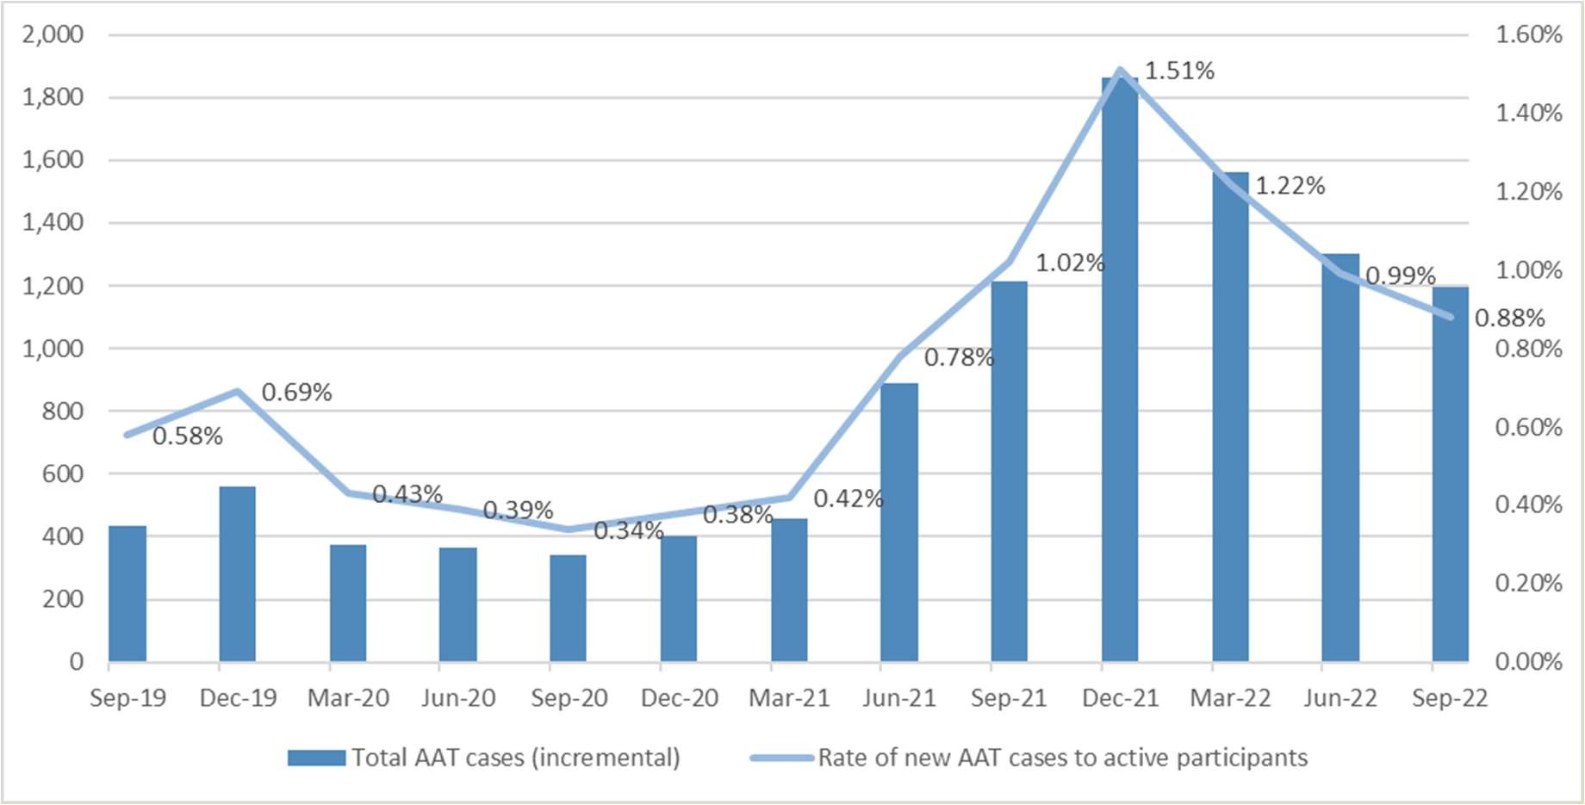

FIGURE 1: NUMBER OF AAT CASES AS A PROPORTION OF ACCESS REQUESTS

However, in the first half of the 2021-22 financial year, the number of AAT cases rose sharply relative to the proportion of active participants. This was the partly the result of an increase in requests for internal review of NDIA decisions, amidst wide scale media reports that the NDIA may have been arbitrarily cutting plan funding and pursuing operational changes to slow growth in participant numbers and spend per participant. During this time, applications to the AAT relating to changes to participant plans increased by just under 200 per cent, and overall, the number of applications on hand in the AAT increased by more than 250 per cent, from just over 1,600 cases at 30 June 2021 to more than 4,000 at
30 June 2022. At their highest, AAT case numbers on-hand were in the order of 4,500.

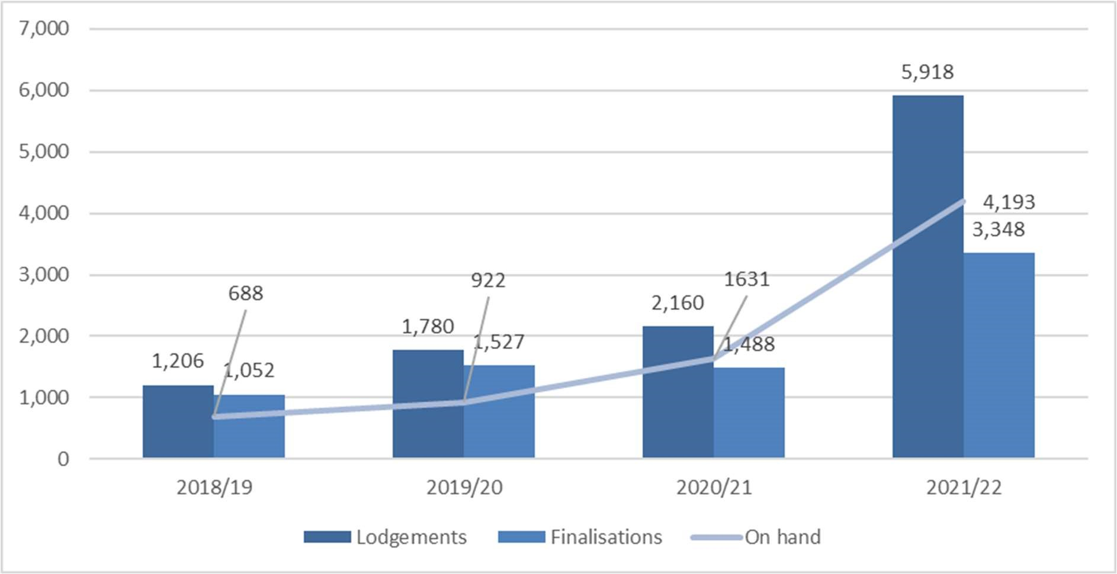

FIGURE 2: AAT APPLICATIONS LODGED, FINALISED AND ON HAND

Recent efforts by the NDIA to improve internal review decisions have seen around a 26 per cent reduction in new applications to the AAT in the three months to August 2022, compared to the prior three month period (March to May 2022). This is a positive sign. In addition, as at 30 November 2022, the NDIA’s efforts to resolve existing AAT appeals has contributed to the closure of over 2,534 cases, with 2,507 (98.9 per cent) of these resolved without a substantive hearing.

Notwithstanding these improvements, the number of new of applications to the AAT continues to be high, meaning the overall AAT caseload has only reduced by around 600 cases from its peak, or 3,825 active AAT cases at 30 November 2022. The IER is designed to complement the NDIA’s existing initiatives to reduce the pressure on the AAT, however it is too early in its implementation to gauge its effectiveness. The IER will be subject to a separate evaluation framework, commencing in early 2023.

Other considerations
It is important to align merits-review approaches across Government, but it must be recognised that the decisions made under the NDIS are unique when compared to other Commonwealth programs or schemes of entitlement. No other system has a framework of decision-making that is so individualised and complex, nor is guided by a statutory principle of “choice and control” in the provision of funded supports. This lends weight to having a bespoke model of merits-review for the NDIS.

The NDIS’ style of decision-making is inherently vulnerable to a misunderstanding between what the person is requesting and believes falls within the scheme, and what the delegates under the NDIS Act consider is the scheme’s responsibility to provide. This reinforces the need to clarify what the scheme can and will fund so that participants can better focus their exercise of choice and control within the agreed boundaries of the scheme. This will also ensure original decisions are transparent and responsive to the individual’s circumstances, and should be supported by legislation, as appropriate.
Indeed, the design of a long-term approach for merits review should be dictated by the complexity of decision-making under the NDIS and the proportionate impact on people with disability. The system needs to be as sophisticated as the decisions it is reviewing, streamlining processes and shifting the focus away from an overly legalistic or medico-legal approach while delivering accessible, efficient and personalised outcomes consistent with the NDIS Act. The system should not be designed simply in response to the number of appeals that have materialised in recent years.
Any reform must also seek to make the external review process participant focussed and simpler to navigate. Reform should not add further steps or complexity to a process where people with disability often feel vulnerable or need the most support. The goal of the reform should be to make the system more accessible, as well as sustainable.
There are also two key existing legislative restrictions under the NDIS Act that must be considered.

Firstly, there is currently no opportunity for external reconsideration of a decision prior to consideration by the AAT. However, it is acknowledged that internal review decisions are made by a NDIA delegate not involved in the marking of the original decision.

Secondly, administrative law principles require the NDIA delegate conducting the internal review to exercise their discretion independently. This means there are statutory limits on the capacity for independent consideration of a matter to formally occur as part of the NDIA’s current decision-making processes. In saying that, the NDIA would not be prevented from arranging for an independent person to informally comment on its proposed decisions before they were made, provided that the delegate was satisfied that his or her decision was not influenced (dictated) by that comment. However, there are challenges to sharing participant’s personal information outside the Agency in order to obtain that comment that would need to be overcome.

In any event, legislative amendment will likely be required in order to effect any material improvement to current arrangements. However, legislative change will not happen overnight. A balance needs to be found between what outcomes can be achieved operationally in the short-term and what outcomes can only be achieved by structural (legislative) reform.

Another relevant consideration is the parallel review of NDIS design, operation and sustainability, which is due to report to Government in October 2023. The review has a broad terms of reference, including a focus on the participant experience and user journey of eligibility, assessment, planning and review processes. In addition, the OC notes the Government is yet to respond to a 2021 Senate Committee recommendation to consider broader changes to Australia’s merits review system to increase accountability, transparency and public confidence in government decision-making. It is highly likely both matters, once settled, will yield relevant considerations for any new long-term model of external review under the NDIS Act. To this extent, this report is the first step in a larger and long-term discussion.

Chapter 3: Existing review and appeal pathway

The NDIS review and appeals process

In law, the pathway for seeking review of a NDIA decision is relatively straight forward.
Firstly, the NDIA makes an original decision (“the reviewable decision”) and secondly, a NDIA delegate not involved in making the reviewable decision can conduct an internal review of the reviewable decision.

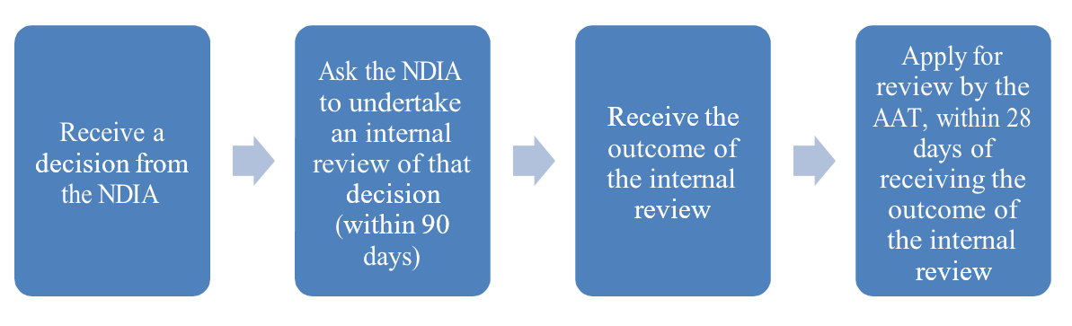

FIGURE 3: PROCESS FOR SEEKING REVIEW OF AN NDIA DECISION
Note: This pathway is empowered under Part 6 of the NDIS Act, with the AAT’s jurisdiction enlivened at s.103.

It is only when a person is unsatisfied by the outcome of the internal review that recourse to the AAT is available. Importantly, while an application for review by the AAT must be made within 28 days of the internal review decision, an applicant may also seek an extension of time for making an application outside of that 28-day period.
It is also worth noting that the NDIA cannot apply to the AAT under current arrangements, chiefly because the NDIA is the final decision maker before AAT jurisdiction is enlivened. It would make no sense for the NDIA to seek further review of its own decisions. This should remain the same in any reformed approach. As is current practice, the NDIA should also remain empowered, alongside the person with disability, to seek review of the AAT’s decision to the Federal Court of Australia.

Role and function of the AAT’s NDIS Division

Jurisdiction in relation to the NDIS was conferred on the AAT in 2013, in the form of a specialist Division under the Administrative Appeals Tribunal Act 1975 (the AAT Act). As set out at section 2A of the AAT Act, the objective of the AAT is to provide a mechanism of merits review that is:
- accessible
- fair, just, economical, informal and quick
- proportionate to the importance and complexity of the matter
- promotes public trust and confidence in the decision-making of the AAT.

In relation to the NDIS, the AAT is said to “step into the shoes of the original decisionmaker” and may exercise all the powers and discretions that are conferred on the original decision-maker. While there are many instances where the law clearly points to only one legally available or ‘correct’ option, the AAT has the power to make a ‘preferred’ decision when it is able to choose from a range of equally acceptable outcomes. The AAT can either:
- Affirm the decision under review
- Vary the decision under review or
- Set aside the decision under review and
  - make a fresh decision in substitution for the decision under review; or
  - remit the matter for reconsideration in accordance with any directions or recommendations of the AAT.

While no formal doctrine of precedent exists in administrative law, members of the AAT will generally follow earlier decisions of the Tribunal where the facts of the matter or legal issue being considered are similar, unless there is a cogent reason not to do so. Should either the participant or NDIA be dissatisfied with the outcome of the AAT review, they have a right to appeal the decision to the Federal Court on a question of law.⁸ Decisions by the Federal Court create binding precedents.

Existing initiatives to improve the participant experience

The NDIA and AAT have already taken a number of substantial steps to reduce the caseload pressures in the AAT and stem the flow of new cases. This work has been underway for some time, but accelerated in recent months with a clear direction that one of the Government’s key priorities is to quickly clear backlogs in the AAT and improve the NDIA’s case management efficiency. An outline of those initiatives is provided below.
- Improvements to initial decision-making by upskilling staff to have productive conversations with participants and introducing a requirement to provide clear explanations for reasons for decisions, taking into account and responding to all of the material that has been provided by the participant (as required by s100 of the NDIS Act).
- Improvements to internal review processes to reduce the existing backlog of internal reviews, pushing more cases through to resolution at a faster rate.
- Initiating an early resolution approach and a dedicated team to undertake an intensive review of the existing AAT caseload to identify cases with sufficient evidence to allow for quick resolution.
- The early resolution team has also started contacting participants seeking early resolution of new cases. This is to ensure a focus on both older and new cases.

Further, current AAT initiatives include:
- Maintaining a national triage process to identify and expedite reviews in urgent cases. This was initiated in response to the COVID-19 pandemic, but has now been integrated into business-as-usual operations, with a dedicated team triaging all incoming applications to ensure urgent and complex cases are identified and appropriately managed.
- Ongoing assessment and triage of applications, the establishment of a national roster for jurisdiction and urgent cases, assigning additional staff resources to the NDIS Division for a specified period to address high caseload numbers and more proactive and streamlined approaches to case management.
- The continued use of ADR as a key mechanism for the parties to reach agreement without the need to progress to a formal hearing.
- Undertake a trial of initiatives which assist to resolve or progress cases that have been in the system for some time as well as alternative ADR processes for early resolution of matters.
- The development of new Practice Directions for the NDIS Division which will seek to:
  - clarify expectations of parties and their representatives who appear before the AAT
  - introduce timeframes for the provision of documents and new information o develop and institute best practice as to caseload management of applications and to maximise the timely finalisation of applications.
The OC understand these new Practice Directions are currently under development.

The OC welcomes and encourages such initiatives so long as they are developed through engagement with all AAT users in this jurisdiction, including applicants, their advocates and the disability community.

Chapter 4: A participant-focused approach to reform

In Australia, many matters outside the NDIS are considered by a tier of independent review prior to review by the AAT. For example, War Veterans’ pension decisions must first be reconsidered by the Veterans’ Review Board (VRB), an independent statutory tribunal established under the Veterans’ Entitlements Act 1986 (the VEA Act), before they progress to the AAT if they remain unresolved.

Pre-2015, social security and income support and similar decisions were reconsidered by an independent statutory tribunal, the Social Security Appeals Tribunal (SSAT), before review by the AAT. Since 2015, such decisions have been considered in a two tier system of AAT review, first by the AAT’s Social Services & Child Support Division (SSCSD), and secondly by the AAT General Division. Like in the current NDIS AAT Division, should a party disagree with the outcome in the AAT General Division, they may appeal to the Federal Court on a question of law.

Conciliation is a method of ADR that is employed by the AAT pursuant to section 34A of the AAT Act so to avoid matters going to hearing. It has also proven valuable in other jurisdictions to resolve disputes, including includes workers compensation, discrimination and human rights and workplace relations. Under such arrangements, each party can negotiate an outcome in a relatively informal manner and explore the possibility of reaching an agreed settlement. The conciliator may have an advisory role on the content of the dispute or the outcome of its resolution, but not a determinative role. That is, if a matter cannot be resolved by conciliation, the person making the complaint can make an application to have the matter heard by arbitration or by a court, where the decision of the arbitrator or court is considered final and binding.

The IER program represents a first-tier of independent review, albeit for matters already before the AAT. In many respects, it is similar to non-binding arbitration, whereby an independent expert provides a non-binding recommendation, which is then implemented by the parties should they agree. The independent expert’s recommendation cannot be determinative as the independent expert does not have delegation under the NDIS Act to make or change reviewable decisions nor are they members of the Tribunal, empowered by the AAT Act. Similar to a conciliatory model, either party is also able to choose to accept the recommendation and resolve the matter or pursue their AAT review rights without further delay. The NDIA will generally accept the recommendation unless it contains a demonstrable error of fact or law, or has the potential to cause risks to the participant or third parties.

It is too early to tell if the IER program, and the NDIA’s other initiatives, will stem the amount of external reviews proceeding to advanced or determinative stages in the AAT. However, it is clear they do not represent a structural solution to existing pain points nor address the larger concern about whether it is appropriate that the AAT is the only independent review process for NDIS disputes.

The remainder of this chapter summarises what is critical in a new model of external review, based on consultation feedback.

Guiding Principles

A new model for external review should be based on a set of principles that provide a pathway to avoiding the problems of the past and underpin best practice approaches to empowering people with disability. It should also take a rights-based approach consistent with the principles of the Convention on the Rights of Persons with Disabilities 2006, and provide an accountability mechanism to ensure it promotes independence, neutrality, transparency, trustworthiness and has the capacity to support and recognise the voice of people with disability.

“The process [needs to be] more personal and aim to hear the voice of the person with disability, taking into account lived experience and acknowledge their current circumstances”

“The clients’ voice [needs to be] centred and respected as the experts in their own lives
and the supports they need”

In this respect, consultation feedback demonstrated strong support for five principles to guide any reform to the dispute resolution pathway.

Principle | Description | Average score  (Not important to Very Important. n=79)
Independent | The person reviewing decisions should be independent of the NDIA and the government. | 4.5 / 5.0
Informal | The process should be as informal and straightforward as possible, steering away from legal processes and legal terminology (jargon). | 4.2 / 5.0
Timely | Disputes should be resolved as quickly as practicably possible, commensurate to the complexity of the case and the particular circumstances and needs of the applicant. | 4.5 / 5.0
Inquisitorial | The review process should be focused on ascertaining the facts, where the person does not feel like they have to negotiate with or rebut the position the agency takes (i.e. the process is not adversarial in nature) | 3.5 / 5.0
Accessible | The process and documentation allows meaningful participation in the process for all parties involved, but particularly for the applicant. | 4.6 / 5.0
TABLE 1: GUIDING PRINCIPLES

Consultation feedback also suggested other appropriate principles to guide any change to existing review processes should include: fairness, equity, inclusion, restorative (justice), trauma-informed and underpinned by a positive contemporary attitude to disability.

The OC notes these principles are similar to the service standards enshrined under the NDIS
Participant Service Guarantee (PSG), which is reflected in the NDIA’s Participant Service Charter. The PSG service standards guide expectations for how the NDIA and its partner organisations will work alongside people with disability in delivering the NDIS. The PSG service standards are: Transparent, Responsive, Respectful, Empowering and Connected.

“The principle of accessibility should cover supported decision-making, advocacy and funding for reports”

“[Need to] promote fairness and equality principles”.

“[Important to have] equity and consistency in review decisions, with transparency around decisions and sharing case studies”.

“[Need a principle] about supporting people with limited capacity or for someone present to be engaged in supported decision making”

“Families are completely traumatized and burnt out from fighting for basic needs for their loved ones. Please consider the trauma that this system is creating.”

“No transparency in decision making = no clarity about what additional evidence might be needed to justify a review = people putting in reviews with no additional evidence =
people going to the AAT unnecessarily.”

Pain points

Consultation feedback indicated that, for some people with disability, there are barriers to accessing the review and appeal process which likely prevents them from exercising their right of appeal. This may mean they may not be getting the support from the NDIS they are entitled to. This appears to be most prominent in First Nations and Culturally Linguistically Diverse (CALD) communities, and people who are socially isolated and/or do not have the support of an advocate.

“Participants not understanding the NDIA’s key requirements, obligations, decision making/language, nor why the decision maker didn’t ask them for more information.”

“Formal language, lack of understanding the time frame, the formality can seem scary and lack of support through the process can mean they don’t submit.”

“[The process is not] accessible to people from all cultures, and people with cognition difficulties, and people who are non-verbal”.

Consultation feedback also reinforced that the current review process is “drawn out” and overly legal in nature, which contributes to stress and anxiety and does not facilitate effective or positive outcomes. People with disability do not want to participate in protracted negotiations with the agency or complex medico-legal litigation at the AAT. They simply want fair and expeditious decision-making where they feel heard, understood and that their perspective is valued.

Comments were also made about how labour-intensive it is for people with disability to seek a review of a NDIS decision, that there were excessive layers of bureaucracy, inaccessible and insufficient detail in correspondence, that decision-makers and reviewers do not understand their disability and support needs, and that, from end-to-end, the process was unnecessarily complicated and complex in nature. References were also made to the review process being regarded as a “tick and flick” exercise that did not engage the person with disability in a meaningful way, or where participants felt the information they had provided had not been taken into account.

The OC also heard that people with disability, more often than not, do not receive clear explanations of the reasons from the NDIA of why it made a particular decision, and that this did not promote their right to an informed appeal. Comments were also made in respect of “moving goalposts” for the evidence the NDIA considered was necessary to support decision-making, which protracts the time it takes to resolve disputes.

It is clear that current processes perpetrates confusion and anxiety for those unfamiliar with AAT processes and the framework for NDIS decision-making, coupled with the emotional, administrative and financial burden of producing further information.

“No transparency in decision making = no clarity about what additional evidence might be needed to justify a review = people putting in reviews with no additional evidence = people going to the AAT unnecessarily.”

Feedback was also provided reinforcing that cost is a key barrier to seeking a review for many people with disability. In this regard, consultation feedback suggested that the financial costs of obtaining reports to evidence their satisfaction of the legislative requirements is prohibitive and is often the reason why a person does not pursue their review rights. In this respect, consultation feedback suggested that any new model should include a no-cost option for participants who are required to produce further information to support decision-making.

“Massive barriers to seeking more reports, providing further evidence when participants feel like the evidence they have already submitted has not been considered.”

“Making participants get multiple reports is an abusive process particularly when the reports are rejected or not considered by the NDIA.”

Finally, the overwhelming feedback across all engagement platforms was that there is currently insufficient capacity in the advocacy and legal aid sectors to support people with disability to pursue their right of review, given the number of appeals underway with unrepresented applicants. The importance of adequately resourcing supported decision making was also underscored as critical in the development of any new model in keeping with a rights-based approach.

“[It is important to] Ensure the person with disability is well supported for the duration of the process, particularly when the funds in dispute are funds required for the person to live an ordinary life (e.g. SIL)”.

"MORE ADVOCATES! It is a legal process and participants accessibility needs will be different. More advocates allows for a more tailored approach for each participant.”

“It is important to look at alternative options for participants to show they satisfy the criteria, other than the burdensome task of obtaining additional reports.”

Key features of a new model

A new model of external review under the NDIS should be framed to mitigate the extent and impact of the above pain points. Its design should also promote the experience of people with disability and ensure they have voice and recognition. Implementing this will require a multifaceted approach, with meaningful co-design at the centre, and a strong commitment to:
- simplifying processes
- moving away from legal terminology and processes
- improving accessibility, transparency and accountability
- providing advocacy support and legal representation to those who need it, or wish to self-represent.

A new model should also provide for independent review of decisions before a matter progresses to the AAT. Consultation feedback indicated broad support for such an approach, with over 76 per cent of people agreeing an earlier layer of independent review would provide additional scrutiny of decisions and improve the consistency and quality of decisions, such that reviews do not progress when they could have otherwise been resolved.

One participant referred to an independent review process pre-AAT as a valuable “circuit breaker” that would level the playing field and provide objective consideration of the facts in a forum that was less overwhelming and intimidating than the AAT. Another referred to it as an opportunity to “get out of the NDIS mindset” and have an unbiased view of the facts, not filtered by key performance indicators and a budget bottom-line.

“An independent review would mean that the NDIS longer has an opportunity to mark its own homework. It [would] hopefully remove the conflict of interest, and disrupt political interference.”

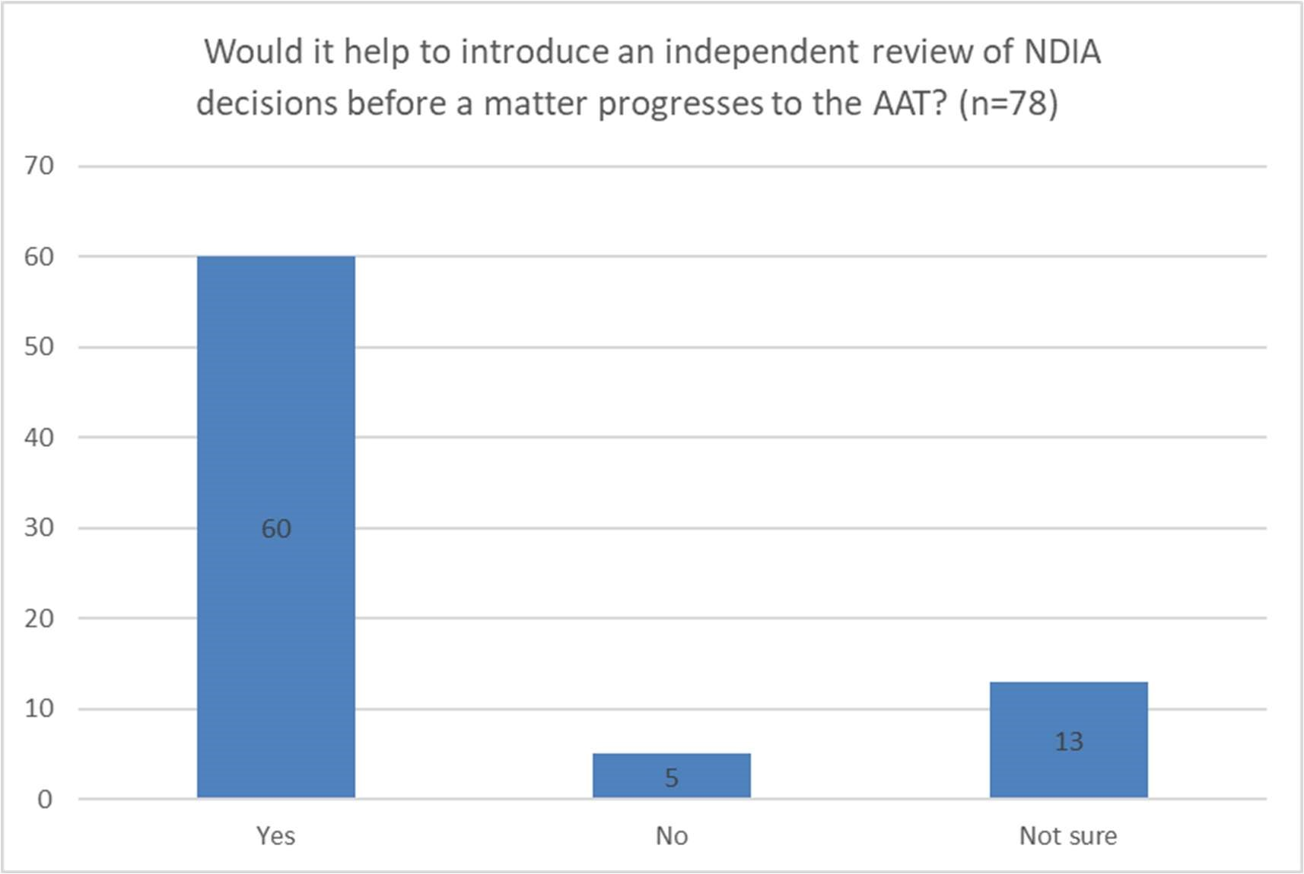

FIGURE 4: BENEFIT OF INDEPENDENT REVIEW

In respect to when a new tier of independent review should occur, consultation feedback reinforced that there is merit in a model that would see independent review occur following an internal review decision by the NDIA. However, this was balanced against feedback suggesting a multifaceted approach may be best, where the timing for independent review was based on the nature of the review and how complex the persons support needs are. That is, if the participant has more complex needs, that it may be beneficial for an independent party to review the plan before it was approved. However, having independent review available at request, rather than as a set stage of the review process would be challenging within the current parameters of administrative law principles.
On this note, consultation feedback also reinforced that the provision of draft plans would go some way to improving original decisions and reducing further reviews.

“Draft plans should be an important process in the planning stage to remove errors and inconsistencies.”
“Providing draft plans as part of the plan meeting allows for feedback on what’s proposed and would help in removing errors or plans not meeting need.”

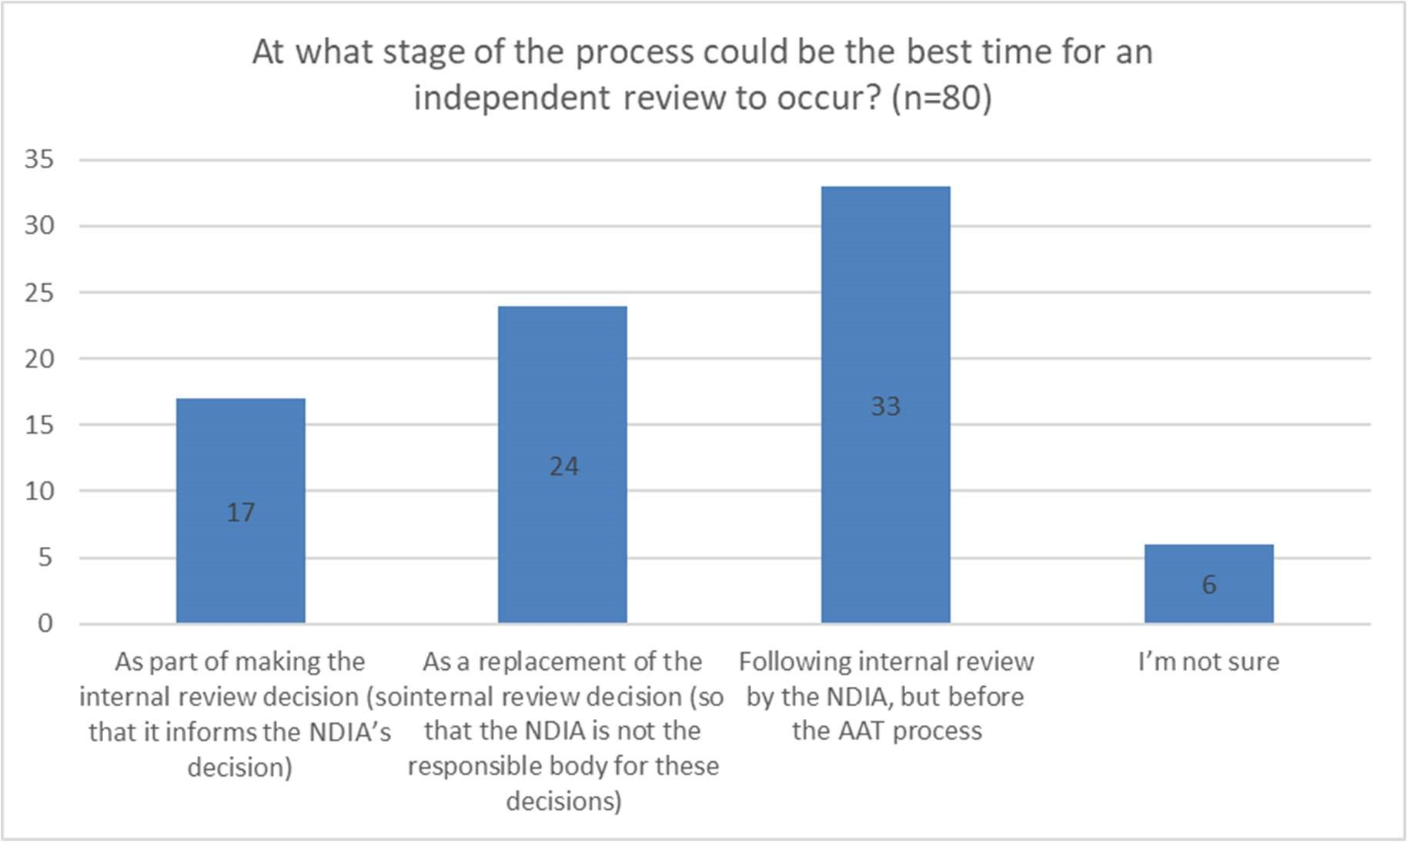

FIGURE 5: TIMING OF INDEPENDENT REVIEW
Irrespective of when independent review occurred, there was a clear preference for designing such a pathway in a way that significantly increases the likelihood of applicants getting an independent review outcome quickly, while also leaving open capacity to seek review by the AAT where needed.
In addition, consultation feedback reinforced that any new model for independent review under the NDIS should:
- Ensure the people appointed to independently review the NDIA’s decisions include persons who are representative of who the scheme supports (e.g. people with disability or have contemporary involvement in the disability sector).
- Be appropriately resourced, such that capacity is always commensurate with demand, including for case management and advocacy functions.
- Ensure the imbalance of power between people with disability and decision-makers is mitigated as much as possible.
- Provide financial support to ensure applicants can gather the most appropriate evidence if it is lacking (i.e. the model should not assume people with disability have pre-existing financial capacity to gather the evidence they require to make their case).
- Ensure all information about the process and any evidentiary requirements is universally accessible for people of all ages, abilities and backgrounds (including in easy read and languages other than English).
- Clear timeframes for making review decisions (ideally legislated).
- Provide appropriate training for all people involved in disputation in disability and human rights (e.g. decision makers, lawyers, case managers, support persons etc.)
- Provide choice and control for people with disability in the process and how it is conducted, including the time of meetings, conferences and hearings, and the nature and extent of any formal administrative process/es, such as requirements to gather evidence and supporting documentation.
- Promote timely decision-making, while providing a just process for each appeal that recognises its complexity and empowers the people with disability involved.
- Be personal and person-centred and acknowledge the complex intersectionality between disability, gender, sexuality, cultural diversity, age etc.
- Deliver a model that is respectful, inclusive and trauma-informed, with an emphasis on meeting people with disability where they are.

Publishing of outcomes

Consultation feedback also reinforced that publishing anonymised decisions and reasons for decisions could be a very valuable guide to participants in an area where the power imbalance is significant. This would be in keeping with a guiding principle of transparency and would include summaries of IER outcomes and the reasons for those decisions and the outcomes and reasons of AAT matters resolved prior to hearing.

The Australian Human Rights Commissions (AHRC) conciliation register is a helpful example of what publishing outcomes could look like in practice. The conciliation register provides summaries of complaints that have been resolved through the AHRC’s conciliation process, serving as a guide to help people involved in complaints to prepare for conciliation. Anecdotal reports suggests the conciliation register is one of the most frequently visited webpages on the AHRC website, and has been extremely beneficial in reducing the number of cases that have progressed to more advanced or determinative stages.

The OC is aware the NDIA has committed to publish the outcomes of matters considered as part of the IER program, but has not determined how such publication will occur or when it will commence. This is pleasing, but should be well embedded in time for Phase 2 and Phase 3 rollout.

The OC also notes that should IER and AAT decisions be published, careful consideration will need to be given to how consent will be obtained and how they are published, including maintaining the privacy of participants, even if provided in a de-identified form. It also needs to be made clear to participants what the purpose of publishing outcomes are, to avoid a misconception that the terms of agreement reached between the applicant and the NDIA in one matter could be indicative of a likely outcome for other applicants. To this end, while de-identified summaries can be instructive, it should be made clear that each matter will ultimately be decided on its own facts.

In addition, a review of past decisions would also be a valuable source of evidence for the design of a new long-term model – understanding the number of appeals and their outcomes, which have been perceived to stem from a failure of the NDIA’s process or a lack of information, the NDIA making the incorrect decision, or where the expectation of the applicant was not reasonable (or lawful).

Chapter 5: Comparable models of dispute resolution
As set out in Chapter 4, the VRB and SSCSD models of review may be appropriate comparators to the NDIS and each have features that consultation feedback underscored as important. Both models, albeit in different ways, seek to provide access to justice, are sound ways for the parties to a dispute to reach an agreed outcome, are founded on informality and expedition, and seek to deal with individual matters at the lowest possible cost.

Model 1: An independent statutory tribunal
This would involve the establishment of a new independent tribunal or decision-making body under the NDIS Act, with jurisdiction to review internal review decisions. That tribunal or body would have all the powers and discretions available to the original decision–maker, including the power to set the decision aside, replace it with a new one, change it, affirm it, or send the matter back to the NDIA for reconsideration. This would be akin to the legislated role of the VRB (current) or the SSAT before it became part of the AAT in 2015 as part of a broader amalgamation of Commonwealth statutory tribunals.
In practice, the VRB provides a filter between the original decision-maker and a more formal merits-review process, such as that undertaken by the AAT. In 2021-22, the VRB provided an efficient model to resolve disputes, with most cases resolved in just 3.5 months, less than 2.4 per cent of matters progressing to the AAT, and only 0.4 per cent of AAT cases at hearing decided differently to the VRB.
This is perhaps reflective of the VRB’s active use of ADR (which is enshrined in law as a permanent function) and a suite of case management powers which ensures it is well equipped to support veterans through the review process and resolve complex cases. It may also be reflective of a broad composition in the VRB’s review panel, which includes least three members for all matters, including a person specifically nominated to represent the interests of service members. Situated in the NDIS, this would involve a person with disability, or a person with significant experience in the sector, reviewing NDIS decisions, not just lawyers or people from judicial backgrounds.
However, the VRB model it is unlikely to be fiscally sustainable if the effect is to remove the NDIA’s role in conducting internal reviews and instead delegates these to an external body, as is the legislated function of the VRB. There are two key problems with this approach.

Firstly, the NDIA undertook 51,402 internal reviews in 2021-22, more than 1800 per cent greater than the VRB’s caseload of 2,781. The VRB’s total annual budget for 2021-22 was $4.8m, with staffing costs of $4.6m. Using simple scaling, the funding required for such a model under the NDIS would be in the order of $75m per year, which is comparable to the annual budget provided for the NDIS Quality and Safeguards Commission. In addition, standing up a panel of reviewers to manage a caseload of this size would present a significant organisational and workforce challenge, which might ultimately preclude such a model if requests for internal review remain high.

Secondly, removing the opportunity for the NDIA to conduct internal reviews would remove a valuable opportunity to provide a quick and accessible form of review for people with disability who might otherwise choose not to take up external review rights (because of perceived barriers). It would also fail to provide a filter for the more resource and time-consuming external process and remove the NDIA’s ability to quality control its practice. That is, retaining the first right of review with the NDIA provides the best chance of feeding back, influencing, and improving, primary decision making such that disputes do not continue to flow.

To this extent, the more sensible option would be for a new tier of independent review to occur following internal review by the NDIA and before recourse to the AAT. This would be a more manageable workload-assuming current flow rates to the AAT remain, in the order of 150 cases per month. It would also have resourcing impacts of just double that of the VRB.

Such a model would be broadly consistent with the views of those consulted in the development of this report and could employ key features of the VRB model including:
- An emphasis on outreach and active case management for complex cases.
- Informal processes and minimal evidentiary requirements.
- Private, confidential hearings between the applicant and their support persons and the review panel, where a representative from NDIA does not attend.
- Having a review panel of 2-3 members, including a person with disability.
- The review panel makes decisions on the day of hearing, or if the decision cannot be made on that day due to a lack of evidence or consensus, a commitment on that day to a date for decision.

There may also be merit in the model adopting conciliation as one of a range of ADR approaches, noting this method has proven valuable in the VRB and in the AAT.

However, conciliation should not be the sole purpose or only function of the new review body. There is limited empirical data confirming if it is any more effective than any other ADR approach and consultation feedback also expressed doubts whether conciliation as a stand-alone model would be effective in an environment where there has been a significant trust deficit. To this end, the OC considers there is value in adopting conciliation as part of ordinary decision-making and review, where appropriate, and in including in the NDIA’s conduct of internal reviews, but needs to be accompanied with a more structural solution, such as what the VRB model offers.
A new tier of independent review would need to be supported by legislative amendment to the NDIS Act to enshrine the functions and powers of the review body. Otherwise, the NDIA would be limited in its ability able to give effect to the reviewer’s decisions. Further, under this model, the NDIA would need to be given give a right to appeal decisions made by the review body if they did not agree. Currently, the NDIA is not empowered to be the applicant for appeal to the AAT because they are the final decision-maker. Of course, as a matter of best practice, if the independent reviewer’s decision was within the law, then the NDIA should not seek further review. Otherwise this would cause an unnecessary extension of disputation, leading to poor reputational impacts.

Model 2: An expanded role of the AAT
An alternative model could be to introduce the opportunity for two-tiers of merits review in the AAT for NDIS appeals. This would look similar to the two-tier system for merits review in the established Social Services and Child Support Division (SSCSD) of the AAT (AAT-1), where unresolved or disputed decisions by the SSCSD can be escalated by either party to the General Division of the AAT (AAT-2).
There are three key reasons why the two tiers of review in the AAT for NDIS disputes could be an improvement on current arrangements.
Firstly, Tribunal operating costs in an AAT-1 review (administration and hearing costs) are significantly less than of an AAT-2 review, including because an AAT-1 appeal is generally listed for one hour and there is no appearance by Centrelink or the Department of Social Services. The process is also less legalistic and relatively informal with no requirements for the lodgement of documents such as statements of facts, issues and contentions.
Secondly, AAT-1 is a quicker process. For Centrelink decisions, the median time to finalise a proceeding in AAT-1 was 9 weeks in 2021-22 with more than 99 per cent of cases finalised within 12 months. Conversely, the median time to finalise a proceeding in AAT-2 was 24 weeks, with 80 per cent of cases finalised within 12 months.
Thirdly, less cases proceed to AAT-2, with the vast majority of cases able to be resolved at AAT-1. For Centrelink decisions, there were 11,177 applications to AAT-1 in 2021-22, with only 1,179 or 10.54 per cent of applications proceeding to AAT-2 for second review.
Comparatively, the median time to finalise a NDIS proceeding in the NDIS Division in 202122 was 23 weeks, with 10 per cent taking more than 12 months. In that financial year, there were 5,918 applications for review of NDIA decisions, with 3,348 applications finalised. Despite there being no earlier formal step of independent merits review, the NDIS Division was successful in resolving 60 per cent of applications through the consent of both parties, with only 2 per cent of matters being formally determined by an AAT member following a substantive hearing. This suggests that the appeal could have been resolved earlier, should there have been a prior avenue for independent review or mediation.
Ultimately, a two tier AAT model for consideration of NDIS disputes will only generate greater efficiencies and have more legitimacy if the first tier is both less resource intensive than current arrangements and works better for people with disability. That is, the first tier would need to effectively filter out the majority of appeals, allowing a concentrated focus of legal resources on the second tier, which would more likely involve more complex factual and legal issues, and matters of public interest.
It is unclear what proportion of cases could be resolved in the equivalent of AAT-1, although once further progressed, the IER may offer some evidence on the nature of cases that can be resolved via relatively informal arrangements. That said, the outcome of matters at the SSCSD detailed above provides cause for optimism that such a two-tiered model could be effective and efficient in resolving many disputes, whether the first tier is part of the AAT or housed separately as stand-alone independent statutory tribunal, similar to the VRB model.
The OC also notes there has previously been a call for Government to consider the role, function and membership of the AAT, including potentially to disassemble the AAT and re-establish a new, federal administrative review system. While the Government has not indicated its position on these matters, any suggestion to expand/amend the role of the AAT for NDIS disputes will need to complement any broader structural shifts that may occur. This makes consideration of this model challenging until the Government provides further clarity on its position.

Chapter 6: The way forward
The disability community want to work in partnership with the NDIA and Government to design a new external (independent) review process. It is evident current arrangements are not fit-for-purpose and a better way is needed. Undertaking meaningful co-design will be critical to design a process that is responsive to the needs of its users, reflects the complexities of decision-making under the NDIS, and builds trust and confidence in the handling of reviews.
Ultimately, the best model will come down to which offers the most effective method of resolving disputes quickly, provides the best experience for all parties and is balanced against the complexity of the review pathway and its cost. Each of the models outlined in this report will require different degrees of legislative changes to implement, and introducing such legislation will take time.
On balance, the OC considers the best way forward would be to preference a new tier of independent review, after an internal review decision and before the AAT, that includes representation by the disability community on the review panel. Where possible, such a model should also be led by a person with disability so as to model community confidence and place value on lived experience. In particular, a model built from the foundations of the VRB, enshrined as a separate entity or built into an initial tier within the AAT would appear to be preferable.
Five guiding principles should underpin the development of this new model. The process should be independent, informal, timely, inquisitorial in its approach and accessible for people with disability of all abilities and backgrounds. The VRB offers a helpful guidepost to consider what features of a model may be fit-for-purpose at the scheme’s maturity, with a strong focus on case management and additional advocacy support for those who need it.
However, introducing a new tier of independent review does create some tensions with the goals of an informal and quick process. A new tier of independent review will mean the path to the AAT or Federal Court takes longer, should the dispute not be resolved earlier. Hopefully this is not the experience for the vast majority of participants. To provide clarity on this point, it would be beneficial to legislate timeframes for independent review, perhaps as part of the Participant Service Guarantee, such that people with disability know when they can expect the review to be completed.
Noting there was not sufficient time to undertake broader consultation in the development of this report, it would be beneficial to undertake further consultation to refine the parameters of such a model, including:
- Mechanisms to ensure participants only have to tell their story once.
- How the requirement for evidence of functional capacity can be satisfied, at no cost to the participant and as informally as possible.
- How, and where appropriate, facilitative dispute resolution processes can be incorporated, such as mediation and conciliation.
- The process for appointment of independent reviewers, and the selection criteria that should apply.
- Governance arrangements for the new entity.
The OC also consider it is critical that a new model for independent review under the NDIS be incorporated into broader considerations of the design, operation and sustainability of the NDIS, and any other consideration of merits-review arrangements across the
Commonwealth. To this extent, this report is a helpful input into such deliberations.

NDIA Quarterly Report to DRC for the period ending 30 September 2022, p.76.
See for example., https://www.theguardian.com/australia-news/2021/apr/13/ndis-cost-cutting-taskforcetold-to-reduce-growth-in-participants-and-spending
AAT statistics are available publically at: https://www.aat.gov.au/about-the-aat/corporateinformation/statistics
See recommendations made in the Senate Standing Committee on Legal and Constitutional Affairs’ 2021 interim report on The Performance and Integrity of Australia’s Administrative Review System, noting the Government is yet to provide a formal response to these.
Section 29(2) of the AAT Act.
Section 29(7) of the AAT Act.
However, the AAT has no general discretion to review NDIA decisions, with only reviewable decisions listed in s99 of the NDIS Act able to progress to the AAT after a decision has been made under s100 of the NDIS Act. ⁸ Section 44 of the AAT Act.
Resolutions made via ADR in the AAT are recorded pursuant to section 42C of the AAT Act.
Veterans’ Review Board 2021-22 Annual Report, page 21 and 24
NDIA Quarterly Report to DRC for the period ending 30 September 2022, p.186.and Veterans’ Review Board 2021-22 Annual Report, page 22
Veterans’ Review Board 2021-22 Annual Report, page 8
Administrative Appeals Tribunal 2021-22 Annual Report, pg. 45 and 54.
Administrative Appeals Tribunal 2021-22 Annual Report, pg. 46 and 54.
Administrative Appeals Tribunal 2021-22 Annual Report, pg. 62.
Administrative Appeals Tribunal 2021-22 Annual Report, pg. 63.
See recommendation 3 of the Senate Standing Committee on Legal and Constitutional Affairs’ 2021 interim report on The Performance and Integrity of Australia’s Administrative Review System.

