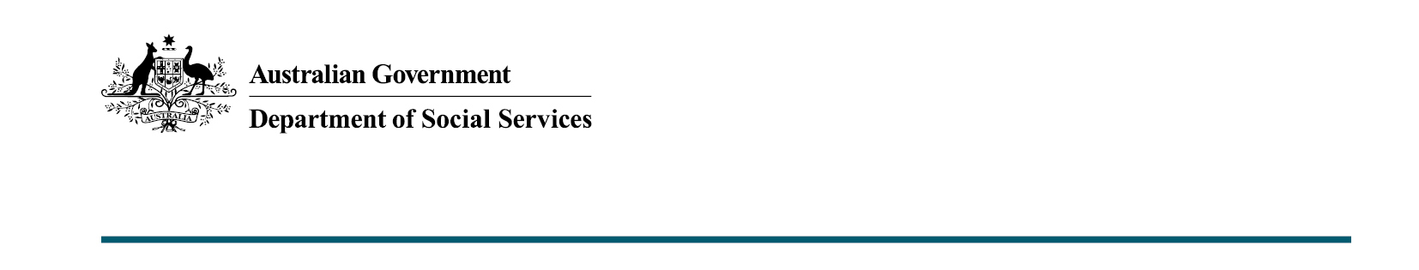

Volunteer Management Activity

The Future of the Program
From 1 July 2021, the Department of Social Services (the department) will distribute $40.1 million, over five years, to the seven state and territory volunteering peak bodies, to administer the redesigned VMA program.
This includes $33.5 million (ex. GST) over five years for the peak bodies to develop and implement strategies that will:
  - Deliver online services to build the capacity of Volunteer Involving Organisations (VIOs) within their relevant jurisdictions and;
  - Break down barriers to volunteering faced by identified priority groups, including, People with Disabilities, First Nations People, and Newly Arrived Migrants.
Through the 2021-22 Budget, additional one off funding of up to $6.6 million (ex. GST) was provided to support a smooth transition to the redesigned VMA in its first year.
The Commonwealth Government further invested a one off sum of $3.4 million
in 2020-21 to develop and improve volunteer management IT infrastructure.

What the redesigned VMA looks like
The redesigned VMA involves:
- online services to build the capacity of VIOs; and
- breaking down barriers to volunteering for certain priority groups.
The online services delivered to VIOs will focus on implementing best practice recruiting and training of volunteers, retaining volunteers, volunteer management and understanding regulatory obligations and risk management. There will also be online resources.
Increasing the accessibility of volunteering opportunities for people in priority groups includes building the capacity of VIOs to engage volunteers from these groups and providing face to face and other services to support these groups to participate in volunteering.
The priority groups the Commonwealth Government can support are People with Disability, First Nations People, and Newly Arrived Migrants.
The redesigned VMA program is now aligned to the Australian Constitution; is more efficient and effective; and responds to the changing volunteering environment.

Peak Body Requirements
As required, the volunteering peak bodies will develop and implement strategies to deliver and manage the VMA in their respective jurisdictions. These strategies must include how the peak bodies will work with local organisations to deliver the program and create state-wide consistency. The peak bodies will determine how funding is distributed
to partner organisations. Volunteer Support Services are encouraged to engage with peak bodies in relation to what services they could offer to support the redesigned VMA.
Peak bodies were responsible for the management and distribution of additional funding
of up to $6.6 million in 2021-22 to leverage the experience and resources of previously funded VMA providers in their jurisdictions.

