DISABILITY REFORM MINISTERS’ MEETING (DRMM)
Canberra – 18 March 2022
COMMUNIQUÉ
Commonwealth, state and territory Disability Ministers met on Friday 18 March 2022 face to face for the first time since late 2019. Minister Punch and Minister Worden from Western Australia and Northern Territory respectively attended virtually. Ministers noted it was not possible for the South Australian Minister to attend due to caretaker arrangements currently in place in South Australia.

Ministers welcomed the NSW Minister for Families and Communities and Minister for Disability Services, the Hon Natasha Maclaren-Jones MLC and the Tasmanian Minister for Disability Services, the Hon Madeleine Ogilvie MP to their first Disability Reform Ministers’ Meeting.

Ministers also welcomed the newly-appointed National Disability Insurance Scheme (NDIS) Quality and Safeguards Commissioner, Ms Tracy Mackey, to her first Disability Reform Ministers’ Meeting and the acting National Disability Insurance Agency (NDIA) Chairman, Mr Jim Minto.

Ministers discussed key priorities for 2022 agreeing to a work plan that would serve as a living document to guide the work of Ministers during this calendar year and tasked officials with ensuring that work against the priorities set by Ministers is delivered.

Ministers discussed state and territory disability inclusion plans. The goal of Australia’s Disability Strategy is to deliver an inclusive Australian society, and jurisdictional inclusion plans play a critical role. Ministers acknowledged the efforts that all jurisdictions are taking to ensure state and territory plans align with the Strategy and agreed that these are essential to improving outcomes for people with disability.

Ministers discussed the significant progress being made in vaccinating people with disability against COVID-19, including providing access to booster shots. The importance of continuing to focus on increasing vaccination rates as we move into winter, particularly for children and teenagers was raised. Ministers also noted measures undertaken to improve access to Rapid Antigen Testing (RAT) both from the Commonwealth Government and States and Territories. This includes the ongoing distribution of RATs to NDIS Supported Independent Living providers, the Commonwealth program to provide tests free of charge for concession card holders and the Government’s recent announcement that eligible NDIS participants can purchase RAT kits with funds from their NDIS plan.

Ministers noted the publication of the Taylor Fry review of the NDIA actuarial forecast model and drivers of Scheme costs and discussed the current status of work to better understand the growth of the Scheme, including the need for further analysis on how levels of supports through the Scheme have changed over time for different kinds of participants.

Ministers noted the release of the NDIS Quarterly Report to December 2021 with more than 500,000 participants (including more than 20,384 added in the quarter) and the additional funding of $26.4 billion provided by the Commonwealth to support the Scheme over four years to 2024-25.

Ministers noted they would continue to continue to work with people with disability, their supporters and disability representative organisations to develop a shared understanding of Scheme sustainability and effectiveness, including understanding the long term economic benefits and lifetime impacts of the Scheme on participants and carers.

Ministers discussed long-term transport policy for NDIS participants, committing to co-design across jurisdictions and with representatives of people with disability on a long-term approach to how transport supports are included in participants’ plans and will work alongside accessible public transport.

Noting the potential impact on programs administered by state and territory governments, such as taxi subsidy schemes, Ministers agreed in-principle an extension to current arrangements while long-term reforms are developed.

Ministers noted that since the last DRMM in December 2021, the NDIA has taken a number of steps to further progress the timely discharge of NDIS participants from hospital, including expanding the Hospital Liaison Officer (HLO) network across the country, increasing engagement with Local Health Districts and establishing an expedited process for approving Home and Living supports. Ministers acknowledged the progress in establishing data sharing arrangements between the NDIA and state and territory health services to enable timely discharge of NDIS participants in hospital settings.

Ministers agreed to meet again before the end of the financial year.

Disability Reform Ministers’ Meeting 18 March 2022

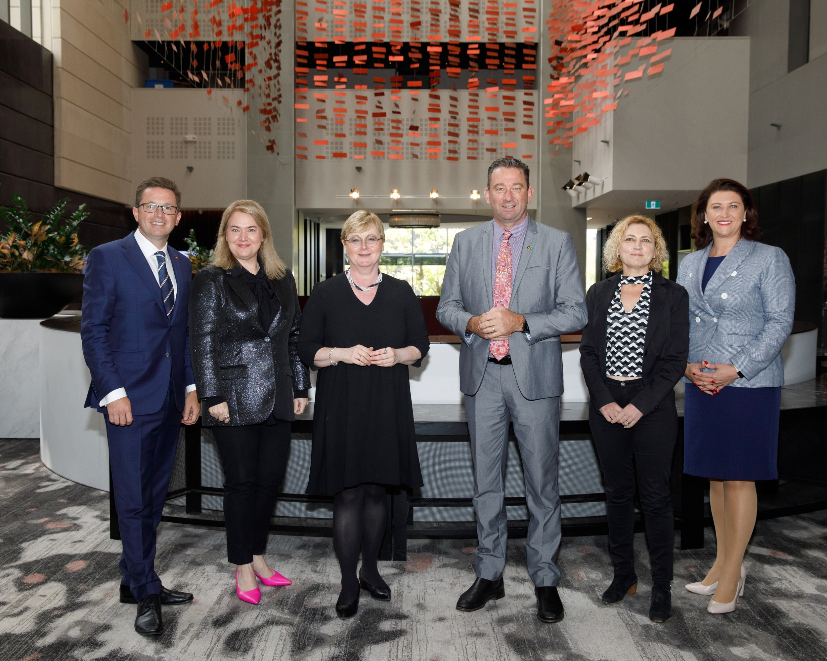
Left to right: The Hon Anthony Carbines MP (VIC), the Hon Madeleine Ogilvie MP (TAS), Senator the Hon Linda Reynolds CSC (Chair– Commonwealth), the Hon Craig Crawford MP (QLD), Ms Emma Davidson MLA (ACT), the Hon Natasha Maclaren-Jones MLC (NSW). Absent from photo: Senator the Hon Anne Ruston (Commonwealth),
the Hon Don Punch MLA (WA), the Hon Michelle Lensink MLC (SA), the Hon Kate Worden MLA (NT)

