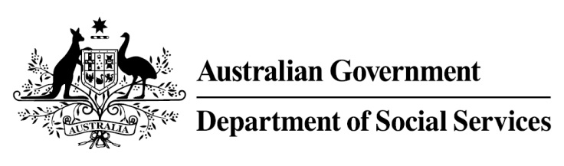

Try, Test and Learn Fund

  - Train and Care
Using insights from the Priority Investment Approach, the Try, Test and Learn Fund is trialling new and innovative approaches to assist groups of people at risk of long-term welfare dependence.
The Try, Test and Learn Fund will help achieve the objectives of welfare reform — that is, to develop a modern welfare system that increases the capacity of individuals, reduces the risk of welfare dependency and maintains a strong welfare safety net.

Fast facts
Note: This project has ended.
Priority group: Young parents
Target Participant number: 135
(Actual participants: 73)
Location: Western Sydney and South Coast New South Wales
Trial period: 28 months
Total funding: $1.2 million
Co-designers: Apprenticeships R Us, and Mission Australia
Service providers:
Apprenticeships R Us
Potential future saving: The purpose of these initiatives is to test whether an intervention works to reduce long-term reliance on welfare. If 11 per cent of participants (8) move off welfare, the savings to the welfare system are likely to outweigh the costs.

What does the evidence tell us?
- In 2016, there were 3,760 young parents in Australia aged 18 or under receiving Parenting Payment. On average, current young parents are expected to be on income support for around 48 years over their future lifetime.
- If nothing changes for these young parents, 79 per cent will be receiving income support payments in 10 years, and 57 per cent will be receiving income support payments in 20 years.
- In addition, analysis shows, around 620 current young parents will remain on income support for the rest of their lives.

What was Train and Care?
Young parents were offered 7 to 8 weeks of practical training to equip them with the skills expected in entry-level positions in a range of industries. The trainers offered flexible hours to accommodate family commitments. The young parents were also offered a child care placement, in a convenient location (depending on availability of child care places) as close as possible to home or the training location.
Once training was complete, the young parents were offered entry-level work placements that could lead to a job.
During the training and work placement period, financial assistance was available to cover all out-of-pocket child care costs.

What were we trying to achieve?
Helping young parents transition to work by combining training and child care support. A smoother transition to work is more likely to result in positive, long-term outcomes. How was this initiative new and innovative?

How was this initiative new and innovative?
The initiative’s innovation was in providing a practical workplace-training program and work experience, and at the same time supporting participation by removing the barriers faced by young parents relating to child care access and affordability.

