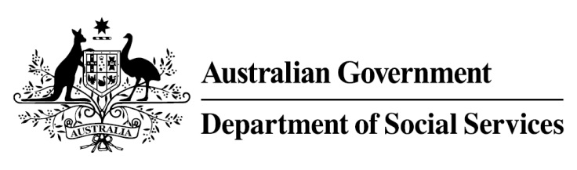

Try, Test and Learn Fund

  - Support for VET students
Using insights from the Priority Investment Approach, the Try, Test and Learn Fund is trialling new and innovative approaches to assist groups of people at risk of long-term welfare dependence.
The Try, Test and Learn Fund will help achieve the objectives of welfare reform — that is, to develop a modern welfare system that increases the capacity of individuals, reduces the risk of welfare dependency and maintains a strong welfare safety net.

Fast facts
Note: This project has ended.
Priority group: Young students
Target Participant number: 400
(Actual participants: 406)
Locations: Adelaide, regional Queensland and New South Wales
Trial period: 19 months
Total funding: $1.75 million
Co-designers: Mission Australia, Youth Insearch, MAX Solutions, The Social Deck and Marist180
Service provider: Mission Australia (subcontracting Youth Insearch Foundation, MAX Solutions and Marist Youth Care)
Potential future saving: The purpose of these initiatives is to test whether an intervention works to reduce long-term reliance on welfare. If 14 per cent of participants (58) move off welfare, the savings to the welfare system are likely to outweigh the costs.

What does the evidence tell us?
- 22 per cent of all current 17–19 year olds receiving student payments are expected to be on income support in 10 years.
- From 2003 to 2012, there were 7,160 vocational or university students who started receiving a student payment aged 17 to 19; then experienced more than 12 months on unemployment payments; and were receiving unemployment payments in 2015-16. On average, these former young students who transitioned directly to unemployment payments are likely to receive income support in 33 years of their future lifetimes.
- If nothing changes for these former young students, 39 per cent will be receiving income support payments in 10 years, and 30 per cent will be receiving income support payments in 20 years.

What was Support for VET students?
Caseworkers worked with students one-on-one and linked them to appropriate support services that ranged from low-intensity to high-intensity, such as support to improve mental health, or to increase motivation to continue studying.
The support was tailored to the student, depending on the level of need.

What were we trying to achieve?
An increase participants’ engagement with, attendance at, and completion of their studies.
The Support for VET students project aimed to improve wellbeing, increase the rate of transition to employment, and reduce reliance on unemployment payments.

How was this initiative new and innovative?
This trial sought to provide important evidence about the effectiveness of individualised support for vocational education and training (VET) students who are at-risk.

