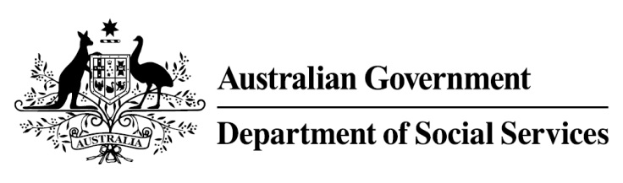

Try, Test and Learn Fund

  - Rewire the Brain
Using insights from the Priority Investment Approach, the Try, Test and Learn Fund is trialling new and innovative approaches to assist groups of people at risk of long-term welfare dependence.
The Try, Test and Learn Fund will help achieve the objectives of welfare reform — that is, to develop a modern welfare system that increases the capacity of individuals, reduces the risk of welfare dependency and maintains a strong welfare safety net.

Fast facts
Note: this project has ended.
Priority group: Young students and at risk youth
Target participant number: 240
(Actual number: 353)
Locations: South-West/Western Sydney, Brisbane and the Sunshine Coast
Trial period: 18 months
Total funding: $2 million
Co-designers/service providers: Pathways to Resilience Trust and Stronger Brains
Potential future saving: The purpose of these initiatives is to test whether an intervention works to reduce long-term reliance on welfare. If around 26 per cent of participants (91) move off welfare, the savings to the welfare system are likely to outweigh the costs.

What does the evidence tell us?
- 22 per cent of all current 17–19 year olds receiving student payments are expected to be on income support in 10 years.
- From 2003 to 2012, there were 7,160 vocational or university students who started receiving a student payment aged 17 to 19; then experienced more than 12 months on unemployment payments; and were receiving unemployment payments in 2015-16. On average, all of these former young students who transitioned directly to unemployment payments are expected to receive income support in 33 years of their future lifetimes.
- If nothing changes for these former young students, 39 per cent will be receiving income support payments in 10 years, and 30 per cent will be receiving income support payments in 20 years.

What was Rewire the Brain?
The project targeted young people who had been exposed to major adverse life events that impacted their executive functioning skills.
Participants were assessed to identify their particular needs and a personalised plan was developed. The plans involved either computerised neuroplasticity programs that aimed to help restore efficient brain function, or non-computerised training programs that aimed to help improve motor or speech control, or both.
The project also linked the young people to external services to support them to gain long-term employment.

What were we trying to achieve?
Increase participants’ ability to remain engaged or re-engage in education and to obtain and sustain employment through improving cognitive function, social and emotional skills, mental control and self-regulation.

How was this initiative new and innovative?
This initiative was the first of its kind in Australia and was based on the relatively new understanding that, like a muscle, the brain can be trained and improved.

