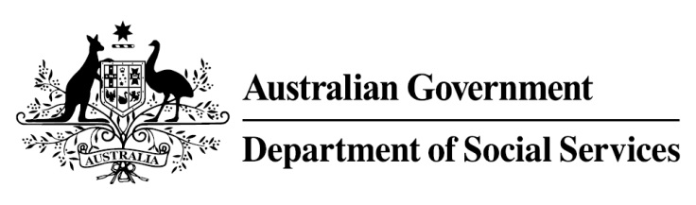

Try, Test and Learn Fund

  - My Maintenance Crew
Using insights from the Priority Investment Approach, the Try, Test and Learn Fund is trialling new and innovative approaches to assist groups of people at risk of long-term welfare dependence.
The Try, Test and Learn Fund will help achieve the objectives of welfare reform — that is, to develop a modern welfare system that increases the capacity of individuals, reduces the risk of welfare dependency and maintains a strong welfare safety net.

Fast facts
Priority group: At-risk youth
Target participant numbers: 94
Location: Greater Geelong region
Trial period: 37 months
Total funding: $3.04 million
Service provider: Diversitat (Geelong Ethnic Community Council Inc)
Potential future saving: The purpose of these initiatives is to test whether an intervention works to reduce long-term reliance on welfare. If 35 per cent of participants (33) move off welfare, the savings to the welfare system are likely to outweigh the costs
Note: Due to changes in circumstances, adjustments have been made to target participant numbers, trial period and total funding.

What does the evidence tell us?
- 22 per cent of all current 17–19 year olds receiving student payments are expected to be on income support in 10 years.
- From 2003 to 2012, there were 7,160 vocational or university students who started receiving a student payment aged 17 to 19; then experienced more than 12 months on unemployment payments; and were receiving unemployment payments in 2015-16. On average, these former young students who transitioned directly to unemployment payments are likely to receive income support in 33 years of their future lifetimes.
- If nothing changes for these former young students, 39 per cent will be receiving income support payments in 10 years, and 30 per cent will be receiving income support payments in 20 years.

What is My Maintenance Crew?
This initiative involves a new social enterprise offering work in event clean-up and maintenance services to unemployed former students, addressing previously unmet demand in the greater Geelong region.
Participants are offered skills training, personal development opportunities, mentoring and counselling, and are directly matched with available jobs. This supports the development of the skills and knowledge required to provide event clean-up and maintenance services via the social enterprise, or on completion of the program, as independent contractors in these markets.

What are we trying to achieve?
Participants gain employment, income, experience and connections in a part of the economy that is expected to provide ongoing employment prospects.
This experience will improve participants’ employability and, potentially ongoing employment in the mainstream economy.

How is this initiative new and innovative?
This initiative offers the opportunity of gaining real work experience and paid employment through the development of a social enterprise that targets an existing gap in the greater Geelong region.

