Australian Government
Department of Social Services
& Year13

Disability & Career Advice Survey

RESEARCH RESULTS & FINDINGS

January 2021

Contents
Introduction 3
What 3
Why 3
Who 3
How 3
Participation & representation 4
Summary 6
Social Demographic Profile 10
Key learnings: Demographic data 10
Key learnings: Disability type 13
Key learnings: Current situation 14
Employment and background information 17
Key learnings: Background and attitudes towards employment 17
Key learnings: Why don’t they want to be employed? 19
Key learnings: Who are the biggest sources of encouragement? 21
Experiences at school 23
Key learnings: Preparation for post-school employment 23
Key learnings: Formal work experience whilst at school 27
Key learnings: Enablers of work experience opportunities 31
Key learnings: Equality at school with career development 32
Career support systems 33
Key learnings: Sources of guidance 33
Key learnings: Identifying opportunities 36
Key learnings: Support to create a career plan 39
Levels of confidence 40
Key learnings: Activities where more confidence is required 40
Key learnings: Confidence to have a successful career as an adult 43
Levels of control 44
Key learnings: Overall 44
Key learnings: Young respondents vs parents 45
Channels to access information 47
Key learnings: Preferences of young people with disability 47
Key learnings: Preferences of parents 49

Introduction
This report analyses the data collected from the Disability and Career Advice survey, conducted by Year13, on behalf of the Department of Social Services.

What
The Disability and Career Advice survey was designed to identify the barriers young people with disability face in receiving career advice; identify the issues they face in transitioning from school to work; and to provide insight on how to better support them to successfully enter the workforce.

Why
To help young people with disability to successfully transition from school to work and improve their long-term economic, social and personal wellbeing.

Who
The survey was completed by 889 young people with a disability aged 15 to 24 and 288 parents of young people with a disability aged 15 to 24. In total, 1177 completed surveys were received.

How
A 15-minute online survey with respondents sourced from Year13’s email database and social media channels, as well as partner organisations and Department of Social Services funded organisations, who distributed it to their mailing lists and networks.

Participation & representation
The Disability and Career Advice survey was designed to provide a better understanding of the experiences and attitudes of young Australians with a disability aged 15 to 24, as well as their parents or caregivers, towards employment, work experience and career support.

All responses were anonymous and collected using online survey tool Qualtrics. Respondents were invited to participate using Year13’s email database, social media channels and partner organisations who shared it with their mailing lists and networks. The Department of Social Services also reached out to its funded providers with a request to share the survey link as appropriate.

The survey was undertaken between December 11th 2020 and December 24th 2020. The survey was completed by 889 young people with a disability aged 15 to 24 and 288 parents of a young person with a disability aged 15 to 24. In total 1177 completed surveys were analysed as part of this study.

A total of 1177 responses provides a large enough sample size to draw valid conclusions that represent Australia’s population of young people with disability.

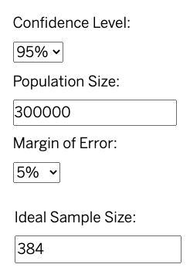
With a sample size of at least n=384, we can be 95% confident that the metrics are within +5/-5% of the result had we surveyed all young people with disability aged 15 to 24 (n=300,000).

Throughout the report, findings are presented for the following groups:
- Young Australians with disability
- Parents of young Australians with disability
- Combined sample of young Australians and parents

In addition to descriptive statistics for each survey question across the above-mentioned groups, the analysis includes statistically significant differences for each question across the following variables/groups:
- Demographic: age, gender, state, region
- Background: school type attended and household responsibilities
- Disability type

The analysis was applied at a 95% confidence interval, meaning that you can be 95% certain the results contain the true average of the population. Any relevant and significant differences amongst the variables and groups listed above compared to the average have been highlighted. The average percentage of a given response amongst these variables and groups was compared for a difference of + / - 10% from the overall average and have been included if it met these criteria. If not mentioned, it can be assumed the difference was less than 10% and not statistically significant.

Quotes included in this report were sourced from extended responses in the survey with identifying information left out to ensure anonymity.

Summary
It is crucial that young people with disability receive the support required to participate in the workforce. Appropriate support at a young age can improve a young person’s long-term employment prospects and maximise the benefits that come from having a job, such as better standards of living and social inclusion.

Year13, on behalf of the Department of Social Services, surveyed young people with disability aged 15 to 24 from across Australia to find out about their experiences with career advice and their transition from school to work. As part of the research, parents of young people with disability aged 15 to 24 were also asked the same questions about their child, as well as a number of questions specific to them, which weren’t asked of young people with disability.

A key purpose of the survey was to identify gaps in existing career and transition to work supports for young people with disability, and data from the survey will provide insight into where and how supports can be improved. The survey also provided an opportunity for young people with disability to have a voice in this important area of their lives. Their responses to the survey indicated they have a great desire to speak about this issue. This was evidenced by the quick time in which survey responses were collected.

Respondents were asked to identify their disability type in the survey and most survey respondents were young people with a developmental or psychosocial disability. Parents surveyed were more likely to complete the survey about a child who had a developmental or intellectual disability.

The survey data indicates that the vast majority of young people with a disability want to be employed. A total of 92% said they want to have a job, with this figure slightly lower amongst parents answering on their child’s behalf at 82%. These results reveal employment is the preferred outcome for young people with any form of disability on their post-school journey. For those who did not want to be employed, the main reasons were a lack of social skills, concerns they would be treated poorly and a hesitation to ask for adaptations in the workplace. It is important to note that just 1 in 12 young people with disability did not want to be employed.
“I’m such a stubbornly independent person so I try not to let my disability impact me but it is really hard. I’ve always wanted to use my experience to help people so I have based my career goals around that. I do regular volunteering and am starting a role at my dream employment provider next year to help children with a disability in hospital catch up on school.”
Overall, just under two thirds of respondents said they agreed they could have a productive and successful career throughout their adult life. However, a quarter disagreed with this statement, showing a significant amount of young people who want to work but who are lacking in the self-belief or support to do so.
“I generally find that getting employment is easier than keeping employment. Neither is easy of course but in that first interview it’s a lot easier to put on a mask and act like a functioning person. As time goes on though they start seeing how much I struggle with everyday things like standing and interacting with customers and I either get let go or get less and less shifts. My conditions are unpredictable which make me an unreliable employee no matter how much I value being a reliable and hardworking employee. It’s frustrating for all involved and I only hope I can find either stability in my condition in the future or a suitable and flexible job that I will be happy in for a long time.”
When it comes to providing support for young people with disability, schools play a vital role. The research findings contained in this report however, show many young people with disability think their schools are lacking in their provision of career support. A quarter of respondents said their school provided them with a lower level of career development than students without a disability. Another fifth of those surveyed said they didn’t receive any career development at all from their school. This means only a little over half of young people with disability received an equal or higher level of career support than students without a disability.
“Many people including my schoolteachers told me to just give up. One schoolteacher told my mum during an interview that I wouldn’t make it into university and even if I did, I wouldn’t survive so she should just start planning to look after me my whole life. I’m currently in my second year of veterinary science and am going strong. I love university. I wish more people would just encourage us and believe in us.”
A sign of this was a lack of work experience opportunities for school students with disability. In total, 42% of respondents said they did not do any work experience whilst at school, with half of this group saying it was because it wasn’t offered to them. This means 1 in 5 young people with disability were not offered work experience at school. Positively though, around three quarters of those who did do work experience said their school had helped organised it for them. A third however said their work experience did not match their likes, interests, passions and skills, showing a misalignment in the organisation of work experience for a significant amount of young people with disability.
“I haven't had a lot of help with achieving my career choices - almost all of my decisions I had to make for myself. I have ADHD so I will need a lot of encouragement along the way so I can stay confident and productive in what I want to achieve. My school never offered work experience because they did not want to fill out the paperwork for it, and this has been a setback for me when trying to find a part time job because I don't have any prior experience in any workplaces. I think work experience should be compulsory and schools should be encouraged to see the benefits of it for young adults entering the workforce.”
The home also plays a vital role in providing encouragement and the building of expectations and aspirations for young people with disability to find employment. The central role of family and carers in supporting young people in their transition from school to work was highlighted in the findings. In a series of questions asking which sources of support had helped them channel their interests into a career; helped them identify new skills they need to learn; introduced them to role models and mentors; helped them identify local employment opportunities and helped them develop a career plan, ‘family/carers’ was consistently the top answer. Across these questions, roughly a third of students also said they received support from their school, highlighting an opportunity for schools to provide greater assistance in these areas of career development for youth with disability.
“I believe it is my family that has helped me the most. They have always believed in me and encouraged me to try and reach my goals, and I’m now doing my Masters. It is because of them that I have been able to access other support systems like a disability job support person, and because of them I had early intervention and feel super comfortable seeing a psychologist and neurologist to discuss my disabilities. I do need support to achieve my goals as my severe anxiety disorder makes it hard for me sometimes. For example, I can’t drive at the moment because of this, so my parents take me to all my appointments, and drive me to work every day. I am so lucky to have them.”
While the transition to work is usually focussed on during a young person’s teenage years, their own personal journey of considering their future career often begins significantly earlier. According to the survey, 17 is the most common age for young people with disability to start formally planning their transition into post-school employment. However, the majority of youth surveyed said they first started considering having a job in the future when they were between the ages of 5 and 10. When it comes to the type of work they would like to be engaged in, most would like to be an employee. Close to a third however, wanted to be self-employed.
“It’s very hard for me to work due to anxiety and my depression and lack of confidence, but I'm setting up my own chicken business on our family farm and want it to be my job and future.”
An important part of the pathway to work for youth with disability is having the confidence to carry out the basic tasks that carry across different industries and jobs. To find out where they need help, respondents were asked to choose which activities they were not confident with from a list of options. Their top worry was expressing their needs to a boss or a manager, followed by doing a job interview, connecting with employment service providers, driving, talking on the phone, writing a resume, interacting with customers, interacting with co-workers, catching public transport and managing money. All of these were chosen by over a third of respondents.
“I also need more deaf awareness training in education providers and workplaces so my teachers and employers can understand my needs. In general, I wish the stigmatism around people with disabilities in education or the workplace would lessen as it is so exhausting to be rejected over and over again by potential employers and to have the stereotype of being stupid just because I am deaf hang over my head.”
This list of activities they are not confident with can guide both school career support and online content responses for youth with disability on their transition from school to work. By tapping into their top work-related concerns and providing assistance to help young people develop these skills, career support will have a greater likelihood of leading to better employment outcomes. The way to deliver this content most effectively was found to be written articles, with more than half of respondents saying they would like to receive career advice this way online.

In two parent-only questions to conclude the survey, it was found access to a disability employment expert was the top requirement they needed to support their child’s career development. When asked where they go for information and advice to support their child’s career development, the internet was the number one resource. Of note was how less than a quarter of parents said they go to their child’s school for career advice and information.

Social Demographic Profile

Key learnings: Demographic data
- Over half of the completed surveys were a person aged 18 or below.
- There were a relatively even number of completed surveys for males (n= 530) and females (n=517), and 1 in 11 respondents identified as non-binary.
- Overall, 1 in 20 completed surveys represented an Indigenous Australian. There was a higher percentage of surveys completed by a parent about an Indigenous young person than there were self-completed surveys by an Indigenous respondent.
- Sixty per cent of all completed surveys came from respondents who live in NSW/ACT or VIC/TAS, which generally follows the trend of Australia’s population spread.
- There was a 50/50 split between those who live in a capital city and those who live in a regional or rural area.
Figure 1: Age of respondents
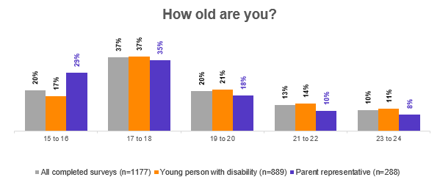
Figure 1 shows the age of respondents. Based on all completed surveys, 20% of respondents were aged 15-16, 37% were aged 17-18, 20% were aged 19-20, 13% were aged 21-22 and 10% were aged 23-24.

Figure 2: Gender of respondents
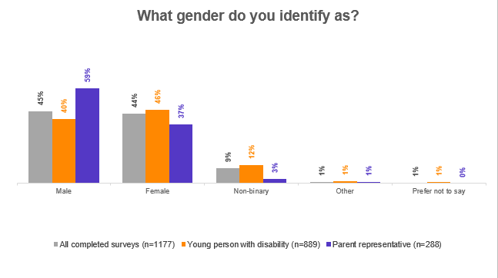
Figure 2 shows respondents identified genders. Based on all completed surveys, males accounted for 45% of respondents, females for 44%, non-binary respondents for 9%, and other and prefer not to say for 1% each.
Figure 3: Aboriginal or Torres Strait Islander respondents
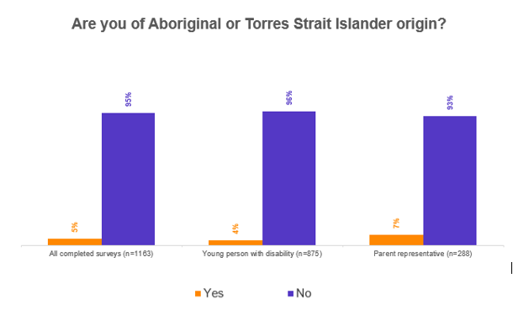
Figure 3 shows that, based on all completed surveys, 5% of respondents identified as Aboriginal or Torres Strait Islander.

Figure 4: Location of respondents
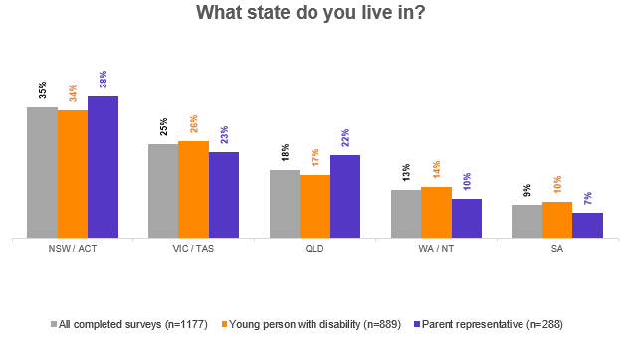
Figure 4 shows respondent locations by state and territory. Based on all completed surveys, NSW/ACT accounted for 35% of respondents, VIC/TAS for 25%, QLD for 18%, WA/NT for 13% and SA for 9%.
Figure 5: Geographical area of respondents
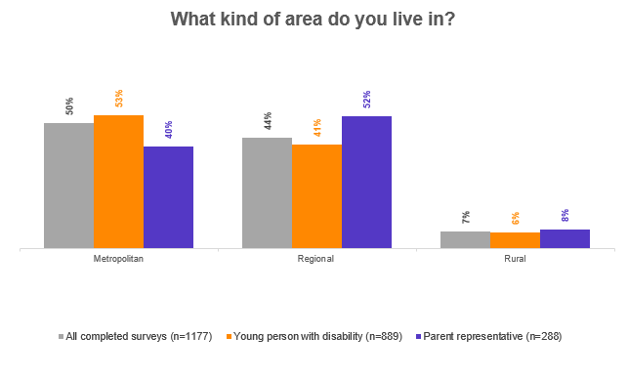
Figure 5 shows respondents by geographical location. Based on all completed surveys, metropolitan areas accounted for 50% of respondents, regional areas for 44% and rural areas for 7%.

Key learnings: Disability type
- Most survey respondents were young people with a developmental or psychosocial disability.
- Parents were more likely to complete the survey about a child who had a developmental or intellectual disability.
Figure 6: Disability type of respondents
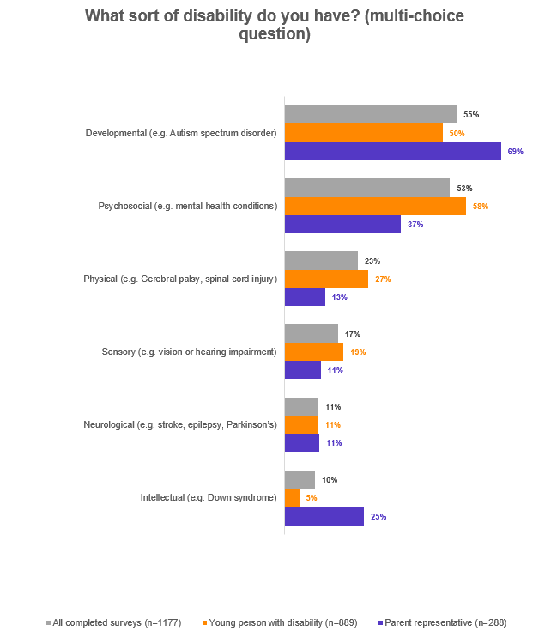
Figure 6 shows the disability types of respondents (multiple answers possible). Based on all completed surveys, 55% of respondents had a development disability, 53% a psychosocial disability, 23% a physical disability, 17% a sensory disability, 11% a neurological disability and 10% an intellectual disability.

Key learnings: Current situation
- One-third of all completed surveys were from high school students.
- Seven out of ten respondents had attended a public school and half had attended a private school (at some point in time).
- About one-third of the respondents were employed in some form.
- Nearly one-third were unemployed and looking for work.
- One in ten were unemployed and not looking for work.
- One in five were studying at a university/college level and 1 in 10 were attending TAFE.
- Amongst young survey respondents, females were significantly more likely to be attending university than males (29% females vs 15% males).
- Employment was also higher amongst females (41% females vs 31% males).
- Those doing apprenticeships were more likely to be male (5% males vs 2% females).
- Nine per cent of females, 10% of males and 19% of non-binary/non-confirming were unemployed and not looking for work.
- Nearly all respondents were expected to help with household jobs to some degree when they were growing up. Over half of them were expected to help as part of their weekly responsibilities.
Figure 7: School types
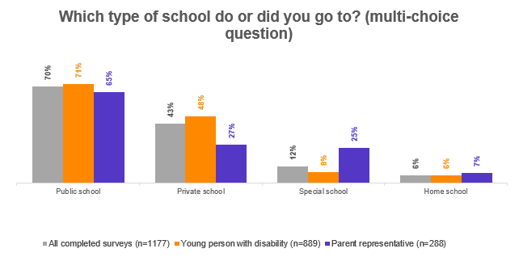
Figure 7 shows the schools respondents attend or have attended (multiple answers possible). Based on all completed surveys, 70% of respondents selected public school, 43% private school, 12% special school and 6% home school.

Figure 8: Situation of respondents
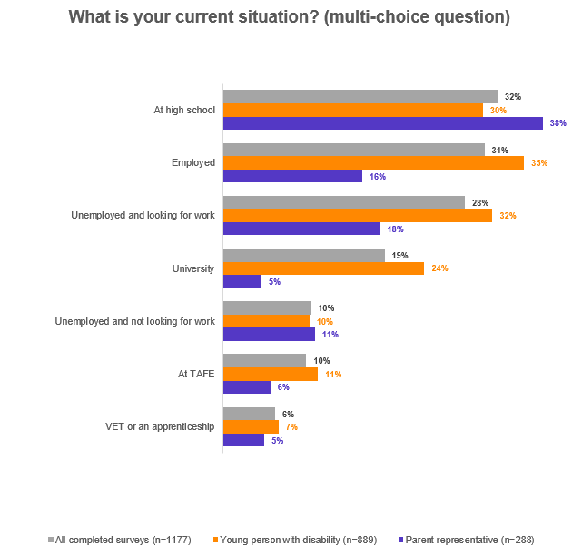
Figure 8 shows respondents current situation (multiple answers possible). Based on all completed surveys, 32% of respondents were at high school, 31% were employed, 28% were unemployed and looking for work, 19% were at university, 10% were unemployed and not looking for work, 10% were at TAFE and 6% were undertaking VET or an apprenticeship.

Figure 9: Level of responsibility
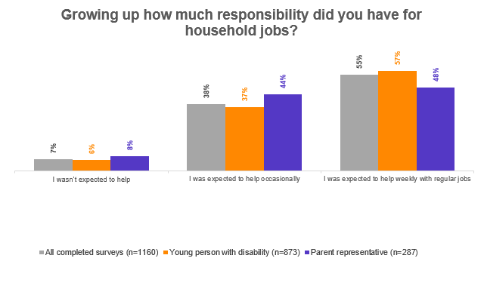
Figure 9 shows the level of responsibility respondents had for household chores while growing up. Based on all completed surveys, 7% of respondents were not expected to help, 38% were expected to help occasionally and 55% were expected to help weekly with regular jobs.

Employment and background information

Key learnings: Background and attitudes towards employment
- Nine in ten young people with disability want to be employed. Of those who want to be employed, 7 out of 10 would prefer to be an employee while the remaining 3 out of 10 would prefer to be self-employed.
- Females were most likely to want to be employed (95%) and those who identify as non-binary were least likely to want to be employed (83%). Ninety-one per cent of males wanted to be employed.
- Females were also more likely to prefer being employees (72%) than males (64%), instead of being self-employed.
- Those who identified as non-binary were significantly more likely to want to be self-employed (42% compared to 33% males and 26% females).
- Nearly two-thirds of respondents began considering the prospect of having a job before the age of 16. Nearly half of the respondents who completed the survey themselves said they started thinking about a job before the age of 10.
- The age males and females started considering the prospect of having a job was statistically different. Forty-nine per cent of young females with a disability considered having a job as early as 5-10 years old, as opposed to 30% of males. On the other hand, 29% of males started considering having a job between 16-20 years old, as opposed to 16% of females.
- Those expected to help weekly with household responsibilities were more likely to consider having a job at an early age. Forty-six per cent first started considering having a job at 5-10 years old, as opposed to 33% of those who were not expected to help with household work.
Figure 10: Employment desire
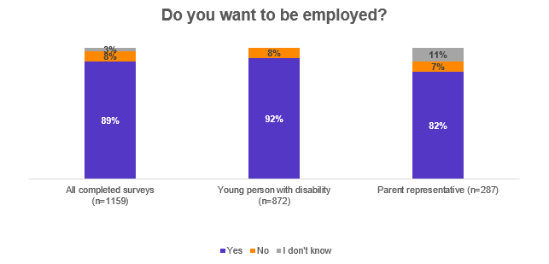
Figure 10 shows respondents desire to be employed. Based on all completed surveys, 89% of respondents want to be employed, 8% did not want to be employed and 3% said they didn’t know.
Figure 11: Preferred employment
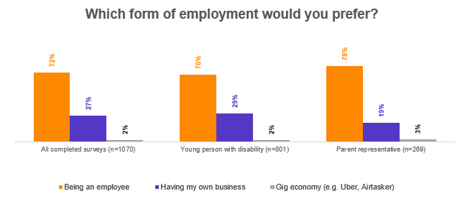
Figure 11 shows respondents preferred type of employment. Based on all completed surveys, 72% of respondents want to be an employee, 27% want to have their own business and 2% want to work in the gig economy.
Figure 12: Considering a job
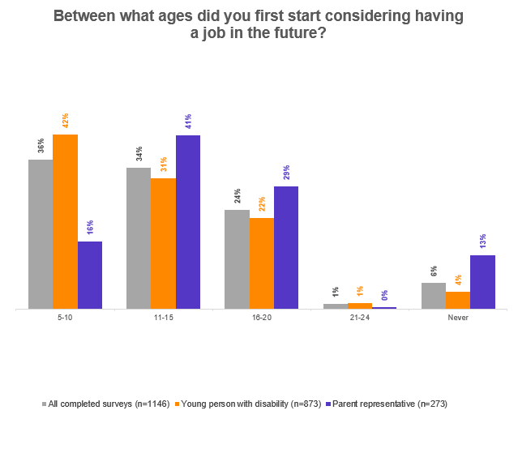
Figure 12 shows the age respondents first considered having a job. Based on all completed surveys, 36% first thought about it between ages 5 and 10, 34% between ages 11 and 15, 24% between ages 16 and 20, 1% between ages 21 and 24, and 6% never considered having a job.

Key learnings: Why don’t they want to be employed?
- Overall, 1 in 12 respondents said they did not want to find employment.
- The top reason for not wanting to be employed was a lack of social skills. However, those with a disability who completed the survey themselves were equally concerned about being treated poorly and having to ask an employer for adaptations to meet their needs.
- Nearly half of the respondents said a lack of motivation was a factor for being unemployed, or the belief that a suitable job does not exist.
- Roughly 1 in 3 respondents who were not looking for employment said:
  - They do not have the skills to work.
  - It is too hard to get a job.
  - They do not know where to get the support they need.
  - They do not believe they can get a job.
Figure 13: Reasons for not wanting employment
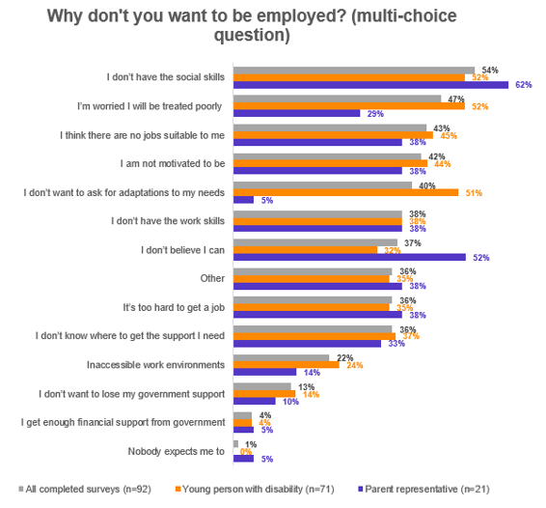
Figure 13 shows why respondents don’t want to be employed (multiple answers possible). Based on all completed surveys, 54% of respondents said they don’t have the social skills; 47% were worried about being treated poorly; 43% think there aren’t any suitable jobs; 42% aren’t motivated; 40% don’t want to ask for adaptations; 38% said they don’t have the work skills; 37% don’t believe they can; 36% said other reasons; 36% said it’s too hard; 36% said they don’t know where to get support; 22% cited inaccessible work environments; 13% said they don’t want to lose government support; 4% said they get enough money from government; and 1% said nobody expects them to.

Key learnings: Who are the biggest sources of encouragement?
- Encouragement to find employment mostly came from family and carers.
- Roughly half of the young people/parents said encouragement was also provided by their school.
- Nearly half of young people with a disability said their friends encouraged them to find employment, in comparison to only a quarter of parents who think their child’s friends are positive influencers.
- One quarter of young people with a disability said they have a role model who encourages them.
- One in ten young people with disability and 1 in 20 parents said that nobody provides them with encouragement to find employment.
- Those who identified as non-binary were significantly less likely to have family/carers encouragement (20%).
- Males were more likely to receive encouragement to find employment from disability support workers (19%) than females (11%).
- Non-binary respondents were more likely to use employment service workers (25%) compared to 12% of females and 15% of males.
Figure 14: Sources of encouragement
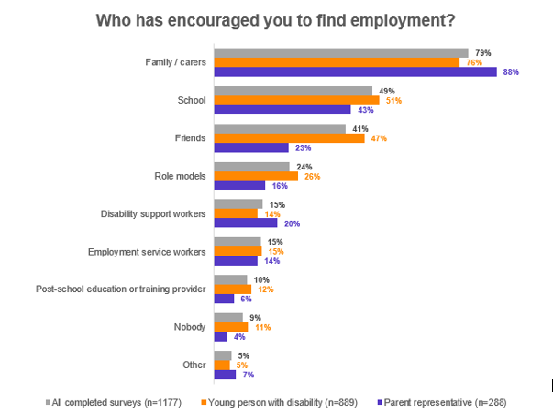
Figure 14 shows the sources of encouragement for respondents to find employment (multiple answers possible). Based on all completed surveys, 79% of respondents selected families/carers, 49% said school, 41% said friends, 24% selected role models, both disability support workers and employment service workers were selected by 15% of respondents, 10% said a post-school or training provider, 9% said nobody and 5% answered other.

Experiences at school

Key learnings: Preparation for post-school employment
- Nearly half of respondents did not have a paid job whilst at school.
- Of those that did, 1 in 3 were helped by family/carers to get a job. The data shows that family/carers provided the greatest support in this area.
- Out of the respondents who completed the survey themselves, 1 in 6 said nobody helped them.
- Males were more likely to get support finding employment from disability support workers than females (4% males and 1% females). Males were also more likely to get support finding employment from employment services than females (4% vs 2%).
- Those not expected to help with household jobs were significantly more likely to be respondents who did not have a paid job whilst at school (58%), as opposed to 38% of those who were expected to help weekly and 47% of those who were expected to help occasionally with household jobs.
- Those living in rural areas were significantly more likely to get family/carers support to get a paid job (56%), as opposed to 36% across all location groups.
- Ages 16 to 17 were the most common ages to start planning the transition into post-school employment.
- Nearly half of respondents said they did some form of tertiary studies at school, and 1 in 3 said they did volunteer work. Very few said they did any form of traineeship or apprenticeship at school.
- Males were more likely to do apprenticeships (6%) and traineeships (10%) than females (3% and 4% respectively). Females on the other hand were more likely to do volunteer work (42%) than males (33%).
- One in three respondents did not do any type of tertiary studies, apprenticeship, traineeship or volunteering whilst at school.
- Half of these respondents said it was because they were not interested in doing them, and one-quarter said it was because they were not offered.

Figure 15: Sources of help to get a job
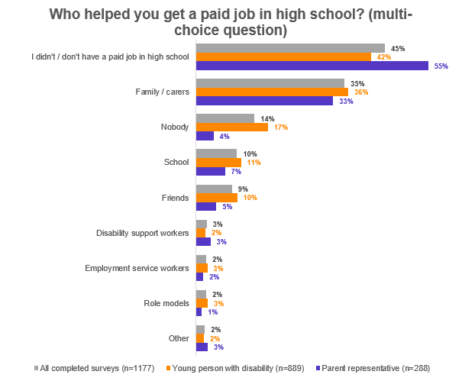
Figure 15 shows the sources that helped respondents get a paid job in high school (multiple answers possible). Based on all completed surveys, 45% of respondents said they didn’t have a paid job in high school, 35% said that family/carers helped them, 14% answered nobody, 10% said their school helped, 9% indicated friends, 3% answered disability support workers and 2% (each) said employment service workers, role models or other.

Figure 16: Planning the transition to work
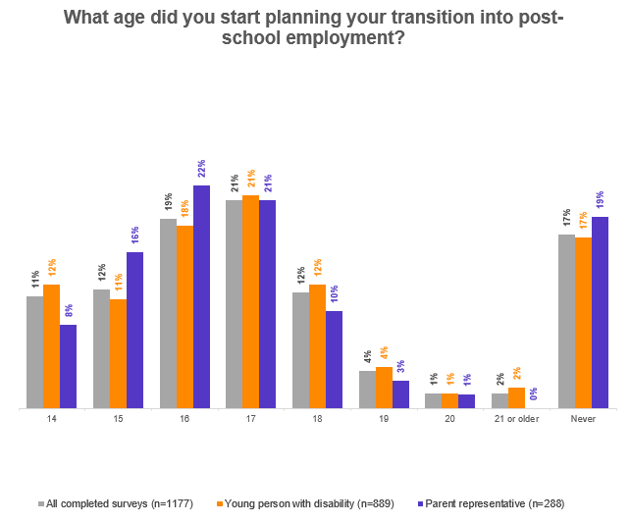
Figure 16 shows the age respondents started planning their transition into post-school employment. Based on all completed surveys, 11% commenced at age 14, 12% at 15 and 18, 19% at 16, 21% at 17, 4% at 19, 1% at 20, 2% at 21 or older and 17% said they never started planning their transition to work.

Figure 17: Work-related extracurricular
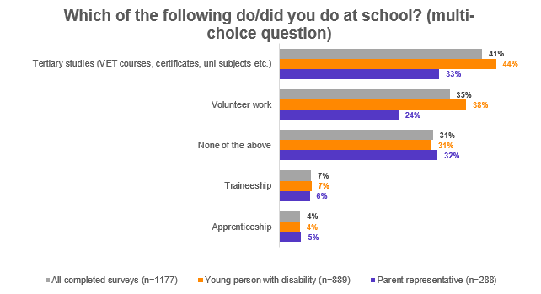
Figure 17 shows the work-related extracurricular that respondents undertook while at school (multiple answers possible). Based on all completed surveys, 41% of respondents undertook tertiary studies while at school, 35% did volunteer work, 31% did no work-related extracurricular, 7% did a traineeship and 4% undertook an apprenticeship.
Figure 18: Reasons for not doing work-related extracurricular
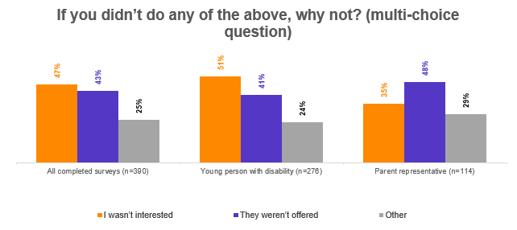
Figure 18 shows the reasons that respondents did not undertake any work-related extracurricular while at school (multiple answers possible). Based on all completed surveys, 47% weren’t interested, 43% said it wasn’t offered to them and 25% provided other reasons.

Key learnings: Formal work experience whilst at school
- Fifty-eight per cent of all respondents said they took part in a form of work experience whilst at school, mostly on their own rather than being part of a group.
- Two thirds of those who did work experience at school said the experience matched their likes, interests, passions and skills.
- Age was related to work experience not matching likes, interests, passions and skills with respondents aged 21 and 22 more likely to answer no.
- Those with a psychosocial disability were less likely to say their work experience matched their likes, interests, passions and skills (56% vs average of 64%).
- Respondents from South Australia were significantly more likely to say yes (79%).
- A third of those who did work experience tried different type of jobs.
- This increased significantly to 58% when work experience was done ‘in a group and by myself’.
- Males were significantly more likely to try out different types of jobs through their work experience programs than females (41% males vs 27% females).
- Those who attended a special school (56%) and those who had the assistance of role models in organising their work experience (65%) were more likely to say yes to trying out different types of jobs.
- Forty-two per cent of all young people/parent representatives said they did not do any formal work experience whilst they were at school.
- Half of these respondents said the reason was because it was not offered to them.
- Therefore, out of the entire sample, 1 in 5 were not offered work experience opportunities at school.
- About 1 in 12 of the entire sample did not want to take a work experience opportunity.

Figure 19: Work experience opportunities
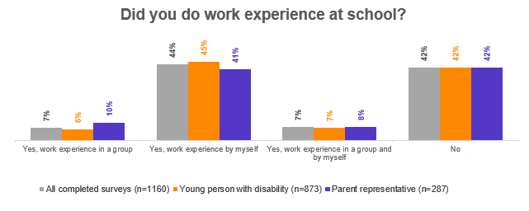
Figure 19 shows the work experience opportunities that respondents had while at school. Based on all completed surveys, 7% of respondents said they did work experience in a group, 44% said they did work experience by themselves, 7% said both by themselves and in a group and 42% said they didn’t do any work experience.
Figure 20: Suitability of work experience
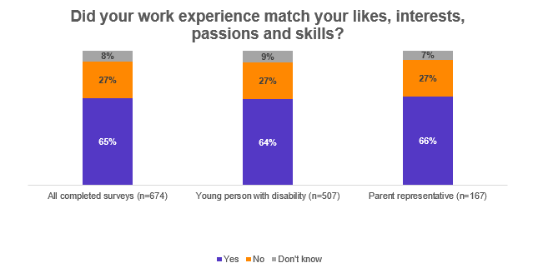
Figure 20 shows respondents opinion on whether their work experience opportunities matched their likes, interests, passions and skills. Based on all completed surveys, 65% said that it did, 27% said that it didn’t and 8% said they didn’t know.

Figure 21: Variety of work experience
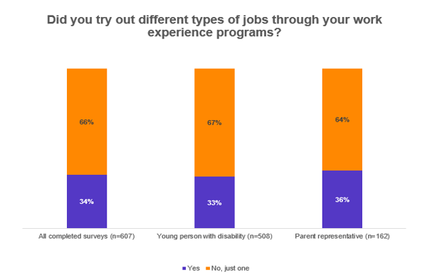
Figure 21 shows the opportunity of respondents to undertake different jobs through their work experience. Based on all completed surveys, 34% said they tried different jobs and 66% said they only tried one job.

Figure 22: Reasons for not undertaking work experience
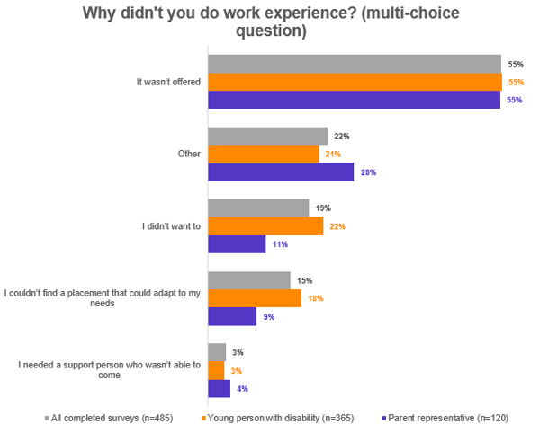Figure 22 shows why respondents did not undertake work experience at school (multiple answers possible). Based on all completed surveys, 55% said it wasn’t offered, 22% said other reasons, 19% said they didn’t want to, 15% said they could find a placement that could adapt to their needs and 3% said they needed a support person who couldn’t come.

Key learnings: Enablers of work experience opportunities
- About three-quarters of those who did work experience at school said their school helped them organise it, while roughly half also said their family/carer helped. They were the two main organisers of work experience for young people with disability.
Figure 23: Enablers of work experience opportunities
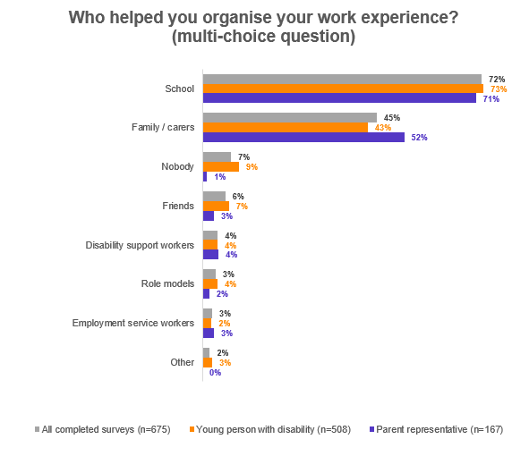Figure 23 shows the sources that helped respondents organise their work experience (multiple answers possible). Based on all completed surveys, 72% said their school helped, 45% answered family/carers, 7% said nobody, 6% said friends, 4% selected disability support workers, 3% selected both role models and employment service workers and 2% said other.

Key learnings: Equality at school with career development
- Overall, only half of young people with a disability felt their school offered them the same level of career development as students without a disability. Parents had a lower perception of this, with only one third feeling their child had equal career development opportunities.
- One in four respondents said the career development opportunities available were at a lower level than those offered to students without a disability.
- One in five respondents said they were not offered any career development opportunities at all.
- Those with an intellectual disability were less likely to say they received an equal level of career advice.
Figure 24: Career development
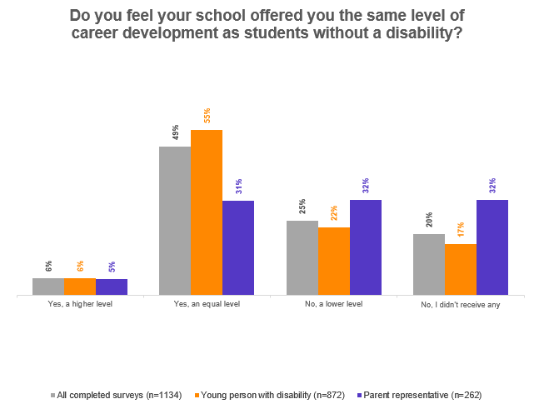
Figure 24 shows respondents opinion on the level of career development support they received in comparison to students without disability. Based on all completed surveys, 6% of respondents believe they received a higher level, 49% said an equal level, 25% said a lower level and 20% said they didn’t receive any career development support.

Career support systems

Key learnings: Sources of guidance
- Parents and young people had different perspectives on who had shown them how to turn their interests, likes, passions and skills into a career.
- Parents said that family/carers were significantly more likely to do this (77%) compared to young people with disability who said their parents/carers helped with this (48%).
- Young people with disability said that friends and role models played a large part in this too.
- One in seven respondents said that nobody had showed them how to turn their interests, likes, passions and skills into a career, and 1 in 6 said that nobody had introduced them to a role model or mentor.
- Males were more likely to get support turning their interests, likes, passions and skills into a career from disability support workers (14%) and employment service workers (8%) than females (5% and 4% respectively).
- Young people with disability who didn’t know how to turn their interests, likes, passions and skills into a career or who said nobody had helped them with this were more likely to not want to be employed (16% and 12% respectively, as opposed to the average of 6% who had help from someone doing this).
- Similar to the previous question, parents and young people had different perspectives for who had introduced them to role models.
- Parents said that family/carers were twice as likely to introduce their children to role models and mentors (64%) compared to young people with disability (32%) who said their parents/carers did this.
- Young people with disability who had a family member/carers or their school introduce them to role models were more likely to want to be employed (98% and 95%) compared to those who hadn’t met any role models (87%).

Figure 25: Sources of guidance for career options
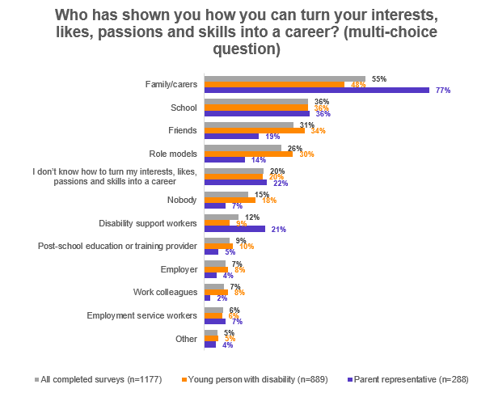
Figure 25 shows the sources that supported respondents to turn their interests, likes, passions and skills into a career (multiple answers possible). Based on all completed surveys, 55% of respondents received guidance from their family/carers; 36% from their school; 31% from friends; 26% from role models; 20% said they don’t know how to turn their interests, likes, passions and skills into a career; 15% said that nobody showed them; 12% said disability support workers; 9% selected a post-school education or training provider; both employers and work colleagues were selected by 7% of respondents; 6% said an employment service worker and 5% answered other.

Figure 26: Introduction to role models
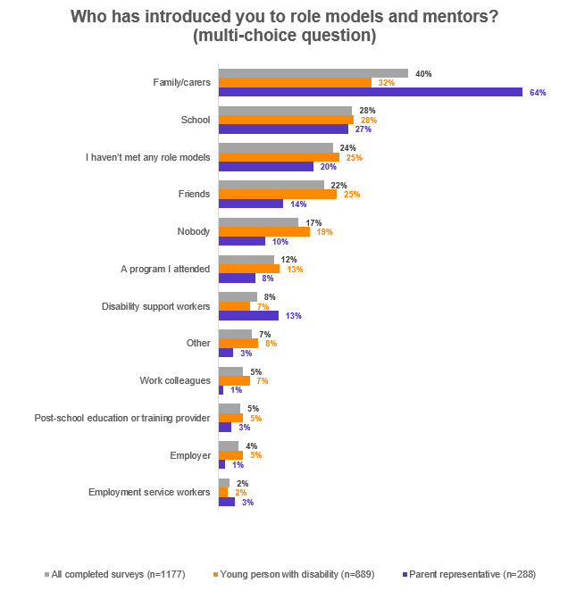
Figure 26 shows the sources that introduced respondents to role models and mentors (multiple answers possible). Based on all completed surveys, 40% of respondents answered family/carers; 28% said their school; 24% said they haven’t met any role models; 22% said friends; 17% said nobody; 12% answered a program they had attended; 8% said disability support workers; 7% selected other reason; both work colleagues and a post-school education or training provider were selected by 5% of respondents; 4% said their employer and 2% answered an employment service worker.

Key learnings: Identifying opportunities
- Parents and young people had different perspectives about who is helping them the most to identify employment opportunities and the skills they might need in their career. Parents said that family/carers were the main, and potentially only, source of support to help them identify career and skill development opportunities, whereas young people said that school and friends played an almost equally large role.
- One in five of all respondents said that nobody had helped them identify local employment opportunities and 1 in 6 said they don’t know about local employment opportunities.
- One in six of all respondents said that nobody had helped them identify the skills they could learn to aid their career, and 1 in 7 said they don’t know what new skills they need.
- Males (13%) were more likely to be assisted by disability support workers in identifying opportunities in their local areas than females (6%).
- Those who were not expected to help with jobs at home were also more likely to say nobody (40%) had helped them identify local employment opportunities.
- Those who said they don’t know about employment opportunities in their local area were also more likely to say they don’t want to be employed.
- Those who selected they ‘don’t know the new skills they need’ or ‘nobody helped them’ were also more likely to say they don’t want to be employed.
- Those who said school had helped them identify new skills were more likely to say they wanted to be employed.
- Males were more likely to have disability support workers help them identify new skills than females (12% vs 6% respectively).

Figure 27: Sources of guidance – employment opportunities
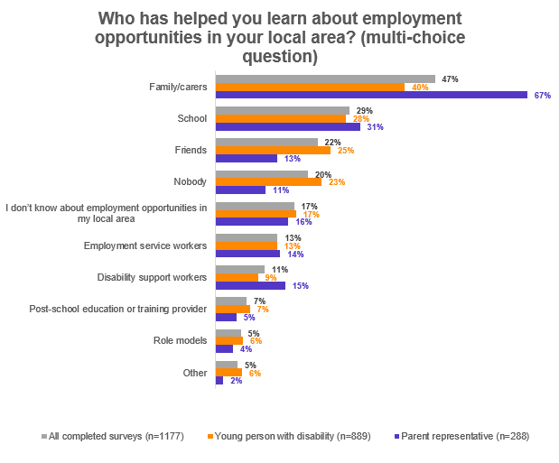
Figure 27 shows the sources that helped respondents learn about local employment opportunities (multiple answers possible). Based on all completed surveys, 47% of respondents selected family/carers; 29% said their school; 22% said friends; 20% said nobody; 17% said they didn’t know about local employment opportunities; 13% selected employment service workers; 11% answered disability support workers; 7% selected a post-school education or training provider; and both role models and other were selected by 5% of respondents.

Figure 28: Sources of guidance – new skills
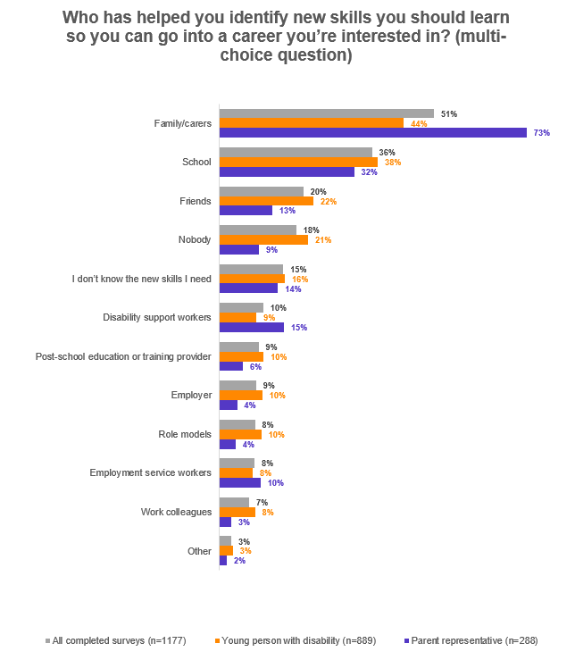
Figure 28 shows the sources that helped respondents identify new skills for their career (multiple answers possible). Based on all completed surveys, 51% of respondents selected family/carers; 36% said their school; 20% selected friends; 18% said nobody helped them; 10% said disability support workers, both a post-school education or training provider and employers were selected by 9% of respondents; role models and employment service workers were both selected by 8% of respondents; 7% said work colleagues and 3% said other.

Key learnings: Support to create a career plan
- Family/carers and school were the main sources of support to help young people with disability to create a career plan.
- One in five said that nobody had helped them with their career plan.
- One in five said they do not have a career plan at all.
- Unlike the other questions in this section, friends didn’t offer as much support.
- Respondents from Victoria were significantly more likely to have received support with a career plan from school (44% in Victoria compared to the average of 35%).
Figure 29: Career plans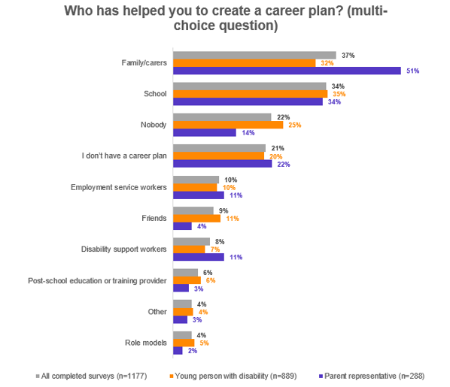Figure 29 shows the sources that helped respondents develop a career plan (multiple answers possible). Based on all completed surveys, 37% selected family/carers; 34% said their school; 22% said nobody helped them; 21% said they don’t have a career plan; 10% selected employment service workers; 9% said friends; 8% said disability support workers; 6% selected a post-school education or training provider; and both role models and other were selected by 4% of respondents.

Levels of confidence

Key learnings: Activities where more confidence is required
- Parents indicated their child had much lower levels of confidence than young people indicated about themselves.
- Two in three young people with disability and 3 in 4 parents said they were not confident to express their needs to their boss/manager. This insight is similar to another cited earlier in the report where half of young respondents who did not want to be employed said this was due to concerns about asking an employer for adaptions to suit their needs.
- About half of the entire sample said they were not confident with doing job interviews, connecting with employment service providers, driving, and talking on the phone.

Figure 30: Confidence in undertaking work-related activities
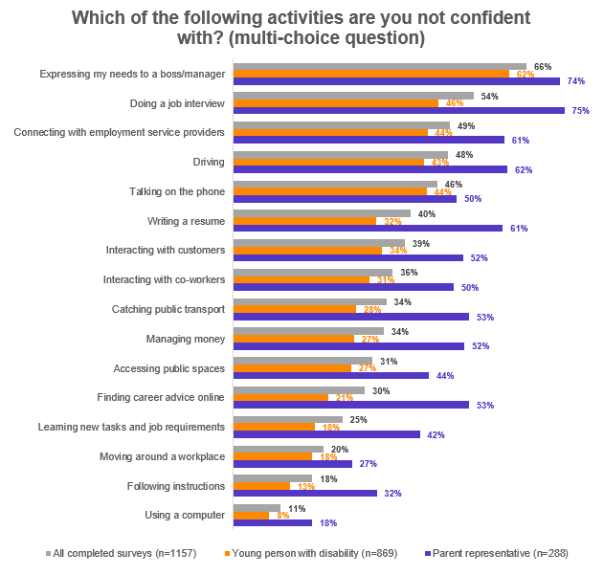
Figure 30 shows the work-related activities that respondents identified they were not confident with (multiple answers possible). Based on all completed surveys, 66% of respondents selected expressing my needs to a boss; 54% said doing a job interview; 49% selected connecting with employment service providers; 48% said driving; 46% talking on the phone; 40% writing a resume; 39% interacting with customers; 36% interacting with co-workers; both catching public transport and managing money were selected by 34% of respondents; 31% said accessing public spaces; 30% said finding career advice online; 25% said learning new tasks/job requirements; 20% selected moving around the workplace; 18% said following instructions; and 11% said using a computer.

- The table below provides a breakdown of disability types and the activities where respondents are lacking confidence. Statistically significant differences are highlighted.
- Dark blue signifies those who were more likely to say they were not confident with an activity, and light green those who were less likely to say they were not confident with an activity (when compared to the average of the total responses received).
Table 1: Activities respondents are not confident with (by disability type)
Disability type (across) /  Activity (down) | Developmental | Intellectual | Neurological | Psychosocial | Physical | Sensory | Average
Accessing public spaces | 30% | 27% | 31% | 33% | 33% | 32% | 31%
Catching public transport | 29% | 32% | 36% | 31% | 37% | 31% | 33%
Connecting with employment service providers | 49% | 46% | 42% | 53% | 47% | 48% | 48%
Doing a job interview | 54% | 67% | 39% | 53% | 40% | 52% | 51%
Driving | 47% | 59% | 59% | 47% | 48% | 45% | 51%
Expressing my needs to a boss / manager | 67% | 54% | 62% | 74% | 64% | 58% | 63%
Finding career advice online | 23% | 46% | 28% | 25% | 26% | 26% | 29%
Following instructions | 18% | 29% | 17% | 16% | 9% | 19% | 18%
Interacting with co-workers | 42% | 46% | 22% | 38% | 22% | 29% | 33%
Interacting with customers | 43% | 46% | 28% | 40% | 24% | 35% | 36%
Learning new tasks and job requirements | 25% | 34% | 22% | 23% | 18% | 21% | 24%
Managing money | 34% | 42% | 36% | 31% | 23% | 24% | 32%
Moving around a workplace | 18% | 15% | 19% | 21% | 31% | 19% | 21%
Talking on the phone | 50% | 44% | 51% | 56% | 34% | 44% | 47%
Using a computer | 9% | 17% | 10% | 10% | 9% | 7% | 10%
Writing a resume | 39% | 54% | 36% | 38% | 26% | 38% | 39%

Key learnings: Confidence to have a successful career as an adult
- The results for this question were not significantly different between young people and parents.
- Overall, a quarter of young people and parent representatives strongly agreed that they were confident they could have a productive and successful career throughout their adult life.
- In total 62% of young people and 58% of parents said they ‘strongly agree’ and ‘somewhat agree’ with this statement.
- Overall, a quarter of respondents said they ‘strongly disagree’ or ‘somewhat disagree’ with this statement.
- Parents were more likely to say they ‘strongly disagree’ than young people.
- Those with a neurological disability were less likely to agree with the statement.
Figure 31: Confidence in future career
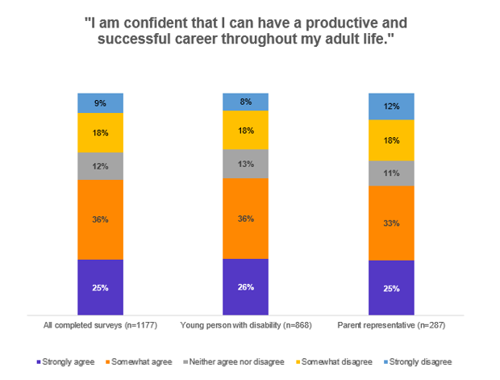
Figure 31 shows the level of confidence respondents have for a productive and successful career throughout their adult life. Based on all completed surveys, 25% of respondents strongly agree with the statement, 36% somewhat agree, 12% neither agreed nor disagreed, 18% somewhat disagreed and 9% strongly disagreed.

Levels of control

Key learnings: Overall
- Roughly two-thirds of young people with a disability said they have total control or a lot of control over their school subject choices, post-school choices and their career choices. However, the remaining third have little or no choice about these aspects of their life.
- Just over half (56%) had total control or a lot of control over their work experience choices but the remaining 44% had little or no control at all.
- Those with an intellectual disability were more likely to have less input across these four areas.
Figure 32: Control over work-related choices
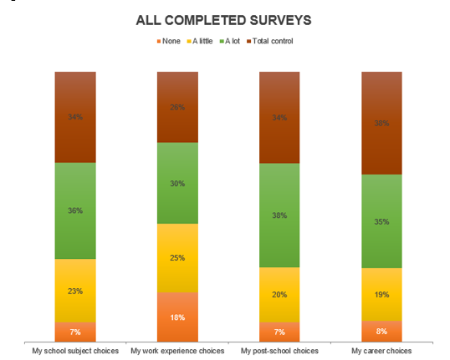Figure 32 shows how much control respondents believe they have over different work-related aspects of their lives. Graph breaks down responses from all completed surveys. For school subject choices, 7% said they are no control, 23% said a little, 36% said a lot and 34% said total control. For work experience choices, 18% said no control, 25% said a little, 30% said a lot and 26% said total control. For post-school choices, 7% said no control, 20% said a little, 38% said a lot and 34% said total control. For career choices, 8% said no control, 19% said a little, 35% said a lot and 38% said total control.

Key learnings: Young respondents vs parents
- Young respondents said they had more control over all four aspects of their life than parents indicated about their own child.
Figure 33: Control over work-related choices – young people with disability
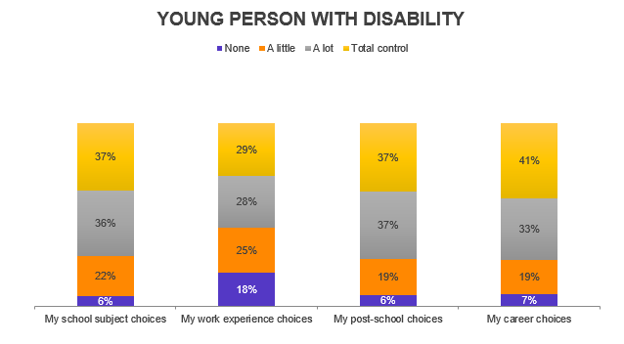
Figure 33 shows how much control young people with disability believe they have over different work-related aspects of their lives. For school subject choices, 6% said they are no control, 22% said a little, 36% said a lot and 37% said total control. For work experience choices, 18% said no control, 25% said a little, 28% said a lot and 29% said total control. For post-school choices, 6% said no control, 19% said a little, 37% said a lot and 37% said total control. For career choices, 7% said no control, 19% said a little, 33% said a lot and 41% said total control.

Figure 34: Control over work-related choices – parent representatives
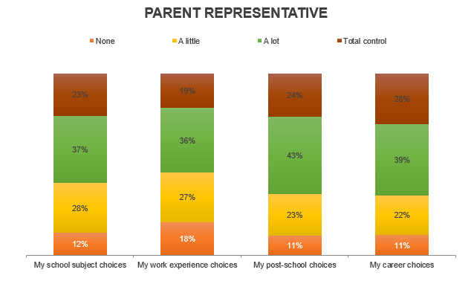
Figure 34 shows how much control parents believe their young person has over different work-related aspects of their lives. For school subject choices, 12% said they have no control, 28% said a little, 37% said a lot and 23% said total control. For work experience choices, 18% said no control, 27% said a little, 36% said a lot and 19% said total control. For post-school choices, 11% said no control, 23% said a little, 43% said a lot and 24% said total control. For career choices, 11% said no control, 22% said a little, 39% said a lot and 28% said total control.

Channels to access information

Key learnings: Preferences of young people with disability
- Young respondents preferred to access written articles or informative videos about career information.
- These forms of media were favoured by at least twice as many as those interested in live webinars or podcasts.
- Two-thirds said they would prefer an in-person careers expo/job fair to an online one.
Figure 35: Preferred type of online career information
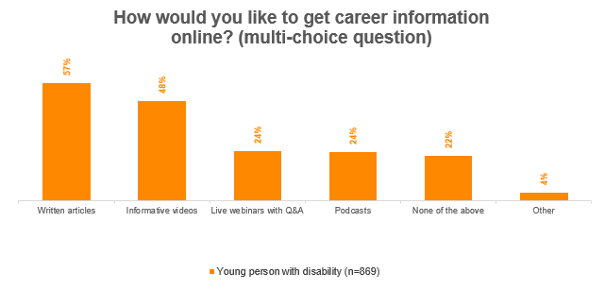
Figure 35 shows the type of online career information that young people with disability want (multiple answers possible). For young respondents, 57% preferred written articles, 48% selected informative videos, both live webinars with Q & A and podcasts were selected by 24% of young people, 22% said none of the available choices and 4% provided other responses.

Figure 36: Career expo / job fair preference
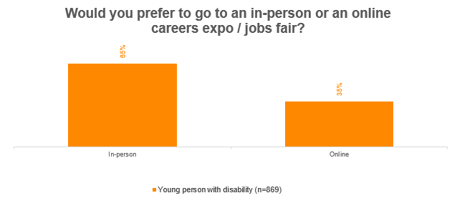
Figure 36 shows that 65% of young respondents prefer in-person career expos and job fairs, compared to 35% who prefer an online format.

Key learnings: Preferences of parents
- Access to a disability employment expert was the top requirement parents needed to support their child’s career development, followed by the availability of career development guides, tools, resources and online information.
- Parents mainly searched for information online to gain advice about ways to support their child with their career, and half of them turn to family, friends or colleagues. These were the two primary channels they use to find information.
- Less than a quarter of parents said they went to their child’s school for career development support information for their child.
Figure 37: Supports for parents of young people with disability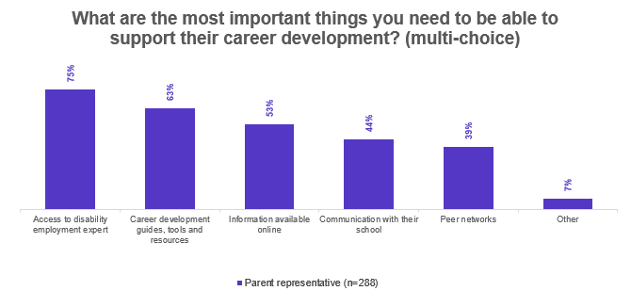
Figure 37 shows the supports parents of young people with disability need to assist in their child’s career development (multiple answers possible). Of parent respondents, 75% want access to a disability employment expert, 63% want career development guides, tools and resources, 53% want information available online, 44% want communication with their child’s school, 39% want access to peer networks and 7% provided other responses.

Figure 38: Sources of information for parents of young people with disability
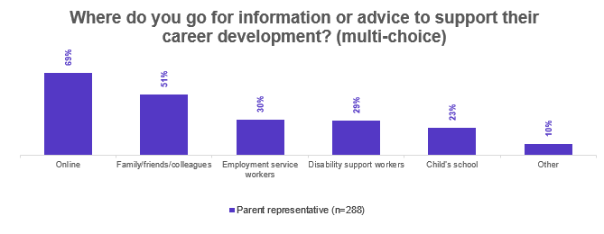
Figure 38 shows where parents of young people with disability prefer to go for information and advice to support their young person’s career development (multiple answers possible). For parents, 69% go online, 51% ask family/friends/colleagues, 30% said employment service workers, 29% selected disability support workers, 23% said their child’s school and 10% provided other responses.

