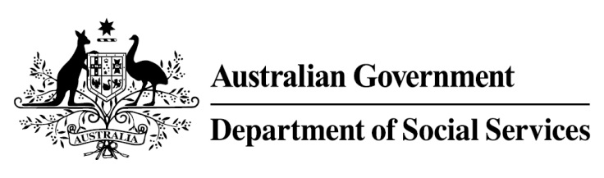

Try, Test and Learn Fund

Initiative: Career Skills for New Jobs

Location: New South Wales

Fast facts
Note: This project has ended.
Priority group: Older unemployed
Target participant number: 250
(Actual number: 71)
Locations: South-Western Sydney.
Trial period: 12 months
Total funding: $2.98 million
Service provider: PricewaterhouseCoopers with EML, ReadyTech and Esher House
Potential future saving: If around 49 per cent (35) of participants move off income support because of this project, the savings to the welfare system are likely to outweigh the costs of the project.
Using insights from the Priority Investment Approach, the Try, Test and Learn Fund is gathering evidence on new or innovative approaches to addressing barriers to work.
The Try, Test and Learn Fund will help achieve the objectives of welfare reform — that is, to develop a modern welfare system that increases the capacity of individuals, reduces the risk of welfare dependency and maintains a strong welfare safety net.

What were we trying to achieve?
To support older jobseekers to re-enter and stay in the workforce by equipping them with the skills and confidence they need to manage their own careers. The project also sought to engage employers to understand their challenges with recruiting and retaining older jobseekers.

What was Career Skills for New Jobs?
Participants were referred to this project through jobactive providers. Participants were linked to career practitioners. Using diagnostic tools specifically designed for this cohort, the career practitioner worked one-on-one with each participant to help them understand their existing skillset and gain awareness of potential future career pathways. The career practitioner also provided one-on-one assistance on how to effectively search for jobs and interview techniques.
Using an online career management tool, participants received guidance on how to manage their career trajectories. This could include developing their CVs, information on local employment and training opportunities, or other services to improve their health, wellbeing and financial literacy.

What does the evidence tell us?
- Many unemployed older Australians want to work but struggle to find or stay in work.
- Australians are on average living into their 80s, and older jobseekers may draw on income support payments for many years.
- If nothing changes, 75 per cent of this group will be receiving income support payments in 10 years, and 74 per cent will be receiving income support payments in 20 years.

How was this initiative new and innovative?
This project combined personalised, career coaching and guidance with access to an online Career Management Tool — to help older jobseekers build the skills and confidence to self-manage their career, and connect them to a network of existing tools, information and resources to help them find and stay in work.

