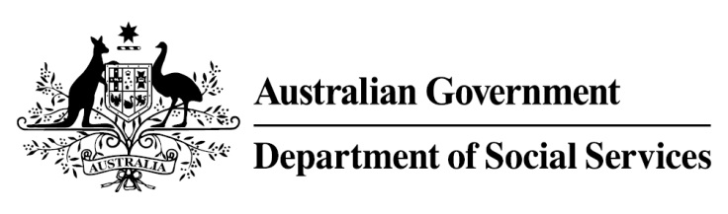

Try, Test and Learn Fund

  - Career Readiness for Young Parents
Using insights from the Priority Investment Approach, the Try, Test and Learn Fund is trialling new and innovative approaches to assist groups of people at risk of long-term welfare dependence.
The Try, Test and Learn Fund will help achieve the objectives of welfare reform — that is, to develop a modern welfare system that increases the capacity of individuals, reduces the risk of welfare dependency and maintains a strong welfare safety net.

What does the evidence tell us?

Fast facts
Priority group: Young parents
Target participant number: 110
Location: Mandurah and Rockingham, Western Australia
Trial period: 37 months
Total funding: $1.42 million
Co-designers: Bridging the Gap, Australasian Housing Institute and Ruah Community Services
Service providers: Bridging the Gap Inc
Potential future saving: The purpose of these initiatives is to test whether an intervention works to reduce long-term reliance on welfare. If 8 per cent of participants (9) move off welfare, the savings to the welfare system are likely to outweigh the costs.
Note: Due to changes in circumstances, adjustments have been made to target participant numbers, trial period and total funding.

- In 2016, there were 3,760 young parents in Australia aged 18 or under receiving Parenting Payment. On average, these young parents are likely to be on income support for around 48 years over their future lifetime.
- If nothing changes for these young parents, 79 per cent will be receiving income support payments in 10 years, and 57 per cent will be receiving income support payments in 20 years.
- In addition, analysis shows around 620 current young parents will remain on income support for the rest of their lives.

What is Career Readiness for Young Parents?
Young parents are paired with a case manager to support them to improve their job readiness. The case manager provides advice and assistance on the development of a career path, and works with each young parent to increase their understanding of expectations within a work environment.
Young parents are also provided with work experience opportunities, and will be assisted in finding local child care places.

What are we trying to achieve?
Empower young parents to address barriers to their employment and gain critical skills for future work.
Achieving this will make the young parents more likely to achieve long-term employment and financial independence, which will in turn help their children have better life outcomes.

How is this initiative new and innovative?
The innovation in this initiative is delivery of intensive support to young parents from a trusted advisor; and the focus on non-vocational barriers to employment, such as developing a work mindset, or assisting with housing stability, financial management, justice system problems, or social/emotional wellbeing.

