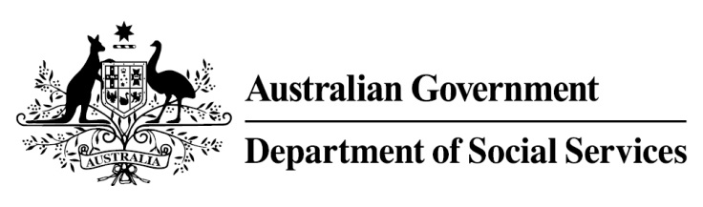

Try, Test and Learn Fund

Initiative: The Australian Way

Location: New South Wales and Victoria
Using insights from the Priority Investment Approach, the Try, Test and Learn Fund is gathering evidence on new or innovative approaches to addressing barriers to work.
The Try, Test and Learn Fund will help achieve the objectives of welfare reform — that is, to develop a modern welfare system that increases the capacity of individuals, reduces the risk of welfare dependency and maintains a strong welfare safety net.

What were we trying to achieve?

Fast facts
Note: This project has ended.
Priority group: Migrants and refugees
Target participant number: 500 (Actual number: 662)
Locations: NSW and VIC
Trial period: 16 months
Total funding: $1.23 million
Service provider: Our HR Company
Potential future saving: The purpose of these initiatives is to test whether interventions work to reduce long-term reliance on welfare. If around two per cent of participants (15) move off income support because of this project, the savings to the welfare system are likely to outweigh the costs of the project.
This initiative was designed to test whether an app-based approach can support the orientation employment module of the Humanitarian Settlement Program to improve work readiness and employment outcomes for humanitarian entrants.

What was The Australian Way?
Participants completed the orientation employment module of the Humanitarian Settlement Program with access to an app to support their learning. This element provided information about Australian workplace culture and expectations, and how to prepare for and look for a job.

Information was provided through animated storytelling in English and four other languages in the app and in hard copy. The app also helped participants to prepare resumes and applications, access other job-seeking support and attend English language classes.

What does the evidence tell us?
- While many migrants and refugees successfully gain employment within the first few years of arrival, a small group continue to struggle and is at elevated risk of long-term welfare dependence.

- On average, migrants and refugees who currently receive income support are likely to receive income support payments in 30 years over their future lifetime.

- If nothing changes, 56 per cent of this group will be receiving income support payments in 10 years, and 52 per cent will be receiving income support payments in 20 years.

How was this initiative new and innovative?
This was the first time that an app of this nature has been trialled or delivered for migrants and refugees in Australia.

