Targeted Compliance Framework: Mutual Obligation Failure Guidelines

V 1.3
Disclaimer
This document is not a stand-alone document and does not contain the entirety of Disability Employment Services Providers' obligations. It should be read in conjunction with the Disability Employment Services Grant Agreement and any relevant guidelines or reference material issued by the Department of Social Services under or in connection with the Disability Employment Services Grant Agreement.

Table of Contents
Targeted Compliance Framework Guidelines 1
Table of Contents 2
Document Change History 3
Background 3
Disability Employment Services Grant Agreement Clauses: 4
Reference documents relevant to this Guideline: 4
Explanatory Note: 4
1. The Targeted Compliance Framework 5
2. Accruing Demerits and moving into the Warning Zone 6
Acceptable Reason 8
Provider may manually remove confirmed Demerits 11
3. Setting a Re-emgagement Requirement 12
Managing Multiple Re-engagement Requirements 12
Re-engagement Requirement automatically set 12
Formally notifying the Participant of their Re-engagement Requirement 13
Participant is Unable to Re-engage within two Business Days 13
Certain Re-engagement Requirements not subject to two Business Days’ rule 13
Re-engagement not required or not appropriate 13
Rescheduling the Re-engagement Requirement 14
4. The Capability Interview 14
5. The Capability Assessment 15
Participant fast-tracked to Capability Interview or Capability Assessment 15
Other Failures that must be reported to Services Australia 15
6. In the Penalty Zone 16
7. Participant exits the Penalty Zone after fully meeting requirements for three months 16
8. Different processes for some Mutual Obligation Failures in the Warning and Penalty Zones 17
9. Participant may lodge a complaint about Demerit decisions with National Customer Service Line 18
10. Participant may appeal decisions made under Social Security Law 18
Summary of Required Documentary Evidence 18
Attachment A - Overview of the Targeted Compliance Framework 19
Attachment B – Reasons to Manually Remove a Demerit 20
Attachment C – Single Re-engagement Requirement Warning Zone 30
Attachment D – Single Re-engagement Requirement Penalty Zone 31
Attachment E – Multiple Re-engagement Requirements Warning Zone 32
Attachment F – Multiple Re-engagement Requirements Penalty Zone 33

Targeted Compliance Framework Guidelines

Document Change History
Version | Effective Date | End Date | Change & Location
1.3 | 9 March 2020 |  | Replace references of Department of Human Services with Services Australia.
1.2 | 1 Jul 2019 |  | Included new attachments B, H and J, and renumbered attachments accordingly.
1.1 | 3 Dec 2018 | 30 Jun 2018 | Updated the Guidelines name to Targeted Compliance Framework: Mutual Obligation Failures Guidelines  Clarified that income support can be suspended for unsatisfactory Job Search  Updated all ‘should’ to ‘must’ when discussing scheduling of Mutual Obligation Requirements
1.0 | 01 Jul 2018 | 2 Dec 2018 | Original version of document

Background
In the 2017–18 Budget the Australian Government announced the introduction of the Targeted Compliance Framework (TCF) commencing from 1 July 2018. The TCF is designed to ensure only those job seekers who are persistently and wilfully non-compliant incur financial penalties while providing protections for the most vulnerable. It is designed to encourage job seekers to engage with their employment services provider (Provider), take personal responsibility for managing and meeting their Mutual Obligation Requirements, and actively look for work.

The TCF is comprised of three zones: the Green Zone, the Warning Zone and the Penalty Zone. All job seekers will start in the Green Zone and so long as they meet all their Mutual Obligation Requirements, they will remain in this zone. Where a job seeker commits a Mutual Obligation Failure they will move to the Warning Zone. If they continue to be non-compliant, they will be in either the Warning Zone or the Penalty Zone.

Mutual Obligation Failures committed by job seekers in the Green or Warning Zone result in the creation of a Demerit. If the Provider establishes that the job seeker has a Valid Reason for the failure, the Demerit is removed. If the Provider establishes that the job seeker did not have a Valid Reason, the Demerit is confirmed. A job seeker’s first confirmed Demerit will move them from the Green Zone to the Warning Zone.

Job seekers accrue Demerits but not financial penalties for Mutual Obligation Failures in the Green or Warning Zone. Instances of non-compliance will result in suspension of payment until the job seeker re-engages with their requirement. Providers are responsible for managing job seeker non compliance by using payment suspensions and the accrual of Demerits. This will encourage job seekers to remain engaged and change their non-compliant behaviour prior to the application of any financial penalties.

Non-compliance without a Reasonable Excuse when the job seeker is in the Penalty Zone will result in financial penalties. Job seekers will only enter the Penalty Zone following multiple Mutual Obligation Failures and two reviews—one by their Provider and one by Services Australia—to confirm they have the capacity to meet their requirements outlined in their Job Plan.

Disability Employment Services Grant Agreement Clauses:
Section 3C – Control of Information
Section 3D – Records management
Section 5G – Job Plans
Section 5H – Targeted Compliance Framework and activities
Annexure A - Definitions

Reference documents relevant to this Guideline:
Job Plan and Setting Mutual Obligation Requirements Guidelines
Work Refusal and Unemployment Failures Guidelines
Capability Assessment Guidelines
Capability Interview Guidelines

Explanatory Note:
All capitalised terms have the same meaning as in Disability Employment Services Grant Agreement.
In this document, “must” means that compliance is mandatory and “should” means that compliance represents best practice.

Targeted Compliance Framework Guidelines

The Targeted Compliance Framework
DES Providers must actively monitor and record DES Participants’ compliance with their Mutual Obligation Requirements in the Department’s IT Systems, including:
- attending Provider Appointments;
- attending Third Party Appointments;
- recording own attendance at Third Party Appointments, Activities and Job Interviews where relevant;
- attending other Activities included in the Job Plan;
- following up on Job Referrals; and
- satisfactorily completing Job Search Requirements.
A Participant’s Income Support Payment may be:
- suspended, reduced and/or cancelled if they commit a Mutual Obligation Failure; that is, fail to comply with obligations such as attending appointments, undertaking activities, reporting satisfactory Job Search or taking action to gain employment as per requirements included in their Job Plan;
- suspended and cancelled if they commit a Work Refusal Failure; that is, refuse or fail to accept an offer of suitable employment; or
- cancelled if they commit an Unemployment Failure; that is, become unemployed because of a voluntary act (except a reasonable act) or misconduct.
One of the key principles of the TCF is ‘personal responsibility’. Participants will be personally responsible for managing and meeting their Mutual Obligation Requirements each fortnight in return for their Income Support Payment. This means that Participants will be responsible for:
- meeting their requirements as outlined in their Job Plan,
- recording or reporting their participation against the Mutual Obligation Requirements in their Job Plan (including requirements recorded in the Participant’s Electronic Calendar) where they are reasonably capable of doing so, and
- looking for work and reporting their Job Search efforts on time each month (where required to do so).
Providers must make an assessment on whether a Participant is capable of self-reporting or recording their own attendance at requirements. Where a Participant is assessed as not being capable of recording their own attendance the Provider must record attendance in the Calendar for the Participant. Providers are encouraged to work with Participants assessed as not capable of self-reporting to build the required skills to be able to report or record their own attendance. Where a Provider makes an assessment that a Participant is capable of reporting or recording their own attendance the Provider must confirm with the Participant that they understand that they must enter the attendance results by the close of business of the day of the requirement or their payment will be suspended until a result is entered.
Participants assessed by Providers as being reasonably capable of reporting their attendance at requirements will be expected to take personal responsibility for doing so. This includes:
- reporting their attendance at activities;
- reporting their attendance at Third Party Appointments;
- reporting their attendance at Job Interviews;
- where they are not able to record their own attendance, supporting their Provider to record their attendance at daily requirements before the close of business by reporting their attendance either prior to the requirement or well before close of business;
- using IT functionality to schedule their own Personal Events to assist their Providers to schedule their Mutual Obligation Requirements at appropriate times;
- using IT functionality to access their own personal schedules to ensure they are aware of what they need to do and where they need to be each day to meet their requirements;
- taking the initiative or being responsive when referred to a specific job or required to undertake a specific Job Referral task; and
- disclosing changes in personal circumstances or any issues which may be impacting on their ability to meet their requirements, so these can be considered and, where appropriate, their requirements changed or adjusted.
Participants’ self-recording and reporting of attendance at requirements is one of the most significant components of the personal responsibility component of the TCF.
All Mutual Obligation Requirements must be scheduled in the Calendar, and attendance results for these requirements must entered by close of business on the day of the requirement. If there is no result entered by close of business, either by Providers or Participants, the Department’s IT Systems will automatically suspend the Participant’s payment and the Participant must contact their Provider. While there is no Demerit associated with failure to report attendance at a requirement, a Demerit may apply for the requirement for which no result was entered if the job seeker did not attend without a Valid Reason (see Accruing Demerits and moving into the Warning Zone below).
Therefore, it is important that results are entered immediately when attendance is known.
For information on how Providers can assess the Participant’s capability to record and report their own attendance and whether this should be included in the Participant’s Job Plan, refer to the Job Plan and Setting Mutual Obligation Requirements Guidelines.

Accruing Demerits and moving into the Warning Zone
When they first commence in employment services, all Participants start in the Green Zone. Participants who meet all their Mutual Obligation Requirements and continue to take personal responsibility for meeting these requirements will stay in the Green Zone. Where a Participant commits a Mutual Obligation Failure without a Valid Reason and accrues their first Demerit, they will enter the Warning Zone.
A Participant commits a Mutual Obligation Failure if they do one of the following:
- fail to attend, fail to be punctual for, or behave inappropriately at, a Provider Appointment; or
- fail to attend, fail to be punctual for, fail to participate in, or behave inappropriately at, an Activity; or
- fail to attend, or behave inappropriately at, a Third Party Appointment; or
- fail to submit their required Job Searches; or
- fail to enter into, amend, or comply with a requirement of a Job Plan; or
- fail to attend a Job Interview, or fail to follow up on a Job Referral; or
- intentionally act in a manner that could sabotage a potential offer of employment.
- submit inadequate quality or quantity of Job Search efforts, resulting in an Unsatisfactory Job Search assessment.
To assess whether the Job Search efforts submitted are adequate, in relation to assessing the quality of the job seeker’s Job Search efforts, the Provider must consider whether the jobs applied for were:
- at variety of levels of seniority or remuneration that is suitable for job seeker,
- is in a variety of fields and occupations in which the job seeker is suitably qualified or has experience, if that work is suitable for the job seeker; and
- whether the job seeker is using a variety of methods to contact potential employers.
Mutual Obligation Failures are referred to as ‘non-compliance’ or ‘non-compliance events’.
Providers are responsible for making Demerit decisions based on their assessment of whether a Participant has a Valid Reason for a Mutual Obligation Failure.
Most Mutual Obligation Failures without a Valid Reason will result in the Participant accruing a single Demerit. Each accrued Demerit remains on the Participant’s record for six active months (for the meaning of six active months refer to the instrument made under section 42AR of the Social Security (Administration) Act 1999 dealing with Mutual Obligation Failures) in employment services, after which the Demerit will expire from the Participant’s record.
If a Participant in the Warning Zone continues to full meet their Mutual Obligation Requirements and does not accrue any further Demerits within a six month period, their Demerits will expire and the Participant will return to the Green Zone.
If a Participant in the Warning Zone accrues five confirmed Demerits and is considered capable to meet their requirements at their Capability Assessment, they will then enter the Penalty Zone and their Income Support Payment will be reduced or cancelled if they commit a Mutual Obligation Failure without a Reasonable Excuse.
See Attachment A for a visual overview of the Targeted Compliance Framework.
- Documentary evidence: Provider Appointment or Third Party Appointment – where the Participant does not attend a Provider Appointment or a Third Party Appointment or behaves inappropriately at either appointment, evidence could include prior notification of details provided to a Participant in relation to attending an Activity with an Employment Provider or third party or details of the incident, including dates, the parties involved and what occurred.
- Documentary evidence: Job Search - where the Participant has chosen to report their Job Search efforts either fully or partially by completing and providing a hard copy form to their Provider, this evidence must be retained by the Provider and provided to the Department on request. The Provider may store any hard copy evidence into their own or the Department’s IT Systems.
- Documentary evidence: Job Plan – where the Participant refuses to enter into a Job Plan, evidence could include a record of the discussion with the Participant that is recorded in the ‘Comments’ screen in the Department’s IT Systems.
- Documentary evidence: Job Referral – where a Participant fails to act on a Job Referral, evidence could include a job application (which counts towards the Participant’s monthly Job Search Requirement), an updated résumé or advice from an employer that the Participant has been in contact with them/provided relevant information.
- Documentary evidence: Job Interview - where the Participant does not attend a Job Interview or behaves inappropriately at the Interview, evidence could include prior notification of details provided to a Participant in relation to attending the Interview or details of the incident, including dates, the parties involved and what occurred.

Acceptable Reason
If a Participant knows they will be unable to meet their requirement they must contact their Provider to give a reason for their inability to attend. The Provider must assess if the reason given is an Acceptable Reason for being unable to comply with the Mutual Obligation Requirement on the date or at the time the Mutual Obligation Requirement is scheduled to occur in their Calendar. If the Provider assesses the reason to be an Acceptable Reason, the Provider must reschedule or remove the requirement from the Participant’s Calendar.
If the Provider does not consider the reason to be an Acceptable Reason they must record why in the Department’s IT Systems. The Provider must tell the Participant why the reason is not considered acceptable and remind them that they are still expected to meet their requirement and the consequences of non-compliance.
If the Participant still does not meet the requirement, the Provider must, where relevant, again attempt to contact the Participant to discuss the reasons for the non-compliance. Providers must attempt to contact the Participant on the day the requirement was missed to assess if there were other reasons impacting the Participant’s ability to participate on that day. If the Provider assesses that there were other reasons impacting the Participant’s ability to attend, this could be considered a Valid Reason (see below).

Contacting the Participant to assess non-compliance
When a Participant does not comply with a Mutual Obligation Requirement a Demerit is notionally created on the Participant’s record. The Demerit remains in place until such time as it is either confirmed or removed by the Provider, depending on the outcome of the Provider’s discussion with the Participant.
The Provider must attempt to make contact with the Participant on the same day they become aware of the non-compliance to discuss the circumstances and assess whether the Participant has a Valid Reason for non-compliance.

Contact Attempt Not Required
The Provider is not required to attempt to contact the Participant if the non-compliance was because:
- the Participant failed to report the required number of Job Searches by the end of their Job Search Period; or
- the Participant refuses to sign their Job Plan, with or without the Participant using their two days’ think time.
If contact attempt is not required as outlined above, the Provider should wait for the Participant to make contact. Until the Participant makes contact with their Provider to discuss the non-compliance the Participant’s Income Support Payment will remain suspended until they meet the Re-engagement Requirement or, for some failure types, until the Provider enters a Valid Reason (see ‘Setting a Re-engagement Requirement’).

Contact not successful
If contact attempt is not successful, the Provider must record ‘Did Not Attend—Invalid’ in the Department’s IT Systems. This will suspend the Participant’s payment and notionally create a Demerit on the Participant’s record.
If the Participant has a mobile number on record, the Department’s IT Systems will automatically notify them via SMS that their payment has been suspended. If the Participant does not have a mobile number on record, the Provider will need to print off a letter to notify Participant of the payment suspension, and will need to post this letter to the Participant.
Whether sent by SMS, email or mail, the payment suspension notice must advise the Participant that:
- their payment is suspended;
- they will need to contact their Provider immediately to discuss their reasons for non-compliance and to arrange re-engagement;
- payment suspension will remain in place until the Participant has re-engaged; and
- what they must do to re-engage and have their payment restored.
If the Participant does not make contact with their Provider or meet their Re-engagement Requirement within 4 weeks, their payment is cancelled. There may be circumstances where the Participant is legitimately unable to meet their Re-engagement Requirement in the required timeframe. In these instances, the Provider may lift the Participant’s payment suspension if the Participant has an Acceptable Reason for being unable to meet their Re-engagement Requirement. In the Department’s IT Systems, the Provider will record the reason the Participant is unable to re-engage.

Contact Successful
If contact is successful, the Provider must discuss the reasons for non-compliance with the Participant. During this discussion, the Provider should consider:
- the reason the Participant gave for the non-compliance;
- if the Participant had a Valid Reason for the non-compliance;
- whether the Participant could have reasonably given prior notice before the non-compliance; and
- what the Provider knows of the Participant’s personal circumstances.

Valid Reason
If a Participant does not meet their Mutual Obligation Requirements and has not contacted contacted their Provider prior to the requirement to give an Acceptable Reason, Providers must assess if the Participant has a Valid Reason for the non-compliance.
There are two considerations a Provider must take into account when assessing if the Participant has a Valid Reason for failing to comply with a requirement. These are:
- if the reason the Participant gave for not complying with their requirement is reasonable; and if so,
- was it reasonable to expect the Participant to give prior notice of their inability to attend or comply.
If the Participant did not give prior notice of their inability to attend or comply and it would have been reasonable to do so, a Valid Reason cannot be established as the Participant could have told the Provider prior to the event.
For a full list of Valid Reasons from which Providers can select to record their decision please refer to Attachment B. The list of Valid Reasons is exhaustive: if the reason the Participant gives does not appear on the list of Valid Reasons, then the Participant does not have a Valid Reason for non-compliance.
When discussing non-compliance Providers must not use the list of Valid Reasons to prompt and elicit a response from Participants. Providers should use their judgement in selecting a reason that correctly reflects Participant’s circumstances at the time.

Where Valid Reason is assessed – Demerit Removed
If the Provider assesses the Participant had a Valid Reason for not meeting a requirement, the Provider must record ‘Did Not Attend—Valid’, in the Department’s IT Systems and the reason accepted into the Department’s IT Systems. When the Provider enters the reason into the Department’s IT Systems, the Demerit is auto removed from the Participant’s record.

Where No Valid Reason assessed – Demerit Confirmed
If the Participant does not have a Valid Reason for the non-compliance, the Provider must record ‘Did Not Attend—Invalid’ or ‘Did Not Attend – Misconduct’, and the reason not accepted as Valid in the Department’s IT Systems. When the Provider enters the reason they did not accept for the non-compliance, a Demerit is confirmed on the Participant’s record. Where a Demerit is confirmed, the Provider must explain their decision to the Participant to ensure the Participant understands why the Demerit was confirmed and the consequences for the Mutual Obligation Failure. This may include:
- that their Income Support Payment has been suspended as a result of a Mutual Obligation Failure;
- the impacts to the Participant’s Participation (Compliance) History and Compliance Status Indicator on their Dashboard;
- whether the failure type fast-tracks the Participant to the Capability Interview;
- why the reason for non-compliance was not accepted by the Provider;
- the number of Demerits the Participant has accrued;
- the importance of being compliant with Mutual Obligation Requirements;
- the consequences of persistent non-compliance, including financial penalties and cancellation of payment;
- the reasons for re-engaging and that Income Support Payments remain suspended until the Re-engagement Requirement is met; and
- the Re-engagement Requirement details.
Through reinforcing the consequences of not meeting requirements, Participants will be encouraged to continue future participation.
See Setting the Re-engagement Requirement in this document for information on setting Re-engagement Requirements.

Drug or alcohol dependency or misuse cannot repeatedly be used as an Acceptable or Valid Reason
From 1 July 2018, drug or alcohol dependency or misuse cannot be repeatedly used by a Participant as a reason for not being able to meet requirements unless the Participant agrees to participate in treatment, where treatment is available and appropriate.
The first time a Participant uses drug or alcohol misuse or dependency as a reason, Providers may accept this reason if it genuinely prevented the Participant from complying. Providers will source and identify available and appropriate treatment programs, and they will encourage Participants to participate. Participation in treatment services to address drug or alcohol misuse or dependency will either meet or reduce other Mutual Obligation Requirements.
Participants who decline to participate in treatment services, where treatment services are available and appropriate, will not be able to use drug or alcohol dependency as a reason for future non-compliance. Therefore, if they fail to meet a requirement in future due to their drug or alcohol misuse or dependency, this will not be considered when assessing compliance.
Where a Participant agrees to participate in treatment services but the treatment was not available or appropriate, drug or alcohol misuse or dependency may be considered an Acceptable or Valid Reason if it impacted a Participant’s ability to comply.

Provider may manually remove confirmed Demerits
If a Provider becomes aware after confirming a Demerit that:
- the requirement for which the Demerit was accrued was not appropriate for the Participant;
- the Participant had not disclosed circumstances that directly affected their capability to meet their requirements at the time and for which they are now receiving assistance to resolve;
- the Participant’s undisclosed circumstances meant they had a Valid Reason for
non-compliance; or
- because of an administrative error, the Demerit should not have been confirmed
the Provider must manually remove the confirmed Demerit from the Participant’s record. When manually removing the Demerit, the Provider must record the reasons why the Demerit is being removed in the Department’s IT Systems. Manual removal of Demerits by the Provider may occur any time before the Participant enters the Penalty Zone. The reasons for manual removal of Demerits will differ depending on the reason the Demerit was accrued.
See Attachment C for a list of the overarching reasons to be used by Providers when manually removing a demerit.

Setting a Re-engagement Requirement
A Re-engagement Requirement is the requirement, following non-compliance that a Participant must meet to have their income support payment restored. A Re-engagement Requirement is referred to a Reconnection Requirement under legislation.

Managing a Single Re-engagement Requirement
When a Provider discusses a Mutual Obligation Failure with a Participant (and confirms whether the Participant had a Valid Reason for the non-compliance), the Provider also sets the Re-engagement Requirement in the Department’s IT Systems at the same time.
In most cases, the type of Re-engagement Requirement will be what the Participant failed to meet – i.e. if the Participant missed a Provider Appointment, the Re-engagement Requirement is a Provider Appointment. The Department’s IT Systems will confirm the Re-engagement Requirement or identify the options for Providers to select from where more than one failure is outstanding. The Re-engagement Requirement may differ depending on the zone the Participant is in.
The Participant’s Payment will remain suspended until such time as the Participant meets their
Re-engagement Requirement.
See Attachment D for further information on managing a single Re-engagement Requirement for Participants in the Warning Zone.
See Attachment E for further information on managing a single Re-engagement for Participants in the Penalty Zone.

Managing Multiple Re-engagement Requirements
If a Participant commits another Mutual Obligation Failure before contact is made to discuss a first Mutual Obligation Failure, only one Re-engagement Requirement can be set.
For example: If a Participant to attend a Provider Appointment in the morning and contact is not made with the Participant before the Participant then fails to attend an Activity in the afternoon, only one Re-engagement Requirement is set when contact is made.
Some Re-engagement Requirements will take priority over others. For example: if the Re-engagement Requirement is a Capability Interview, this would take priority over an Activity.
See Attachment F for further information on managing multiple Re-engagement Requirements for Participants in the Warning Zone.
See Attachment G for further information on managing multiple Re-engagement Requirements for Participants in the Penalty Zone.

Re-engagement Requirement automatically set
If the Participant fails to agree to the Job Plan following the two days’ ‘think-time’, the Department’s IT Systems will automatically confirm a Demerit and set the Re-engagement Requirement for the Participant to sign the Job Plan. The Participant's payment will remain suspended until the Participant meets the Re-engagement Requirement or the Provider enters a Valid Reason.
A similar process occurs if a Participant fails to submit the correct number of Job Searches by the end of the Job Search Period. A Demerit will be automatically confirmed and the Re-engagement Requirement set, to complete the required number of Job Searches. Payment will remain suspended until the Participant meets the Re-engagement Requirement or the Provider enters a Valid Reason.
In both cases, if the Provider enters a Valid Reason they must remove the Demerit, triggering restoration of payment and removing the Re-engagement Requirement.
However, payment suspension will not be lifted when the non-compliance triggers a Capability Interview or Capability Assessment. Payment suspension will remain until this Re-engagement Requirement is met.
See the Capability Interview Guideline and Capability Assessment Guideline for information on the Capability Interview and Capability Assessment.

Formally notifying the Participant of their Re-engagement Requirement
Participants must be formally notified of their Re-engagement Requirement either by phone or face to face. Re-engagement Requirements must be scheduled to occur within two Business Days of making contact with the Participant. Providers must formally notify Participants of the date and time of the Re-engagement Requirement at the same time they record if a Valid Reason existed.
If the Participant has multiple Re-engagement Requirements, as outlined in the Managing Multiple Re-engagement Requirements section of this document, the Provider must advise the Participant they only need to meet one requirement.

Participant is Unable to Re-engage within two Business Days
If the Participant has a Valid Reason for being unable to meet their Re-engagement Requirement within the required timeframe, the Provider may lift the Participant’s payment suspension by recording the reason for the Participant’s inability to re-engage. This is because the Participant’s Income Support Payment cannot remain suspended for longer than two Business Days after contact has been made with them. The reasons for Participants being unable to re-engage will differ depending on the Re-engagement Requirement type.
For a list of reasons of Unable to Re-engage reasons for each Re-engagement Requirement type, refer Attachment H.

Certain Re-engagement Requirements not subject to two Business Days’ rule
If the Participant’s Re-engagement Requirement is to:
- sign a Job Plan
- submit further Job Searches or improve submitted Job Search efforts, or
- follow-up on a Job Referral
then the two Business Days’ rule does not apply. In this case, the Participant’s payment will remain suspended until they complete their Re-engagement Requirement.

Re-engagement not required or not appropriate
While a Participant has an outstanding Re-engagement Requirement, exceptional personal circumstances—or other circumstances that may not be directly related to the Participant’s situation (e.g. natural disasters)—may make it inappropriate for the Participant to meet that Re-engagement Requirement.
The reasons that re-engagement may no longer be required or appropriate will differ depending on the Re-engagement Requirement.
Recording the reason why the Re-engagement Requirement is no longer required or appropriate will lift the Participant’s payment suspension.
For a list of reasons why re-engagement may no longer be required or appropriate for each Re-engagement Requirement type, refer Attachment J.

Rescheduling the Re-engagement Requirement
Re-engagement Requirements can only be rescheduled if the Participant has an Acceptable Reason.
The Re-engagement Requirement must be rescheduled to occur within seven calendar days of the original Re-engagement Requirement, unless the Re-engagement Requirement is a Capability Interview. If a Capability Interview Re-engagement Requirement needs to be rescheduled, the Capability Interview must be rescheduled to occur within 14 calendar days of the original Re-engagement Requirement.
The Participant must be notified that they must meet their Re-engagement Requirement by its scheduled date at the same time they call their Provider with an Acceptable Reason for rescheduling the Re-engagement Requirement. Formally notifying the Participant of Re-engagement Requirements—including those that have been rescheduled—must be done over the phone, or face to face.
Once the Provider reschedules the Re-engagement Requirement and enters the Acceptable Reason into the Department’s IT Systems the payment suspension will be lifted.
Participants are notified that they must contact Services Australia when the Re-engagement Requirement is a Capability Assessment. The Participant’s Income Support Payment remains suspended until the Participant meets their Re-engagement Requirement.

The Capability Interview
Where a Participant accrues three Demerits in a six-month period, or following a failure that ‘fast tracks’ them (see below), they will be required to attend a compulsory Capability Interview with their Provider.
The Capability Interview is designed to protect the most vulnerable Participant. The focus of the Capability Interview is to ensure that Participants are capable of meeting their Mutual Obligation Requirements as set out in their Job Plan and to ensure that there are no unknown circumstances preventing the Participant from meeting those requirements.
Where a Provider determines that a Participant is not capable of meeting their requirements, or that the Participant requires further services or more tailored assistance, the Provider must update the Participant’s Job Plan to ensure their requirements are appropriate and that the Participant is capable of successfully meeting them.
Following the Capability Interview, the Provider must include information about their assessment in the Department’s IT Systems to decide if the Participant is capable of meeting the current requirements in their Job Plan.
If, during the Capability Interview, the Provider determines that the Participant is not capable of meeting their current requirements, the Participant will return to the Green Zone with no accrued Demerits.
If the Provider assesses that the Participant is capable of meeting their current requirements as set out in their Job Plan, the Participant will continue in the Warning Zone.
See Capability Interview Guidelines for further information on conducting the Capability Interview.

The Capability Assessment
If, after accruing three Demerits and being assessed as capable of meeting their Mutual Obligation Requirements at the Capability Interview, a Participant commits a further two failures within a six-month period, or following failures that ‘fast-track’ them (see below), they will be required to participate in a Capability Assessment conducted by Services Australia.
The Capability Assessment will assess whether the Participant is capable of meeting their Mutual Obligation Requirements as set out in their Job Plan, or whether there are personal circumstances or other issues impacting on the Participant’s ability to meet their requirements given that they have continued to be non-compliant following the Capability Interview. The Capability Assessment represents another review point prior to a Participant moving into the Penalty Zone.
During the Capability Assessment, Services Australia may determine that the requirements in the Participant's Job Plan are not appropriate and that, therefore, the Participant is not capable of meeting their requirements. In this case, Providers must review the Capability Assessment outcomes with the Participant and action them as appropriate—i.e. amend the requirements in the Job Plan to better suit the Participant's current capacity and capability.
Services Australia will notify the Provider of what requirements are inappropriate and/or which parts of the Job Plan must be changed. The Participant will be returned to the Green Zone with no accrued Demerits.
If Services Australia refers the Participant for an Employment Services Assessment (ESAt), this will finalise the Capability Assessment. However, Participants are still required to meet their Mutual Obligation Requirements, such as attend Provider Appointments and complete their monthly Job Search - until the ESAt is finalised.
If Services Australia assesses that the Participant is capable of meeting the requirements set out in their Job Plan, then the Participant will move into the Penalty Zone and any accrued Demerits will stand.
For information on conducting the Capability Assessment, refer to the Capability Assessment Guidelines.

Participant fast-tracked to Capability Interview or Capability Assessment
If a Participant commits one of the following failures and they have not yet had either a Capability Interview or a Capability Assessment, then they will be fast-tracked to the next Capability review point, regardless of their existing Demerit count:
- failure to follow up on a Job Referral, or
- failure to attend, or behave inappropriately at, a Job Interview.
For example: If a Participant has accrued one Demerit on their record and then fails to follow up on a Job Referral, they will have to attend a compulsory Capability Interview with their Provider.
For example: If a Participant has accrued three Demerits on their record, has already had a Capability Interview that found they were capable of meeting their requirements, and fails to attend a Job Interview, they will have to attend a compulsory Capability Assessment with Services Australia.

Other Failures that must be reported to Services Australia
Providers must report any Work Refusal Failures and Unemployment Failures to Services Australia.
Work Refusal Failures are:
- failing to accept an offer of a suitable job
- refusing to accept an offer of a suitable job.
Unemployment Failures are becoming unemployed because of:
- a voluntary act of the person; or
- as a result of the person’s misconduct as an employee.
See the Work Refusal and Unemployment Failures Guidelines for information on reporting these failures.

In the Penalty Zone
Providers must report and initially discuss non-compliance that occurs when the Participant is in the Penalty Zone. Providers will be responsible for submitting Non-Compliance Reports if it seems that the Participant has committed a Mutual Obligation Failure without a Valid Reason.
A Participant will only enter the Penalty Zone following a Capability Assessment conducted by Services Australia if they are found to be capable of meeting their requirements. Under these circumstances, the Participant’s non-compliance is considered to be wilful and persistent.
Participants do not continue to accrue Demerits in the Penalty Zone; instead, when further non-compliance occurs, Providers submit a Non-compliance Report to Services Australia. If Services Australia determines that the Participant has committed a failure without a Reasonable Excuse, a financial penalty will be applied. The decision to apply financial penalties is made by Services Australia under Social Security Law.
If a financial penalty is applied for a Mutual Obligation Failure in the Penalty Zone the Participant will incur:
- a loss of 50 per cent of their fortnightly payment after the first failure in the Penalty Zone
- a loss of 100 per cent of their fortnightly payment after the second failure in the Penalty Zone
- payment cancellation and a four-week post cancellation non-payment period after the third failure.
Financial penalties and four-week preclusions from payment cannot be waived.

Participant exits the Penalty Zone after fully meeting requirements for three months
If a Participant in the Penalty Zone incurs no applied penalties for a period of three months, they will return to the Green Zone with no accrued Demerits.
The three-month period is calculated from either the date that Services Australia decides the Participant is capable of meeting the requirements in their Job Plan following a Capability Assessment, or the date of the Participant's last applied financial penalty.

Different processes for some Mutual Obligation Failures in the Warning and Penalty Zones
There are some Mutual Obligation Failures that have different processes.
Participants in the Warning Zone will be subject to the following non-compliance processes:
- Job Search – Where a Participant fails to:
  - submit the required number of Job Search efforts online by the end of their Job Search period, the Department’s IT Systems will automatically record Unsatisfactory and/or
  - submit quality efforts as assessed by Providers up to five Business Days after the Job Search Period
their payment will be suspended, they will accrue a Demerit and their Re-engagement Requirement is to satisfactorily meet their Job Search Requirements to have their payment reinstated.
- Job Plan – Where a Participant:
  - fails to agree to their Job Plan through the Job Seeker App or jobactive website after two Business Days;
  - refuses to agree to the Job Plan at their Provider Appointment; or
  - fails to agree to or return the accepted Job Plan after they accepted two Business Days ‘think time’;
their payment will be suspended, they will accrue a Demerit and their Re-engagement Requirement will be that they must agree to the Job Plan. Once they agree to their Job Plan, their payment will be reinstated.
- Job Referral – Where a Participant fails to act on a Job Referral, they will accrue a Demerit and will be fast tracked to the next capability review regardless of their existing Demerit count. This capability review will be set as the Participant’s Re-engagement Requirement, which they must meet to have their payment reinstated.
Participants in the Penalty Zone will be subject to the following non-compliance processes:
- Job Search – When the Participant does not satisfactorily submit the number of required Job Search efforts or they are not of adequate quality, the Provider will submit a Non-Compliance Report to Services Australia for investigation. If Services Australia considers that the Participant did not have a Reasonable Excuse, this will result in a financial penalty.
- Job Plan – Where a Participant:
  - fails to agree to their Job Plan through the Job Seeker App or jobactive website after two Business Days ‘think time’;
  - refuses to agree to the Job Plan at their Provider Appointment; or
  - fails to agree to or return the accepted Job Plan after they accepted two Business Days ‘think time’;
the Provider must submit a Non-Compliance Report to Services Australia for investigation. If Services Australia considers that the Participant did not have a Reasonable Excuse for persistent non-compliance, this will result in a financial penalty.
- Job Referral – Where a Participant fails to act on a Job Referral, their Re-engagement Requirement will be to act on the outstanding Job Referral, as applicable, to have their payment restored. Providers must monitor the Participant to ensure they meet their Re-engagement Requirement. Providers will also need to submit a Non-Compliance Report to Services Australia for investigation, which may result in a financial penalty.

Participant may lodge a complaint about Demerit decisions with National Customer Service Line
While Participants are not able to appeal a Provider’s decision to impose a Demerit, they should contact their Provider in the first instance to discuss Demerit decisions. If, after this discussion, they still wish to contest Demerit decisions, they may then contact the Department of Education, Skills and Employment’s National Customer Service Line (NCSL). In effect, when contacting the NCSL, the Participant would be making a servicing-related complaint. Where required, Providers must action complaints referred to them by the NCSL. This may include reviewing their decision-making processes, the Valid Reason decision or reviewing information recorded in the Department’s IT Systems.

Participant may appeal decisions made under Social Security Law
All Participants have a right to appeal a decision to suspend their Income Support Payment due to non-compliance, and they have the right to appeal a decision by Services Australia to apply a financial penalty. These are decisions made under Social Security Law.
The accrual of a Demerit is not a decision made under Social Security Law, and as such, Participants are not able to ask for a review of the decision under Social Security Law, or appeal this decision to a court or tribunal.

Summary of Required Documentary Evidence
Depending on the failure that has occurred, in addition to the evidence recorded in the Department’s IT Systems, evidence could include:
- prior notification of the requirement to attend, Job Referral, referral to a Job Interview or notification of an Employment Offer
- prior notification of details provided to a Participant in relation to attending an Activity or Appointment with a Provider or third party
- the format of the notification (i.e. SMS, email or letter)
- fully or partially completed Job Searches provided in hard copy form
- a record of a discussion with a Participant where it has been recorded in the 'Comments' screen in the Department’s IT Systems
- details of the job/employer and/or details of the incident, including dates, the parties involved and what occurred, or
- details of the incident, including dates, the parties involved and what occurred.

Attachment A - Overview of the Targeted Compliance Framework

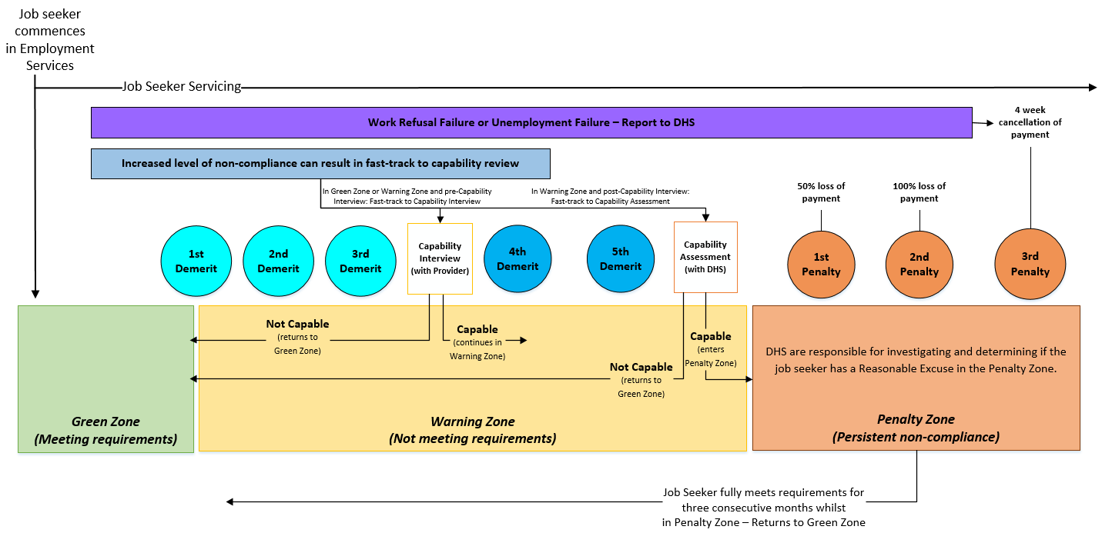

Attachment B – Full list of Valid Reasons from which Providers can select to record their decision
Failure to attend a Provider Appointment, Third Party Appointment, Activity or Job Interview
Reasons Accepted | Reasons Not Accepted
Caring/family reasons that were unforeseeable—unable to advise prior  Conditions or pay not suitable*  Conditions/skills beyond job seeker capacity*  Cultural business—unable to advise prior  Believe job seeker thought they were exempt  Housing instability issues—unable to advise prior  Housing—landlord/property inspection—unable to advise prior  Legal requirements—unable to advise prior  Local issue/natural disaster—unable to advise prior  Major personal crisis affected job seeker—unable to advise prior  Medical/health reason—unable to advise prior  Notification issue—not aware of requirement  Travel/transport, did not have money to pay—unable to advise prior  Travel/transport access issue—unable to advise prior  Working on day of requirement—unable to advise prior | Away from home/on holiday  Caring/family reasons  Caring—claims childcare will be too expensive if offered job*  Conditions—claims job does not match skills*  Conditions—claims not in preferred* employment industry*  Did not believe they had a requirement  Did not think they had to attend—thought exempt  Did not want to attend requirement  Forgot about requirement  Got lost/got time wrong  Housing instability issues  Medical/health reason  Slept in/missed requirement  Travel/transport—did not have money to pay  Travel/transport issue—did not have access  Travel/transport issue—claims distance too great  Undertaking other non-mutual obligation requirement  Prior notice not given and reasonable to expect:  Caring/family reasons  Housing—landlord/property inspection  Legal requirement  Medical/health reason  Travel/transport—did not have money to pay  Travel/transport issue—did not have access  Working on day of requirement
*Applicable to Job Interviews only

Misconduct at Provider Appointment, Third Party Appointment, Activity or Job Interview
Behaviours that may be considered misconduct which prevent the purpose of the requirement from being met include:
Appeared intoxicated/under the influence  Disingenuous  Disruptive/disengaged—unable to complete requirement  Inadequate presentation/attire at requirement | Left prior to completion of requirement  Physically abusive—unable to deliver requirement  Self-sabotage  Theft  Verbally abusive—unable to deliver requirement.
*Applicable to Job Interviews only
Reasons Accepted | Reasons Not Accepted
Did not have appropriate attire to wear at requirement  Disability/condition presenting itself as misconduct  Major personal crisis affected job seeker  Medical issue/condition contributed to behaviour | Couldn’t control behaviour/self  Denied nature of misconduct  Did not believe they were impacted by substances  Did not think they had to stay for the duration  Did not think they were dressed inappropriately  Did not want to participate/engage with requirement  Falsified disability/condition presenting itself as misconduct  Did not want that job*
*Applicable to Job Interviews only

Failure to agree to Job Plan
Reasons Accepted | Reasons Not Accepted
Did not understand requirement to agree to Job Plan  Required further assistance to understand terms of Job Plan  Housing instability issues—unable to return Plan or advise prior  Local issue/natural disaster—unable to return Plan or advise prior  Legal requirements—unable to return Plan or advise prior  Medical/health reason—unable to return Plan or advise prior  Travel/transport access issue—unable to return Plan or advise prior | Away from home/on holiday  Caring/family reasons—claims no time to participate  Does not believe they have to meet requirements  Refuses to participate in employment services  Refuses to look for work—number or overall  Refuses to participate due to study  Refuses to participate in specific activity  Refuses to participate/claims to have no time due to paid work  Refuses to participate due to self-employment  Refuses to discuss requirements  Refuses to participate due to undertaking other, non-mutual obligation requirements  Does not want to enter into a Job Plan  Forgot about requirement  Medical/health reason—could not return Plan  Caring/family reasons—could not return Plan  Travel/transport issues—could not return Plan

Failure to satisfactorily meet Job Search Requirement
Reasons Accepted | Reasons Not Accepted
Caring/family duties that were significant—no exemption  Cultural business for extended period  Housing instability issues  Legal requirements impacted job search  Local issue/natural disaster impacted job search  Medical/health reason—no exemption  Major personal crisis—no exemption | Away from home/on holidays  Caring/family requirements affected job search  Claims other requirements affected job search  Does not believe suitable jobs are available  Does not want to apply for jobs  Does not want to apply for jobs using different methods  Does not want to look for work in diverse industries  Does not want to tailor applications to industry  Forgot about job search/got due date wrong  Housing instability  Medical/health reasons  States not required to look for work  States too many job searches required  Technology issue—claims could not submit efforts online  Technology issue—reported job search efforts incorrectly  Thinks quality of applications is satisfactory

Failure to act on Job Referral
Reasons Accepted | Reasons Not Accepted
Caring/family duties were significant—no exemption  Commute to/from workplace—distance too great/expensive  Conditions or pay not suitable  Conditions/skills for job beyond job seeker capacity  Cultural business for extended period  Cultural—workplace unsuitable for cultural/religious reasons  Housing instability issues  Legal requirements prevented compliance  Local issue/natural disaster prevented compliance  Major personal crisis affected job seeker  Medical/health reason prevented compliance  Notification issue—not aware of requirement  PCP—job seeker not better off financially  Technology—no access to technology to complete requirement  Technology—no phone or credit to contact employer | Acted in a manner that did not result in a job offer/interview  Away from home/on holiday  Believes not required to look for work  Caring/family requirements  Caring—claims childcare will be too expensive if job offered  Conditions—claims job does not match skills  Conditions—claims not in preferred employment industry  Conditions—claims too many or too few hours  Conditions—pay not enough (within allowable policy)  Does not want job  Forgot about requirement  Housing instability  Medical/health reason  Résumé not acceptable standard  Technology—claims no access to technology to complete requirement  Technology—claims no phone or credit to contact employer  Travel/transport issue—claims distance too great/expensive

Failure to accept a suitable job
Reasons Accepted | Reasons Not Accepted
Caring/family duties that are significant  Conditions or pay not suitable  Conditions/skills beyond job seeker capacity  Cultural—workplace unsuitable for cultural/religious reasons  Housing instability issues  Legal requirements  Medical—employment will exacerbate medical condition  PCP—job seeker not better off financially  PCP—unable to arrange suitable childcare  Travel/transport—distance too great/expensive | Caring/family requirements  Caring—childcare not organised as required  Caring—claims childcare too expensive  Conditions—claims job does not match skills  Conditions—claims not in preferred employment industry  Conditions—claims too many or too few hours  Conditions—does not want to undertake certain part of job  Conditions—pay not enough (within allowable policy)  Does not want job  Housing instability  Travel/transport issue—claims distance too great/expensive

Failure to commence a suitable job
Reasons Accepted | Reasons Not Accepted
Caring/family duties that were unforeseeable—unable to advise prior  Caring—unable to obtain suitable childcare/childcare too expensive  Conditions or pay not suitable  Conditions/skills for job beyond job seeker capacity  Cultural business—unable to advise prior  Cultural—workplace unsuitable for cultural/religious reasons  Housing instability issues  Housing—landlord/property inspection—unable to advise prior  Legal requirements—unable to advise prior  Local issue/natural disaster presented attendance  Major personal crisis affected job seeker—unable to advise prior  Medical/health reason—unable to advise prior  Travel/transport issue on the day—unable to advise prior  Travel/transport—did not have money to pay  Travel/transport—distance too great/expensive | Away from home/on holiday  Caring/family requirements  Caring—childcare not organised as required  Caring—claims childcare too expensive  Conditions—claims too many or too few hours  Conditions—claims job does not match skills  Conditions—claims not in preferred employment industry  Conditions—does not want to undertake certain part of job  Conditions—pay not enough (within allowable policy)  Does not want job  Got start date/time wrong/got lost  Housing instability  Housing—landlord/property inspection  Medical/health reason  Travel/transport issue—claims distance too great/expensive  Travel/transport—did not have money to pay  Travel/transport—did not have access  Prior notice not given and reasonable to expect:  Caring/family reasons  Housing—landlord/property inspection  Legal requirement  Medical/health reason  Travel/transport—did not have money to pay  Travel/transport—did not have access

Voluntarily left suitable job
Reasons Accepted | Reasons Not Accepted
Caring/family duties that are significant  Conditions/skills for job beyond job seeker capacity  Conditions—pay disputes  Conditions—work environment unsafe/no longer accessible  Conditions—workplace conflicts  Cultural—workplace unsuitable or cultural/religious reasons  Housing instability issues  Legal requirements  Major personal crisis affected job seeker  Medical—employment exacerbates medical condition  PCP—childcare no longer suitable  PCP—no longer financially suitable  Travel/transport issue—distance too great/expensive | Caring/family requirements  Caring—claims childcare too expensive  Conditions—claims job does not match skills  Conditions—claims not in preferred employment industry  Conditions—claims too many or too few hours  Conditions—does not like the type of work  Conditions—does not like the workplace/employees  Conditions—does not want to undertake certain part of job  Conditions—pay not enough (within allowable policy)  Conditions—workplace conflicts  Does not want job  Housing instability  Medical/health reason  Travel/transport issue—claims distance too great/expensive

Dismissed due to misconduct
Behaviours that may be considered misconduct include:
Appeared intoxicated/under the influence  Continually late/leaving early without agreement  Dishonest reporting of work hours  Disruptive/disengaged—not completing work | Does not follow procedures/rules in workplace  Inadequate presentation/uniform at work  Misappropriation of employer assets  Physically abusive in workplace  Verbally abusive/inappropriate language at work.
Reasons Accepted | Reasons Not Accepted
Caring/family duties impacted work hours  Claims of misconduct by employer are false  Did not have appropriate attire to wear at requirement  Disability/condition presenting itself as misconduct  Major personal crisis affected job seeker  Medical issue/condition contributed to behaviour  Significant breakdown in employer relationship | Believes rules are too strict/not applicable to them  Claims accidentally miscalculated work hours—excessive  Claims of misconduct are false  Conflict started by other people  Couldn’t control behaviour/self  Denied nature of misconduct  Did not believe they were impacted by substances  Did not think they were dressed inappropriately  Falsified disability/condition presenting itself as misconduct

Attachment C – Reasons to Manually Remove a Demerit
Overarching reasons to be used by Providers when manually removing a demerit.
 | Requirements applicable to:
Issue affected overall capability - requirements changed | All
New information disclosed – job seeker in services to address | All
New information disclosed - likely impacted compliance | All
Departmental override | All
Provider Error | All
Job Search efforts submitted after end of Job Search Period – Valid Reason identified | Job Search
Adjustment not made – paid work impacted number required | Job Search
Adjustment not made – exemption impacted number required | Job Search
Adjustment not made to number of Job Search efforts required | Job Search
Job Search efforts were reported manually within Job Search Period | Job Search
Job Search efforts were satisfactory | Job Search
Job Plan accepted online – Valid Reason identified | Job Plan
Signed Job Plan was returned | Job Plan – where think time granted (hardcopy)
Job Plan terms unreasonable/inappropriate | Job Plan – all scenarios
Job seeker did agree to Job Plan at appointment | Job Plan – think time granted (hardcopy) or refusal recorded
Job seeker did not refuse to sign Job Plan | Job Plan – refusal

Attachment D – Single Re-engagement Requirement Warning Zone
The diagram below outlines the Re-engagement requirement the Provider will set depending on the Mutual Obligation Failure for Participants in the Warning Zone.
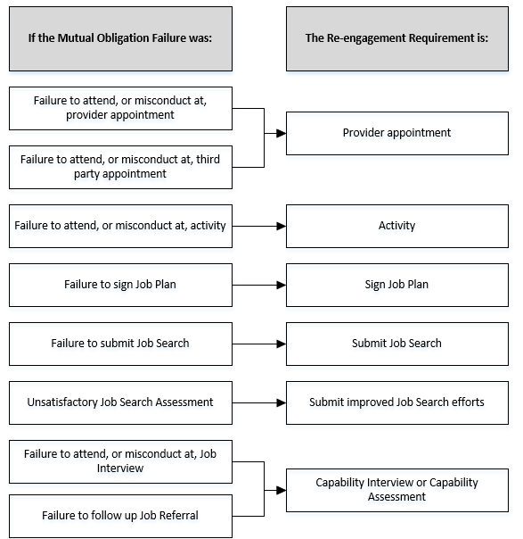

Attachment E – Single Re-engagement Requirement Penalty Zone
The diagram below outlines the Re-engagement Requirement the Provider will set depending on the Mutual Obligation Failure for Participants in the Penalty Zone.
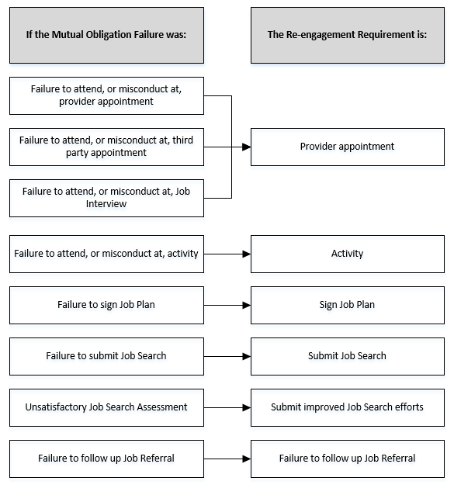

Attachment F – Multiple Re-engagement Requirements Warning Zone
The diagram below outlines how Re-engagement Requirements are prioritised by the system if a Participant in the Warning Zone has more than one outstanding Re-engagement Requirement.
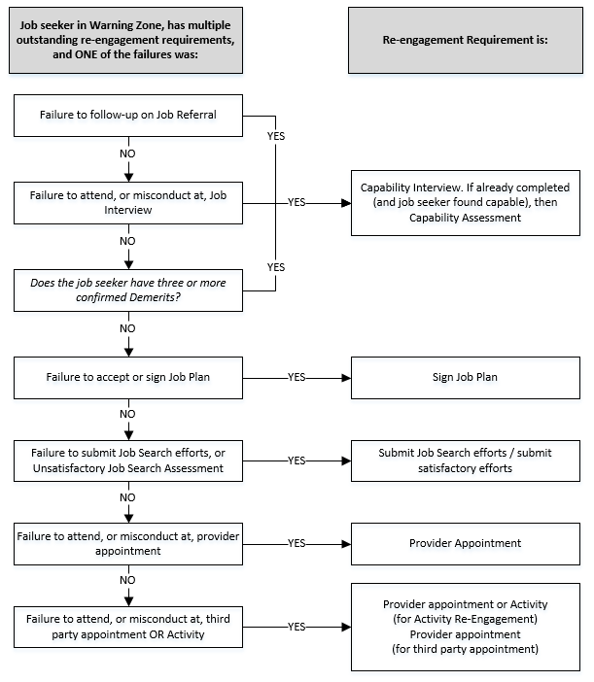

Attachment G – Multiple Re-engagement Requirements Penalty Zone
The diagram below outlines how Re-engagement Requirements are prioritised by the system if a Participant in the Penalty Zone has more than one outstanding Re-engagement Requirement.
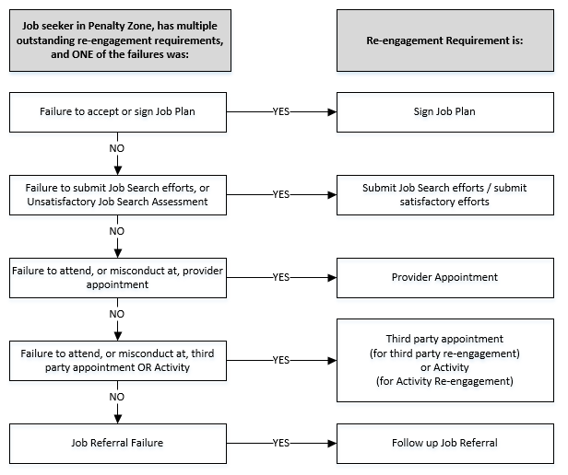

Attachment H – Unable to Re-engage within Two Business Days
- Where a job seeker is unable to re-engage within two Business Days of job seeker contact following non-compliance, Providers will record this in the Department’s IT System. The following is the list of reasons for selection. This will apply where the job seeker is required to attend the Re-engagement Requirement to restore payment.
Caring/family duties that were unexpected impacts attendance
Cultural business over next two Business Days impacts attendance
Full-Time Activity/Training impacts attendance
Housing instability/emergency impacts attendance
Legal requirements impact attendance
Local issue/natural disaster impacts attendance
Major personal crisis affecting job seeker impacts attendance
Medical/health issue over next two days impacts attendance
Travel/transport - exceptional issue impacts attendance
Working over next two Business Days

Attachment J – Re-engagement Not Required Reasons
- Where, due to circumstances outside of a job seeker’s control, they are not required to re-engage to restore their payment, Providers will record this in the Department’s IT System. The following is the list of reasons for selection and the type of Mutual Obligation Failure it relates to.
Reasons |  | Provider Appointment or Third Party Appointment | Activity | Job Interview | Job Plan | Job Referral
 | Reconnection not required—non-compliance discussed
 | Outreach/Part-time site impacts re-engagement
 | Unable to be arranged in next two days
 | Applications closed/Vacancy withdrawn
 | Local issue/natural disaster impacts compliance | Where these circumstances occur, it will be recorded as ‘unable to re-engage within 2 business days’ |  |  | Can record compliance action no longer appropriate
 | Major personal crisis impacts compliance
 | Departmental Override*
 | Exit/Transfer from services*
* Departmental Users or the IT System (automatically) only

