ILC Program Performance Measurement Framework
Outcomes Framework
DSS APRIL 2023

Contents
Preface 3
List of abbreviations 3
Introduction 4
Background and context 4
The Outcomes Framework 5
Navigating the Outcomes Framework 7
Key elements 7
Beneficiaries of the ILC program 7
Other considerations for the Outcomes Framework 9
Alignment with the Australian Disability Strategy 9
Theories of change 10
Overarching ILC program 10
Individual Capacity Building stream 14
National Information Program 19
Mainstream Capacity Building Program 24
Economic and Community Participation Program 28
Appendix A: Consultation activities 33
Appendix B: Sector Advisory Panel 33

Figures
Figure 1. ILC Program Theory of Change 12
Figure 2. Individual Capacity Building – Visual Representation of Outcomes 18
Figure 3. National Information Program - Visual Representation of Outcomes 23
Figure 4. Mainstream Capacity Building - Visual Representation of Outcomes 27
Figure 5. Economic and Community Participation Program - Visual Representation of Outcomes 32

Preface
The ILC Outcomes Framework has been developed by Social Ventures Australia through the generous support of many people who shared their time, knowledge and experiences. We are grateful for the support of all those who contributed towards this work, particularly the Sector Advisory Panel and the individuals and organisations who participated in consultations.

List of abbreviations
Abbreviation | Definition
DESE | Department of Education, Skills and Employment
DPO/FO | Disabled Peoples Organisations/Families Organisations
DSS | Department of Social Services
ECP | Economic and Community Participation
ICB | Individual Capacity Building
ILC | Information, Linkages and Capacity Building
LAC | Local Area Coordination
MCB | Mainstream Capacity Building
NDIA | National Disability Insurance Agency
NDIS | National Disability Insurance Scheme
NIP | National Information Program
PMF | Performance Measurement Framework
ADS | Australia’s Disability Strategy 2021-2031

Introduction

Background and context

What is the ILC Program
246BThe Information, Linkages and Capacity Building (ILC) Program funds projects in the community that benefit all people with disability across Australia. This includes people who are not eligible for the NDIS. It also has benefits for the families, carers, and supporters of those people.
247BThe ILC program funds organisations to run projects that aim to:
- 26Bcreate connections between people with disability and their community
- 27Bdevelop the capabilities, knowledge, and confidence of people with disability
- 28Bdrive access to community and mainstream services
- 29Bbuild the capacity of these services to be more inclusive and accessible.
248BThe ILC Program aligns with Australia’s Disability Strategy 2021-2031 (ADS). The ADS is a plan to ensure people with disability can participate as equal members of society, and continuing to improve the lives of people with disability in Australia over the next ten years.
249BThe Department of Social Services (DSS) is in charge of the ILC Program. It also involves Local Area Coordination services (LAC). The National Disability Insurance Agency (NDIA) is in charge of LAC services.
250BThe ILC program has four key grant funding streams:
- 111BIndividual Capacity Building (ICB) – helps people with disability, their families and carers to access peer support, mentoring and other ways to build skills
- 112BNational Information Program (NIP) – provides easy to understand, relevant and timely information on supports and services to people with disability, their families and carers
- 113BMainstream Capacity Building (MCB) – improves the capacity of mainstream services to include people with disability, increasing accessibility and use of these services
- 114BEconomic and Community Participation (ECP) – improves pathways to employment and increasing participation in the community for people with disability.

The Performance Measurement Framework
251BThe ILC Program has a Performance Measurement Framework (PMF). It aims to help organisations and DSS create better outcomes for people with disability. It does this by describing the outcomes that are being created by the ILC Program and the projects it funds, and helping track the outcomes over time. As part of this, the PMF aims to improve how data is measured, captured and shared, making the data more useful for DSS, the organisations that get grants and the community. The PMF describes how the Outcomes Framework is implemented in practice.
252BThe PMF aligns with the ADS. It shows how the different parts of the ILC work together to create impact for people with disability.

Principles for creating the Performance Measurement Framework
253BThe PMF follows these guiding principles:
- 30BCentring the voice of people with disability – people with disability had a say in creating the PMF. They helped to define the outcomes, what data is collected, and how data is collected. This will help make sure the PMF is easy to use.
- 31BEvidence-informed – the PMF has been built by looking at outcomes and indicators we already know work. It also includes new outcomes and indicators.
- 32BCollaboration and common language – the PMF has been created with people across the disability ecosystem. This will make sure that we define and measure outcomes that are important for people with disability.
254BThe PMF is designed to be used by all organisations that get ILC funding, no matter how big or small. It will help understand how the ILC program is changing people’s lives. This means DSS and the organisations that get funded will be able to improve their work. It will also help understand how grant activities are going. The PMF is flexible so that it can change if things are different in the future. The Performance Measurement Framework is optional and has been created for organisations who would like to improve how they measure and capture data.

The Outcomes Framework

Purpose of the Outcomes Framework
255BThe Outcomes Framework is an important part of the PMF. It describes the changes to people’s lives that each program stream will create.

How it will be used
256BThe Outcomes Framework will:
- 33BOutline the outcomes and impact of the ILC Program and each grant stream
- 34BShow how each grant stream contributes towards the overall ILC program
- 35BHelps organisations understand the ILC program and the outcomes it wants to create. This can help when applying for funding, delivering activities, and reporting back to DSS.

How the Outcomes Framework was developed
257BThe Outcomes Framework was made by listening to many people. This includes a Sector Advisory Panel, organisations in the disability sector, and the wider disability community. It also builds on other people’s research, and on older frameworks and reports for the ILC Program. A list of the listening activities can be found in Appendix A.
258BThe Sector Advisory Panel is a group of people that came together to help advise how we create the PMF. It includes disability community representative organisations, industry peaks and an academic advisor. They provided ideas and guidance. A full list of panel members can be found in Appendix B.

Navigating the Outcomes Framework

Key elements
259BThe Outcomes Framework has theories of change for each program stream and one for the whole ILC program. A theory of change is a story of how a program or project makes a difference in the world. Each theory of change has the following:
- 36BIssue. The key issues the program stream is trying to solve
- 37BImpact. The overall impact that the ILC program wants to create
- 38BActivities. The core activities that are funded
- 39BBeneficiaries. The key people for whom the program stream seeks to create change
- 40BOutcomes. The change that we hope to see as a result of the activities
- 41BOutcome domains. Higher-level groupings of outcomes for each program stream.

Beneficiaries of the ILC program
260BThe main goal of the ILC program is to make positive change for people with disability across Australia. There will also be some outcomes created for the other groups of people in the list below. The end goal is to improve the lives of people with disability.
- 42BPeople with disability, recognising the very different experiences across gender, cultural background, geography, age, type of disability and First Nations communities
- 43BFamilies, supporters and unpaid carers of people with disability
- 44BDisabled Peoples and Families Organisations (DPO/FOs), run for and by people with disability and/or their families. This means most of the members, as well as the board, are people with disability or their family members.
- 45BDisability service providers, that provide services for people with disability. This includes paid support workers
- 46BMainstream service providers, that provide services to the community that are not just for people with disability. This can include schools and education, banking, healthcare, early learning and housing.
- 47BCommunity, including the broader community, community organisations and businesses that employ people with disability

How will the Outcomes Framework be relevant for diverse communities?
261BPeople with disability are not all the same. They can have different experiences, wants and needs. For example, First Nations people can have different needs than non-First Nations people. The same is true for:
- 48Bpeople from different cultural backgrounds
- 49Bpeople of different sexual orientations
- 50Bpeople with different types of disability
- 51Bpeople of different age groups
- 52Bpeople that live in regional and remote areas.
53BThe Outcomes Framework aims to apply to all people with disability. But it also needs to be simple and easy to use. To do this, the outcomes in this framework are the same for everyone. But the indicators that organisations use to measure these outcomes may differ. In this way, organisations can measure their outcomes in a way that makes sense for the people that they work with.
262BFor example:
- 54BAn Aboriginal community controlled organisation helps people with disability stay connected to their culture and community. They can select the outcomes “Increased sense of belonging and connection” or “Greater opportunities to participate in community”. To measure these, they can create their own questions, relating them back to the outcomes in this framework. They might ask people about “Connection to their culture” and “Staying on country”.
- 55BA migrant resource centre helps communities connect to their culture through an event. They might select outcomes around “Increased sense of belonging and connection”. To measure this, they might ask people about “Connection to their culture”.
- 56BA local council helps a community fair to be more welcoming and inclusive of children with disability. They might select outcomes around “Greater opportunities to participate and contribute in the community”. To measure this, they might ask children or their family about “Chances to be involved in community events”.
- 57BA charity works with a fitness program in a rural community to make them more accessible to people with disability. They might select the outcome “Greater engagement and trust in services and community activities”. To measure this, they might ask about “Time spent in the local community”.

Other considerations for the Outcomes Framework
- 58BWe have shared the outcomes in two formats below, written into the body of this document, commencing under the heading ‘Overall ILC program outcomes’, and as a diagram starting from page 10. This makes it easier to read. The only difference between them is that the diagram shows which outcomes lead to others.
- 59BTo keep the Outcomes Framework simple, the links between the outcomes for different groups of people have not been shown in detail. We know that, in reality, the outcomes for some groups of people are essential to create outcomes for others. This has been shown at a high level in the visual charts through arrows between stakeholder groups.
- 60BWe know that each person experiences outcomes differently, and that the time needed to achieve these outcomes will vary. The outcomes are laid out from shorter-term to longer-term. The meaning of ‘long term’ may differ by outcome and by person. Also, in reality, outcomes might not happen in this order.
- 61BIt is likely that grant activities often won’t be able to measure long-term outcomes, as these often take years to create. They have been included to show the long-term goals of the ILC program.
- 62BThe ILC program does many things, which means that not all outcomes will be relevant to everyone. For example, not everyone will have goals to be leaders in their community, but for others it is important.

Alignment with the Australian Disability Strategy
263BThe outcomes created through the ILC program align and work towards the Outcome Areas identified in the ADS. The way the ILC program contributes to the ADS is shown after the outcomes are listed, with each outcome domain of the grant streams linking to an outcome area of the ADS.
264BAll of the outcomes fall into one or more domains. Each of these domains matches one of the outcome areas in the ADS. We show how they link together at the end of each theory of change. See Table 1 on page 13.

Theories of change

Overarching ILC program
265BThis is a theory of change for the whole ILC program. This ILC theory of change shows how the high-level outcomes of each program stream work together to create change and achieve the broader goals.

Funded activities
266BAt a high-level, the ILC funds activities through the four key grant streams to achieve the intended outcomes
- 63BIndividual Capacity Building (ICB)
- 64BNational Information Program (NIP)
- 65BMainstream Capacity Building (MCB)
- 66BEconomic and Community Participation (ECP)

ILC program beneficiaries
- 67BPeople with disability
- 68BFamilies, supporters, and unpaid carers
- 69BDPO/FOs
- 70BMainstream service providers
- 71BCommunity, including employers and community organisations

Overall ILC program outcomes
267BThe shorter-term outcomes include:
- 115BDPO/FOs are effective in supporting and empowering people with disability
- 116BPeople with disability, their families, supporters and unpaid carers are connected and have the information they need to make meaningful choices and decisions
- 117BCommunities and employers are inclusive, accessible and welcoming of people with disability
- 118BMainstream services are inclusive, accessible and welcoming of people with disability
268BThe medium-term outcomes include:
- 119BFamilies, supporters and unpaid carers have greater resilience, capacity and capability to support people with disability
- 120BPeople with disability have the skills and confidence to self-advocate, lead and contribute
- 121BPeople with disability have greater independence, resilience, choice and control
- 122BPeople with disability meaningfully engage, participate and benefit from the same services, community and economic activities as those without disability
269BLonger-term outcomes include:
- 123BPeople with disability actively contribute to shaping and influencing the community
- 124BPeople with disability have the capability and opportunity to live the life they choose
- 125BIncreased sustainability of the NDIS scheme
270BThese outcomes are affected by many things outside of the ILC program. This includes the level of support someone gets, their wealth, their community or what the government is doing. Outcomes can also be shaped by other supports, including LAC, NDIS funding, employment services and DESE support.
271BFigure 1 on the following page shows these outcomes visually.

20BOutcomes of the ILC program
272B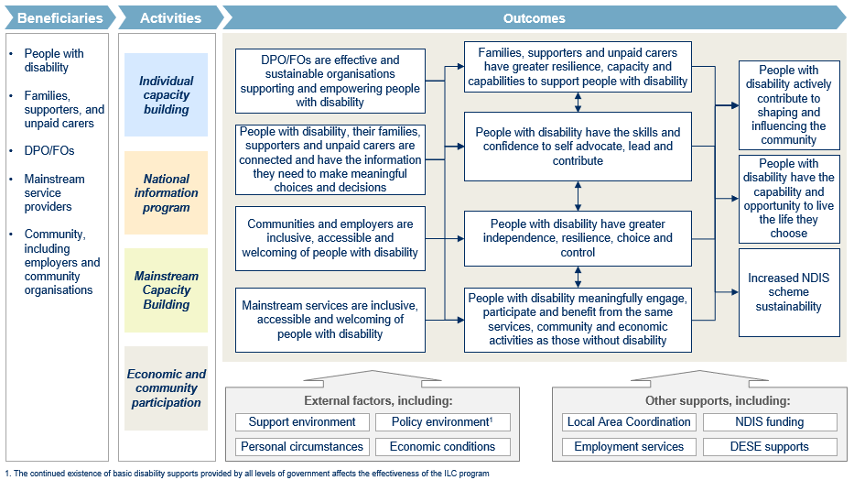
0BFigure 1 ILC Program theory of change
1BTable 1. The ADS Outcome Areas
Outcome Areas | Description
Personal and community support | People with disability have access to a range of supports to assist them to live independently and engage in their communities.
Safety, rights and justice | The rights of people with disability are promoted, upheld and protected, and people with disability feel safe and enjoy equality before the law.
Health and wellbeing | People with disability attain the highest possible health and wellbeing outcomes throughout their lives.
Community attitudes | Community attitudes support equality, inclusion, and participation in society for people with disability.
Employment and financial security | People with disability have economic security, enabling them to plan for the future and exercise choice and control over their lives.
Education and learning | People with disability achieve their full potential through education and learning.
Inclusive homes and communities | People with disability live in inclusive, accessible and well‑designed homes and communities.

Individual Capacity Building stream

Issue
273BWe want to build an inclusive world in which all people with disability can thrive. To do this, we can support people with disability by increasing their skills, confidence and opportunities to participate and live their lives in the way they want.

Impact
- 72BPeople with disability have the skills and confidence to meaningfully participate in, and contribute to the community.
- 73BPeople with disability have choice and control in their lives, in protecting their rights and influencing the community and systems around them.

Activities
274BProviding access and opportunities to learn important skills, make new connections, have peer support and mentoring.

Priority beneficiaries
- 74BPeople with disability
- 75BFamilies, supporters and unpaid carers
- 76BDPO/FOs

Individual Capacity Building outcomes
275BThere are a different set of outcomes for each priority beneficiary. Figure 2 on the following pages provides a visual depiction of these outcomes.

Outcomes for people with disabilities
276BThe short-term outcomes are:
- 126BIncreased skills and knowledge:
  - 127BAbout disability rights and self-advocacy
  - 128BTo socially connect and develop meaningful relationships
  - 129BTo participate in education
  - 130BTo enable greater independence
  - 131BTo lead and contribute
- 132BGreater opportunities to participate, lead and contribute in the community
- 133BGreater opportunities to connect with peers, and maintain natural relationships

277BThe medium-term outcomes are:
- 134BIncreased confidence
- 135BIncreased informed and meaningful decision-making
- 136BIncreased independence, choice and control
- 137BIncreased motivation to participate, lead and contribute in the community
- 138BIncreased social engagement with peers for knowledge, support and wellbeing
278BThe long-term outcomes are:
- 139BIncreased self-advocacy and empowerment
- 140BIncreased connection to community and sense of belonging
- 141BGreater role in influencing, leading and contributing to the community
- 142BIncreased resilience and safety
- 143BPeople with disability are represented in leadership and high-profile positions

Outcomes for family members, supporters and unpaid carers
279BThe short-term outcomes are:
- 144BIncreased skills and knowledge:
  - 145BTo support people with disability to self-advocate
  - 146BTo advocate on behalf of people with disability
  - 147BTo support people with disability to have greater independence, choice and control
  - 148BTo provide care and support to people with disability
  - 149BIn self-care and resilience
- 150BGreater opportunities to connect with peers and the broader community, and maintain natural relationships
280BThe medium-term outcomes are:
- 151BGreater capability to support, through:
  - 152BIncreased ability to support people with disability to self-advocate
  - 153BIncreased ability to support people with disability to have greater independence, choice and control
  - 154BIncreased ability to provide care and support to people with disability
- 155BImproved mental health
- 156BIncreased social engagement with peers for knowledge, support and wellbeing
281BThe longer-term outcomes are:
- 157BEffectively support people with disability to participate, contribute and self-advocate
- 158BIncreased resilience and capacity to sustainably support people with disability
- 159BGreater wellbeing
- 160BIncreased connection to community and sense of belonging

Outcomes for DPO/FOs
282BThe short-term outcomes are:
- 161BIncreased skills and knowledge to operate effectively, including leadership and governance
- 162BIncreased skills and knowledge to effectively empower the voices of people with disability
283BThe medium-term outcomes are:
- 163BEffectively deliver on the strategic priorities of the ILC grants program
- 164BEffectively deliver on own strategic priorities
- 165BEffectively advocate for people with disability, family, supporters and unpaid carers
- 166BPeople with disability are centred in organisational decision-making and leadership
284BThe longer term outcomes are:
- 167BEffectively support people with disability to participate, contribute and self-advocate
- 168BEffectively drive change towards an inclusive and accessible society

Outcome domains
285BEach of the outcomes above falls under an outcome area, or domain, which aligns with the ADS.
2BTable 2. Individual Capacity Building – outcomes domains and alignment to the ADS for people with disability
Domain | ADS Outcomes Areas
Belonging and connection | Personal and community support
Self-advocacy and empowerment | Safety, rights and justice
Influencing, leading and contributing to the community | Community attitudes
Resilience and safety | Safety, rights and justice

3BTable 3. Individual Capacity Building - outcomes domains and alignment to the ADS for families, supporters and unpaid carers
Domain | ADS Outcomes Areas
Effectively supporting people with disability to participate, contribute and self-advocate | Safety, rights and justice
Resilience and capacity to sustainably provide support | Personal and community support
Greater wellbeing | Health and wellbeing
Increased belonging and connection | Personal and community support
4BTable 4. Individual Capacity Building - outcomes domains and alignment to the ADS for DPO/FOs
Domain | ADS Outcomes Areas
Well-run and sustainable organisations | Safety, rights and justice
Effectively support people with disability to participate, contribute and self-advocate | Safety, rights and justice
Effectively drive change towards an inclusive and accessible society | Safety, rights and justice

21BOutcomes of the Individual Capacity Building stream
22B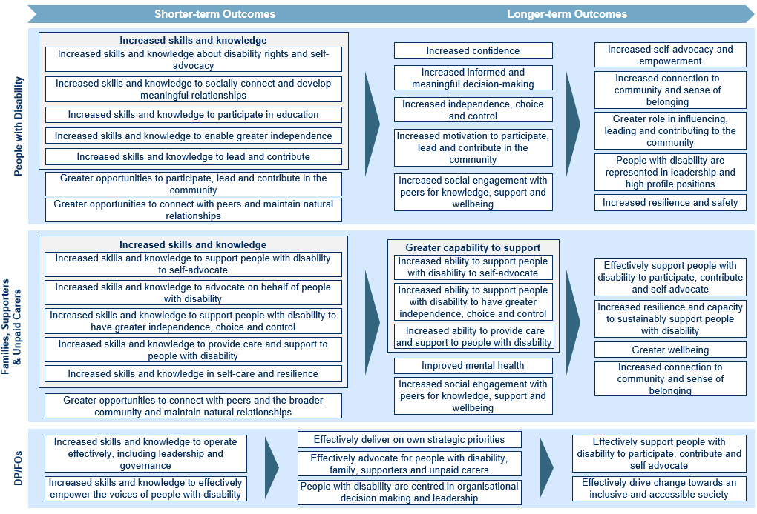
5BFigure 2. Individual Capacity Building – Visual Representation of Outcomes

National Information Program

Issue
286BThere is a lack of quality and trusted information for people with disability, their families and supporters. A lot of information is not easy to read or not up to date. This makes it harder for people with disability to make good choices, live the lives they want to live and engage in the world around them.

Impact
- 287BPeople with disability, their families, supporters and unpaid carers have the information they need to make meaningful choices and decisions
- 288BPeople with disability have choice and control in their lives to participate, contribute and influence the world around them

Activities
289BProviding information that is useful and meets the needs of people with disability, their families and supporters.

Priority beneficiaries
- 77BPeople with disability
- 78BFamilies, supporters, and unpaid carers
- 79BServices – including disability service providers, mainstream service providers and community services

Outcomes for the National Information Program
290BThere are a different set of outcomes for each priority beneficiary. Figure 3 on the following pages provides a visual depiction of these outcomes.

Outcomes for people with disabilities
291BThe short-term outcomes are:
- 169BGreater access to quality information that is relevant, accessible, trusted and timely
- 170BGreater awareness of available information
- 171BEngaged as knowledge holders and important partners in driving inclusion and accessibility
292BThis information leads to:
- 172BIncreased knowledge of disability rights
- 173BIncreased knowledge of opportunities, services and community activities, including how to access them
- 174BServices and community activities that are more inclusive
293BThe medium-term outcomes are:
- 175BIncreased informed and meaningful decision-making
- 176BIncreased independence, choice and control
- 177BGreater opportunities and options in services and community activities
- 178BBetter able to navigate and access services and community activities
294BThe long-term outcomes are:
- 179BGreater engagement and trust in services and community activities
- 180BIncreased self-advocacy and empowerment
- 181BGreater role in influencing, leading and contributing to the community
- 182BIncreased resilience and safety
- 183BGreater economic, social and community participation

Outcomes for families, supporters and unpaid carers
295BThe short-term outcomes are:
- 184BGreater access to quality information that is relevant, accessible, trusted and timely
- 185BEngaged as knowledge holders and important partners in driving inclusion and accessibility
296BThis information leads to…
- 186BIncreased knowledge of disability rights, opportunities, services and community activities
- 187BServices and community activities are more inclusive
297BThe medium-term outcomes are:
- 188BFeel informed and supported at all stages of the journey and across the life course
- 189BBetter able to navigate and access services and community activities
298BThe long-term outcomes are:
- 190BEffectively support people with disability to participate, contribute and self-advocate
- 191BIncreased resilience and capacity to sustainably support people with disability
- 192BGreater engagement and trust in services and community activities

Outcomes for disability, mainstream and community service providers
299BThe short-term outcomes are:
- 193BIncreased skills and knowledge of how to provide information in a way that is relevant, accessible, and timely
- 194BIncreased skills, knowledge and networks to make effective referrals
- 195BGreater awareness of people with disability, their families and supporters as experts in their own lives
300BThe medium-term outcomes are:
- 196BActive involvement of and collaboration with people with disability to drive inclusion, accessibility
- 197BInformation comes from trusted, relevant and stable sources that are accessible to people with disability

Outcome domains
6BEach of the outcomes is part of an overall domain that aligns with the ADS.
7BTable 5. National Information Program - outcomes domains and alignment to the ADS for people with disability
Domain | ADS Outcomes Areas
Resilience and safety | Safety, rights and justice
Engagement and trust in services and community activities | Inclusive homes and communities
Influencing, leading and contributing to their community | Community attitudes
Economic, social and community participation | Employment and financial security
Self-advocacy and empowerment | Safety, rights and justice
8BTable 6. National Information Program - outcomes domains and alignment to the ADS for families, supporters and unpaid carers
Domain | ADS Outcomes Areas
Effectively supporting people with disability to participate, contribute and self-advocate | Safety, rights and justice
Resilience and capacity to sustainably provide support | Personal and community support
Engagement and trust in services and community activities | Inclusive homes and communities

Domain | ADS Outcomes Areas
Collaboration with people with disability to drive inclusion and accessibility | Community attitudes
Information and referrals come from trusted, stable, relevant and accessible sources | Education and learning

23BOutcomes of the National Information Program
301B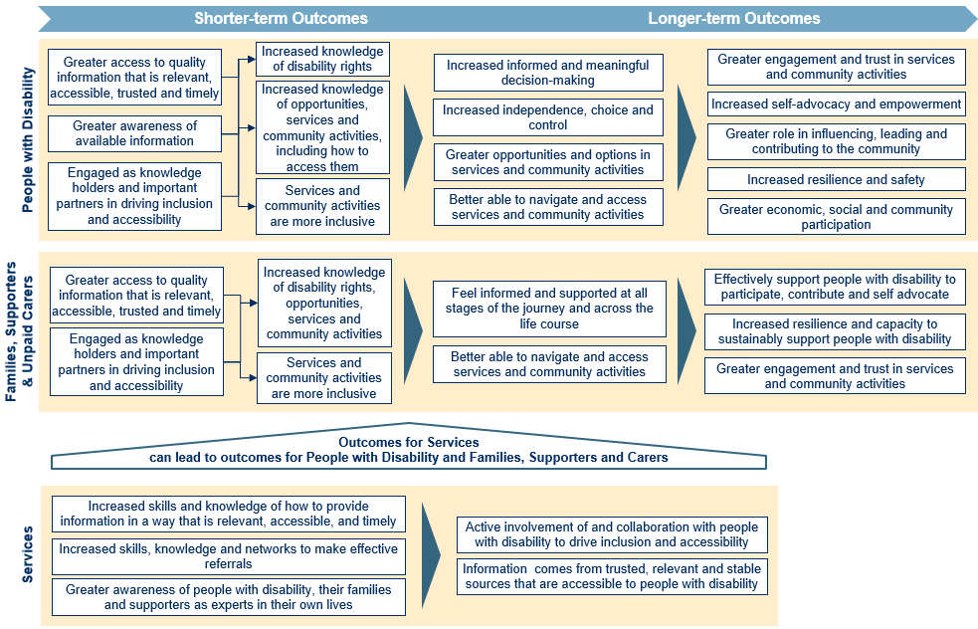
9BFigure 3. National Information Program - Visual Representation of Outcomes

Mainstream Capacity Building Program

Issue
302BMainstream services are services that are used by all people, like banks or schools. They are often not accessible and don’t provide support for people with disability in a way that is useful or meets their needs. This can have a big impact on life outcomes. It can be driven by a lack of skills, knowledge and the ways of working in services.

Impact
- 80BPeople with disability use and benefit from the same mainstream services as people without disability

Activities
303BHelping mainstream services build their skills, knowledge and ways of working, so that they meet the needs of people with disability.

Priority beneficiaries
- 81BMainstream Service Providers
- 82BFamilies, supporters, and unpaid carers
- 83BPeople with disability

Outcomes for Mainstream Capacity Building
304BThere is a different set of outcomes for each priority beneficiary. Figure 4 on the following pages provides a visual representation of these outcomes.

Outcomes for mainstream services
305BThe short-term outcomes are:
- 198BIncreased knowledge and skills to effectively engage and support people with disability
- 199BGreater awareness of the rights and capabilities of people with disability
- 200BAwareness of the barriers faced by people with disability in accessing services and their role in addressing these barriers
- 201BGreater connections and networks with DPO/FOs and Disability Service Providers
- 202BGreater opportunities to support people with disability
306BThe medium-term outcomes are:
- 203BIncreased confidence to engage and support people with disability
- 204BIncreased positive attitudes towards people with disability
- 205BGreater ability to create and improve services that effectively support people with disability
- 206BIncreased partnerships with DPO/FOs and Disability Service Providers
307BThe long-term outcomes are:
- 207BMainstream services are inclusive, accessible and welcoming of people with disability
- 208BMainstream services are advocates for inclusive practices
- 209BMainstream services can better meet the needs of people with disability due to connections with DPO/FOs and Disability Service Providers

Outcomes for people with disability
308BThe short-term outcome is:
- 210BEngaged as knowledge holders and important partners in driving inclusion and accessibility
309BThe medium-term outcomes are:
- 84BGreater access to mainstream services that are accessible, inclusive and relevant
- 85BPositive experiences using mainstream services
- 86BGreater confidence using mainstream services
- 211BFeel included, supported and safe using mainstream services
310BThe long-term outcomes are:
- 87BExperience high-quality support from mainstream services
- 88BGreater independence, choice and control
- 212BDecreased reliance on disability specific services

Outcomes for families, supporters and unpaid carers
311BThe short-term outcome is:
- 213BEngaged as knowledge holders and important partners in driving inclusion and accessibility
312BThe medium-term outcome is:
- 214BGreater access to mainstream services that are accessible, inclusive and relevant
313BThe long-term outcome is:
- 215BGreater ability to use mainstream services with the people they support

Outcome domains
10BEach of the outcomes is part of an overall domain that aligns with the ADS.
11BTable 8. Mainstream Capacity Building - Outcome domains and alignment to the ADS for mainstream services
Domain | ADS Outcomes Areas
Confidence to engage and support people with disability | Community attitudes
Positive attitudes towards people with disability | Community attitudes
Ability to create and improve services that support people with disability | Community attitudes
12BTable 9. Mainstream Capacity Building - Outcome domains and alignment to the ADS for people with disability
Domain | ADS Outcomes Areas
Mainstream services are better suited to people with disability | Inclusive homes and communities
People with disability have the confidence and opportunity to use mainstream services | Education and learning
13BTable 10. Mainstream Capacity Building - Outcome domains and alignment to the ADS for families, supporters and unpaid carers
Domain | ADS Outcomes Areas
Greater ability to use mainstream services | Inclusive homes and communities

24BOutcomes of the Mainstream Capacity Building Program
314B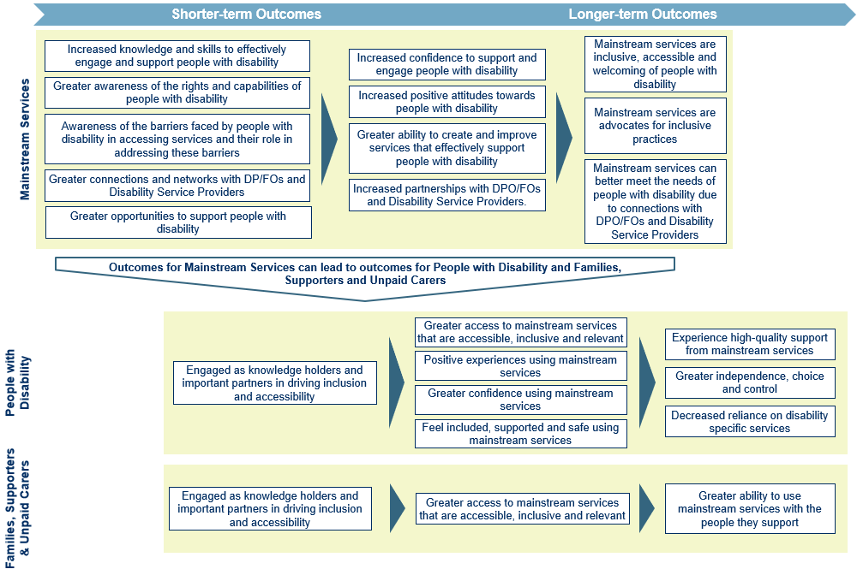
14BFigure 4. Mainstream Capacity Building - Visual Representation of Outcomes

Economic and Community Participation Program

Issue
315BPeople with disability often face barriers to getting jobs and being able to participate and be active members in their community.

Impact
- 316BPeople with disability meaningfully participate, use and benefit from the same community and economic activities as those without disability.
- 317BPeople with disability have the choice and control in their lives to contribute to and influence the world around them.

Activities
318BProviding ways for people with disability to connect and engage with jobs, events and activities in society.

Priority beneficiaries
- 89BCommunity, including the broader community, organisations that provide community events and facilities, and businesses that employ people with disability
- 90BPeople with disability
- 91BFamilies, supporters, and unpaid carers

Outcomes for Economic and Community Participation
319BThere is a different set of outcomes for each priority beneficiary. Figure 5 on the following pages provides a visual representation of these outcomes.

Outcomes for the community
320BThe short-term outcomes are:
- 216BEmployers and community organisations have the knowledge and skills to be inclusive and accessible
- 217BEmployers and community organisations have greater awareness of the rights and capabilities of people with disability
- 218BThe broader community is aware of the rights and capabilities of people with disability
321BThe medium-term outcomes are:
- 219BIncreased confidence to engage and support people with disability
- 220BIncreased positive attitudes towards people with disability
- 221BActive involvement of and collaboration with people with disability to drive inclusion and accessibility
- 222BEmployers and community organisations have greater motivation to be inclusive and accessible
322BThe long-term outcomes are:
- 223BCommunity organisations and employers are inclusive, accessible and welcoming of people with disability
- 224BCommunity organisations and employers are advocates for inclusive practices

Outcomes for people with disability
323BThe short-term outcomes are:
- 225BIncreased skills and knowledge to participate in employment and volunteering
- 226BGreater opportunities for employment and volunteering
- 227BGreater opportunities to participate and contribute in the community
- 228BIncreased accessibility and inclusivity in communities and workplaces
- 229BIncreased motivation to participate and contribute in the community
324BThe medium-term outcomes are:
- 230BIncreased employment of people with disability
- 231BEngaged as knowledge holders and important partners in driving inclusion and accessibility
- 232BFeel included, supported and safe in the workplace and community
- 233BIncreased social engagement with peers for knowledge, support and wellbeing
- 234BIncreased confidence to participate in employment and the community
325BThe long-term outcomes are:
- 235BGreater independence, choice and control
- 236BIncreased connection to community and sense of belonging
- 237BGreater economic, social and community participation
- 238BPeople with disability are represented in leadership and high profile positions

Outcomes for families, supporters and unpaid carers
326BThere are no short-term outcomes for families, supporters and carers. The medium-term outcomes are:
- 239BFeel included, valued and welcomed as part of the community
- 240BGreater opportunities to connect within the broader community
- 241BTrust in employers and the community
327BThe longer term outcomes are:
- 242BGreater wellbeing
- 243BIncreased connection to community and sense of belonging
- 244BGreater capacity to support people with disability to participate in employment and the community
328B* See visual chart of outcomes below

Outcome domains
15BEach of the outcomes is part of an overall domain that aligns with the ADS.
16BTable 11. Economic and Community Participation - Outcome domains and alignment to the ADS for the community
Domain | ADS Outcomes Areas
Confidence to support and engage people with disability | Community attitudes
Positive attitudes towards people with disability | Community attitudes
Collaboration with people with disability to drive inclusion and accessibility | Community attitudes
17BTable 12. Economic and Community Participation - Outcome domains and alignment to the ADS for people with disability
Domain | ADS Outcomes Areas
Belonging and connection | Inclusive homes and communities
Economic, social and community participation | Employment and financial security
Represented in leadership and high profile positions | Employment and financial security
Independence, choice and control | Safety, rights and justice

18BTable 13. Economic and Community Participation - Outcome domains and alignment to the ADS for families, supporters and unpaid carers
Domain | ADS Outcomes Areas
Greater wellbeing | Health and wellbeing
Belonging and connection | Inclusive homes and communities
Capacity to support participation | Personal and community support

25BOutcomes of the Economic and Community Participation Program
329B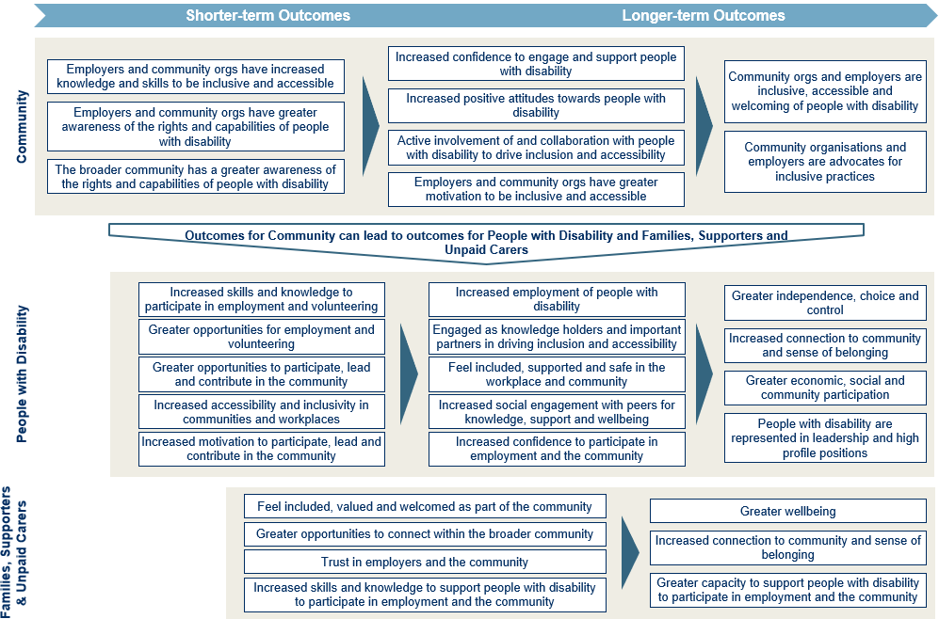
19BFigure 5. Economic and Community Participation Program - Visual Representation of Outcomes

Appendix A: Consultation activities
330BThis section lists the different groups of people we engaged, and how we listened to them when building this Outcomes Framework.
331BConsultations included:
- 92B6 x interviews / group interviews with key internal DSS and NDIA stakeholders
- 93B4 x workshops with the Sector Advisory Panel
- 94B10 x interviews with Sector Advisory Panel members
- 95BWorkshops with the disability community and sector:
- 96B4 x workshops with organisations
- 97B3 x workshops with people with disability
- 98B1 x workshop with families, supporters and unpaid carers
- 99B5 x interviews with people with disability and organisations

Appendix B: Sector Advisory Panel
332BThe Sector Advisory Panel was comprised of representatives from:
- 100BPeople with Disability Australia (PWDA)
- 101BInclusion Australia
- 102BFirst People's Disability Network (FPDN)
- 103BChildren and Young People with Disability Australia (CYDA)
- 104BNational Ethnic Disability Alliance (NEDA)
- 105BWomen with Disabilities Australia (WWDA)
- 106BCarers Australia
- 107BAbility First Australia (AFA)
- 108BNational Disability Services (NDS)
- 109BAustralian Federation of Disability Organisations (AFDO)
- 110BAn academic from Swinburne University

Commonwealth of Australia, Department of Social Services. 2021 Australia’s Disability Strategy 2021–2031
Commonwealth of Australia, Department of Social Services. 2021 Australia’s Disability Strategy 2021–2031 Outcomes Framework

