Commonwealth, State and Territory Disability Ministers met for the first time in 2024 on
9 February in Canberra. Ministers welcomed new members to the Council, the
Hon Charis Mullen MP from Queensland and Ms Rachel Stephen-Smith MLA from the ACT.
Ministers discussed priorities for 2024 following the two landmark decisions of
National Cabinet on 28 April 2023 to ensure a sustainable NDIS can support future generations of Australians through an annual growth target of no more than 8 per cent by 1 July 2026; and on 6 December 2023 to introduce an initial tranche of legislation in response to the NDIS Review, and develop and implement Foundational Supports. These reforms are aimed at getting the NDIS back on track and changing the landscape of the disability ecosystem in Australia.
Ministers agreed to elevate the importance of Foundational Supports in the Council’s work in 2024 – reflecting the priority all governments place on working together through the First Secretaries Group and Council of Federal Financial Relations to establish a vision for and actions needed to establish a system of Foundational Supports across all jurisdictions. Ministers noted legislative amendments will be introduced to the Australian Parliament in the first half of 2024.
Ministers discussed timeframes around Foundational Supports and a shared commitment to work together to inform the design of an effective Foundational Supports system that is evidence-informed and delivers effective outcomes for Australians with disability. They also discussed the importance of Foundational Supports for people outside the NDIS.
Ministers discussed the need for a harmonious approach to governments’ significant disability reform agenda, which includes responding to the recommendations of the NDIS Review and Disability Royal Commission and how they intersect.
Ministers agreed on the importance of continuing to deeply engage with the disability community as improvements to the disability ecosystem are progressed. This includes those with a range of diverse lived experiences to ensure all people with disability experience better outcomes in the future ecosystem of mainstream, foundational and NDIS supports.
Ministers welcomed Ms Jane Spring, Chair of the Australia’s Disability Strategy Advisory Council (Advisory Council), to provide advice on how governments can strengthen the design and impact of new Targeted Action Plans (TAPs) under Australia’s Disability Strategy 2021-2031, and in response to DRC recommendations. Ms Spring noted the vital role of the Outcomes Framework in transparently representing progress across the ADS policy priorities.
Following Ms Spring’s presentation, Ministers endorsed an updated Advisory Council Terms of Reference and the Advisory Council 2024 Forward Work Plan. In 2024, the Advisory Council will focus on issues including housing, employment and justice, with the work informed by the outcomes of the NDIS Review and Disability Royal Commission.
Ministers endorsed an approach for conducting a focused review of Australia’s Disability Strategy, as committed to under the existing strategy. The review will include targeted consultation with the disability community that builds on what has already been heard during the first two years of the Strategy. The terms of reference for the Review will be settled out-of-session by the end of the month and updates to the Strategy will be considered by DRMC in the last quarter of 2024.
Ministers noted the inter-jurisdictional and community engagement that is underway to consider the approach to responding to joint recommendations of the Disability Royal Commission.
Ministers endorsed an updated National Disability Insurance Agency (NDIA) Risk Management Strategy, which reflects the maturity and development of the NDIA.
The next DRMC meeting will be held in the coming months.
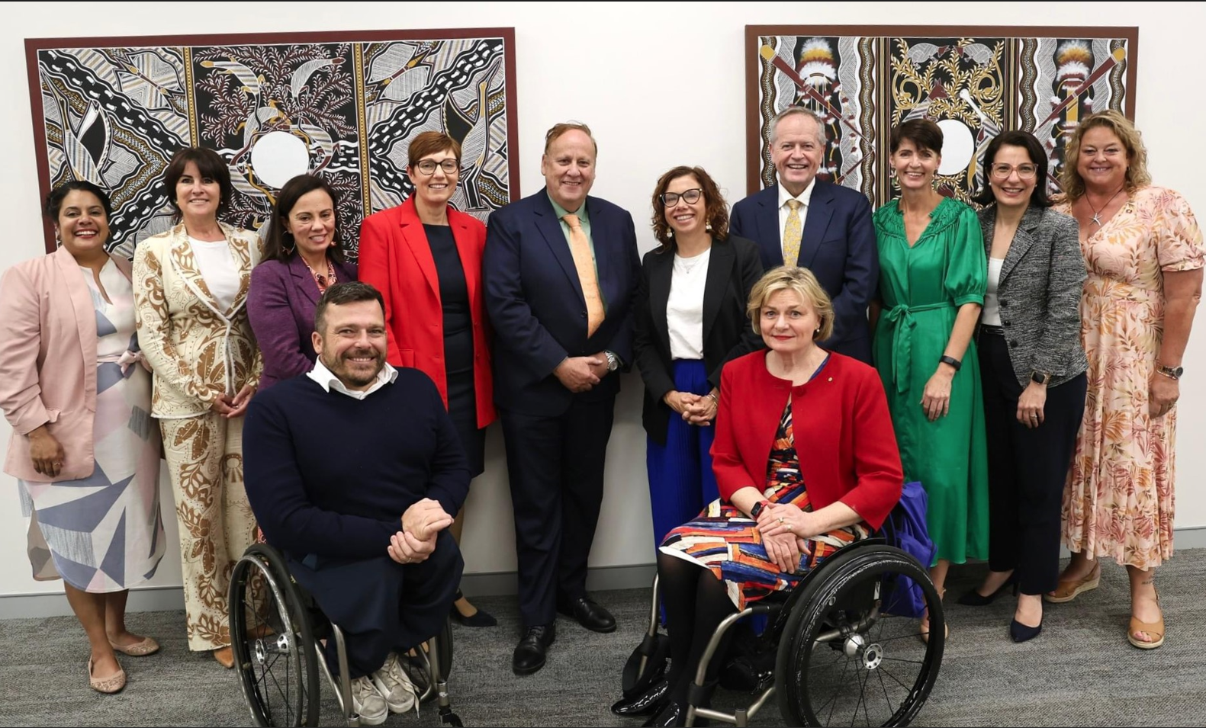
Image – Left to right - Minister Ah Kit (NT); Minister Palmer (TAS); Minister Blandthorn (VIC); Minister Stephen-Smith (ACT); Minister Punch (WA) Minister Rishworth (Minister for Social Services); Minister Shorten (Minister for the NDIS); Minister Washington (NSW); Minister Mullen (QLD); Minister Cook (SA).
Guests: Mr Kurt Fearnley AO, Chair (National Disability Insurance Agency Board) and Ms Jane Spring AM, Chair
(Australia's Disability Strategy Advisory Council).

