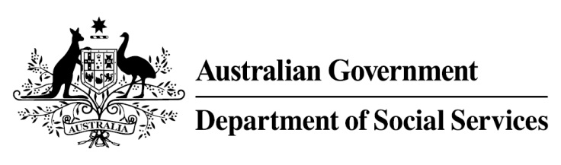

Try, Test and Learn Fund

  - Y4Y Youth Force
Using insights from the Priority Investment Approach, the Try, Test and Learn Fund is trialling new and innovative approaches to assist groups of people at risk of long-term welfare dependence.
The Try, Test and Learn Fund will help achieve the objectives of welfare reform — that is, to develop a modern welfare system that increases the capacity of individuals, reduces the risk of welfare dependency and maintains a strong welfare safety net.

What does the evidence tell us?

Fast facts
Note: This project has ended.
Priority group: Unemployed former students
Target participant number: 80
(Actual number: 80)
Locations: Melbourne
Trial period: 24 months
Total funding: $1.38 million
Co-designer: Whitelion Youth Agency
Service provider: Whitelion Youth Agency (subcontracting Nous Group)
Potential future saving: The purpose of these initiatives is to test whether an intervention works to reduce long-term reliance on welfare. If 25 per cent (20) of participants move off welfare, the savings to the welfare system are likely to outweigh the costs.
- 22 per cent of all current 17-19 year olds receiving student payments are expected to be on income support in 10 years.
- From 2003 to 2012, there were 7,160 vocational or university students who started receiving a student payment aged
17 to 19; then experienced more than 12 months on unemployment payments; and were receiving unemployment payments in 2015-16. On average, former young students who transitioned directly to unemployment payments are expected to receive income support in 33 years of their future lifetimes.
- If nothing changes for these former young students, 39 per cent will be receiving income support payments in 10 years, and 30 per cent will be receiving income support payments in 20 years.

What was Y4Y Youth Force?
This project aimed to assist unemployed former students, many of whom have never had a job, to gain some work experience and skills.
Participants were provided with small-group training, and were assisted by mentors, youth and employment-focused support to address any vocational or non-vocational barriers. Training offered included barista courses, IT skills, customer service, administration work or maintenance.
To help build their work experience, participants were offered one-off tasks donated by community partners and supported to participate in short-term work via the online gig economy, if interested, as a way to build skills, confidence and work experience. Participants were provided with transport to task locations and access to a central hub to network and borrow shared resources (such as tools) for tasks.

What were we trying to achieve?
Development of participants’ work experiences and skillset, the result of which is longer-term employment opportunities and potentially interest in further education.

How was this initiative new and innovative?
This initiative sought to generate evidence on the effectiveness of supporting unemployed former students to build work experiences and skills through the task-based economy, as a way to support their longer-term engagement in work and education.

