Counselling support

For people with disability who have experienced violence, abuse, neglect or exploitation
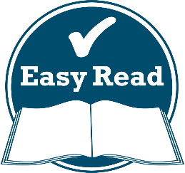

How to use this fact sheet
 | The Australian Government wrote this fact sheet. When you see the word ‘we’, it means the Australian Government.
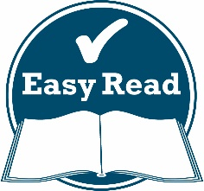 | We have written this fact sheet in an easy  to read way.  We use pictures to explain some ideas.
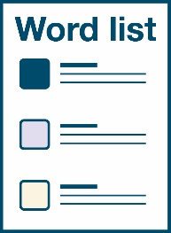 | We have written some words in bold.  We explain what these words mean.
You can ask for help to read this fact sheet.
A friend, family member or support person
may be able to help you.

Do you need support?
Counselling support is available for people with disability who have experienced:
- violence – if someone is hurting
you physically
- abuse – if someone is treating you badly
- neglect – if someone is not helping you
the way they are supposed to help you
- exploitation – if someone is taking advantage of you.
If you are experiencing any violence or abuse,
or if you feel unsafe, call 000 or contact the Police.

Counselling support
Counselling support is when you:
- talk to someone about how you think
and feel
- talk about ways to help you feel better.
You might need support from a counsellor.
A counsellor will support you to:
- talk about your feelings and emotions
in a safe space
- work out a problem or issue.
The support you can get is:
- free – it won’t cost you any money
- independent – it is run by disability organisations, not by the Australian Government
- confidential – the person you talk to won’t share what you say with anyone else.

Who provides counselling?
The National Counselling and Referral Service provides counselling services to:
- people with disability
- their families and carers
- people who work with people with disability.
It is run by the Blue Knot Foundation.
Blue Knot provides counselling:
- over the phone
- through an online chat
- in a video call.
There are also other counselling organisations that offer:
- long-term counselling services
- culturally appropriate support for Aboriginal and Torres Strait Islander people

Who can you call?
You can contact the National Counselling and Referral Service to speak to a counsellor.
1800 421 468
or
(02) 6146 1468
From:
- 9 am to 6 pm (AEST/AEDT) on weekdays
- 9 am to 5 pm (AEST/AEDT) on weekends and national public holidays.
You can also find counselling services on our website at www.dss.gov.au/disability-royal-commission-support

If you speak a language other than English,
you can call:
Translating and Interpreting Service
131 450
If you are deaf or have a speech or hearing impairment, you can call:
TTY
1800 555 677
Speak and Listen
1800 555 727
National Relay Service
133 677
www.relayservice.gov.au

The Information Access Group created this Easy Read document using stock photography and custom images. The images may not be reused without permission. For any enquiries about the images, please visit www.informationaccessgroup.com. Quote job number 3512-I.

