Carer Support Framework
Integrated Carer Support Service (ICSS)

Version 1.0 December 2019
Contents
Overview 3
Carer Support Planning Process 6
Support Planning Process Guidance 7
1. Intake 7
2. Registration 9
3. Understand Needs 11
4. Support Planning 13
5. Coordination 14
6. Support 15
7. Check-in 15
Guiding Questions 16
Service matching wheel 18
Service Matching Table 19

Overview
This document provides guidance on the Carer Support Framework (the framework), which outlines how Carer Gateway regional delivery partners (RDPs) provide support to carers. The purpose of the framework is to ensure a consistent and effective experience for clients of the Integrated Carer Support Service (ICSS).
The framework was tested and iterated through pilots undertaken by the Department in September 2018 and March 2019.
Carers StarTM
A central component of the framework is the Carers StarTM, an evidence-based tool that supports and measures change when working with people. The Carers StarTM is particularly used in the Understand Needs and Support Planning stages.
The Carers StarTM was developed in the UK specifically for use with carers, both full-time and part-time, and covers seven key areas:
- Health
- The caring role
- Managing at home
- Time for yourself
- How you feel
- Finances
- Work
Activities undertaken to design the framework
The Department has undertaken the following in the design of the framework:
- User Research: Working with carers and staff at carer support organisations to understand their needs, in context – Complete.
- Ideation: Exploring ideas to provide a guided, consistent approach to understanding the needs of carers and then connect them with support – Complete.
- Concept development: Creating an initial version of the framework for discussion with members of the sector – Complete.
- Consultation: Presentation of the framework to members of the sector for validation, feedback and iteration – Complete.
- Development of an alpha version: Preparation of the framework for use by carer support organisations in a limited pilot. Includes consultation with experts to successfully incorporate the Carers StarTM into the support planning process – Complete.
- Pilot (September 2018): Use of the alpha version of the framework with real carers to evaluate suitability and inform improvement– Complete.
- Development of a beta version: Creation of a framework version that is ready for broader use by the sector in preparation for live deployment from September 2019 – Complete.

Principles underpinning design of the framework
The user research and subsequent consultation input from sector stakeholders informed the following as key principles to guide design of the framework:
Principle | Description
Holistic approach | Assessment needs to be comprehensive and holistic, considering all relevant aspects of the carer’s circumstances.
Engage carers in a conversation | The most effective way to understand the needs of a carer is through a natural conversation between them and a Carer Support Worker.
Collect only what’s relevant | To provide an efficient experience, only the information that is most useful should be captured when needed, building carer and care recipient records over time.
Outcomes for carers | The process of identifying services for a carer must consider their aims, as they relate to their caring role and support outcomes that are in line with their needs as a carer.
Empower carers to self-manage | Enable carers to direct and manage their own support arrangements, empowering them to choose how and when supports are utilised.
Inclusive support | Planning supports for a carer must accommodate needs and preferences for service delivery that are specific to their cohort (including but not limited to Aboriginal and Torres Strait Islander, Culturally and Linguistically Diverse (CALD) and Lesbian, Gay, Transgender, Intersex and Queer (LGBTIQ) people).
Sustainable outcomes | Supports must enable caring arrangements to be maintained in the long term. Measuring carer outcomes is required to confirm and respond, where adjustments are needed.
Nationally consistent, locally adjusted | The framework needs to support a common way of working for all RDPs but still allow variations that support carer needs and service arrangements specific to the region they live in.

Components of the framework
The following components have been developed to support use of the framework by Carer Support Workers, who work for an RDP:
- Carer Support Planning Process: The steps that RDPs follow to provide support to carers who need it. The support planning process also defines the inputs and outputs at each stage in the carer’s journey.
- Support Planning Process Guidance: The criteria that should be met when supporting a carer through the process of accessing supports available under the ICSS.
- Understand needs Guiding Questions: Suggested approaches for Carer Support Workers when working through the seven Carer StarTM outcome areas to understand a carer’s needs and circumstances.
- Action Plan Guiding Questions: Suggested approaches for Carer Support Workers to guide creation of a Carer StarTM Action Plan.
- Service Matching Table: Assists with the identification of appropriate ICSS services to address the needs of carers.

Carer Support Planning Process
The process model (refer page 6) sets out the process for RDPs to follow to ensure that carers receive a consistently good experience when seeking support. The Carer Support Worker will facilitate the process for each individual carer, including the following stages:
- Intake: Initial contact with a carer when they present with an enquiry or request. Includes:
  - Identifying the carer;
  - Understanding what has prompted them to seek assistance;
  - Determining their eligibility to access carer support services, by confirming their role as a carer and confirming they are located in the RDPs service region;
  - Assessing the urgency of their request, based on their request timeframe and if they have any emergency circumstances; and
  - Educating the carer about the RDP’s role and available services.

- Registration: Capture of a carer's identifying information and basic information about the person they care for, where required. Registration establishes a record of the carer in the RDP's system to support ongoing management of support services and monitoring of carer wellbeing, post-delivery of services.

- Understand needs (incorporating the Carers StarTM) : Undertaken to understand a carer’s aims, responsibilities, care load, living circumstances, support network (including both current paid services and informal support from others) and general relationship with the person they care for. The process identifies the carer’s needs and is the key input to successfully completing the support planning process.

- Support Planning:
  - Identification of the types of supports/services that will benefit the carer, in line with their needs as identified through a conversation.
  - Development of an individual action plan to document the carer’s goals and the actions that will be undertaken (by the carer and others) to support them.

- Coordination:
Activities to put services in place for the carer either via:
- Referral to appropriate providers;
- Direct brokerage of services on the carer’s behalf; or
- Information to enable the carer to self-refer.

- Support: Delivery of services to the carer by appropriate service provider(s).

- Monitoring: Reconnecting with the carer to:
  - Check they have sustainable supports in place.
  - Measure support outcomes by checking their wellbeing against their baseline Carers StarTM reading.
Return to Understand Needs Stage to revise Carers StarTM based on new circumstances.

Carer Support Planning Process
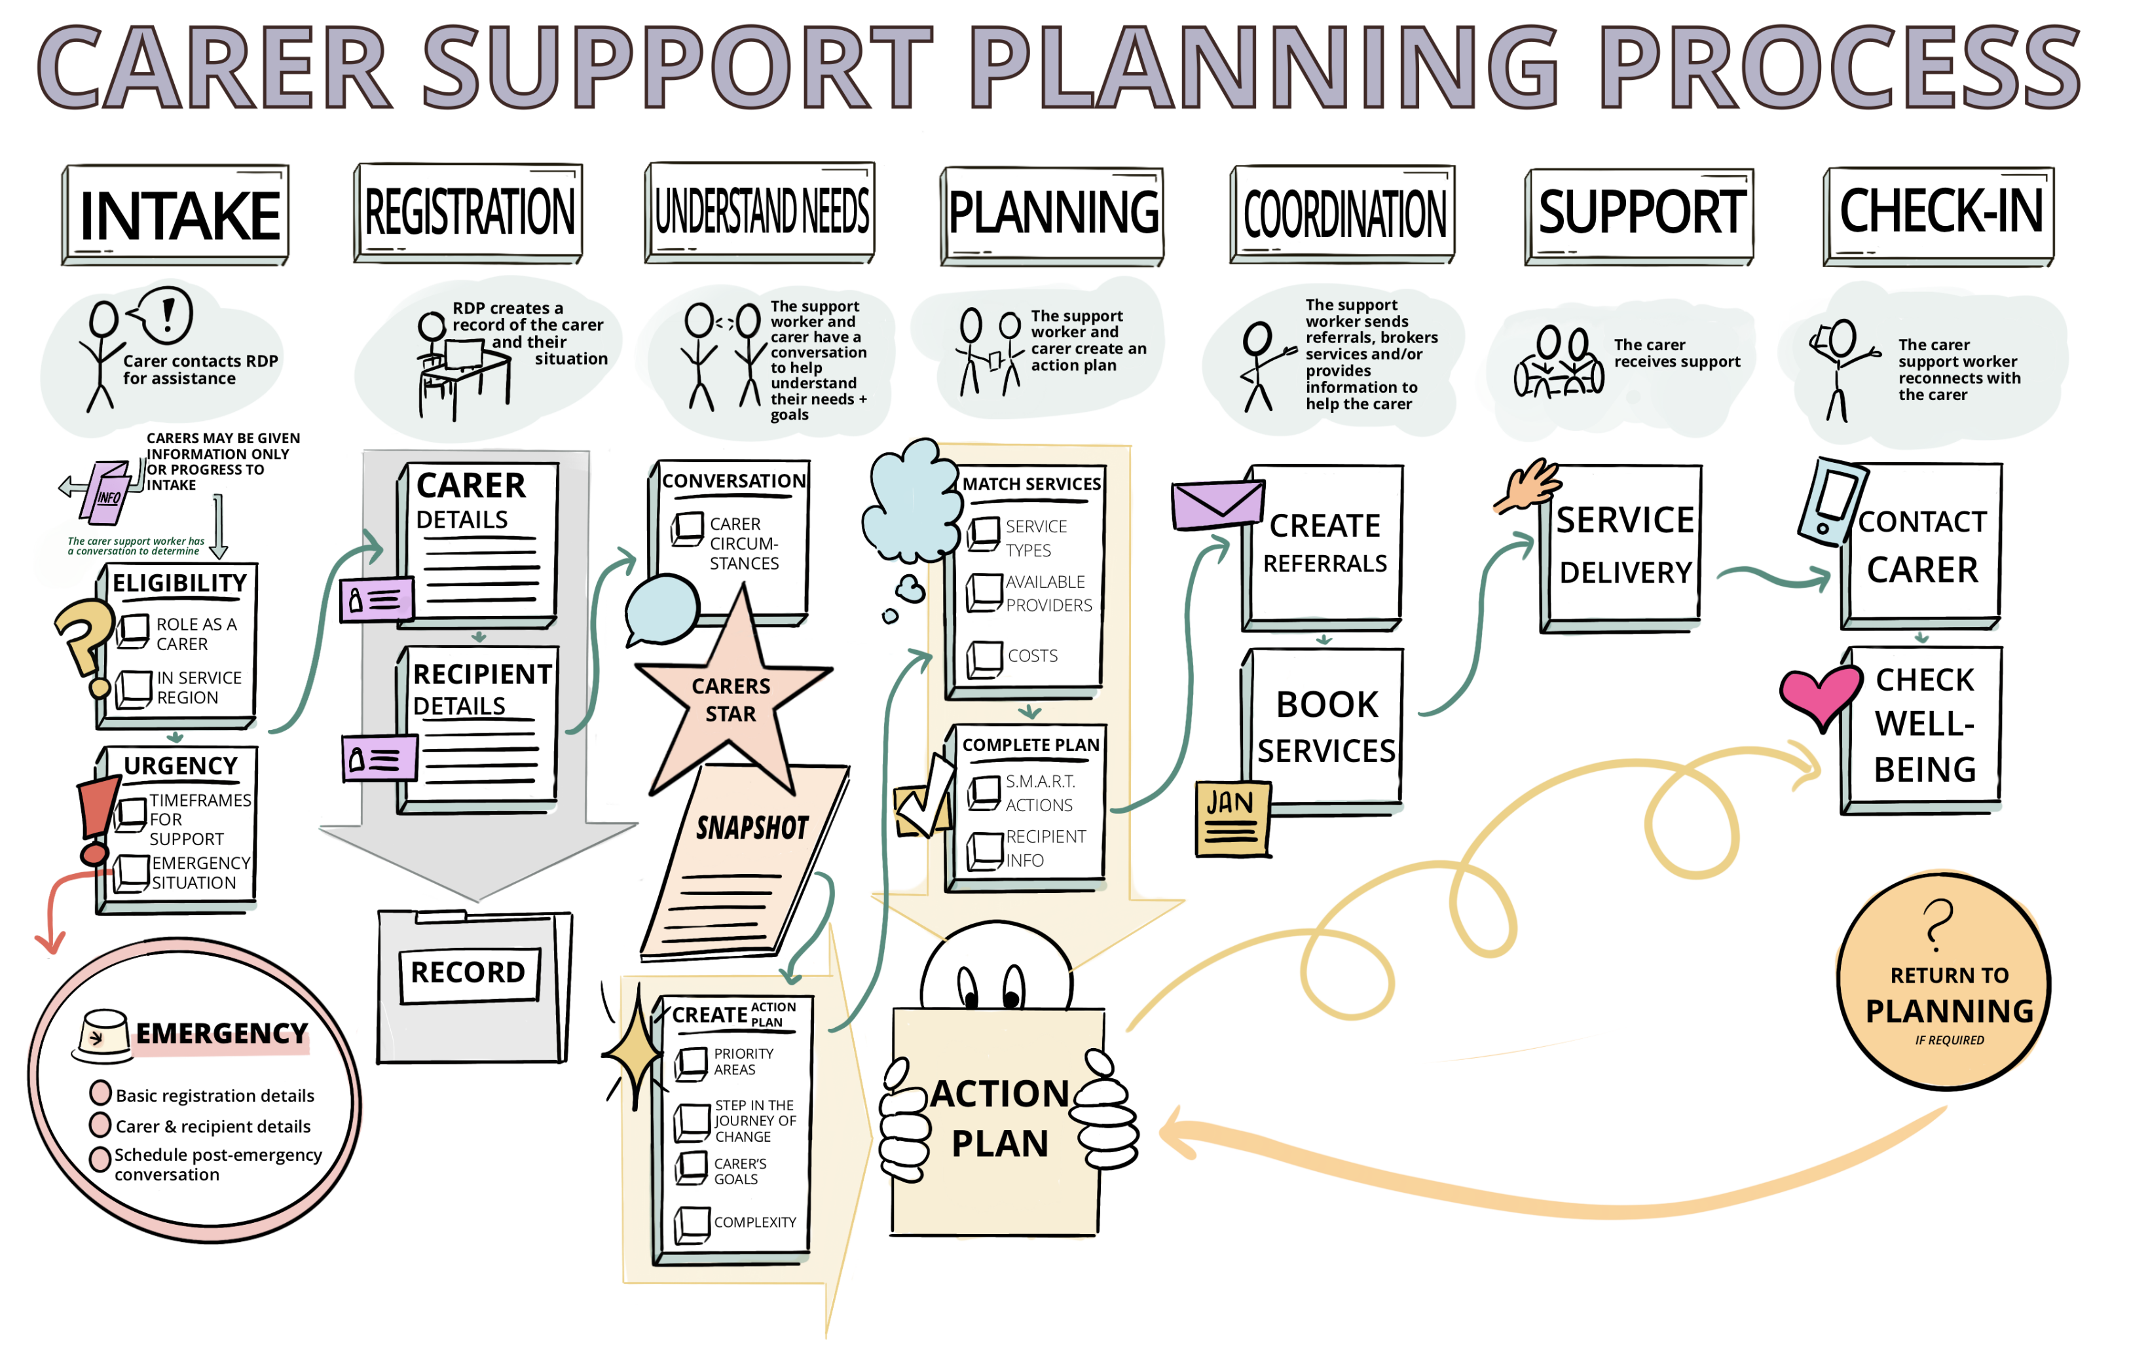

Support Planning Process Guidance

Intake
When a carer contacts the RDP for assistance, determine their eligibility and urgency for supports. Can occur over the phone or face-to-face. Undertaken by a carer support worker (trained in Carers Star) or office intake worker (not trained in Carers Star). May take between 5 to 15 minutes.
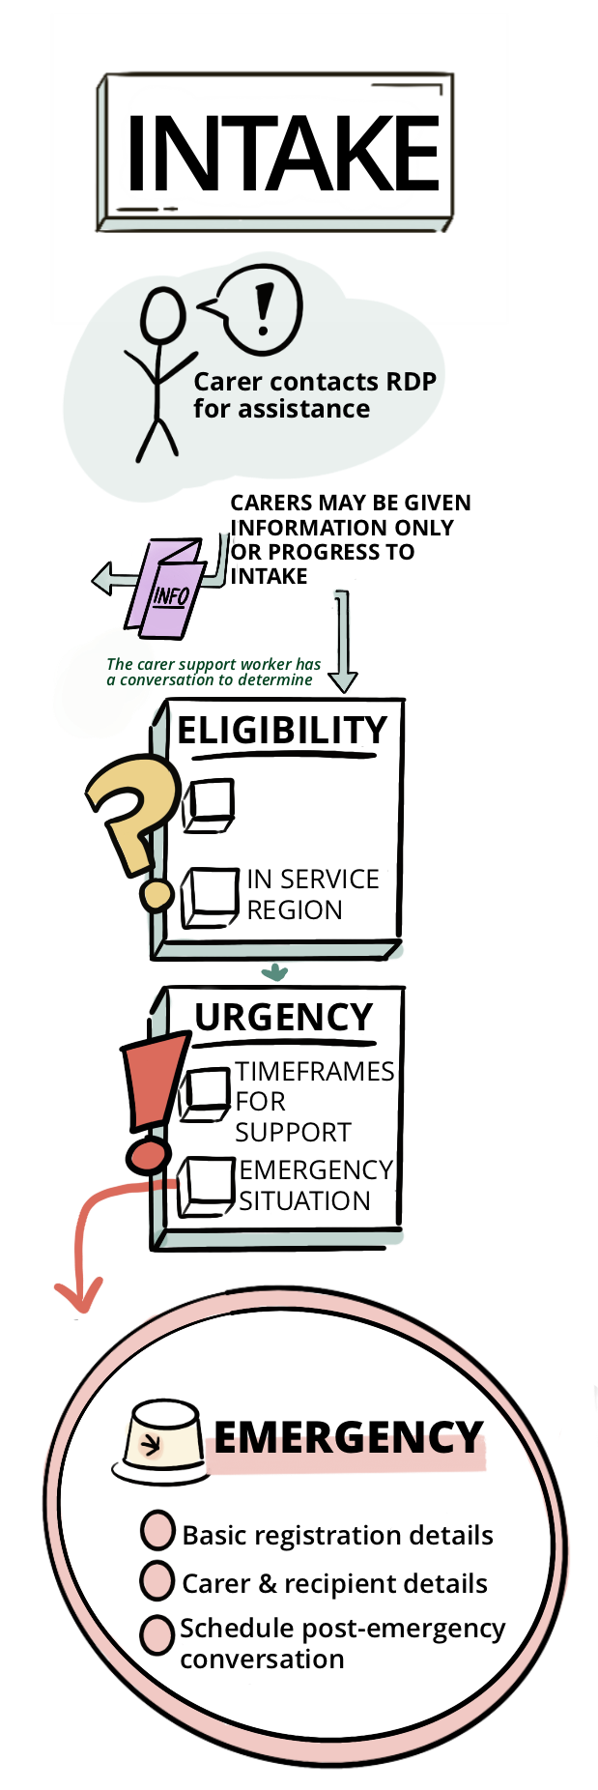
Carer contact
A carer may contact your organisation via phone, email, or through a third party, such as a health professional or other government service.
If the carer was referred by a third party, the information provided may not be a complete picture of the person’s circumstances and needs. In this case you can:
- Contact the referrer (preferably by phone) to get a better picture; or
- Contact the carer directly to determine the nature of their request.
A person’s contact with an RDP is often for information. Moving to the next step (registration) is only required for carers requesting support. However, requesting information is often the first step for people to recognise that they are carers and to build trust and rapport with your organisation. Many conversations that begin as a request for information end in a request for support.
Eligibility
- The person has taken responsibility for the care of another person who:
  - has a disability
  - has a mental health problem
  - has a medical condition (including a terminal or chronic illness
  - is frail aged
- Or the person has ceased being a carer within the past 12 months
- Lives within the service area of the RDP
If the person meets these criteria, complete registration using your IT system.

Urgency
EMERGENCY: The care relationship is under high stress and breakdown has either occurred or will occur, if support is not received within 72 hours. If this occurs:
- Understand the driver for the contact
- Assist immediately
Follow your organisation’s emergency process

If the person is not experiencing an emergency, determine if their urgency is high, medium or low.
Urgency | Criteria | Next steps
HIGH | There is a high level of stress in the care relationship and there is a risk of breakdown if support is not received in the next 7 days (for less than 72 hours see ‘EMERGENCY’ above). | Contact carer for registration and/or understand needs within 24 hours
MEDIUM | The care relationship is under moderate stress and support is needed within the next 14 to 21 days. | Contact carer for registration and/or understand needs within 48 hours
LOW | The care relationship is under low stress. | Contact carer for registration and understand needs within 72 hours

When determining urgency, ask yourself:
- Is there anyone supporting the carer or the care recipient?
- Does the caring role seem sustainable?
- What would happen if there were no supports?
- Has a sudden event occurred such as a recent hospitalisation?

Registration
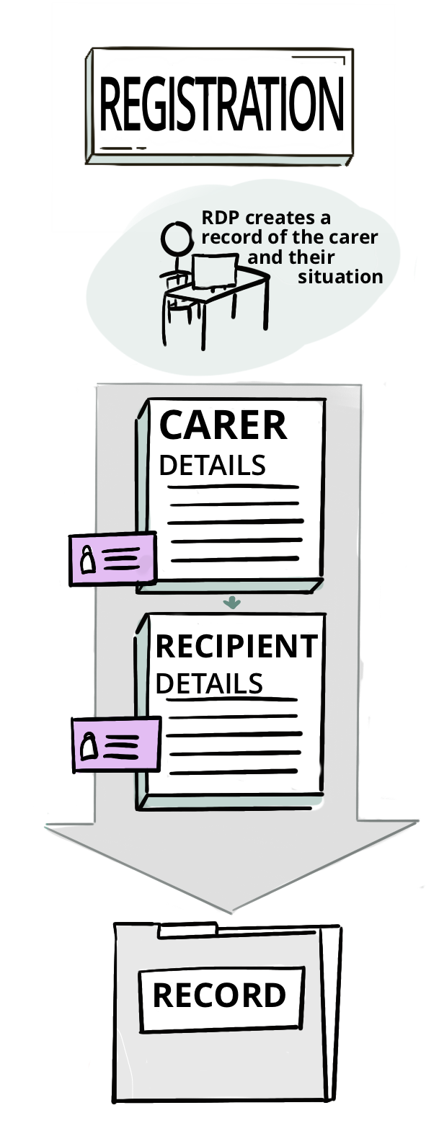
When a carer needs support, record their details and the details of the person they care for. Can occur over the phone or face-to-face. Undertaken by a carer support worker (trained in Carers Star) or office intake worker (not trained in Carers Star). May take between 5 to 15 minutes.
Record the carer’s details
Registration may happen in the same conversation as intake. Alternatively, some people may provide an initial set of details (name, date of birth, phone number), and a more detailed registration may occur at understand needs.
Asking carers for their details will often prompt their whole story. When this happens:
- Take notes so that the information can be used later, or
- Steer the conversation into understanding needs, if the carer has time (60 minutes); and the person taking registration details is trained and able to undertake the conversation, or
- Gently remind the carer that their story will be covered later and redirect to capturing their details.
For registration to be complete, the following details should be recorded:
- Given name
- Family name
- DOB
- Gender
- Residential address
- Phone
- Indigenous status
- Country of birth
- Main/preferred language
- Consent (includes consent to act on recipient’s behalf)
- Carer status (Primary/Shared/Other)
- Alternate carer’s name
- Alternate carer’s phone

Additional details will support further conversations with the carer and delivery of supports to them:
- Preferred name
- Disability/health condition (if any)
- Employment status
- Employment type (Full-time/Part-Time/Casual/Volunteer)
- Current Payment Type (Pension/Carer Payment)
- Carer status (Primary/other)
- Care recipients:
- Name of recipient 1
- Name of recipient 2
- Name(s) of other recipient(s)
- Relationship to recipient(s)
If this information is not captured at registration, it may be provided in later conversations with the carer. It’s important to update the record with the information if this happens.
Record care recipient details
For each person the carer is caring for, the following details should be recorded at a minimum:
- Given name
- Family name
- DOB
- Gender
- Residential address
- Phone
- Disability/health condition
- Pension Type
- Indigenous status
- Country of birth
- Main/preferred language
- Consent (for each carer to act on their behalf)
- For each carer:
  - Carer’s name
  - Carer’s phone
  - Relationship to carer
Additional details will support further conversations with the carer and delivery of supports to them:
- Preferred name
- Program (My Aged Care / NDIS / Other)
- Type of funded plan/package
If this information is not captured at registration, it may be provided in later conversations with the carer. It’s important to update the record with the information if this happens.

Understand Needs
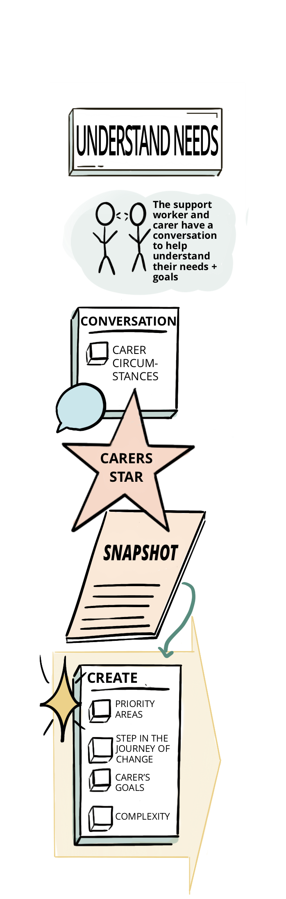
Establish the carers needs through a conversation and record their goals, priorities and supports in an action plan. Can occur over the phone or face-to-face. Undertaken by a carer support worker (trained in Carers Star). May take between 30 to 90 minutes, 60 minutes on average.
Conversation
A full conversation including the Carers StarTM and action planning will take around 60 minutes to complete. For many carers, this is best scheduled a day or two after intake and registration, when they can:
- Make arrangements to be sitting comfortably, ideally without the person they care for in the same room, and
- Have had time to look at the Carers StarTM snapshot and scales before the conversation.
The Carers StarTM materials can be provided to the carer by:
- Email (preferred)
- Text message (where the carer does not have access to a computer at the time of the conversation)
- Mail (in cases where there is low urgency / the conversation is scheduled to occur in a week or more)
If the carer cannot be provided with Carers StarTM materials , or they aren’t ready to ready to engage with the Carers StarTM, the snapshot can be completed by the Carer Support Worker only, and in this instance a record of ‘Worker Only’, should be recorded in the star.
Once the carer is ready to have the conversation, use Carers StarTM to guide a conversation about their needs, and record where they sit for each domain, making notes on their responses.
Whilst most conversations can occur on the phone, face to face is appropriate or preferred when:
- The person is Aboriginal or Torres Strait islander, and it isn’t culturally appropriate to engage over the phone.
- The person requires an interpreter to communicate, and the Translating and Interpreting Service (TIS) isn’t available or appropriate.
- The person is a young carer under 18.
More guidance on using the Carers StarTM to have a conversation with carers is covered in the Carers StarTM user guides and training material.
Action plan
Through the understanding needs conversation you have identified the main areas of concern for the carer and may have already touched on the carer’s goals and priorities. Building on what you’ve learned, have a conversation with the carer to establish some immediate goals and actions, and document these in a plan. A good way to start the conversation is to reflect back what they’ve said are their main priority areas and suggest actions, e.g. “You mentioned that getting to sleep is an issue for you, particularly when you’re caring for your mum the next day. Have you thought about trying a relaxation tape at bedtime?”.
Depending on where the carer is at in their journey of change, actions may be undertaken by the carer support worker or by the carer themselves. Action plans are most effective when they reflect the carer’s own priorities and include realistic, achievable actions that relate to a broader goal.
An action plan will generally include between 1-5 actions structured with the following information:
- The priority area from the Carers StarTM (e.g. ‘Health)
- The step in the journey of change (e.g. ‘Finding what works’)
- The carer’s goal (e.g. ‘To sleep better so I have more energy in the day’)
- The action to be undertaken, by whom and when (e.g. ‘I will try streaming relaxation audio tapes at bedtime in the next week’)
More guidance on using the Carers StarTM to build an action plan with carers is covered in the Carers StarTM user guides and training material.

Support Planning
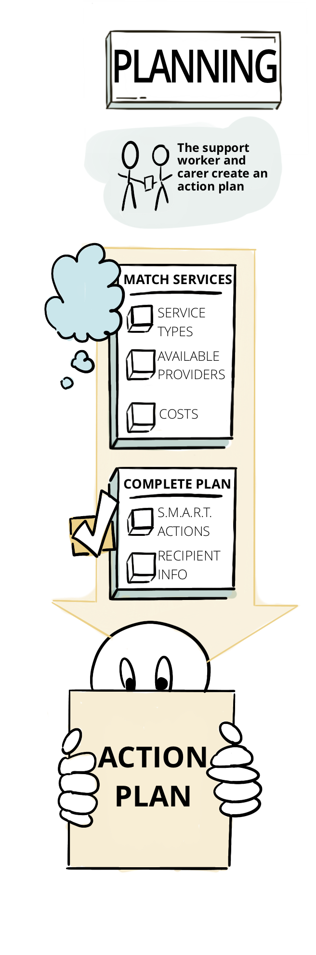
Find supports for the carer and finalise the action plan with the carer. Can occur over the phone or face-to-face. Undertaken by a carer support worker (trained in Carers Star). May take between 10 to 30 minutes.
Find supports
The service matching wheel (page 19) may help in identifying available supports for the carer based on the domains of the carers star. However, your local networks and knowledge of informal supports should also be considered in forming the action plan.
When looking for supports, consider:
- The service types needed by the carer, e.g. if the client requires more than one service, look for providers that will cover all;
- The availability of the providers and the urgency of the client’s needs, e.g. does the provider have a three month waitlist for a service the carer needs next week;
- The costs associated with the services, e.g. if the carer has difficultly affording services, are there financial hardship provisions for fees
The carer’s communication and cultural needs should be strongly considered at this stage. Where possible, look for providers that caters to a specific cohort, or has indicated that they have additional supports to people with specific needs.
Finalise action plan
The action plan should reflect the conversations with the carer at understanding needs and planning, and should also include:
- Services that the carer has chosen to use.
- Actions for referral and/or purchase of the services.
When the action plan is complete, send a copy of their completed Carers StarTM Star Chart and action plan to the carer by email or post, depending on the carer’s preferences. This is also an opportunity to send any information or brochures that you may have discussed with the carer, e.g. information on local support groups.
At finalisation, the carer’s deidentified information should be recorded in DEX.

Coordination
Send referrals and book or services where required. Can occur over the phone, digitally (via email or eReferral system) or fax. Undertaken by a carer support worker (trained in Carers Star). Duration varies depending on action plan. May be completed the same day as support planning for simple action plans, or occur over 12 weeks for more complex plans requiring ongoing coordination.
Send referrals
If the carer intends to organise services themselves, or the services sit outside of the carer support system (e.g. My Aged Care) the Carer Support Worker creates/provides the appropriate referrals and contact details. Ensure that the carer has provided consent for their information to be provided to another organisation.
Book or broker services
If services can be booked directly, coordinate with the client to nominate a time and book the service using your system
If brokerage of services for the care recipient is required:
- Capture consent to share carer recipient’s and the carer’s personal information with the provider, if required for the services; and
- Ensure sufficient details of the care recipient’s needs are captured if required for the services., e.g. Activities of Daily Living (ADLs) and Instrumental Activities of Daily Living (IADLs)
Once services have been booked or brokered:
- Contact carer so they know what to expect; and
- Post or email the schedule of services, including contribution payment details (only for services where a co-contribution payment is permitted and the carer has agreed to a co-contribution for their service).

Support
Services are delivered by the applicable service provider(s). Can occur face-to-face, over the phone or digitally. Undertaken by the carer themselves (for self-supports), or by services. May be one off, time-limited or ongoing services.

Check-in
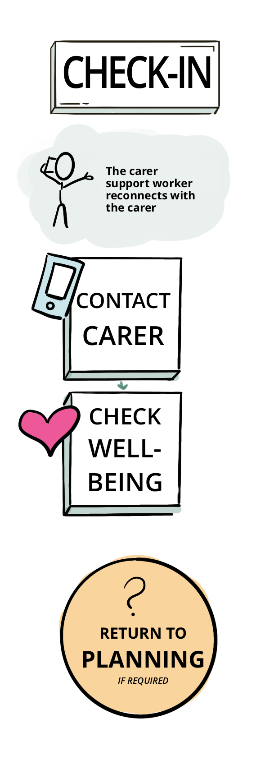
Contact with the carer, check wellbeing and return to support planning if required. Can occur over the phone or face-to-face. Undertaken by a carer support worker (trained in Carers Star). May take between 5 to 30 minutes.
Contact carer
Contact the client 3 months after their initial understanding needs conversation to check their progress against the action plan.
A check in is usually an informal conversation with the carer about their current situation. During the conversation, refer to their action plan and check the progress of each item.
Check wellbeing
In most cases, a check in will naturally lead to a Carers StarTM conversation. If the check in does not naturally lead to a Carers StarTM conversation, ask the carer if they have time to undertake a review of their Carers StarTM snapshot.
Even if the carer is now fully supported and doesn’t intend to seek further support, an updated Carers StarTM snapshot helps to measure the effectiveness of carer supports.
Guide the conversation against each of the domains and encourage the carer to reflect on their progress in the journey of change.
Record your notes and the latest scores in your system, and report the Carers StarTM scores into DEX.
Return to support planning
If the need for new actions arise from the conversation with the carer, create a new action plan (return to step 4 – Support Planning, page 13).
If there are no new actions, arrange a follow up with the carer in 12 months.

Guiding Questions
Purpose
Guiding questions will be developed to inform Carer Support Workers who undertake understanding needs conversations with carers for the ICSS. The intent is to enable Carer Support Workers to apply the Carers StarTM consistently. Sector stakeholders have identified a need for materials that provide guidance on:
- Understand Needs Guiding Questions: Identification of appropriate topics to raise with a carer to understand their needs, in line with Carers StarTM outcome areas.
- Support Planning Guiding Questions: Explain how to correlate Carers StarTM outcomes with services to assist the carer.
The questions below are examples of the type of questions which may be used. They are not intended to be read verbatim as a script – their purpose is to prompt discussion about aspects of the carer’s situation that inform a Carers StarTM reading and can be used in any order, based on the judgement of the Carer Support Worker conducting the conversation.
Examples of the Understand Needs Guiding Questions
- Health
- In general how would you say your health is?
- Do you currently have any health conditions?
- What overall impact is there on your physical health because of your caring role?
- Would you say that you have a healthy lifestyle?
- How’s your diet?
- Do you get enough sleep?
- Are you on any medications?
- Do you listen to what the doctor says?
- The Caring Role
- Any challenges for you in providing support? Are you able to support your person in all areas where they need support?
- DO you understand everything you need to do to support your person? Do you have any questions about it?
- Have you made any plans for the future? Are there already any services in place (if not already asked)?
- Do family and friends provide support to assist you in your caring role (if not already asked)?
- Do you have any concerns about the future?
  - If you were unable to continue caring either in the short term or longer term what may be some of the options?
  - Have you discussed these options with the person or family?
  - Do you have any guardianship/power of attorney arrangements in place?
- Managing at Home
- Overall how are you coping with day to day tasks in the home? Examples include cooking, cleaning and shopping.
- Is your/their home suitable at present? What would make it more suitable?
- Time for yourself
- Do you feel like you currently get some time to yourself and are able to attend to your own needs?
- When was the last time you spent some time by yourself outside the caring role?
- What do you enjoy doing?
- Do you get enough sleep?
- Do you get the chance to spend time with friends/family away from your caring role?
- Do you have any hobbies or interests? Do you have time to do these?
- How you feel
- What overall impact is there on your mental health because of your caring role?
- Do you feel supported by family and friends? Any stress on relationship with person you care for? Has caring caused any strain or impacted on your relationships with family or friends?
- Finances
- Do you receive carer pension/allowance?
- Are you ok with paying bills and groceries?
- Does your person receive a government pension/benefit?
- Has your caring role affected your financial situation?
- Work
- Any paid employment? Status of employment?
- For carers who are employed:
  - Is your employer aware of your caring role? Are they supportive?
  - Does your caring role impact your work?
- Any volunteer work or study currently?
- Are you wanting to get back into the workforce and if so how can we support you?
Examples of Support Planning Guiding Questions
Key questions to guide the creation of an Action Plan for the carer are as follows:
- What’s important to you right now?
- Are you able to identify any goals that you would like to achieve in the near future?
- What kind of support would make the biggest difference for you now or into the future?
- Is there anything in your overall health and wellbeing you would like to change?

Service matching wheel
The following wheel matches the Carers StarTM domains against each of the services available within the ICSS.
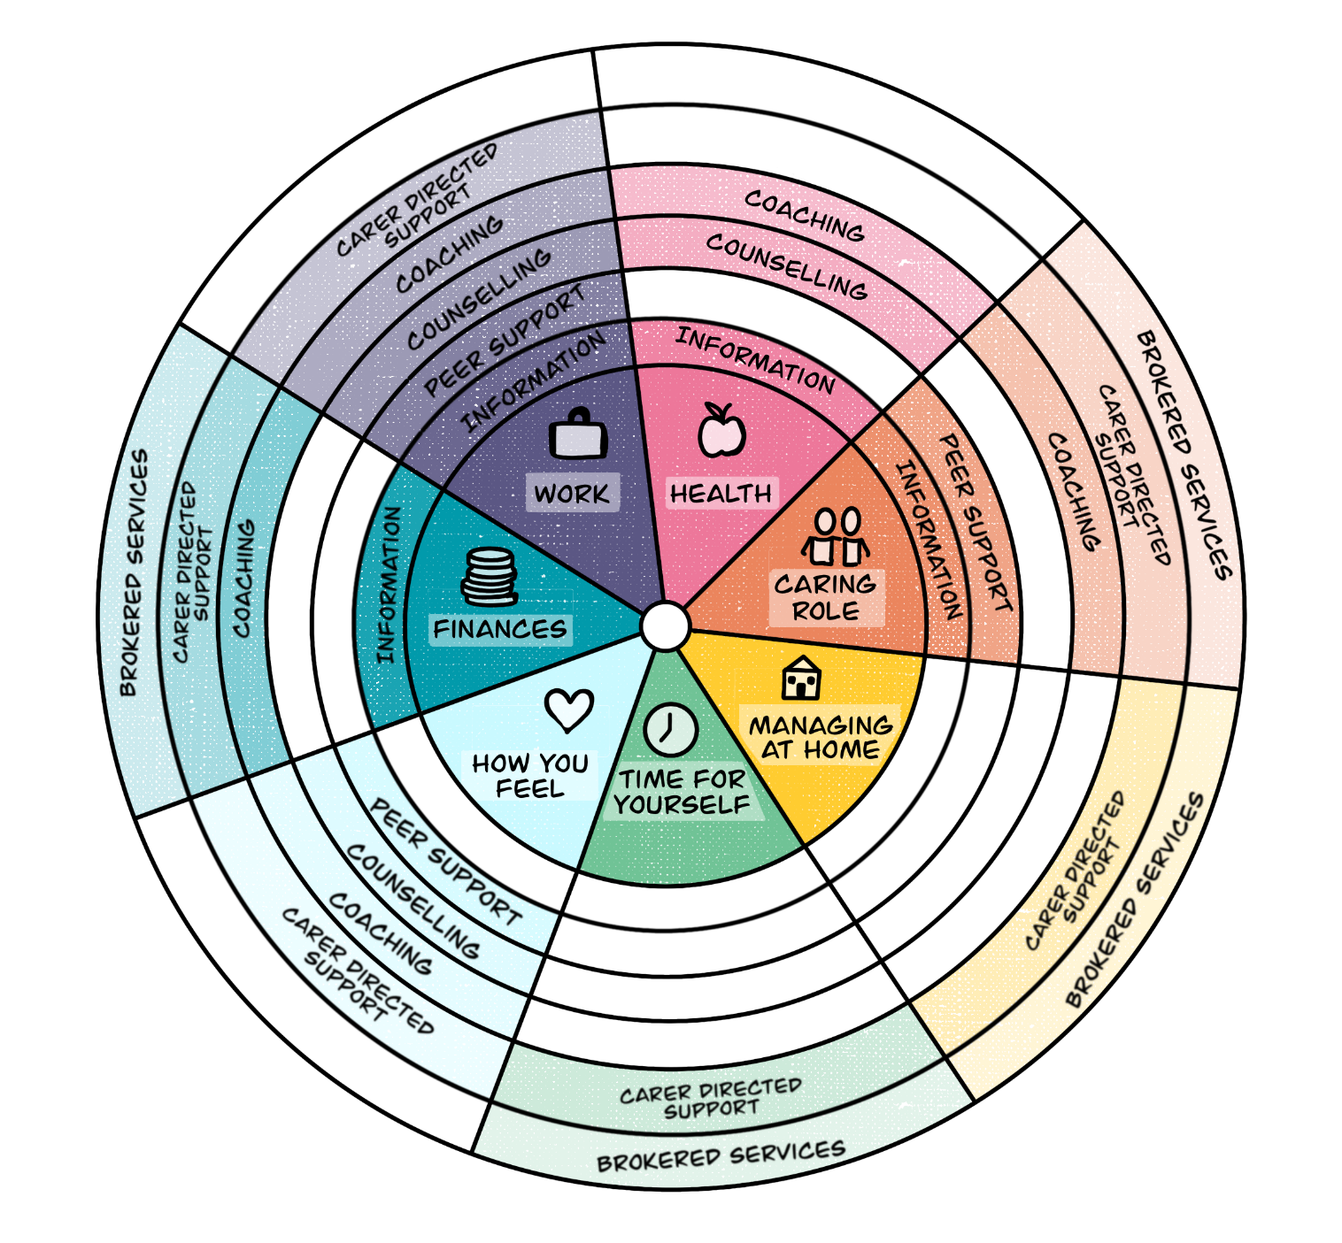

Service Matching Table |  | ICSS Services
This table suggests example ICSS services that may be appropriate to meet a carer’s identified needs. |  | Information | Peer Support |  | Counselling |  | Coaching |  | Carer Directed Support | Emergency Respite | Other Actions | Referral | Brokerage of Recipient Services
Area of Life | Need | Online Resources | Online | In Person | Digital | In Person | Self-guided | Facilitated
Health | Mental Health |  |  |  |  |  |  |  |  | Not Applicable – Refer to Emergency Process
 | Nutrition
 | Fitness
The Caring Role | Practical support with care
 | Access to information/educational resources
 | Training
 | Caring advice/mentoring
 | Legal advice
 | Advocacy
 | Equipment/aids
 | Transport services
 | Contact/connection with other carers
 | Temporary planned respite care
Managing at home | Home repairs or modification
 | Support with cleaning
 | Support with shopping
Time for yourself | Activities away from caring
 | Short breaks (less than a day)
How you feel | To feel:
 | Supported
 | Connected
 | Secure
 | Less stressed
Finances | To apply for Carer Payment/Allowance
 | Funded services for care recipient
 | Legal advice
 | Financial advice
Work | Support to return to work
 | Support reduction of work hours
 | Strategies to communicate/negotiate with employer
 | Support post cessation of employment

Formerly referred to as the Carer Pathway Navigator.
©Triangle Consulting Social Enterprise Ltd. 2018. About the Star – Triangle. [ONLINE] Available at: "about the star" on the outcomesstar website. [Accessed 27 June 2018].
©Triangle Consulting Social Enterprise Ltd. 2018. Carers StarTM – Triangle. [ONLINE] Available at: "carers star" on the outcomesstar website. [Accessed 26 October 2018].
The term “basic information” refers to a simple note or direction regarding the person receiving the care. An example might be – “Provides care for – Robert (Spouse). Condition – Dementia”
Checks may initially be scheduled close to the end of the carer’s first round of services and then, with the carer’s agreement, every three to six months, thereafter, by default.

