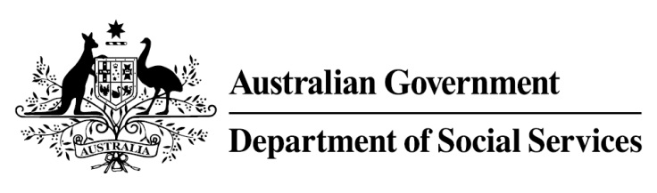

Try, Test and Learn Fund

Initiative: Reach, Train and Employ

Location: Victoria

What are we trying to achieve?
This project aims to re-skill older jobseekers for aged care and disability services sector work. Tailored training with wrap-around support and financial capability support where required will help to prepare participants for the
often-casualised nature of employment in this sector.

Fast facts
Priority group: Older unemployed
Participant numbers: 50
Locations: Melton and Brimbank
Trial period: 23 months
Total funding: $0.65 million
Service provider: Council on the Ageing Victoria with RMIT University
Potential future saving: If around 10 per cent of participants move off income support because of this project, the savings to the welfare system are likely to outweigh the costs of the project.

What is Reach, Train and Employ?
Through Reach, Train and Employ, participants will be supported to complete a Certificate III in Individual Support through RMIT University. The course will be free of charge, delivered at a site that is convenient to the participants, and tailored for this cohort. Potential participants will be screened to assess their suitability for work in this sector prior to being accepted in the project.
Participants will be provided opportunities to improve their financial literacy and where relevant, will be referred to health and wellbeing services. A project
co-ordinator will build relationships with local sector employers to better understand local employment demand, and to build links between participants and potential employers.
What does the evidence tell us?
- Many older Australians want to work but find it difficult to get work.

- Australians are on average living into their 80s, and older jobseekers may draw on income support payments for many years.

- If nothing changes, 75 per cent of this group will be receiving income support payments in 10 years, and 74 per cent will be receiving income support payments in 20 years.
How is this initiative new and innovative?
This project is specifically designed to assist older unemployed people to find work in the burgeoning community services sector. The project’s educational component recognises the unique learning needs of older unemployed jobseekers, and provides support to help ensure participants complete the training. The project also recognises the need to prepare older jobseekers for the often-casualised nature of employment in this sector.
Using insights from the Priority Investment Approach, the $96.1 million Try, Test and Learn Fund is gathering evidence on new or innovative approaches to addressing barriers to work.
The Try, Test and Learn Fund will help achieve the objectives of welfare reform—that is, to develop a modern welfare system that increases the capacity of individuals, reduces the risk of welfare dependency and maintains a strong welfare safety net.

