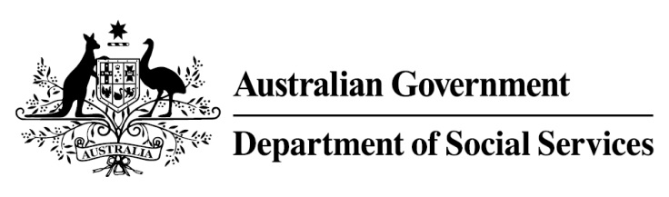

Try, Test and Learn Fund

Initiative: Sonder Employment Solutions
Location: South Australia

What are we trying to achieve?

Fast facts
Priority group: Migrants and refugees
Participant numbers: 300
Location: Adelaide
Trial period: 17 months
Total funding: $3 million
Service provider: Sonder
Potential future saving: If around seven per cent of participants move off income support because of this project, the savings to the welfare system are likely to outweigh the costs of the project.
This project seeks to improve employment outcomes for migrants and refugees by supporting them to overcome complex psychosocial barriers to employment through culturally appropriate employment support and mental health support.

What is Sonder Employment Solutions?
A modified and culturally appropriate version of the Individual Placement and Support (IPS) model of vocational assistance to help vulnerable migrants and refugees overcome complex psychosocial barriers to employment.
Participants will receive employment and vocational support from employment specialists who are integrated with a mental health service and trained in mental health first aid. Employment specialists will use this training to identify signs or symptoms of unrecognised mental health problems or undiagnosed mental health conditions. Where relevant, employment specialists will offer participants mental health services from one of Sonder’s mental health clinicians, and will coordinate employment support with these services and any other services received by participants.
A one-on-one and culturally appropriate employment support program, in conjunction with appropriate mental health support, will improve the likelihood of participants transitioning smoothly into a workplace and maintaining long-term employment.

What does the evidence tell us?
- While many migrants and refugees successfully gain employment within the first few years of arrival, a small group continue to struggle and this group is at elevated risk of long-term welfare dependence.
- On average, migrants and refugees who currently receive income support are likely to be on income support in 30 years over their lifetime.
- If nothing changes, 56 per cent of this group will be receiving income support payments in 10 years, and 52 per cent will be receiving income support payments in 20 years.

How is this initiative new and innovative?
The key innovation of this project is modifying the evidenced-based IPS model of supported employment to specifically support vulnerable migrants and refugees who experience complex psychosocial barriers to employment. The modified model will be culturally sensitive and responsive to the needs of each participant, and will offer access to mental health services as necessary.
Using insights from the Priority Investment Approach, the $96.1 million Try, Test and Learn Fund is gathering evidence on new or innovative approaches to addressing barriers to work.
The Try, Test and Learn Fund will help achieve the objectives of welfare reform—that is, to develop a modern welfare system that increases the capacity of individuals, reduces the risk of welfare dependency and maintains a strong welfare safety net.

