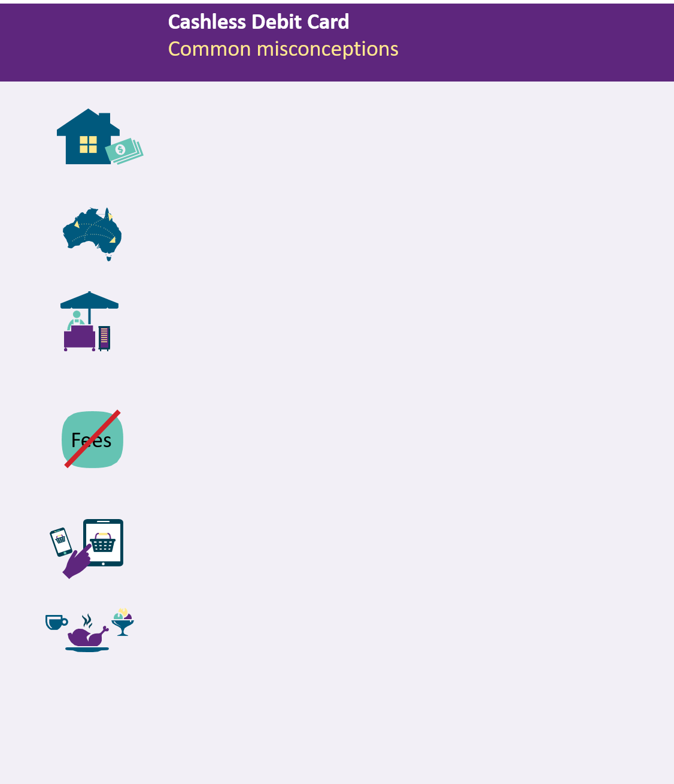

Misconception 1: I can’t pay rent on the Cashless Debit Card.

You can pay rent with your Cashless Debit Card
In many instances, your rent will be paid before your payment goes onto your Cashless Debit Card. In other private rental agreements, you can use your Cashless Debit Card to pay rent by BPAY, eftpos or direct debit.

Misconception 2: I can’t use my card interstate

You can use your Cashless Debit Card across Australia
You can use your Cashless Debit Card in any store that accepts eftpos, nationwide, except to buy alcohol, gambling products, some gift cards or to withdraw cash.

Misconception 3: I can’t buy second hand items (furniture, cars etc) or items at markets.

You can purchase items with cash from markets and stalls
You can use the 20 per cent of your payment paid into your regular back account to make cash purchases. There is also an ability to transfer additional funds in certain circumstances where you need access to additional cash.

Misconception 4: Indue charge fees to use the card.

The Cashless Debit Card is a fee-free account
The Cashless Debit Card is a fee-free account for participants. You can check your account balance and transaction history for free online, over the phone or at an ATM. Lost or stolen cards are replaced for free and purchases do not incur transaction fees or account keeping fees.
Misconception 5: I can’t shop online.

You can shop online using your Cashless Debit Card
You can use your card to make purchases from all online retailers, except those that sell alcohol or have gambling activities available such as online casinos.

Misconception 6: I can’t use my card at restaurants and bistros.

You can use your Cashless Debit Card at restaurants and bistros
You will be able to purchase food using your Cashless Debit Card at most restaurants and bistros in Cashless Debit Card trial sites, however alcohol cannot be purchased with the card.

Where can I find out more? Contact the Department of Social Services:
Go to www.dss.gov.au/cashlessdebitcard
Or contact the Cashless Debit Card hotline on 1800 252 604

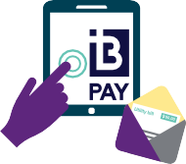

4 4 4

$
Misconception 7: The Cashless Debit Card is only for Indigenous people.

The Cashless Debit Card supports people, families and communities experiencing high levels of welfare dependence and social harm
The Cashless Debit Card is being trialled in both Indigenous and non-Indigenous communities. Now that the Cashless Debit Card is rolled out across the Bundaberg and Hervey Bay region, only around 34 per cent of total participants are Indigenous.

Misconception 8: I can’t use Direct Debit

You can use your Cashless Debit Card to make direct debit payments
Direct Debits can be made using either your card number or your BSB and Account Number.

Misconception 9: The Minister selected Indue as the card provider.

The Department of Social Services has contracted Indue as the Cashless Debit Card provider
The card provider is contracted by the Federal Government. Independent analysis found that Indue was the most feasible service provider for the Bundaberg and Hervey Bay region. This procurement represented the best value for money and aligned with the Commonwealth Procurement Guidelines.

Misconception 10: The Cashless Debit Card is not working

The Cashless Debit Card is making a difference
The card is working. Independent evaluation of the Cashless Debit Card found there has been a “considerable positive impact” in the two trial communities of Ceduna and the East Kimberley. The Cashless Debit Card trial has been effective in reducing alcohol consumption, gambling and drug use. A second independent evaluation of the program is currently taking place with the final report due in late 2019.

Misconception 11: The Cashless Debit Card costs

$10,000 per person.

The Cashless Debit Card is significantly cheaper than people think
For the Bundaberg and Hervey Bay region, the ongoing per head cost of the Cashless Debit Card is approximately $820 per annum, based on the card provider maximum value.

Where can I find out more? Contact the Department of Social Services:
Go to www.dss.gov.au/cashlessdebitcard
Or contact the Cashless Debit Card hotline on 1800 252 604

