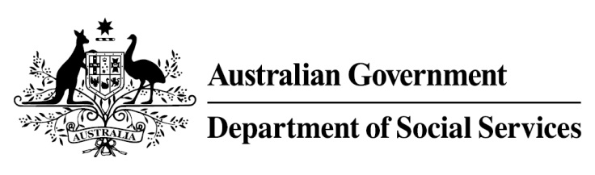

Try, Test and Learn Fund

  - Supporting Expecting and Parenting Teens
Using insights from the Priority Investment Approach, the $96.1 million Try, Test and Learn Fund is trialling new and innovative approaches to assist groups of people at risk of long-term welfare dependence.
The Try, Test and Learn Fund will help achieve the objectives of welfare reform—that is, to develop a modern welfare system that increases the capacity of individuals, reduces the risk of welfare dependency and maintains a strong welfare safety net.

Fast facts
Priority group: Young parents
Recipient numbers: Around 350 will have access to a mentor in trial sites and parents across Australia will have access to online services
Location: Trial sites in: Melbourne and Geelong, VIC; Brighton, Clarence and Derwent Valley, TAS; Darwin, NT; Wyong and Newcastle, NSW; Ipswich and Logan, QLD and nationwide online services
Trial period: 28 months
Total funding: $4 million
Co-designers: Brave Foundation, Drummond Street Services, Royal Women’s Hospital, Micah Projects, Caboolture Hospital, Sanderson Alliance, YFS, Zoe Support, Anglicare WA, Anglicare VIC, The Smith Family, Cape York Partnership, Mission Australia, The Benevolent Society, SYC, Royal Children’s Hospital, Jenny Aiello, DALE Young Parents School, and Jewish Care
Service provider: Brave Foundation
Potential future saving: The purpose of these initiatives is to test whether an intervention works to reduce long-term reliance on welfare. It is not possible to predict success rates in advance—this is the purpose of testing new approaches. If 13 per cent of participants (65) take up some work when they would not otherwise have done so, the savings to the welfare system are likely to outweigh the costs.

What does the evidence tell us?
- In 2016, there were 3,760 young parents in Australia aged 18 or under receiving Parenting Payment. On average, all current young parents are expected to be on income support for around 48 years over their future lifetime.
- If nothing changes for these young parents, 79 per cent will be receiving income support payments in 10 years, and 57 per cent will be receiving income support payments in 20 years.
- In addition, analysis shows, around 620 current young parents will remain on income support for the rest of their lives.

What is Supporting Expecting and Parenting Teens?
Trusted mentors will work intensively with expectant or teenage parents to link them to support they need to achieve their goals.
Young parents will have access to a flexible funding package that they can use prior to the birth of the baby and during the early stages of parenthood. The funding will go towards supports that help to address their individual barriers, and that better prepares them to return to education or search for a job.
A national online platform will also provide information and links to local support services.

What are we trying to achieve?
This initiative aims to support successful adjustment to the responsibility of being a new parent by reducing isolation and supporting development of self-confidence and resilience.
By helping young parents adjust to the responsibility of parenting in a healthy, safe environment, we aim to have young parents in a better position to engage with education and the workforce in a positive, ongoing way, thereby also reducing intergenerational welfare dependency.

How is this initiative new and innovative?
This is an early, pre-ParentsNext initiative, aimed specifically at expecting and parenting teenagers who may experience barriers to good parenting and future workforce participation.

How will this initiative be evaluated?
This initiative will be tracked using a range of evaluation methods, such as surveys, participant interviews and actuarial analysis.

