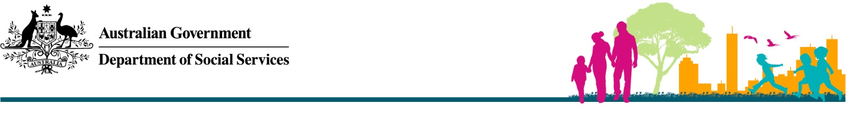

Dowry Abuse

# Dowry-related violence or harassment is a form of domestic and family violence.

Dowry traditions can differ across countries and cultures.

‘Dowry’ is a practice referring to money, property or gifts that are typically transferred by a woman’s family to her husband upon marriage. The use of dowry in itself is not a form of abuse.

Any act of coercion, violence or harassment associated with the giving or receiving of dowry at any time before, during or after marriage is a form of abuse. Dowry-related abuse commonly involves claims that dowry was not paid and coercive demands for further money or gifts from a woman and her extended family.

Domestic and family violence are crimes against the law in Australia. A person who commits these crimes can go to jail, whether they are a man or a woman.

|  |
| --- |
| If you or someone you know is in danger call the police on **000**.  Police in Australia are safe and can be trusted.  For free, confidential counselling and information call 1800RESPECT on **1800 737 732**.  If you need a free interpreter call **131 450**. |

# The Australian Government does not tolerate dowry-related violence or harassment under any circumstances.

The Australian Government takes the issue of family violence, including dowry-related violence and harassment, very seriously. All Australians have the right to live without violence, fear or coercion, regardless of their religious and cultural practices and beliefs.

Dowry-related violence and harassment includes behaviour or threats that aim to control a partner or their family by causing fear or threatening their safety.

# If you are on a visa you can still get help.

A partner, family members or other people in the community cannot threaten your visa status.

If you hold a temporary Partner visa (subclass 309 or 820) or a Prospective Marriage visa (subclass 300) and experience dowry related family violence, there are family violence provisions in Australia’s migration laws to allow you to continue with your permanent Partner visa (subclass 100 or 801) application.

# Dowry cannot be used to force someone into marriage.

If a dowry was used as a means to force a person into marriage without their full and free consent, this may be a forced marriage.

In Australia, everyone has the freedom to choose if, who, and when they marry. It is against Australian law to force, threaten or trick anyone into getting married. It is also against the law to encourage or help organise a forced marriage, and to be party to a forced marriage if you are not the victim. This applies to legal, cultural and religious marriages.

# There are culturally sensitive services in Australia that can help.

**1800RESPECT** is Australia’s national sexual assault, family and domestic violence counselling service. It provides free, confidential telephone and online counselling and information. Counsellors will listen to you, answer questions and can refer you to other support services in your local area.

Call **1800 737 732** or go to the 1800RESPECT website at [www.1800RESPECT.org.au](http://www.1800RESPECT.org.au).

**My Blue Sky** is Australia’s national website and helpline dedicated to forced marriage prevention, information, referrals and free legal advice.

Call **(02) 9514 8115**, text **0481 070 844**, email[help@mybluesky.org.au](mailto:help@mybluesky.org.au), or go to the My Blue Sky website at [www.mybluesky.org.au](http://www.mybluesky.org.au)

Further information on family violence and visas, forced marriage and human trafficking is on the **Department of** **Home Affairs website** at [www.homeaffairs.gov.au](https://immi.homeaffairs.gov.au/visas/getting-a-visa/visa-listing/partner-onshore/family-violence-and-your-visa) and search for “forced marriage”.

# Do you need an interpreter?

Call the **Translating and Interpreting Service** (TIS) on **131 450**. An interpreter from TIS can help you to communicate with other services, however TIS does not provide counselling. All calls are free and confidential.