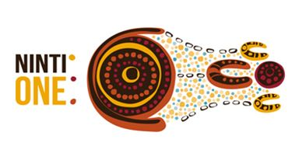

**Community Perspectives on Income Management from Ceduna, Koonibba, Scotdesco, Yalata and Oak Valley**

**Final Report**

December 2013

**Ninti One Limited**

**ABN: 28 106 610 833**

PO Box 3971, Alice Springs, NT, 0871

Ninti One Limited Contacts:

General Manager Business Development: 0401 116 894 [lyn.allen@nintione.com.au](mailto:lyn.allen@nintione.com.au)

Business Development Unit Program Coordinator: 0407 827 049 [ange.vincent@nintione.com.au](mailto:ange.vincent@nintione.com.au)

Contributors

Tammy Abbott, Senior Research Officer, Ninti One

Steve Fisher, Technical Advisor, Ninti One

Paul Josif, Ninti One Researcher

Lyn Allen, General Manager, Business Development

Citation

Abbott, T.; Fisher, S., Josif, P. and Allen, L. 2013. *Community Perspectives on Income Management from Ceduna, Koonibba, Scotdesco, Yalata and Oak Valley; Final Report*. A report produced for the Australian Government by Ninti One Limited, Alice Springs.

Acknowledgements

We wish to acknowledge and thank the following people who have supported and assisted in the project:

Aboriginal Community Researchers from Ceduna, Koonibba, Scotdesco, Yalata and Oak Valley

Senior Traditional Owners of Ceduna

Community organisation representatives from each community

Staff of the Ceduna Indigenous Coordination Centre

Ninti One Limited

ABN: 28 106 610 833

PO Box 3971, Alice Springs, NT, 0871

Ninti One Limited contact:

General Manager Business Development: [lyn.allen@nintione.com.au](mailto:lyn.allen@nintione.com.au). Tel. 0401 116894

Contents

Glossary 4

Executive Summary 5

1.0. Background 7

2.0. Purpose 7

3.0. Planning and preliminary work 8

4.0. Methodology 9

5.0. Survey on Income Management 11

6.0. Analysis 69

6.1. Comparison of responses from service providers with the general population 69

6.2. Research participants and their knowledge of Income Management 70

6.3. Social problems 70

6.4. The impact of Income Management 70

6.5. Information on Income Management 71

6.6. Potential participation in Income Management 71

6.7. Voluntary versus compulsory Income Management 72

6.8. Connections to the Breaking the Cycle initiative 73

7.0. Conclusions 76

Appendix 1: Background to Ninti One and the Aboriginal Community Research Program 77

Appendix 2: Ninti One Research Team for the Income Management Project 78

Appendix 3: Free text responses to questions 79

# Glossary

ACR Aboriginal Community Researcher

SRO Senior Research Officer

ICC Indigenous Coordination Centre

WCASMAG West Coast Alcohol and Substance Misuse Action Group

# Executive Summary

This report presents and analyses data collected on community perspectives on Income Management from the Ceduna, Koonibba, Scotdesco, Yalata and Oak Valley communities of South Australia.

The data was collected during the month of August 2013. A small group of people were employed by Ninti One as Aboriginal Community Researchers (ACRs) to conduct a survey of 204 adults made up of 44% male participants and 56% female participants. Participants in the research were quite evenly spread over age groups, with every age range being represented by between 10% and 18% of participants. They were made up of people of whom 77% identified as Aboriginal and Torres Strait Islander people and 20% from other backgrounds. The remaining 3% of participants were unwilling or unable to provide a response.

Recognition of social problems in the communities that are the subject of the research is high. Responses from participants indicated that 75% consider alcohol and drug use to be a serious problem, 35% consider the neglect of children to be serious (and 36% consider it to be a moderate problem), 40% see humbugging for money and other things as serious and 49% consider people’s lack of ability to make their money last to be serious (with 26% seeing the issue as a moderate problem).

A proportion of 58% of participants said they know somebody in their community would benefit from Income Management. Of those who know someone, the benefits they identified were overwhelmingly to reduce the use of money for alcohol and gambling while increasing spending on more important necessities, identified as being basic essentials for family and children such as food and clothes. The consequent benefits were considered by 37% of participants to accrue mainly at the community level and by 31% at the regional level, both through the reduction of social problems resulting from alcohol use. However, many participants (up to 89%, depending on the question) reported that their own financial management practices are satisfactory and enable them to meet their essential needs, implying disagreement with uniform and compulsory Income Management. In effect, many people are identifying significant problems where Income Management could potentially have a positive impact, but are attributing the problems to other people.

Between 54% and 75% of participants believed that spending on tobacco, alcohol, pornography, and gambling would reduce as a result of Income Management. Between 71% and 80% of participants considered that family and community life, culture, land management, sport and recreation, occupation and work and education and training would all benefit from increased involvement as a result of Income Management.

However, some problems were identified by participants as unlikely to improve and could worsen as a result of Income Management. These include substance abuse (presumably because the cost of other options is lower than alcohol), domestic and other violence, crime (to obtain funds otherwise restricted by Income Management) and anger (due to feelings of unfairness if income management applies to those who consider their money management skills as satisfactory).

A large majority of participants felt that more information on Income Management would be beneficial to local people, with 90% responding positively to a question on this subject. The two most effective ways of providing information were considered to be a community meeting (28%) and through television (25%).

Discussions with participants in the research indicated that many of them observed families who were affected negatively by poor use of money. In particular problems of family instability and neglect of children were seen as the most visible signs of financial problems. We draw from these observations that criteria could be developed as referral guidelines for people to join Income Management or be referred by service providers.

In summary, the survey has shown a high level of anxiety among participants in the survey about social problems that are connected with the use of money for purposes that can be detrimental to children and families. Survey data also shows that many people are likely to make a strong connection between improved management of individual and household income and the reduction of those problems.

# Community Perspectives on Income Management from Ceduna, Koonibba, Scotdesco, Yalata and Oak Valley

## 1.0. Background

This scoping study on Income Management complements the Federal Government’s Breaking the Cycle of Alcohol and Drug Abuse in Indigenous Communities initiative, to assist Ceduna, Koonibba, Scotdesco, Yalata and Oak Valley residents in tackling alcohol abuse.

As applied elsewhere in the country, Income Management seeks to help people pay for essentials like food, rent, clothing, health care, utility bills and school expenses, for the benefit of themselves and their children. Income management directs part of a person’s income support and family assistance payments towards essential items. Income managed funds cannot be spent on alcohol, tobacco, pornographic material and gambling products.

The Australian Government, through the former Department of Families, Housing, Community Services and Indigenous Affairs is seeking to understand community perspectives on the value and role of Income Management in Ceduna, Koonibba, Scotdesco, Yalata and Oak Valley. The Department contracted Ninti One to conduct research on the subject in the region during August 2013. Information on Ninti One is included as Appendix 1 of this report.

## 2.0. Purpose

As per the contractual agreement between the Australian Government and Ninti One, this report is to provide information on community perspectives on Income Management from the Ceduna, Koonibba, Scotdesco, Yalata and Oak Valley areas. Specifically, the research described in the report will:

1. Gather the views of community members, service providers and key stakeholders on the potential usefulness of income management, including:
   1. Exploring whether income management would be beneficial across the community (i.e. Indigenous and non-Indigenous community members); and
   2. Identifying which particular issues income management may assist in addressing.
2. Examine the potential links between income management and the Breaking the Cycle Initiative, and potential links with other services.

The role of Ninti One is therefore to provide community views and not to provide advice about whether or not income management should be introduced, and if so how.  That is a policy decision which will be informed by other factors, as well as the information and analysis presented in this report.

## 3.0. Planning and preliminary work

During late July 2013 Tammy Abbott, Senior Research Officer (SRO) travelled to Ceduna to recruit and prepare Aboriginal Community Researchers (ACRs) for the Income Management Research Project. This involved completing the sign-up forms, conducting the formal Ninti One induction, testing the survey using computer tablets and providing a thorough briefing to the team on the purpose and methods for the research.

The ACRs recruited to the team for the project were:

Tracey Cox

Courtney Forbes

Beaver Dodd

Ronald Freeman

Peter Miller

Peter Miller is also a community elder and operated within the team as the leading liaison person for the work.

Discussion took place about the connections that ACRs might have to the five sites that are the focus of the research and that could benefit the work of conducting the surveys. This is an important part of the process for Ninti One and the ACRs as we can identify who might be better situated with each group and therefore best able to interact with them on the basis of existing connections and local knowledge. This includes, for example, whether males prefer to be interviewed by males and likewise with females, whether it is preferable if each site was familiar with the relevant ACR and similar considerations.

The SRO also met with the local ICC staff, Tracey Meeke and Marnie Wettenhall who were extremely helpful throughout this visit. They introduced Ninti staff members and newly recruited ACRs to local service providers that were of interest to the project. This included Scotdesco and Koonibba community members, Families SA staff member and the CEO of Ceduna Aboriginal Corporation.

Ninti One researcher Paul Josif worked in Ceduna to begin the data collection on the week of the 5th - 16th of August. Prior to commencing the surveys, which was conducted on computer tablets, Paul met with the ACRs and developed a field work plan to look at the target number of participants from each place and discussed community information in terms of logistics and best practices with which ACRs were familiar.

Paul and the ACR team then began to survey the target groups at the sports carnivals, around the town and communities and meeting with service providers. The target group were Aboriginal and Torres Strait Islander and non-Aboriginal And Torres Strait Islander people, community members and stakeholders. The team was notified that cultural ceremonial business had commenced at Oak Valley which prevented all members of the team from attending the community. Therefore hard copy surveys were faxed via the Maralinga Office in Ceduna to the service providers at Oak Valley and ACRs completed surveys with Oak Valley residents who were in Ceduna due to the cultural business taking place. These surveys were done at the town camp and around the streets.

Briefing and action planning sessions were held regularly to plan trips. ACRs were given individual tasks to ensure the team were abreast of any information that might affect the work and travel and also to ensure the information was being uploaded regularly to avoid issues that may occur with the technology devices.

Paul and the ACRs met with 20 or so members from the West Coast Alcohol and Substance Misuse Action Group (WCASMAG) where they provided a briefing about the project, including its progress, stages and feedback. They also allowed time for some questions and answers. Some people were unable to attend as for reasons including that they were on leave, in Adelaide or unavailable at the time. The project required confidentiality so lists of names were not kept, rather the team canvassed organisations generally.

The task would have been very difficult without these researchers’ relationships and contacts within the wider West Coast Aboriginal community. A particularly important part of the project was the engagement of Peter Miller, a senior local traditional owner, to act as a research liaison. His role was fundamental to gaining responses from many local organisations and people. The senior liaison ensured good and up to date knowledge about the project and has also generated strong inputs and discussion about the Breaking the Cycle initiative.

Following their positive experience of being involved in this work, all the ACRs indicated their willingness to participate as researchers in any future work with Ninti One.

## 4.0. Methodology

To meet the objectives of the research, Ninti One chose to design and conduct a survey of the population of the Ceduna, Koonibba, Scotdesco, Yalata and Oak Valley. Drawing on our experience of conducting surveys in many other communities, we consider the advantages in this case to be:

1. A survey enables a range of questions to be selected that serve the research objectives in different ways. So, for example, questions on social problems can be complemented with questions about potential ways of tackling them that enables participants to approach the subject from more than one direction.
2. Surveys enable data to be analysed and presented in diverse ways that shed more light on particular topics or themes. In this research, we have disaggregated certain questions by gender, for example.
3. The survey format we use allows for participants to add further comments or explanations (which we call ‘free text’). This process often adds great value to the responses.

1. Surveys often work well in remote communities because they enable people to work within a semi-structured arrangement and in a location where they are comfortable. Surveys are often conducted in the street or outside the store, for example. They are not so demanding of English language skills as other methods such as interviews or focus groups might be, although these can also have a useful role.

The survey designed for the project is described in the next section.

In addition, we chose to use further individual interviews with key participants, especially service providers and stakeholders in the West Coast Alcohol and Substance Misuse Action Group (WCASMAG) as a means of gaining additional insight. This was especially important in enabling the research to provide strategic commentary on connections between Income Management and the Breaking the Cycle initiative.

## 5.0. Survey on Income Management

The survey was designed to seek community views on the potential usefulness of Income Management in the Ceduna region. It was not designed to inform who it could be applied to and how referral pathways could work.

A draft copy of the survey questions below was sent to the local ICC staff for consideration and input. Prior to this, feedback was given with the original questions to add information and also remove information to protect the identity of particular groups.

The Ninti One team met with and introduced the Income Management and Breaking the Cycle projects to members of the WCASMAG. Contacts were provided to Ninti One by the Ceduna ICC. Members who consisted of the following:

| Aboriginal Family Support Services | Ceduna Aboriginal Corporation | Ceduna Foreshore Hotel |
| --- | --- | --- |
| Ceduna District Health Service | Centacare | Families S.A |
| Housing S.A | Indigenous Coordination Centre | Koonibba Community Aboriginal Corporation |
| Oak Valley Maralinga (Ceduna) | Red Cross Australia | Scotdesco Aboriginal Corporation |
| SAPOL | Thevenard Hotel | DHS (Centrelink) |
| Department of correctional Services | Drug and Alcohol Services SA | District Council of Ceduna |

In conducting the study, local community researchers performed at a high level and produced a good quality and quantity of surveys per day. We achieved a total of 204 completed surveys from individuals who were willing to participate, while there were 98 people who preferred not to participate. This made a total of 302 people surveyed (see chart in Question 1 below). The need to have a good cultural spread within a research group was reinforced by the researcher group, who were able to successfully work across several distinct cultural groups.

The results below give a percentage to the answers that participants have selected while ‘Null’ in some answers has been provided for those that simply do not want to answer.

The survey was written in plain English and loaded onto computer tablets where the ACRs were able to conduct surveys and interpret in their own language.

It is also important to note that, although there were 204 survey participants, some questions only show as little as 176 responses, and some questions show over 550 responses. The reason is that some respondents were unable to respond to certain questions or preferred to decline, while other questions invited a choice of responses that could be more than one.

This approach was used to suit particular questions. For example, where we were seeking cause and effect relationships (for example, asking participants to explain the reasons for something happening), it was logical to allow more than one response so that the range of potential connections was identified. For questions that required a single response, then only one was invited.

In analysing the data, we therefore took care in ensuring that the analysis of data and presentation as proportions or percentages of responses against particular options took this into account. Where more than one response was permitted, then we avoided the inference that this option was chosen by a proportion of individuals when it represents only a proportion of responses.

**Question 1: Consent**

Are you happy to do this survey? 67 per dcent said yes; 33 per cent no.

**Question 2: Gender**

gender pie chart. 56 per cent were female and 44 per cent male.

**Question 3: Age**

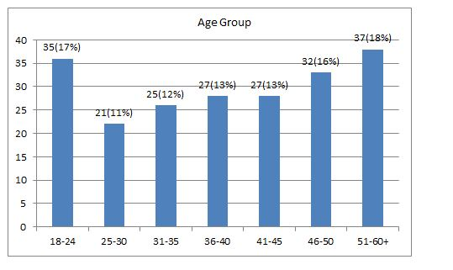

**Question 4: Roles and responsibilities**

table showing most people, 88 per cent, described themselves as local residents 

**Question 5: Place of residence**

Participants in the study were resident in the following communities:

Ceduna: 138 people (64% of total)

Yalata: 35 people (16%)

Koonibba: 22 people (10%)

Scotdesco: Less than 20

Oak Valley: Less than 20

Please note that precise numbers have not been provided to protect the privacy of individuals given that the population of some communities is small and so a defined number might identify participants, for which we have not sought consent.

**Question 6:** **How much of a problem do you see these issues in your community?**

Participants had the choice to select on a scale of five options only. The results were one, three, five, seven and ten (1 = no problem at all; and 10 = very serious problem) including null (no response to this question). For clarity and simplicity, the option to select between these points was not available therefore two, four, six, eight and nine were not an option.

**6.1. Drug and alcohol problems (where 1 = no problem at all; and 10 = very serious problem)?**

The responses from service providers are described in the table below:

| **Scale** | Null | 1 | 3 | 5 | 7 | 10 |
| --- | --- | --- | --- | --- | --- | --- |
| **No. of responses** | 0 | 0 | 0 | 1 | 3 | 2 |

Although the sample size is small, these responses show a similar pattern to the overall population.

In summary, responses to this question show that around three quarters of the participants felt that drug and alcohol misuse was a problem in their community, a level that is significant given that welfare payments make up a significant income source for many people in the region. Less than half felt that it wasn’t a serious problem.

**6.2. Kids going hungry or not being cared for (where 1 = no problem at all; and 10 = very serious problem)?**

The responses from service providers are described in the table below:

| **Scale** | Null | 1 | 3 | 5 | 7 | 10 |
| --- | --- | --- | --- | --- | --- | --- |
| **No. of responses** | 0 | 0 | 1 | 1 | 3 | 1 |

Again, while noting that the sample size is small, these responses show a similar pattern to the overall population.

Responses to this question show that almost an equal amount of participants either felt that children going hungry or not being cared for was a serious problem as well as not much of a problem, while less than that amount felt in the middle or did not respond. However, the fact that the survey returned such a high proportion of 50% with a reasonable degree of concern about the care of children is notable in the context of the broader social problems within the region and how they impact on children.

**6.3. Humbugging (bothering or pestering) for money or other things (where 1 = no problem at all; and 10 = very serious problem)?**

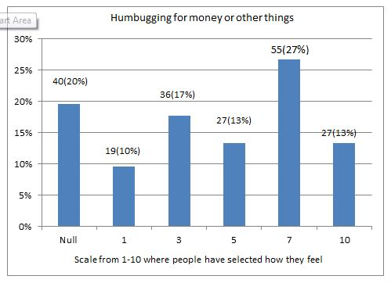

The responses from service providers are described in the table below:

| **Scale** | Null | 1 | 3 | 5 | 7 | 10 |
| --- | --- | --- | --- | --- | --- | --- |
| **No. of responses** | 0 | 0 | 0 | 1 | 4 | 1 |

Responses from service providers show a similar pattern to the overall population.

At 53%, a majority of the participants felt that humbugging was a problem compared with the 27% who felt less strongly on the subject.

An interesting point to which we return in Section 6 is that the humbugging for money could be assumed to increase should Income Management be implemented, since people with money may come under pressure from those whose income is restricted to the purchase of certain items. Given that a majority of participants already feel that humbugging is a problem, this could be an issue to consider carefully in the actions that result from this study.

**6.4. People not making their money last to pay for important things (where 1 = no problem at all; and 10 = very serious problem)?**

Just over half the participants felt this was a serious problem

The responses from service providers are described in the table below:

| **Scale** | Null | 1 | 3 | 5 | 7 | 10 |
| --- | --- | --- | --- | --- | --- | --- |
| **No. of responses** | 0 | 0 | 0 | 1 | 3 | 2 |

Responses from service providers show a similar pattern to the overall population.

In this case, both male and female participants had equal feelings about the question of whether people were able to make their money last for important expenditure items. However, there was a clear tendency for women to respond that humbugging and people not making their money last to pay for important things were less problematic than indicated by men. Overall, just over half the participants felt this was a serious problem, 10% considered it a moderate problem, 17% of participants did not think it was a problem and just under a quarter did not respond.

However, if we take this question (6.4.) to be a proxy measure for financial poverty in the region, then the moderate to high level of concern expressed by 59% of respondents indicates that funds are not meeting basic needs in many cases.

**Question 7: Knowledge of Income Management**

The responses from service providers are described in the table below:

| **Scale** | Null | Yes | A bit | No |
| --- | --- | --- | --- | --- |
| **No. of responses** | 0 | 5 | 1 | 0 |

Compared to the general population, all service providers have some or a little knowledge about Income Management and the BasicsCard.

Overall, almost equally, just under half of the participants either knew about income management and the BasicsCard or didn’t know anything while rest only knew a little about the subject. A desire expressed by participants for more information on the subject is a recurring theme in the study.

**Question 8: Participation in Income Management**

The responses from service providers are described in the table below:

| **Scale** | Null | Yes | A bit | No |
| --- | --- | --- | --- | --- |
| **No. of responses** | 0 | 1 | 0 | 5 |

Responses from service providers show a similar pattern to the overall population.

A quarter of the survey participants had participated in Income Management, or knew of someone who had participated in Income Management. This interesting finding shows the strength of family connections to other locations, most likely Central Australia and the APY Lands. However, it remains the case that the majority had no knowledge of other people participating in Income Management.

**Question 9: Additional opinions**

**Is there anyone else you think we should speak with about Income Management in the Ceduna region (include up to three of the most important voices)?**

The full free text responses to this question are provided in Appendix 3. Key themes and concerns identified by participants were:

* Local Elders and families were most important people to which further discussion about Income Management should be directed
* The circumstances of those individuals likely to participate in Income Management should be taken into account, especially if there are difficulties in transport to shops to use the BasicsCard.
* Local health services, especially Aboriginal health services, should be consulted.

Overall, participants expressed concern that proper planning should be undertaken, with the details of how Income Management would affect individuals and families, together with services and shops, fully understood before any implementation.

**Question 10: Potential beneficiaries of Income Management**

The responses from service providers are described in the table below:

| **Scale** | Null | Yes | No |
| --- | --- | --- | --- |
| **No. of responses** | 0 | 5 | 1 |

Responses from service providers indicate that they know more people who might benefit from Income Management and the BasicsCard than the general population.

**If yes, how might it make a difference?**

The free text option provided for participants to respond to the question above highlighted the following themes and concerns (full version available in Appendix 3):

* A clear understanding that Income Management would direct spending towards necessities instead of running out of money or wasting it on unnecessary expenditure.
* A focus on the needs of families and children, together with improved quality of life and greater family stability through better management of individual and household budgets.
* An interest in building people’s skills in financial management at the family and household level.

This question provided a set of potentially complex responses. A majority of people know people for whom Income Management would be beneficial. In disaggregating the data, it is apparent that men and women equally agreed that they know of people that could benefit from participating in Income Management while 52% of Aboriginal and Torres Strait Islander people said ‘Yes’ to this and 44% said ‘No’ and the remaining 4% said ‘Null’ (no comment).

A point worth noting here is a tendency in any survey on policy measures to draw responses from participants that indicate that there are problems, but that they lie elsewhere in the community. This subject we return to in Section 6.

**Question 11: Potential effects of Income Management**

Chart showing response from participants

This question is difficult to analyse quantitatively as there are 420 responses. However, indications are that male, female and all Aboriginal And Torres Strait Islander people had almost equal feelings about the potential effects of Income Management except where ‘Travel/fuel’ and ‘Making money last’ was concerned. In this case, men felt that income management and the BasicsCard will not make much of a difference, when compared to the responses of women.

Overall, we observe here that the principles underlying Income Management appear clear to the participants in the study. Their responses show an informed analysis of the connection between the management of individual and household finances and spending on a range of goods and services. Anticipating the discussion later in this report on information and communication about Income Management, indications are that many people locally will be readily able to understand how it works and what the implications are for them.

A free text option was offered for those who may have more to say. Only one response was provided by a participant in this case:

*“Affected people may be encouraged to return to their community or settle in Ceduna because they might then have money to do so”*

**Question 12: Extent to which effects of Income Management would potentially be felt**

Chart showing response from participants

The responses of service providers are presented below:

| **Scale** | Null | In your life | In your family’s life | In your community | In this region |
| --- | --- | --- | --- | --- | --- |
| **No. of responses** | 1 | 1 | 2 | 3 | 3 |

The responses above show a similar emphasis to the general population. Overall, this question is difficult to analyse quantitatively as there are 459 responses, which reflects the multiple options we permitted participants to make to this question. However, there is a clear indication that participants consider Income Management more likely to have greater impact in the community and regionally than in their own or their family’s lives.

**If yes, how?**

The free text option provided for participants to respond to the question above highlighted the following themes and concerns (full version available in Appendix 3):

* A strong concern for the care of children and family stability, which is considered to be negatively affected by expenditure on alcohol and drugs.
* Comments about people wasting money and not appreciating its value for purchasing necessities.
* Interest in a more peaceful community with fewer anti-social behaviours.
* Some scepticism as to whether Income Management will make enough difference to the major social problems and should not be seen as a cure-all.
* Concern that the details of Income Management will need to take into account individual circumstances.

**Question 13: Potential spending impacts**

**This question refers to the items that people are not able to buy with income-managed money: tobacco, alcohol, pornography, and gambling (in clubs, casino etc.) Do you think people on Income Management would spend less money on any of the following?**

**13.1. Tobacco?**

The responses of service providers are presented below:

| **Scale** | Null | Yes | No change | No |
| --- | --- | --- | --- | --- |
| **No. of responses** | 0 | 4 | 1 | 1 |

These responses show a similar emphasis to the general population.

**13.2. Alcohol?**

The responses of service providers are presented below:

| **Scale** | Null | Yes | No change | No |
| --- | --- | --- | --- | --- |
| **No. of responses** | 0 | 5 | 0 | 1 |

These responses show a similar emphasis to the general population.

**13.3. Pornography?**

The responses of service providers are presented below:

| **Scale** | Null | Yes | No change | No |
| --- | --- | --- | --- | --- |
| **No. of responses** | 2 | 3 | 0 | 1 |

These responses show a similar trend to the general population.

**13.4. Gambling?**

The responses of service providers are presented below:

| **Scale** | Null | Yes | No change | No |
| --- | --- | --- | --- | --- |
| **No. of responses** | 0 | 5 | 0 | 1 |

These responses show a similar emphasis to the general population.

In summarising the graphs above, it is clear that between a half and three-quarters of respondents considered that less money would be spent on tobacco, alcohol, pornography and gambling, with pornography at the lower end of the range compared to the others. Explanations for this difference are not apparent, although we could assume that respondents feel that spending is already low on pornography or that dependency rates are higher and therefore less affected by management of income. However, only 10% of participants believed spending on pornography would not change, which is a similar response to the questions on alcohol, gambling and tobacco.

The responses indicating that participants expect no change are interesting, being around 20-25% of the total. Given that Income Management restricts spending on these items, participants who answered in this way seem to be saying that they believe people have access to other sources of funds or that the users are people who are not eligible for or affected by Income Management. Alternatively, they believe that individuals will find a way around the restrictions on expenditure on gambling, alcohol, tobacco and pornography.

It is also important to note the high ‘null’ response (26%) to the question on pornography, which suggests that people were not comfortable or interested in answering this question.

**Question 14: Budget management**

A proportion of 34% of Ceduna residents said that their money lasts them less than two weeks compared with 49% of non-Ceduna residents, as summarised by region in the table below.

| Location | Savers | $ lasts < 2 weeks | TOTAL |
| --- | --- | --- | --- |
| Ceduna | 52 (38%) | 47 (34%) | 136 |
| Non-Ceduna | 7 (16%) | 33 (49%) | 67 |

Please note that figures in the table above are not disaggregated by community outside Ceduna to avoid identifying residents in the settlements with small populations.

In the case of responses from service providers, all respondents said they saved money.

**Question 15: Potential effects of Income Management on the individual management of money**

Responses from service providers are presented in the table below.

| **Scale** | Null | Yes | No |
| --- | --- | --- | --- |
| **No. of responses** | 0 | 5 | 1 |

Compared with the general population, a greater proportion of service providers said they believed Income Management would help them or other people manage money.

An option of providing free text responses was provided for those who selected no: If no, why not?

The key themes and concerns are summarised as follows:

* Comments relating to perceived unfairness of uniform application of Income Management by people who feel that are capable of managing their own money without problems.
* Views on the restrictive nature of Income Management, including concerns about restricting people’s choices.
* A desire for more information about the subject.

Full responses are included in Appendix 3.

It could be that the high ‘null’ response also indicates that participants felt under-informed to respond to the question, which is at odds with the high levels of response to similar questions in the study.

**Question 16: Potential effects on health and wellbeing**

Chart showing response from participants

Responses from service providers are presented in the table below. They show a similar pattern to the general population:

| **Scale** | Null | For you | your family | the community | across this region |
| --- | --- | --- | --- | --- | --- |
| **No. of responses** | 1 | 1 | 1 | 3 | 5 |

Overall, approximately three-quarters of the participants felt that there would be benefits to health and wellbeing, either in their community or region if less money was spent on things such as alcohol, tobacco, pornography, or gambling. The majority of these were from participants who selected yes to the Question 15. A small number felt that it would benefit them or their family.

Interesting inferences may be drawn from this pattern of responses. The first is that people may be much more concerned about social, economic and cultural issues at the community and regional level than for themselves or their families. Individuals tend to feel they have more control over events closer to them and more negatively affected by the state of the wider world. The second is that people who are not managing their income well may not be aware of it and so see problems occurring for others rather than themselves. Of course, this may also be accompanied by shame and therefore a natural reluctance to admit to difficulties.

**Question 17: Potential effects on participation in family, community and economic activities**

**If less money was spent on those things do you think there would be more participation in any of the following activities?**

**17.1. If less money was spent on those things do you think there would be more participation in family life?**

Responses from service providers are presented in the table below. They show a similar pattern to the general population:

| **Scale** | Null | More | No change | Less |
| --- | --- | --- | --- | --- |
| **No. of responses** | 0 | 5 | 1 | 0 |

**17.2. If less money was spent on those things do you think there would be more participation in culture and community activity?**

Responses from service providers are presented in the table below. They show a similar pattern to the general population:

| **Scale** | Null | More | No change | Less |
| --- | --- | --- | --- | --- |
| **No. of responses** | 0 | 5 | 1 | 0 |

**17.3. If less money was spent on those things do you think there would be more participation in land management?**

Responses from service providers are presented in the table below. They show a similar pattern to the general population:

| **Scale** | Null | More | No change | Less |
| --- | --- | --- | --- | --- |
| **No. of responses** | 1 | 4 | 1 | 0 |

**17.4. If less money was spent on those things do you think there would be more participation in occupation and work?**

Responses from service providers are presented in the table below. They show a similar pattern to the general population:

| **Scale** | Null | More | No change | Less |
| --- | --- | --- | --- | --- |
| **No. of responses** | 0 | 5 | 1 | 0 |

**17.5. If less money was spent on those things do you think there would be more participation in sport and recreation?**

Responses from service providers are presented in the table below. They show a similar pattern to the general population:

| **Scale** | Null | More | No change | Less |
| --- | --- | --- | --- | --- |
| **No. of responses** | 0 | 5 | 1 | 0 |

**17.6. If less money was spent on those things do you think there would be more participation in education and training?**

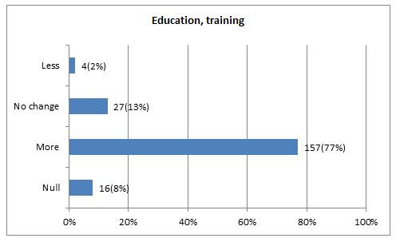

Responses from service providers are presented in the table below. They show a similar pattern to the general population:

| **Scale** | Null | More | No change | Less |
| --- | --- | --- | --- | --- |
| **No. of responses** | 0 | 5 | 1 | 0 |

The graphs above show that, with minor variations between questions, around three-quarters or more of the participants felt there would be greater participation in each category if money wasn’t spent on tobacco, alcohol, pornography and gambling. Less than a quarter either felt there would be no change, less (change) or did not answer (null).

This large majority response needs to be tempered by an understanding that this line of questioning can invite people to exaggerate their positive responses. The reason is that everyone wants to see the situation in which they live improve. Invited to connect a future-positive scenario with a new policy measure, objectivity can sometimes be overcome by the desire for change. However, this should not detract from the positive response, which is a clear one in each case.

**Question 18: Limitations to the impact of Income Management**

Chart showing response from participants

The table below shows responses from service providers:

| **Scale** | Null | For you | your family | the community | across this region |
| --- | --- | --- | --- | --- | --- |
| **No. of responses** | 4 | 1 | 1 | 2 | 3 |

Responses from service providers show a similar emphasis to the general population.

A free text option was provided for those who wished to explain the problems that they felt would not be addressed by Income Management. The key themes and concerns were:

* Alcohol supply would not change.
* Substance abuse would be unlikely to be affected.
* Crime and anti-social behaviour might increase and many social problems will not be affected.
* Some financial problems would not be addressed, such as debts between people.
* Shortcomings in health, parenting and services would most likely be unaffected.
* Some people may be angry about their payments being controlled.
* Services will not improve, such as housing and transport.
* Greater employment opportunities will not be created.

The full version of the free text option above is in Appendix 3. Responses give an idea of the types of comments provided by participants as to why Income Management might not make a difference as well as the kind of support that should follow if it does come into effect (see section in Appendix 3 on ‘Problems not tackled by Income Management relating to needs for services’).

**Question 19: Social and health problems**

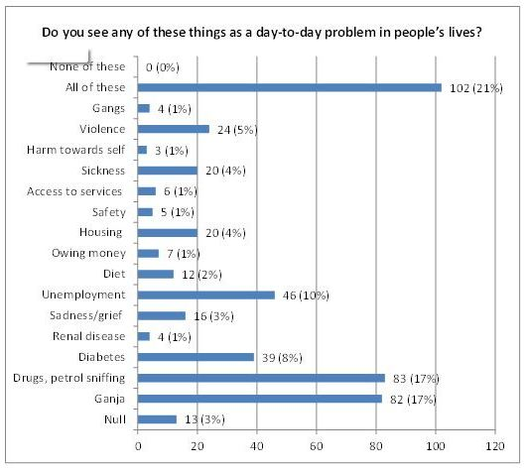

The graph above shows that just under a quarter of the participants felt that all categories were a day-to day problem in people’s lives while ganja and drugs, petrol sniffing were of equal and significantly higher concern than other topics, receiving over 17% of responses in each case. Unemployment and diabetes are of next highest importance at 10% and 8% respectively.

However, it is notable that there is a wide distribution of responses over a range of problems. This indicates the complexity of issues that people face, many of which are likely to compound and reinforce each other. The most obvious examples are grief, alcohol use and unemployment, a combination not uncommon in many communities in Australia and worldwide.

**Question 20: Potential issue-based impacts of Income Management**

**Would income management and the BasicsCard bring any positive day-to-day change on the following issues, where 1 = not at all; 10 = a lot?**

**20.1. Would income management and the BasicsCard bring any positive day-to-day change to unemployment (where 1 = not at all; 10 = a lot)?**

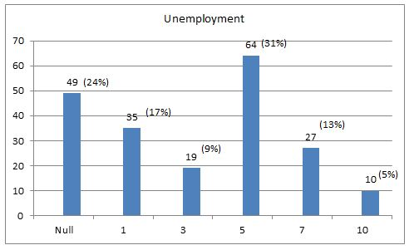

The table below shows responses from service providers:

| **Scale** | Null | 1 | 3 | 5 | 7 | 10 |
| --- | --- | --- | --- | --- | --- | --- |
| **No. of responses** | 1 | 0 | 1 | 1 | 2 | 0 |

Although the sample size is small, the data shows that service providers are slightly less inclined to say that change will occur as a result of Income Management.

**20.2. Would income management and the BasicsCard bring any positive day-to-day change to housing (where 1 = not at all; 10 = a lot)?**

The table below shows responses from service providers:

| **Scale** | Null | 1 | 3 | 5 | 7 | 10 |
| --- | --- | --- | --- | --- | --- | --- |
| **No. of responses** | 1 | 0 | 1 | 1 | 3 | 0 |

Like the general population, the data shows that service providers have a tendency to believe in positive change in housing through Income Management.

**20.3. Would income management and the BasicsCard bring any positive day-to-day change to sickness (where 1 = not at all; 10 = a lot)?**

The table below shows responses from service providers:

| **Scale** | Null | 1 | 3 | 5 | 7 | 10 |
| --- | --- | --- | --- | --- | --- | --- |
| **No. of responses** | 0 | 0 | 1 | 1 | 4 | 0 |

Like the general population, the data shows that service providers have a tendency to believe in positive change in sickness through Income Management.

**20.4. Would income management and the BasicsCard bring any positive day-to-day change to gangs (where 1 = not at all; 10 = a lot)?**

The table below shows responses from service providers:

| **Scale** | Null | 1 | 3 | 5 | 7 | 10 |
| --- | --- | --- | --- | --- | --- | --- |
| **No. of responses** | 1 | 1 | 0 | 1 | 2 | 0 |

The null responses from service providers is not as large as the 35% who responded this way in the general population. However, the service providers are similar to the general population in being slightly likely to believe that Income Management will have a positive impact on gangs.

**20.5. Would income management and the BasicsCard bring any positive day-to-day change to diets (where 1 = not at all; 10 = a lot)?**

The table below shows responses from service providers:

| **Scale** | Null | 1 | 3 | 5 | 7 | 10 |
| --- | --- | --- | --- | --- | --- | --- |
| **No. of responses** | 0 | 1 | 0 | 1 | 2 | 2 |

The data shows a similar emphasis to the general population.

**20.6. Would income management and the BasicsCard bring any positive day-to-day change to safety (where 1 = not at all; 10 = a lot)?**

The table below shows responses from service providers:

| **Scale** | Null | 1 | 3 | 5 | 7 | 10 |
| --- | --- | --- | --- | --- | --- | --- |
| **No. of responses** | 0 | 1 | 0 | 1 | 2 | 1 |

The distribution is similarly to the general population, with most respondents believing that safety would improve through Income Management.

**20.7. Would income management and the BasicsCard bring any positive day-to-day change to harm towards self (where 1 = not at all; 10 = a lot)?**

The table below shows responses from service providers:

| **Scale** | Null | 1 | 3 | 5 | 7 | 10 |
| --- | --- | --- | --- | --- | --- | --- |
| **No. of responses** | 1 | 1 | 0 | 1 | 1 | 0 |

Unlike the general population, which was more likely to say that Income Management would have a positive effect on self-harm, responses from service providers were more evenly spread.

**20.8. Would income management and the BasicsCard bring any positive day-to-day change to people owing money (where 1 = not at all; 10 = a lot)?**

The table below shows responses from service providers.

| **Scale** | Null | 1 | 3 | 5 | 7 | 10 |
| --- | --- | --- | --- | --- | --- | --- |
| **No. of responses** | 2 | 0 | 0 | 1 | 3 | 0 |

The distribution is similar to the general population, although no service providers indicated that they believed Income Management would make none or little difference to people owing money.

**20.9. Would income management and the BasicsCard bring any positive day-to-day change to access to services (where 1 = not at all; 10 = a lot)?**

Responses from service providers are shown in the table below:

| **Scale** | Null | 1 | 3 | 5 | 7 | 10 |
| --- | --- | --- | --- | --- | --- | --- |
| **No. of responses** | 1 | 1 | 0 | 1 | 2 | 1 |

The responses from service providers show a similar pattern to the general population.

**20.10. Would income management and the BasicsCard bring any positive day-to-day change to levels of violence (where 1 = not at all; 10 = a lot)?**

Responses from service providers are below:

| **Scale** | Null | 1 | 3 | 5 | 7 | 10 |
| --- | --- | --- | --- | --- | --- | --- |
| **No. of responses** | 1 | 0 | 0 | 1 | 1 | 2 |

The data in the table indicates that service providers were more likely to show a stronger belief in the positive impact of Income Management on levels of violence.

Taking an overall view of the responses to Question 20, the graphs below show that around a quarter of the participants felt that the situation would not change and 57% of respondents thought that Income Management would bring about some positive results (see graph below for Question 20.11).

Turning to the specific parts of Question 20, responses are reasonably even across the range of topics on which people were asked to comment. There is a slightly stronger response to the subject of people owing money, with 55% of participants believing that Income Management would make some or a lot of difference to people owing money and only 19% saying they think it will make little or no difference. The relatively large ‘null’ response of between 23% and 35% to each of the preceding parts of Question 20, we interpret to reflect a reluctance to provide an answer to the question from people who considered themselves uninformed on Income Management and how it works. In some cases, respondents may have felt unable to make the connection between income and each of the social issues to which the questions referred. The same applies to Sections 20.11 and 20.12 below.

The remaining results below describe how other participants responded, with an emphasis on the data presented in the preceding charts for each issue. More than a quarter of the participants that selected an answer felt that income management and the BasicsCard could bring some or a lot of positive day-to-day change to unemployment, housing, sickness, gangs, diet, safety, harm towards self, owing money, access to services and violence. A proportion of18% of them felt ‘not a lot’ when it comes to gangs and 17% for unemployment, and 15 to 26% either felt ‘not a lot’ or ‘a lot’ to each of the categories.

Overall, there is a level of scepticism revealed in the data under Question 20 as to the impact of Income Management, indicated by the 15 to 26% of participants who thought there would be no change in the various problems described in the question. The reasons for this scepticism could be that participants:

* Have seen many waves of reform over the years without also seeing changes for the better.
* Do not necessarily see the connection between the issues and Income Management due to lack of experience and information.
* Believe that Income Management has little prospect of tackling wider issues beyond individual and household spending.
* Consider that Income Management would not apply to many people or that they would be able to continue their lives without change.

Many participants take a middle road in their responses, which also indicates a level of uncertainty about how Income Management would work in practice.

**20.11. Would Income Management and the BasicsCard bring any positive day-to-day change to all of these (where 1 = not at all; 10 = a lot)?**

Responses from service providers, shown in the table below, are similar to those of the general population, with a similarly high null response:

| **Scale** | Null | 1 | 3 | 5 | 7 | 10 |
| --- | --- | --- | --- | --- | --- | --- |
| **No. of responses** | 2 | 0 | 1 | 0 | 3 | 0 |

**20.12. Would income management and the BasicsCard bring any positive day-to-day change to none of these (where 1 = not at all; 10 = a lot)?**

Responses from service providers, shown in the table below, are similar to those of the general population, with a similarly high null response:

| **Scale** | Null | 1 | 3 | 5 | 7 | 10 |
| --- | --- | --- | --- | --- | --- | --- |
| **No. of responses** | 2 | 1 | 0 | 1 | 0 | 0 |

**Question 21: Individual priorities**

Chart showing response from participants

The graph above shows that education and training, good health and health services and supportive family/good friends are what most participants have selected as being the three most important things that people need to do well in life. It is relevant to Income Management to note that only 2% of participants felt that money is one of the things that people need to do well in life.

The data reflects that almost half the respondents from each site have selected that education and training and good health are important. However, 80% of the Ceduna residents feel that ‘family support and good friends’ are also needed while the remaining amount were from Yalata, Oak Valley and Koonibba. No results were recorded for Scotdesco for this category.

**Question 22: Potential impacts on individuals**

**Would income management and the BasicsCard make any change where 1 = a lot;**

**10 = none at all.** Please note that Q22 uses a reversed scale compared to other questions in the survey.

**22.1. Would income management and the BasicsCard make any change to people’s participation in education and training (where 1 = a lot; 10 = none at all)?**

Responses from service providers show a more positive emphasis than the general population, with a greater proportion believing that Income Management will increase participation in education and training:

| **Scale** | Null | 1 | 3 | 5 | 7 | 10 |
| --- | --- | --- | --- | --- | --- | --- |
| **No. of responses** | 1 | 3 | 2 | 0 | 0 | 0 |

**22.2. Would Income Management and the BasicsCard make any change to people achieving good health and health services (where 1 = a lot; 10 = none at all)?**

Responses from service providers show a more positive emphasis than the general population, with a greater proportion believing that Income Management will make a change to health and health services:

| **Scale** | Null | 1 | 3 | 5 | 7 | 10 |
| --- | --- | --- | --- | --- | --- | --- |
| **No. of responses** | 0 | 2 | 3 | 0 | 0 | 1 |

**22.3. Would Income Management and the BasicsCard make any change to people achieving a home (where 1 = a lot; 10 = none at all)?**

Responses from service providers show a more positive emphasis than the general population, with a greater proportion believing that Income Management will make a change to people achieving a home:

| **Scale** | Null | 1 | 3 | 5 | 7 | 10 |
| --- | --- | --- | --- | --- | --- | --- |
| **No. of responses** | 0 | 3 | 2 | 0 | 1 | 0 |

**22.4. Would Income Management and the BasicsCard make any change to access to country and access to water (where 1 = a lot; 10 = none at all)?**

Responses from service providers show a similar balance to the general population, although with no responses indicating some change (5 on the scale):

| **Scale** | Null | 1 | 3 | 5 | 7 | 10 |
| --- | --- | --- | --- | --- | --- | --- |
| **No. of responses** | 0 | 2 | 2 | 0 | 2 | 0 |

**22.5. Would Income Management and the BasicsCard make any change to personal safety (where 1 = a lot; 10 = none at all)?**

Responses from service providers show a more positive emphasis than the general population, with a greater proportion believing that Income Management will have an impact on personal safety:

| **Scale** | Null | 1 | 3 | 5 | 7 | 10 |
| --- | --- | --- | --- | --- | --- | --- |
| **No. of responses** | 1 | 3 | 2 | 0 | 0 | 0 |

**22.6. Would Income Management and the BasicsCard make any change to people achieving a supportive family and good friends (where 1 = a lot; 10 = none at all)?**

For service providers, responses showed an even distribution across the range, although with none in the middle (5 on the scale):

| **Scale** | Null | 1 | 3 | 5 | 7 | 10 |
| --- | --- | --- | --- | --- | --- | --- |
| **No. of responses** | 1 | 2 | 1 | 0 | 1 | 1 |

**22.7. Would Income Management and the BasicsCard make any change to people achieving good language skills (where 1 = a lot; 10 = none at all)?**

Responses from service providers show a slight tendency to believe that Income Management will have a positive impact on language skills:

| **Scale** | Null | 1 | 3 | 5 | 7 | 10 |
| --- | --- | --- | --- | --- | --- | --- |
| **No. of responses** | 1 | 1 | 2 | 1 | 1 | 0 |

**22.8. Would Income Management and the BasicsCard make any change to people practising strong culture (where 1 = a lot; 10 = none at all)?**

Responses from service providers show a more positive emphasis than the general population, with a greater proportion believing that Income Management will have an impact on people practising culture:

| **Scale** | Null | 1 | 3 | 5 | 7 | 10 |
| --- | --- | --- | --- | --- | --- | --- |
| **No. of responses** | 0 | 3 | 2 | 0 | 0 | 1 |

**22.9. Would Income Management and the BasicsCard make any change to the level of acceptance people receive from others (where 1 = a lot; 10 = none at all)?**

Responses from service providers show a slight tendency to believe that Income Management will have a positive impact on people’s acceptance of others:

| **Scale** | Null | 1 | 3 | 5 | 7 | 10 |
| --- | --- | --- | --- | --- | --- | --- |
| **No. of responses** | 1 | 2 | 1 | 1 | 1 | 0 |

**22.10. Would Income Management and the BasicsCard make any change to the money people have (where 1 = a lot; 10 = none at all)?**

Responses from service providers show a significantly more positive emphasis than the general population, with a greater proportion believing that Income Management will have an impact on the money that people have available:

| **Scale** | **Null** | **1** | **3** | **5** | **7** | **10** |
| --- | --- | --- | --- | --- | --- | --- |
| **No. of responses** | 0 | 4 | 1 | 0 | 0 | 0 |

**22.11. Would Income Management and the BasicsCard make any change to people achieving a comfortable lifestyle (where 1 = a lot; 10 = none at all)?**

Responses from service providers show a more positive emphasis than the general population, with a greater proportion believing that Income Management will have an impact on people achieving a comfortable lifestyle:

| **Scale** | Null | 1 | 3 | 5 | 7 | 10 |
| --- | --- | --- | --- | --- | --- | --- |
| **No. of responses** | 2 | 2 | 1 | 0 | 1 | 0 |

**22.12. Would Income Management and the BasicsCard make any change to people’s occupation and employment (where 1 = a lot; 10 = none at all)?**

Responses from service providers show a more positive emphasis than the general population, with a greater proportion believing that Income Management will have an impact on occupation and employment:

| **Scale** | Null | 1 | 3 | 5 | 7 | 10 |
| --- | --- | --- | --- | --- | --- | --- |
| **No. of responses** | 1 | 3 | 1 | 1 | 0 | 0 |

**22.13. Would Income Management and the BasicsCard make any change to people’s spirituality (where 1 = a lot; 10 = none at all)?**

Responses from service providers show null response from half of them and an emphasis from the others towards believing that Income Management will make a positive impact on spirituality:

| **Scale** | Null | 1 | 3 | 5 | 7 | 10 |
| --- | --- | --- | --- | --- | --- | --- |
| **No. of responses** | 3 | 1 | 1 | 0 | 1 | 0 |

Across the range of topics covered by Question 22 and represented in the charts above, the spread of responses is fairly consistent, with between 29% and 38% of respondents considering that Income Management would have a positive effect in each case and around one-third responding that it would have some positive effect.

One exception to the pattern is the question about money, which showed a stronger positive response than other questions. A proportion of 38% of respondents believed that Income Management would make a positive difference to the money people have available to them. Other responses to this question were that 30% believed that it would have some effect and 25% believed it would have little effect.

Our comments on the data from Question 21 are also relevant to Question 22. There is a large group of responses that fall in the middle ground, showing some hesitancy among participants about making the connection between individual change and Income Management (except in the case of the amount of money people have) and a significant, although smaller number (approx. 20-25%) believing that Income Management will have little effect. The analysis we provided on p.48 is also relevant here.

**Question 23: Information on Income Management**

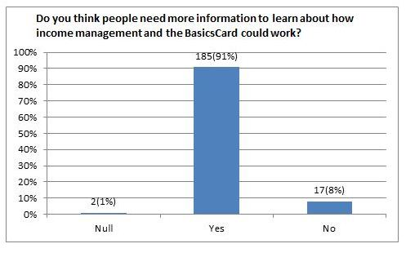

Responses from service providers are presented in the table below and show a similar pattern to the general population:

| **Response** | Null | Yes | No |
| --- | --- | --- | --- |
| **No. of people** | 0 | 6 | 0 |

The vast majority of people from all five sites feel they need to know more about how income management and how the BasicsCard could work.

**Question 24: Communication methods on Income Management**

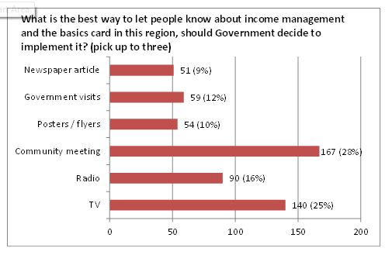

Responses from service providers are presented in the table below and show a similar pattern to the general population:

| **Medium** | TV | Radio | Meeting | Flyers | Visits | Newspaper |
| --- | --- | --- | --- | --- | --- | --- |
| **No. of responses** | 4 | 1 | 4 | 1 | 2 | 3 |

Participants feel that community meetings and the television are the best ways to let people know about income management and the BasicsCard. If these options are selected then the use of Aboriginal languages is an important factor as this allows for a full understanding to be reached.

**Question 25: Use of local services**

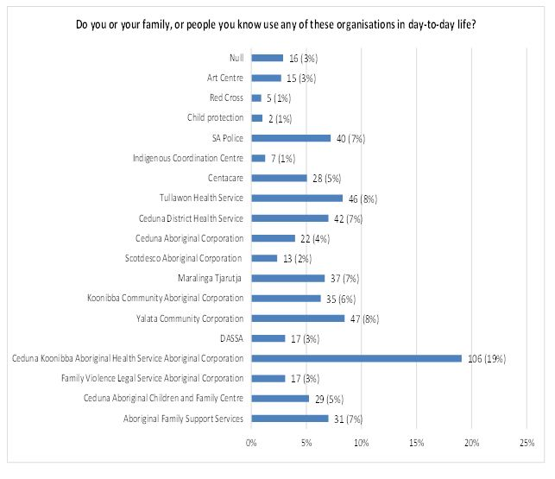Almost an equal percentage of men and women either make use of or know of someone that uses the services above. The exception is that more female participants use the Ceduna Aboriginal Children and Family Centre, Ceduna, Koonibba Aboriginal Health Service Aboriginal Corporation and the Ceduna District Health Service than male participants.

**Question 26: Use of local programs**

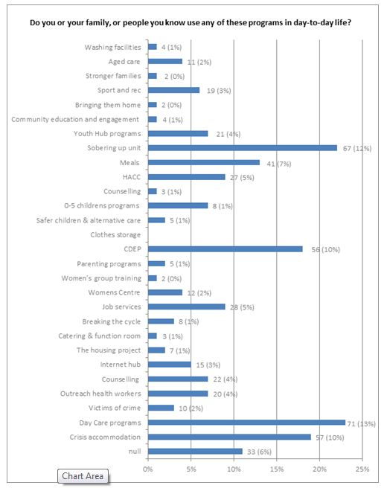

The information from this data shows that more women than men utilise programs such as Victims of Crime, Internet Hub, The Housing Project, Catering and Function Room, Women’s Centre, Women’s Group Training, Parenting Programs, Safer Children and Alternative Care, 0-5 Children’s Programmes, Counselling, Meals, Stronger Families and Aged Care. Men utilise CDEP and Bringing Them Home more than women. The other programs have an equal proportion of men and women using them.

**Question 27: Need for other services**

**What other services would be of assistance?**

The free text option provided for participants led to a range of responses. The majority replies were:

* Legal aid service
* Alcoholics Anonymous
* Rehabilitation centre
* Sporting complex
* Aboriginal organisation
* Ceduna Council

The full responses are provided in Appendix 3.

## 6.0. Analysis

We present our analysis of the data collected through the survey under six headings; research participants and their knowledge of Income Management, social problems, the impact of Income Management, information on Income Management, potential participation in Income Management, voluntary versus compulsory Income Management and connections to the Breaking the Cycle initiative.

### 6.1. Comparison of responses from service providers with the general population

Six service providers participated in the study, which is a very small sample size compared to the sample size for the general population. The results are presented against each question in Section 5. In addition, we have included in the summary below responses drawn from follow-up meetings and conversations with service providers.

The key differences and similarities are as follows:

* All service providers knew something about Income Management and the BasicsCard.
* A greater proportion of service providers said that they knew someone who they thought would benefit from Income Management.
* All service providers said that they saved money from their incomes.
* In general, service providers were more positive about the potential impact of Income Management on individuals.

Issues identified by service providers as problems relating to the implementation of Income Management in the region are:

* Lack of first-hand knowledge of Income Management among the population and service providers
* Potential changes in spending if Income Management was introduced will have an impact on individuals and the local economy
* Greater information on Income Management is required and effective communication channels need to be established

Overall, our analysis is that the responses from service providers present no surprises. Many are under the daily pressures that come from working with individuals and families who are often subject to multiple and compounding problems in their lives. Service providers presented to us as being open to new approaches that might help them make greater headway.

### 6.2. Research participants and their knowledge of Income Management

Research participants were 44% male and 56% female. They were quite evenly spread over age groups, with every age range being represented by between 10% and 18% of participants. They were made up of people of which 77% identified as Aboriginal and Torres Strait Islander people and 20% from other backgrounds. The remaining 3% were unwilling or unable to provide a response.

With respect to their knowledge of Income Management, 58% had some knowledge and 40% had no prior knowledge, while 2% were unwilling or unable to provide a response to this question. A proportion of 25% of people knew somebody who was already a participant in Income Management in a different location.

### 6.3. Social problems

Recognition of social problems in the communities that are the subject of the research is high. Responses from participants indicated that 68% consider alcohol and drug use to be a serious problem, 34% consider the neglect of children to be serious (and 36% consider it to be a moderate problem), 40% see humbugging for money and other things as serious and 49% consider people’s lack of ability to make their money last to be serious (with 26% seeing the issue as a moderate problem).

Other problems identified by participants include substance abuse (17%), unemployment (9%) and diabetes (8%).

### 6.4. The impact of Income Management

A proportion of 57% of participants said they know somebody in their community would benefit from Income Management, while 37% did not. Of those who know someone, the benefits they identified were overwhelmingly to reduce the use of money for alcohol and gambling while increasing spending on more important necessities, identified as being basic essentials for family and children such as food and clothes. A further question indicated that food, children’s needs and the payment of bills are the top three subjects on which people would be likely to manage money better or differently. The consequent benefits were considered by 37% of participants to accrue mainly at the community level and by 31% at the regional level, both through the reduction of social problems resulting from alcohol use, while 15% of participants considered benefits would be felt by their own their families and 11% to them as individuals. The inference from this response and a significant number of free text comments from participants was that their own management of money is satisfactory and does not warrant the imposition of Income Management.

Between 54% and 75% of participants believed that spending on tobacco, alcohol, pornography, and gambling would reduce as a result of Income Management. Between 73% and 80% of participants considered that family and community life, culture, land management, sport and recreation, occupation and work and education and training would all benefit from increased involvement as a result of Income Management.

However, some problems were identified by participants as unlikely to improve and could worsen as a result of Income Management. These include substance abuse (presumably because the cost is lower than alcohol), domestic and other violence, crime (to obtain funds otherwise restricted by Income Management) and expressions of anger.

In turning to individual perspectives on aspects of life considered most important, education and training (28%), health (20%), family and friends (11%) and good language skills (8%) were the top four choices. However, views on whether these characteristics would improve through Income Management were inconclusive. With around one-third of participants suggesting they would partly benefit and only around 10-12% believing that there would be a great improvement. This supports the earlier responses of participants that the benefits of Income Management would largely be felt at the community and regional level, rather than by individuals.

### 6.5. Information on Income Management

A large majority of participants felt that more information on Income Management would be beneficial to local people, with 90% responding positively to a question on this subject. The two most effective ways of providing information were considered to be a community meeting (28%) and through television (25%), while radio attracted 16% of responses. Newspaper articles, government visits and posters or flyers were considered most effective by around 10% of respondents for each.

The Ceduna Koonibba Aboriginal Health Service, Aboriginal Corporation was identified as one of the organisations that most people utilise and the Sobering up Shelter and Day Care were two programs that are accessed the most by participants or someone known to the participant (12% and 13% respectively reported that they used them, or knew of someone who had). These service providers offer strong links to the Breaking the Cycle initiative.

### 6.6. Potential participation in Income Management

Discussions with participants in the research indicated that many of them observed families who were affected negatively by poor use of money. In particular problems of family instability and neglect of children were seen as the most visible signs of financial problems. We draw from these observations that criteria could be developed as referral guidelines for people to join Income Management or be referred by service providers.

In suggesting who else in the community might have useful comments to provide, participants in the research made frequent reference to community elders as well as certain service providers that are likely to be aware of the difficulties individuals and families are facing. For example, the Ceduna Koonibba Aboriginal Health Service, drug and alcohol support services, Centrelink and Families SA were mentioned. These organisations, although with community elders, could be a source of advice on approaches to identifying people who would benefit from Income Management.

### 6.7. Voluntary versus compulsory Income Management

We felt it was too early in the process of discussing Income Management with local people to introduce the subject of whether participation should be voluntary or compulsory. The question may have led to unnecessary rumours circulating in the communities or, indeed, negative reactions to other aspects of the research. The subject is best introduced at planning stage or in the process of further discussions with community elders and local organisations.

A useful inference that can be drawn from the data, however, is that there is a high level of anxiety among participants in the research about social problems that are connected with the use of money for purposes that can be detrimental to children and families. Survey data also shows that many people are likely to make a strong connection between improved management of individual and household income and the reduction of those problems. This analysis probably creates scope for discussing the extent to which compulsory Income Management might be appropriate should the Australian Government wish to consider it.

However, this inference should not be over-stated. Some respondents indicated that they did not consider that Income Management would be effective and in free text responses they pointed out that there are problems that would not be addressed by Income Management. Others expressed scepticism or concern about the impact of Income Management or were worried about how it might be implemented. These comments were provided through the free text option included as part of the survey (see responses to Questions 12, 15 and 18 in Appendix 3).

Some respondents indicated that Income Management could lead to further problems, such as increased crime and humbug (see summary in Section 6.4.), although a there was a strong trend emphasising that Income Management would make greatest difference in the region and their community rather than in their own or their family’s lives. Question 12 shows 68% of respondents saying the difference would be at the family and community level and 26% on their own or their family’s lives. This implies some objection to uniform and compulsory Income Management applied across the communities, although it should not be over-emphasised as respondents were asked to state where they felt the greatest impact would be felt rather than whether they felt it should apply to them. So the results are not conclusive in this case.

### 6.8. Connections to the Breaking the Cycle initiative

#### 6.8.1. Strategic considerations

The research has helped identify potential connections for Breaking the Cycle. They tend to relate to processes that could be incorporated in Breaking the Cycle or opportunities taken up through Income Management. They include the following:

* Income Management could be explored in greater depth as a tool to assist hardened drinkers in the next phase of Breaking the Cycle as well as in the draft Ceduna Community Alcohol and Substance Abuse Management Plan. Income Management could create the space for people practising harmful drinking to choose a different pathway or for service providers to engage more loosely with them.
* The Income Management survey highlights the importance of consulting with local Elders. This will be a key principle for incorporation into the Breaking the Cycle work.
* The research also shows that locals have a close knowledge of the Ceduna and Koonibba Aboriginal Health Service, which could potentially be a key partner in the next phase of Breaking the Cycle.
* Given the comments of participants in the survey about community meetings being the most effective means of communication locally, community level action could be seen as having an important role in the next steps e.g. through holding community meetings early in the next part of the process.

In addition, some comments we received through the research indicated that the Breaking the Cycle work should make a distinction between the degree to which alcohol problems are affecting different communities. One Elder made the point that Ceduna and Koonibba people are much less affected than other communities in the region. He said that “Ceduna people are sports-minded people. When football and netball finish, everyone starts on cricket and basketball”.

#### 6.8.2. How Income Management could foster greater collaboration between BTC service providers and coordinators

The eight priority areas for action under the West Coast Regional Alcohol and Substance Misuse Action Group (the Action Group’s) Alcohol Management Plan are:

1. Decrease access to alcohol/volatile substances

2. Increase school retention

3. Increase access to structured community diversionary activities

4. Improve transport in Ceduna and to communities

5. Increase accommodation in Ceduna

6. Community/Government/Stakeholder coordination

7. Service Coordination

8. An agreed monitoring system

For action to be effective across these eight areas, clearly collaboration between service providers will be necessary for the following reasons:

* To ensure that approaches to care are consistent and ‘joined up’.
* To strengthen case management practices that will ensure tailored work with individual towards specified goals.
* To maximise sharing of information and reduce duplication of effort.
* To build innovation, especially through combining knowledge and professional skills between services.

The role of Income Management within this framework could be a powerful one, depending on the extent to which it influences the behaviour of individuals and their families. For example, if the motivation towards alcohol use as the primary occupation of many people’s lives is reduced since they do not have the funds to purchase it, then a number of changes are possible. These include increased uptake of other services by harmful users of alcohol, increased opportunities for services to connect with people since the hours in which they are intoxicated are reduced and potentially reduced use of services that address the adverse effects of drinking, such as admissions to hospital.

Income Management is certain to be a major tool for alcohol management in the region. A review of the experience of other regions (for example, in the Northern Territory) where Income Management has applied is beyond the scope of this study. However, it seems likely that Income Management itself could perform the role of connecting services since it could potentially be one of the policy mechanisms around which the efforts of services directed towards vulnerable families can be coordinated.

#### 6.8.3. How Income Management could support key services provided under BTC

A key element of BTC is providing access to diversionary programs that encourage rough sleepers andheavy drinkers to participate in meaningful occupation of some kind, whether group activities, physical exercise or other processes that focus on restoring a structured routine to their lives that does not rely on consumption of alcohol.

At present, some service providers report that their programs are rendered ineffective by the attraction of clients to alcohol outlets that commence business in Ceduna from 9.30am. To quote one provider ‘We can do nothing with them after the bottle shops open at 9.30am and most become distracted in the period up until that time, as they get ready to go to the bottle shops’.

The potential for Income Management to make a difference to this particular pattern of behaviour is quite apparent. Participants in Income Management will have restricted access to money to use for the purchase of alcohol. Logically, it follows that some of them will be unable to purchase as much as they might usually do, although it is unclear whether other sources of funds might be available from friends and relatives. There is certainly anecdotal evidence to suggest that drinkers can find ways to maintain the cycle of alcohol consumption to which they have become accustomed. A negative side-effect is that levels of ‘humbug’ could increase as a result, especially directed towards people who are not participating in Income Management.

Within the framework of West Coast Regional Alcohol Management Plan and its four components of supply reduction, harm reduction, demand reduction and leadership and service coordination, Income Management aligns most closely with demand reduction, provided drinkers do not have access to other sources of regular income. But it also has a role in coordination (as described in Section 6.7.2.) and harm reduction in instances where Income Management leads to a different pattern of spending that improves nutrition, leads to safer lifestyles and reduces the presence of individuals in risky locations, such as walking along highways or in situations where physical violence is prevalent.

#### 6.8.4. How Income Management supports the overarching goals of BTC as outlined in the West Coast Regional Alcohol and Substance Misuse Action Group (the Action Group’s) Alcohol Management Plan.

The comments we have made in the preceding sections of this report (6.8.1. and 6.8.2.) address the ways in which Income Management could potentially support the overarching goals of the Alcohol Management Plan. Our underlying analysis is that breaking the cycle of harmful alcohol use relies on making options available to chronic drinkers and rough sleepers that enable them to change their behaviours.

One role of service providers is to manage these options and also encourage individuals seeking to make positive changes to take one of the alternative pathways available to them. It could be that an effective Income Management program will create the breathing space needed for options to be created in which some chronic drinkers and rough sleepers will participate. In other words, by supporting harm reduction and demand reduction, Income Management could act as a new starting point for change.

### 7.0. Conclusions

The conclusions we draw from the research Ninti One has conducted on Community Perspectives on Income Management from Ceduna, Koonibba, Scotdesco, Yalata and Oak Valley are as follows:

1. Participants in the research generally expressed a high level of concern over social problems within the communities. They consider these problems to be partly attributable to individual and family incomes of some community residents being used in ways that do not meet their priority essential needs.
2. Particular concerns identified by participants relate to the neglect of the care of children, instability in families and the perceived waste of money on activities such as alcohol consumption, drug use and gambling. A majority of participants considered that many residents of the communities are not able to make their money last long enough to meet their essential needs.
3. A cause and effect relationship between social problems and poor income management was described by most participants. They identified a range of benefits that would potentially flow from better individual and family budgeting, especially improved health, opportunities to undertake education and training, better care of children and greater family stability.
4. Most participants consider the impact of tackling the problems they identify as being most likely at the community and regional level rather than for them individually or their families. This implies that they see community life and progress being significantly hampered by poor choices being made by individuals and the increased social problems that result. However, many participants reported that their own financial management practices are satisfactory and enable them to meet their essential needs.
5. In comments made through the free text option provided in the survey, some participants pointed out that there are problems that would not be addressed by Income Management and expressed some scepticism or concern about it. These comments were provided through the free text option included as part of the survey (see responses to Questions 12, 15 and 18 in Appendix 3).
6. Awareness of Income Management can be found among around half the participants. An overwhelming majority would like to see more information available locally on the subject.

*Ninti One  
Alice Springs  
12th December 2013*

# Appendix 1: Background to Ninti One and the Aboriginal Community Research Program

Ninti One Ltd was established to operate the Desert Knowledge Cooperative Research Centre (DKCRC), but now operates as an independent not-for-profit company.

One of the primary objectives of the organisation is to develop local Aboriginal research teams who conduct participatory action research, evaluation and monitoring (PAR) in their own communities and deliver their research findings to the client and back to the community so that research recommendations are endorsed and considered at the local level, and the data may be used in making more informed local decisions. We seek to engender capacity-building through researcher mentoring, on-the-job skills development and skill-sharing. This is further developed through the researcher’s participation in multi-skilled teams which plan, prepare and undertake research projects and analyse and report the findings back to the client. Ninti One strives to develop and support Aboriginal community researchers who are competent, skilled, confident and capable of working across a range of research settings using various appropriate research methods and techniques.

Ninti One researchers are selected on the basis of their extensive experience working with Aboriginal people from central and/or northern Australia. They are skilled in the fields of governance, resource management, anthropology, community-based planning, training, governance, participatory research and social analysis. All have long and positive experience and knowledge of the contemporary social, cultural and environmental contexts of Aboriginal communities in remote areas of Australia.

# Appendix 2: Ninti One Research Team for the Income Management Project

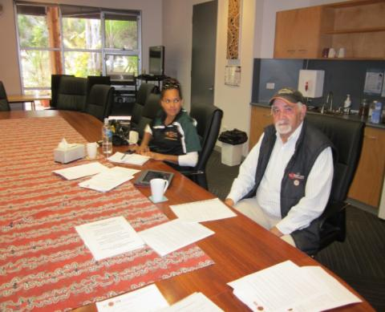 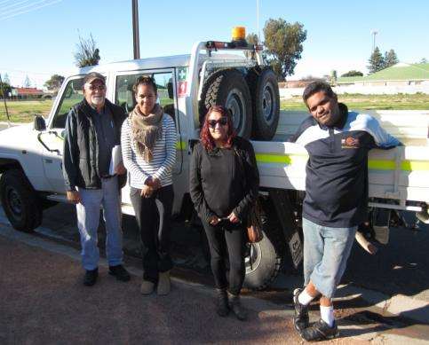

Tracy Cox and Peter Miller working at the Ceduna ICC ACR’s from left to right: Peter Miller, Tracy Cox, Courtney Dodd-Forbes & Beaver Dodd

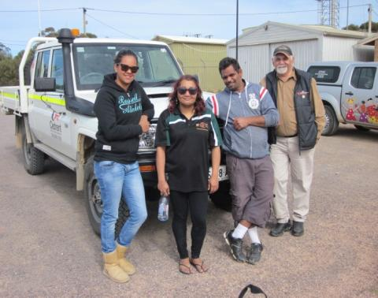 

ACRs from left to right: Tracy Cox, Courtney Forbes, Beaver Ninti One consultant Paul Josif (PJ)  
Dodd & Peter Miller

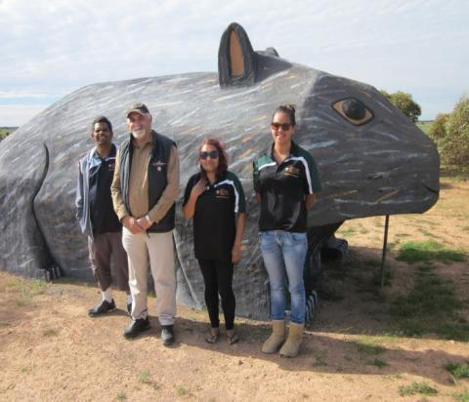 

ACRs in front of the big wombat at Scotdesco community ACR Courtney Forbes working at the Ceduna ICC

Appendix 3: Free text responses to questions

## Question 9: Additional opinions

**Is there anyone else you think we should speak with about Income Management in the Ceduna region (include up to three of the most important voices)?**

Participants provided information which has been categorised into the headings below. The bold selections from the free text above are comments that stand out as representative of several similar remarks from respondents or that provide a particular insight on the subject.

| **Local elders and families:**  *Local elders/elders (x22 responses provided)* | **Community members:**  *A list of individual names were provided by participants as well as youth and teenagers, people in APY lands, homeless people and business owners and local Aboriginal people.* |
| --- | --- |
| **Community:**  *Community members (x61 responses provided), among those and at times more specifically included were*  *“women, children”, ”local agencies, councils”, “families, families S.A”, “ICC”, ‘Community elders”, “local service*  *Providers”, “Traditional elders”, “Older people and younger people”, “Government representatives”, “Council*  *Members”, “SAPOL and other professionals”, “Community advisors and “Grandparents”.* | **Health services:**  *10 x responses provided including a concentration on the* ***Aboriginal Health Service*** *and local medical service.* |
| **Service providers:**  *Ceduna Koonibba Aboriginal Health Service Aboriginal corporation x 5*  *Drug and alcohol support services x 4*  *Families S.A x 6*  *Schools x 4*  *Centrelink x 5*  *Centacare x 3*  ***Ceduna Aboriginal Corporation x 2***  *Courts*  *Child protection*  *Eyre futures*  *Mayor*  ***All local homelands***  *Aged care services*  *Social workers*  *Shops/services* | **Other comments included:**  *“Transient visitors”*  ***“More community members, we have no shop and limited transport so we can't use that BasicsCard, we can't use card to get our needs locally”***  ***“The people who will have to use the BasicsCard if it comes in”***  *“Only in Koonibba, local community members, local chairperson”*  *“Talk to the people that it greatly effects, adults/parents children and grandparents”*  *“People affected by the program. People who must administer the program. People supplying the goods*  *on the program”*  *“The people affected. Welfare service providers. Aboriginal community leaders and their staff”*  *“People who will be using it. Organisations that would be helping people”*  *“People who work in social/counselling services that deal with it commonly”*  *“Youth that are going through it”*  *“All people”*  *“Families of those affected”*  *“People who have to help those affected by misuse of benefits”*  *“Individuals that its intended for”*  *“Free informed choice of communities. No compulsion!”*  *“People who will be involved”* |

## Question 10: Potential beneficiaries of Income Management

**How might it make a difference?**

| **Comments on alcohol, smoking, drugs and gambling** | **Comments on use of money for basic necessities** |
| --- | --- |
| *“Won't be wasting their money on alcohol n drugs, stabilising family's around”*  *“Less alcohol problems”* ***“They can buy food instead of spending their money on alcohol and drugs “***  *“Not having as much drink”*  *“Less spent on alcohol more on education, personal development and food” “Help them not buy alcohol and drugs”*  ***“Slow down the alcohol issues which are affecting our community”***  *“Reduce the amount of money spent on alcohol, tobacco and gambling” “Money not being wasted on alcohol or drugs” “No money for alcohol”*  *“’People pay for the necessities before spending on the pokies or alcohol/ drugs” “Less drinking and drugs”* ***“Reducing the amount of money spent on alcohol, tobacco and gambling”*** *“Stop wasting money on poker machines and alcohol”*  *“People will have money to last and they will purchase food and bills and reduce them to purchase alcohol or drugs”*  *“Money saved for things other than alcohol”*  *“Reduce their ability to buy large volumes of alcohol, but have money to buy food, clothing and shelter*  *when away from their dry communities”*  *“Stops people from spending all money on pokies, grog and drugs focus more on children their education*  *and upbringing”*  *“Slow down on drink and do their job better”*  *“Not wasting on money on alcohol n drugs pay for everyday items”*  ***“Feeding kids. Health wise. Keep up with bills. Travel costs.*** *Reduce amount of money spent on grog, gambling, smokes and drugs”* | *“Them not running out of money on important things including food petrol etc.”*  *“Spending on what's needed”*  *“Manage monies better, provide for family”*  *“No food money”* ***“It may decrease pressure to give all the wages to family members”***  *“Money being used for everyday necessaries”*  ***“It would able people to practice being responsible with their money”***  *“To assist in meeting the needs of families in a positive way” “Better looked after kids, end to gambling problems.”*  *“Quality of life, no ability to waste away on unimportant things”* ***“Food for kids, bills payed for and a better living for families”***  *“Assist in reducing gambling debts. Better care for children. Food. Clothing. Less child and family abuse with less alcohol consumption. Money for electricity”*  ***“Help them organised their life for better future for themselves and their children”******“Children being fed”***  *“Limit their access to alcohol. Make sure their kids have enough food and their basic needs are being met” “The people who have children for food and shelter”*  *“Pay for important things & bills, build budgeting” “Paying for important things”*  *“Paying for important things like food and shelter and bills” “Bills paid & food wise” “Support daily life (e.g. bills, food)” “Food. Clothes and household goods could be purchased”*  ***“Be able to slow down drinking and pay bills “***  *Paying for important things like food, shelter and bills”*  *“More money to spend on everyday items”*  ***“More money for life's needs”***  *“Children needs, family needs”*  *“Money for food and money for clothes. Basic essentials”*  *“To pay bills and buy food”*  *“Paying bills, buying food, making money last, clothes, travel, household goods”*  *“To pay bills and food easier”* |
| **Comments on financial management skills** | **Comments on family stability** |
| *“Giving them control of their budget”* ***“Assist in buying necessary items and being able to budget better”***  *“Pay for important things & bills, build budgeting”*  *“Pay more bills”*  ***“Pay for important things like food, shelter, and bills, and build budgeting skills”*** *“To pay some bills” “Bills and food first then charge later on what’s left over” “Build budgeting skill” “Make their money last and budgeting skills”* | ***“Stabilise family and household circumstances”***  *“In child protection, domestic violence and where there are gambling problems”*  *“Lower levels of violence”*  *“Help them live a balanced life”*  ***“Paying bills, supporting children. Reduction in alcohol, gambling and tobacco spending. Better budgeting and stabilising family situation”***  *“Stabilise family house circumstances”*  *“A big difference to families”* |
| **Other comments** |  |
| *“The government would receive fewer profits from taxation on luxuries such as gambling, alcohol and tobacco”*  *“Best for the people who want it”*  ***“Would like to know more about it”***  *“Might change their life style”*  ***“It will make a lot of difference”*** |  |

## Question 12: Extent to which effects of Income Management would potentially be felt

## If yes how?

| **Comments relating to alcohol and drugs** | **Comments relating to the care of children and family stability** |
| --- | --- |
| *“Minimising the risk of alcohol n drugs” “Less to spend on alcohol” “Less drinking and domestic abuse”* ***“Help to reduce spending money on drug and alcohol”***  *“Community be safer as money is not spent on alcohol” “Money being used on everyday things not wasted on alcohol”*  *“Because there are a lot of drunks and they need help”*  ***“In Ceduna we have a lot of current issues affecting our community in regards to alcohol, drugs, children schooling and gambling so I think it will benefit a lot of families in Ceduna because they not spending money on alcohol and drugs”*** | *“Ceduna has a number of people with alcohol/drugs issues. Ceduna has a large number of children at risk”*  *“People have more control over how they spend. Some people got it here already. Benefit in the long run by spending less on grog and smokes. Just so long as they get some cash so kids can go to shop too”*  *“Money is spent on the necessities and not all at once, nothing worse than hungry children” “Children would have food. Domestic violence would not have quite the same impact. Children may go to school more. Lives would be enriched by participation”*  *“Helps to feed the kids. Helps the local economy”*  ***“Strengthen the family environment”***  *“Families/children will benefit in how monies will be managed and budgeted” “Kids, families, food”*  *“Family's come first “*  *“Good stable family environment”* |
| **Comments relating to financial management** | **Comments expressing opposition, uncertainty or scepticism about benefits** |
| *“Not wasting money” “Money would be spent on everyday things that we need”* ***“Money is being used for things they need and not wasted on drugs and alcohol”*** *“They would appreciate their money with more pride” “Money will be restricted” “My money won't be wasted on things I don't need” “Better control of how monies are spent, families are better off”* ***“Their lifestyle will change money spent on more important stuff”*** *“Make people in my family spend money on necessary things they got to have” “It's a good thing because they will be spending their money on everyday things” “Because their money would be managed and not wasted on other things” “Budgeting skills, less money spent on alcohol and other less important things”*  ***“May help to cut back issues with poverty and gambling”***  *“Financial stability”*  *“Saving money”*  *“Pay bills”*  *“For bread and milk each day it will help”*  *“Feed for everyday”*  *“For every day to day feeds”*  *“Bills paid first. Then food and what's left is for me”*  *“Landlord so rent would be guaranteed to be paid”*  *“That they are ensuring that your money last til your next pay day and using it more wisely and*  *prioritising your spending”*  *“Drinking money going to appropriate places”*  ***“Using income management or the BasicsCard in this community would allow people to only***  ***spend money on essential items that they require on a daily basis”*** | *“Would help a bit” “Little bit but not sure” “Help little bit with everything” “Not sure but might help”*  *“Not sure how much” “It would help somewhat but not all the way”* ***“Help little bit but not everything”***  *“No I manage my money”*  *“Because we already have services set up such as Centrepay and deductions this Income Management will only make it more difficult for people”*  *“They will lose a lot if they don't”*  *“We help each other if we need anything (bread, milk, smokes)”*  *“People always find a way to drink and smoke”*  *“They would still find a way to purchase alcohol and drugs”*  *“Because they would sell their cards for money”* |
| **Comments on anti-social behaviour** | **Comments on the implementation of Income Management** |
| *“By breaking the cycle of what's been happening over the years with the people. Losing to much respect for each other”*  ***“Less disruption of Main Street and community”***  ***“Less visibility of drunken behaviour. Tourism improving. Maybe people staying longer”*** | *“Depends on what money is allocated for”*  *“I would want to see the scheme as a process voluntary - as people will have the choice to take part if they believe they need help with budgeting”*  *“Obviously the basic card and or income management should be placed on a trial basis. If it does not work within the first few weeks or months there is no purpose to leave it in this area if it hasn't made any change”* |
| **Other comments** |  |
| ***“A lot of people would benefit from it”***  *“Assist in people being more responsible”*  ***“Once again it’s about people with the issues”***  *“Through word of mouth and that it will help them in the future”*  *“Loves family and thinks they need a change” “Improvement”*  *“Make a difference in people's life, family's mothers”*  *“Just helping in the matter”* |  |

## Question 15: Potential effects of Income Management on the individual management of money

**If no, why not?**

| **Comments relating to perceived unfairness of uniform application of Income Management** | **Comments on the restrictive nature of Income Management** |
| --- | --- |
| *“Because I'm not useless”*  *“Can manage on their own”*  *“Feel I can budget well enough”*  *“Because I can budget my income”*  ***“No I can manage my money on a fortnightly basis”***  *“Because I can budget my money”*  *“I can budget my income”*  *“Because I can budget my income and people might sell their basic card just for alcohol and drugs” “I manage my funds for present and future needs”*  *“I can manage money on my own budgeting isn't a problem”*  ***“Others yes but not me I can manage my own money”***  *“I budget my money”*  *“Because we are careful with money”*  *“I manage my money well”*  *“I can budget my money”*  *“I already save and manage my money “*  *“I already manage my money fine”*  *“I save my money”*  ***“No because I can budget my money, I don't drink, smoke or gamble”***  *“As long as my bills are paid and food in the cupboard, I'll have a charge” “Food first and bills first, then charge later on with what’s left over”*  *“Pay my bills first and food shopping then spend what I have left”* | ***“Makes life difficult, restricts from using other local shops”***  *“It takes away people's choice in life”*  *“No it won't because it feels like we don't have our own rights and I would like to do whatever I want with my money”*  *“No”*  ***“No information need more information”***  *“I work for a living in order to support myself” “I have always worked but were I currently work I see on a daily basis a lot of alcohol, drug, children issues”* |
| **Other comments** |  |
| *“I am already on a different type of income management”*  *“Because I'm not on Centrelink”*  *“Not sure - never tried it” “Not sure because never tried it”*  *“Because the work is done for them” (it takes away personal responsibility)* |  |

## Question 18: Limitations to the impact of Income Management

Additional comments from participants:

| **Problems not tackled by Income Management relating to alcohol and other substances** | **Problems not tackled by Income Management relating to crime and anti-social behaviour** |
| --- | --- |
| *“Alcohol supply”*  *“Still problem with substance abuse” “Substance abuse, sniffing petrol & glue & paint”*  *“Substance abuse”*  *“Maybe substance abuse”*  ***“Substance abuse”***  *“Substance abuse (sniffing)”* | *“Crime, theft may increase”*  ***“More theft - as less access to alcohol etc.”***  *“Fighting”*  ***“Drugs and alcohol, people will try harder to get them if their money is limited and may resort to crime”***  *“Everyday things change of lifestyle”* |
| **Problems not tackled by Income Management relating to financial management** | **Problems not tackled by Income Management relating to needs for services** |
| *“Reduction in benefits spent on non-essentials”*  *“Limited shops available”*  *“Some of the way to help manage pay bills”*  *“Debts to each other. Affording things out of their range. Have to save for a long time”*  *“People will be angry about their payments being controlled”*  ***“Bartering food goods they want. Going to extreme means to get above items elsewhere “*** | ***“Jobs and Appointment Services desperately needed Housing, D + A rehab etc.”***  *“Long term housing and transport”*  *“Help (support) for groups would benefit a wider area”*  ***“Need better and reliable daily basis transport from Koonibba to Ceduna and return if we have basic card so we can use the card daily if we need to”*** |
| **Problems not tackled by Income Management relating to families** | **Problems not tackled by Income Management relating to social problems** |
| ***“Better nutrition for kids needs to work in partnership with other service providers so we can build a team around the family”***  *“Change the wellbeing of all families and community”*  ***“Parenting skills”***  *“Health would be improved so disease would not affect my family”* | *“Too many local people living payday to payday - drinking and creating issues”*  *“Can't change everything all the time”*  *“The problems are still going to be there regardless this IM won't make any change, it just makes life harder for people”*  *“Other people coming into Ceduna and ruining it for everyone else”*  *“Domestic Violence/Child Neglect”*  *“Domestic violence”*  *“Anangu who are homeless and dispossessed and grieving”*  ***“A proper future to look forward”***  *“Identity”* |

## Question 27: Need for other services

**What other services would be of assistance?**

|  |  |  |  |  |  |  |  |  |
| --- | --- | --- | --- | --- | --- | --- | --- | --- |
| | **Comments on education and sports** | **Comments and health-related services** | | --- | --- | | *“School”*  *“Schools”*  *“Far West Aboriginal Sporting Complex”* (x3) | *“Drug and alcohol”*  *“Aboriginal health”* (x2)  ***“Rehabilitation centres within the region with in-house or contacts for referrals for all requirements needed for treatment and ongoing progress with alcohol gambling &drug addiction.”***  *“Health centres”*  *“Ceduna hospital”*  *“Outreach wellbeing”*  ***“Rehabilitation centre”***  *“Alcoholics Anonymous. Drugs and gambling counselling. Sports and recreation program - got some but not enough.”*  ***“Alcoholics anonymous, a place where they’re not judged!!”***  *“Alcoholics Anonymous. Drugs and gambling counselling. Sports and recreation program - got some but not enough.”*  *“A rehabilitation centre, mentors’ homes, homemaking, how to access services.”*  ***“Mental health, abuse issues, petrol sniffing, marijuana and other drugs support”.***  *“Targeted community care prams service”* | | **Governance and legal services** | **General comments on needs for services** | | *“Legal Aid” (x15)*  *“Legal rights”* (x2)  *“Ceduna Council”* (x3)  *“Aboriginal organisation”* (x3)  *“Elders”* | *“All the services are in Ceduna, however not everyone wants to use them”*  *“Sobering up unit. Youth hub. Washing facilities.”*  ***“Need monitoring or learnings from what happens in NT, QLD and WA.”***  *“More information and discussion about Income Management”*  ***“Interviews from previous IM users to watch”***  *“One-on-one consultations with individuals or small groups having a yarn with people to make them feel comfortable with” “Taking people out on country to talk things over”*  *“Centrelink”* (x2) | |