Child Safe Compliance

Frequently Asked Questions

for Grantees

Why do we have a Child Safe clause in Department of Social Services grant agreement?
The Royal Commission into Institutional Responses to Child Sexual Abuse highlighted the need for organisations to adopt practices to provide an environment in which children and young people are safe, protected and respected, and where staff have the skills, confidence and knowledge to safeguard children.
In response, the Australian Government introduced the Commonwealth Child Safe Framework (the Framework), a whole-of-government policy that sets minimum standards for creating and embedding a child safe culture and practice in Commonwealth entities.
One part of the Framework is for Commonwealth entities to impose child safe obligations on funding recipients through grant agreements. The Department of Social Services (the Department/DSS) includes Child Safe clauses in any grant that, in delivering the activity, may involve interaction with children.
Child Safe clauses articulate the requirements that funding recipients are to meet, committing them to their child safe obligations and driving better child safe outcomes.

How does DSS decide which Child Safe clause to use?
One of 2 Child Safe clauses – CB9 or G8A – will be included in your grant agreement. The following criteria are used by the department to decide which clause to use:
CB9:
Direct contact is where there is direct access to a child, such as through care, training, counselling, consultation, administering medication; or as an employee or volunteer at the organisation, regardless of the level of employee supervision. For example:
- providing early childhood learning services to children, either face to face or online
- providing telephone counselling services to primary school aged children
- teaching children to abseil at an outdoor mentoring program
- delivering online or face to face music therapy sessions to children with autism.
More than incidental to the activity is contact or interaction with children as part of the activity that is more than irregular or unplanned and could occur if grant personnel are likely to be, for example:
- physically touching a child
- building a rapport with a child as an integral and ordinary part of performing the activity, or having contact with multiple children.
G8A:
Incidental contact happens in connection with, or resulting from, the main purpose of the activity that required the contact. It can be interpreted as contact that is likely to be irregular or unplanned, arising as a chance or minor consequence. For example:
- a plumber fixes a blocked drain at a junior sports club where children are training
- a child or children accompany their parents to an appointment at a consumer law centre where the parents are discussing problem gambling matters with a consumer lawyer and the child or children are in the same room.

Where do I find the Child Safe clause?
Child Safe clauses can be found in the Supplementary Terms of your grant agreement, or in a Deed of Variation (where the clause was included after signing the initial agreement). A copy of both clauses can be found on the DSS website.

What are my child safe obligations?
Specific obligations are set out in the Child Safe clauses in your agreement. However, in summary:
- You must comply with all legislation related to the employment (including volunteers) of child-related personnel.
- Child related personnel must have and maintain working with children checks.
- You must make an annual Statement of Compliance against the Child Safe clause.
If you have the CB9 Clause, you will also need to take a number of measures to implement and monitor the National Principles for Child Safe Organisations.
Grants varied or entered into during or after 2022 should also include a requirement to impose the same child safe obligations to subcontractors.

What is the compliance period?
The Statement of Compliance is retrospective and applies to the previous calendar year. Therefore, a statement issued in 2023 is asking if you were compliant for the period 1 January 2022 to 31 December 2022.

Do Child Safe clauses apply to subcontractors?
Grants entered into (or varied) after 2021 should also include a requirement to impose the same child safe obligations to subcontractors that may have interactions with children in delivering the activity. You should use the criteria in question 2 to impose these obligations on subcontractors.
A subcontractor Decision Tree at Diagram 1 has been developed for funding recipients to help them understand where subcontractors should adopt the same child safe obligations.
It is your responsibility to ensure subcontractors are compliant with child safe obligations. You will certify this in your annual Statement of Compliance to the department.
If a subcontractor is non-compliant then you will need to state that your organisation is also non-compliant in your annual statement. If this happens, you have the opportunity to explain these circumstances and what steps you are taking to remedy this in the Statement of Compliance form.
Further information on subcontractor arrangements is on the National Office for Child Safety website.

What if I am not compliant?
The department takes non-compliance with Child Safe clauses seriously. If you cannot comply, the department may apply sanctions, such as:
- requiring the grantee to become compliant by a set date (this must be added to the agreement as a new milestone)
- additional reporting requirements for child safety (that is, new reporting milestones)
- blocked payments
- termination of the agreement
- being ineligible for future DSS grants
- being reported to the relevant authorities.
In the Statement of Compliance you will be asked to provide details about why you are not compliant. You should refer to specific clause you are not compliant with and what you are doing to address this.
The department will be contact you after reviewing your explanation to discuss the situation and what actions to take.

What if I fail to submit my Statement of Compliance?
Failure to submit the Statement of Compliance will result in a risk assessment of the grantee, which may result in reconsidering the grant agreement with that grantee and may impact future grant applications for DSS funding.

My grant agreement has ceased, do I still need to submit a Statement of Compliance?
Yes, you are still obligated to submit a Statement of Compliance, as per your grant agreement.
The child safe compliance process is a retrospective activity. The 2023 process captures funding recipients with active grants from 1 January 2022 to 31 December 2022. As we are engaging with funding recipients in March 2023, it is likely that some contacted funding recipients will have ceased their funding arrangement and/or program. Even if the grant activity has ceased, you are still required to confirm compliance against your child safe obligations, as required in your grant agreement.

What is the timing of Child Safe Compliance process?
Statements of Compliance will be issued in early March and are due by 31 March of each calendar year.
A reminder email is sent on 15 March to funding recipients that have not yet submitted their Statement.

What is the Statement of Compliance form?
The Statement of Compliance is a declaration that you are compliant with the Child Safe clauses in your agreement. The statement is a copy of the text in your Child Safe clause and you will need to check a box indicating if you are compliant with the clauses.
The statement is a template issued by the department. The email sent in March will contain an access code and a link to the statement. Follow the link, copy and paste the access code, and enter your Organisation ID (listed at the top of the grant agreement) as the password.
If you have multiple activities (with Child Safe clauses), you must submit a statement for each activity.

What if I can’t find a Child Safe clause in the agreement?
Child Safe clauses are found in the Supplementary Terms of your grant agreement under the heading ‘Child Safe’. The clause number will be either G8A or CB9, depending on the type of agreement you have with the department. You will also have a compliance milestone listed in your milestone list in the grant agreement.
The Child Safe clause may have been added to your agreement by a variation. If your original agreement was executed before March 2020, the clause and the compliance milestone will be in a variation.
If you still cannot find the Child Safe clause in your agreement documents you can contact your Funding Arrangement Manager for further assistance.

What if I do not work with children?
If you demonstrate that it is highly unlikely or there is a very remote chance of contact with children in the delivery of the grant, it is possible to have the Child Safe clause removed.
You need to consider that while your activity may not provide services directly to children, you may have ‘incidental contact’ with children so will have a Child Safe clause in your agreement (see question 2 for the criteria used to include Child Safe clauses in an agreement).
If you have been sent a Statement of Compliance form to complete, your agreement with the Commonwealth includes a Child Safe clause and associated compliance milestone. You must submit an annual Statement of Compliance to the department in line with this agreement. If you are not compliant you have the opportunity to explain that the activity you are delivering for DSS does not involve interaction with children. You should refer to the criteria in question 7 in your explanation.

Who receives the Statement of Compliance reminder emails and notifications?
Both the reminder emails and the notification to submit the Statement of Compliance are issued to the grantee’s program schedule primary contact.

Is compliance declared for the funded activity or for the whole organisation?
From 2023 on, grantees must submit a Statement of Compliance for each funded activity. Therefore, when a grantee has multiple activities they will receive, and need to submit, a Statement of Compliance for each activity.
This change is a result of a review of the Commonwealth Child Safe Framework, Child Safe Clauses in the Clause Bank (Department of Finance) and consultation with the National Office for Child Safety (NOCS).
This review established that we cannot hold the whole organisation to the Child Safe clause, only the activities that they deliver.

Who needs to sign the Statement of Compliance?
The Statement of Compliance must be completed by the head of the organisation, CEO or an authorised person in an equivalent position.

Can I get an extension?
No, extensions will not be granted. As the child safe compliance process is a retrospective activity, it is inappropriate to allow extensions for your organisation to become compliant.

What if I cannot access or use the Smart Form (Statement of Compliance)?
The forms are accessed from a link in the notification email. Funding recipients should click on the link, copy and paste the access code (provided in the notification email), and enter their GPS organisation ID (listed at the top of the grant agreement) as the password.
For technical assistance with accessing, using or submitting the form, please contact the Community Grants Hub Helpdesk on 1800 020 283 (option 5).

What if I received the incorrect Statement of Compliance?
If you receive an email for the wrong Child Safe clause email childsafetycompliance@dss.gov.au noting you have received the wrong form and provide your activity ID and organisation name.

Can I submit my Statement of Compliance manually?
While not our preferred method of submission, it is possible to complete a manual (PDF) statement. To request a manual lodgement form email childsafetycompliance@dss.gov.au and provide your activity ID, organisation name and the email address we need to send the Statement to.

What if I deleted the Child Safe Compliance email or it was sent to the wrong person?
If you need to request an email to be reissued please contact childsafetycompliance@dss.gov.au telling us if you’ve deleted the email or if it was sent to the wrong person. In that email provide your activity ID, organisation name and the email address we need to send the Statement to.

What if I received an overdue notice but have already submitted my Statement of Compliance?
Overdue notices are triggered automatically. If you have received an overdue notice in error, please disregard the email.

Are there resources to help me to meet my obligations?
There are a range of resources available to help you understand and meet your child safe obligations.
The office of the National Children’s Commissioner developed resources to support organisations to understand and implement the National Principles. These are on the Australian Human Rights Commission’s Child Safe Organisations website. Resources include:
- Introductory Self-Assessment Tool for Organisations
- Example Code of Conduct
- Charter of Commitment
- Child Safety and Wellbeing Policy template
- Checklist for Online Safety (developed in partnership with the Office of the eSafety Commissioner)
- 11 free professional learning units on the National Principles for Child Safe Organisations (National Principles), including separate modules on each of the ten Principles.
The Australian Institute of Family Studies developed a resource sheet outlining state and territory requirements for Pre-employment screening: Working With Children Checks and Police Checks.
For funding recipients with the Child Safe clause CB9, as part of their obligations they will be required to implement the National Principles.
The National Principles give effect to the child safe standards recommended by the Royal Commission into Institutional Responses to Child Sexual Abuse (the Royal Commission). The National Principles set out a nationally consistent approach to creating organisational cultures and practices that promote the safety and wellbeing of children in Australia. The National Principles include information on how to implement them in practice, through key actions and performance measures.

Diagram 1: Decision Tree – Should child safe obligations be imposed on subcontractors?
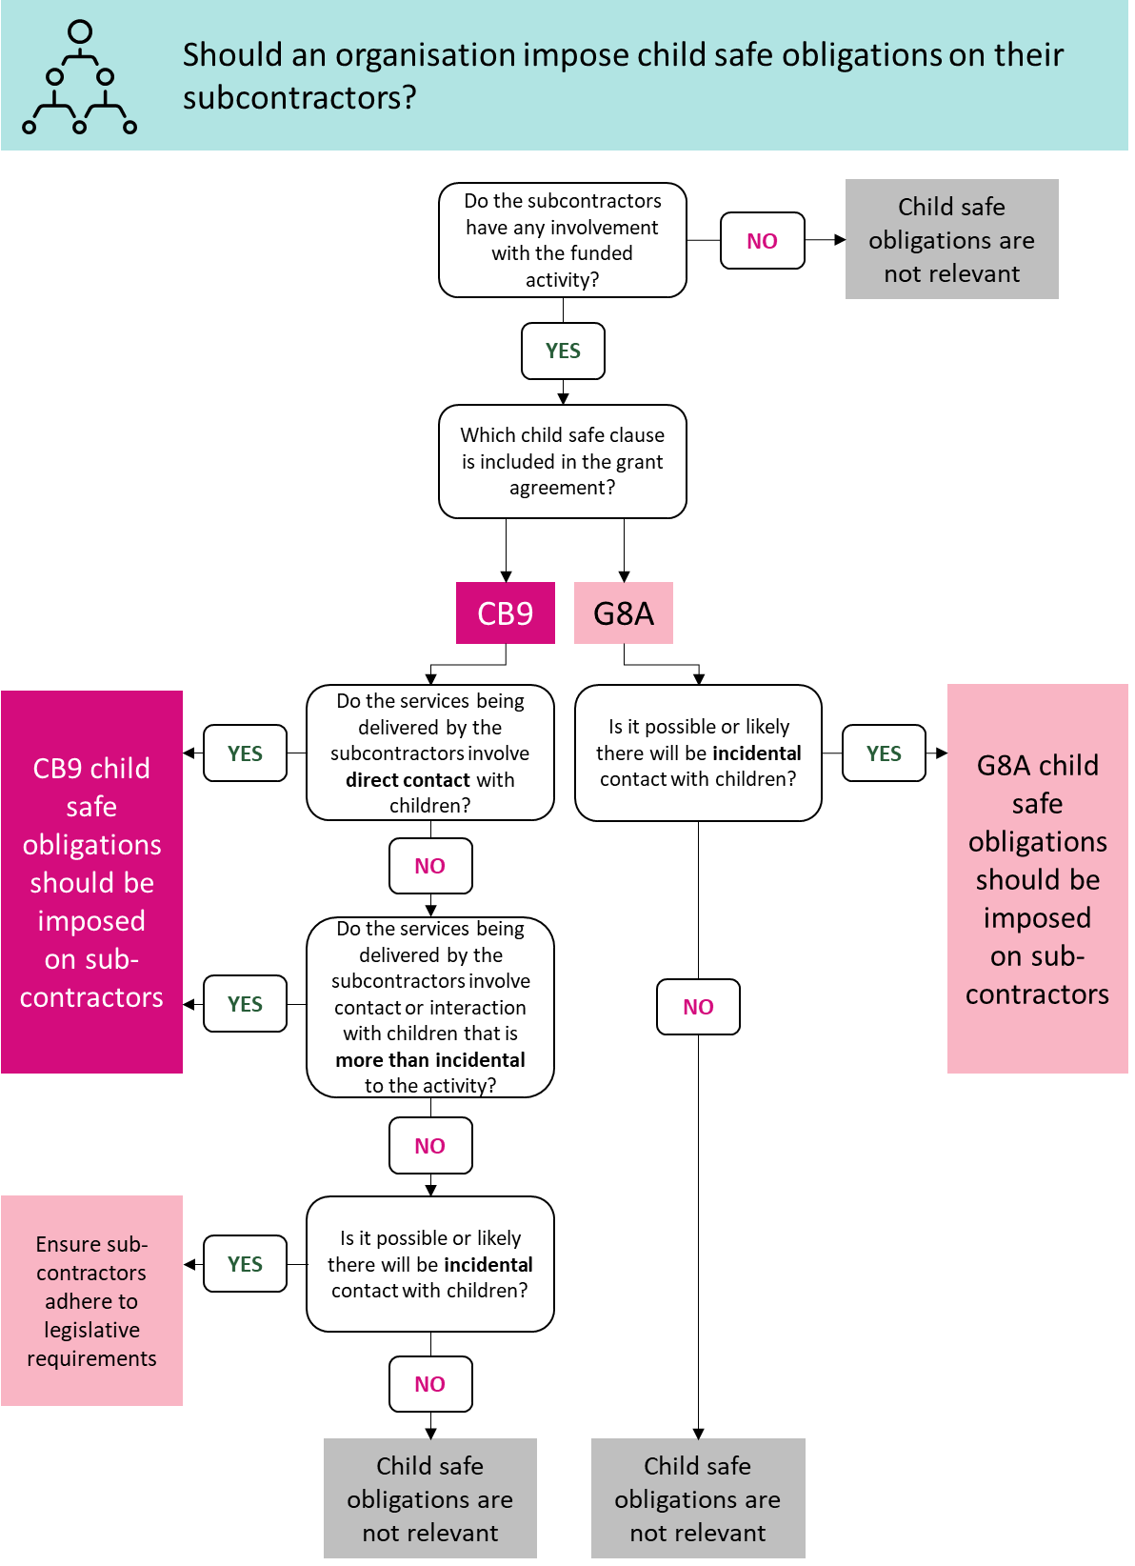

Children/Child/Young Person refers to an individual under 18 years.
Child related personnel means officers, employees, contractors (including subcontractors), agents and volunteers of the Grantee involved with the Activity who as part of that involvement may interact with children.
If you have Clause G8A in your agreement you may still be compliant, as this clause applies to “Child Related Personnel’ (see question 4). You should still contact your Funding Arrangement Manager to discuss if this clause is appropriate to remain in your agreement.
Reporting at the activity level aligns with the National Office for Child Safety advice. Organisations funded by other Commonwealth agencies will report separately covering all funded programs/activities specific to that Commonwealth agency.

